Acquisition and reconstruction
PERUZZETTO Enzo & PEPIN Teiki

The project has been developed for Qt 5.7.1, with the usage of Qt Creator 4.2.0. Some of the functions and rendering methods used might not work properly under other versions.

Interactivity
A few hotkeys are implemented in the current build of the program :
- P will switch the display to a point cloud,
- T will switch the display to triangles,
- escape will close the window,
- the arrow keys will allow you to rotate the model along the X and Y axes.
We can also use the mouse to interact with the display : holding left click allows us to rotate the model whereas, as requested, the scroll wheel allows us to zoom in or out.

Point Cloud
We first implemented a point cloud display where each voxel would be represented by OpenGL as a GL_POINT. This allowed us to make sure that the file was properly read and each voxel had the correct grayscale value and coordinates. We can also use this display to make sure that we properly render only the voxels that neighbor one with a different grayscale value.
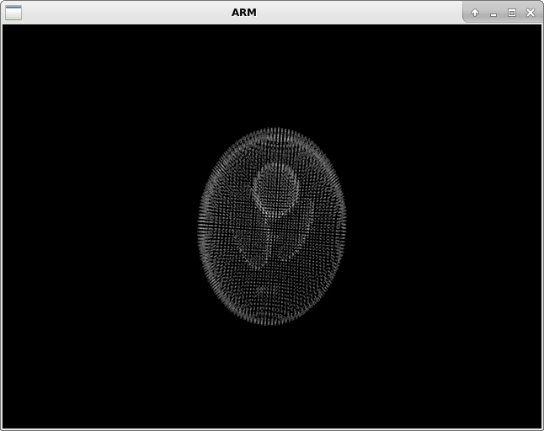

Triangles Display
We then proceeded to the implementation of a GL_TRIANGLES based display. To do this, we currently consider that each voxel is a cube with six faces. Each of these faces is made up of two triangles. Consequently, we render twelve triangles for each of the previous voxel. Colors and grayscale levels are currently not implemented, but with the transparency of each triangle, set by default at 95 %, we can observe the layout of our model with this method.

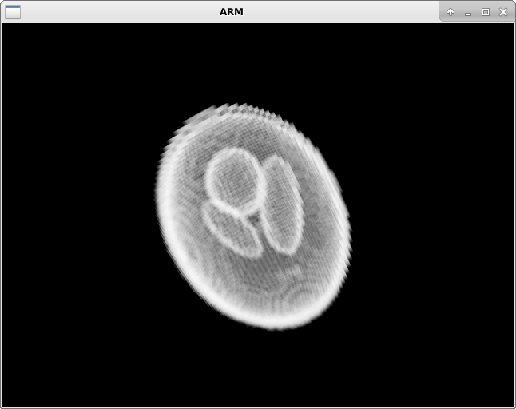
This display will be further improved so that only the triangles between two voxels with different color values are used, instead of all twelve triangles of these two voxels.

