Deep Learning in Computer Vision

Lab 1 – Report

I – Analysis of PersonConvergence_720.MOV

We can observe the frames obtained from PersonConvergence (Illustration 1) to visualize important information about the movement within the video. The flow panel allows us to distinguish how almost all of the motion is located within the frame of the person in the foreground, as well as along the road, where moving vehicles can be seen.
The gme frame does not give much indication of motion since there is little overall motion in the whole of the video itself. In gmeError, we can observe patches of white in the areas of the video where a lot of motion can be observed : the person moving and the vehicles.

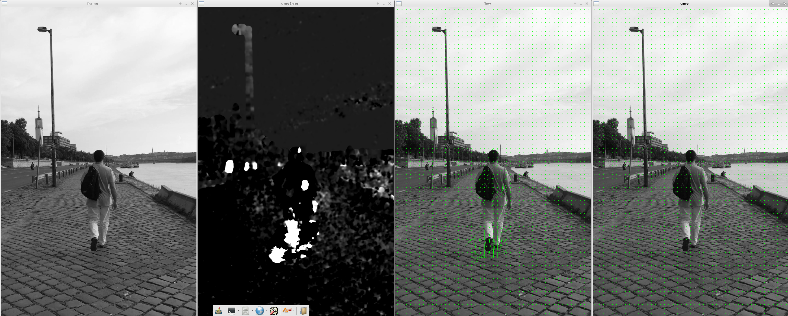
Illustration 1: Images captures from PersonConvergence

In the Mean Square Error graph (Illustration 2), we can observe that from the start of the video until its end, the MSE varies quite significantly between low values and high values. Indeed, the peaks along its curve are caused by the motion of the person, which is then followed by a downtime before his next step. This goes on until the end of the video, with no part of it that is without significant motion for more than a few frames.
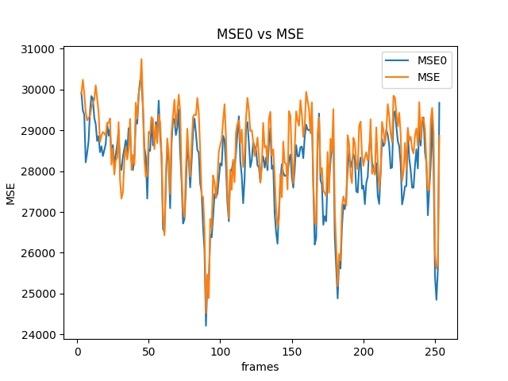
Illustration 2: Mean Square Error of PersonConvergence
In the next graph (Illustration 3), we can observe the PSNR of the same video; which is strongly correlated to the MSE. It evaluates the same sets of data and gives a similar, but inverted, graph. We also observe the fact, that the PSNR of the compensated frame is generally lower than that of the original frame since the compensated frame should have less noise.
For the entropy graph (Illustration 4), we observe that both entropy curves are at all times inferior to 8. The entropy of the original motion picture is very stable during the whole video whereas the entropy of the error sequence is much lower in values as well as being less stable. We can assume that this is due to the fact that the entropy of the error sequence has to deal with less disorder on the image as a whole, since only a smaller part of the image is used for it, as well as the fact that this error image is generated from motion, and thus will have more data in it when there is significant motion in the image sequence, hence the volatility of the curve.

II – Analysis of vtest.avi
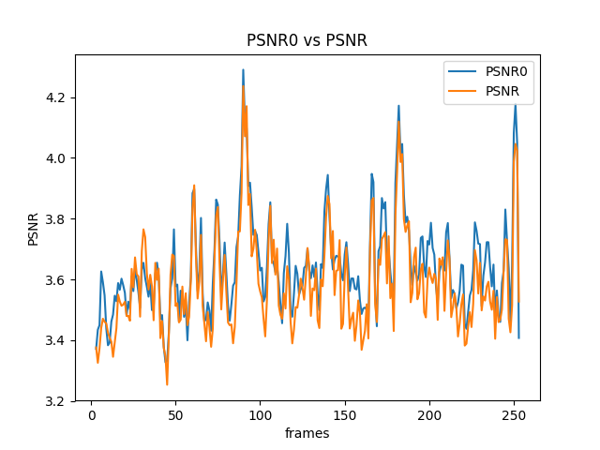
Illustration 3: Peak Signal-to-Noise Ratio of PersonConvergence
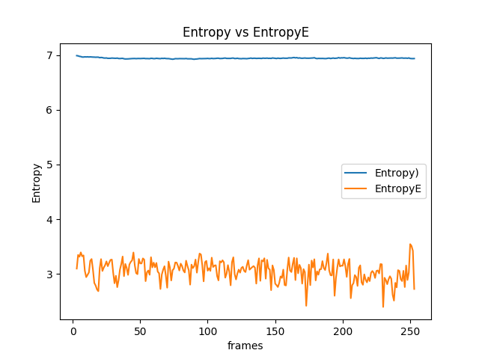
Illustration 4: Entropy graph of PersonConvergence
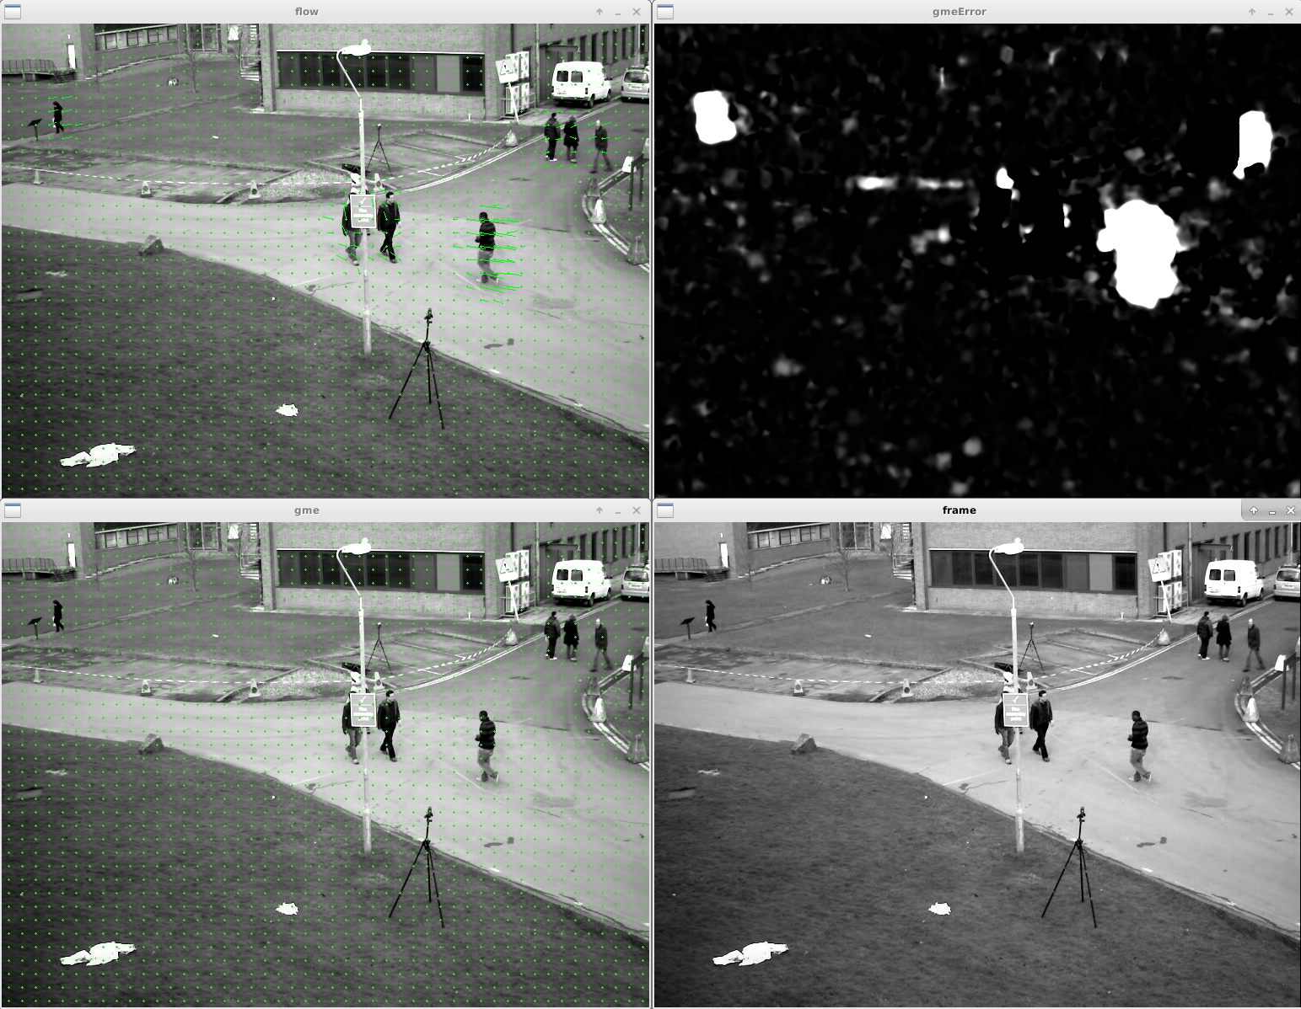
Illustration 5: Images captures from vtest.avi
Similarly to the previous video, in the frames from vtest.avi (Illustration 5), we can observe that the motion vectors in the flow panel are only active around the movement of the pedestrians. In a similar fashion, the gmeError window displays white patches along those very same pedestrians, with some tints of white patches here and there that can be qualified as noise.
Once again, the MSE (Illustration 6) and the PSNR (Illustration 7) are inverted graphs of each other. The PSNR is consistently inferior to the PSNR0, for the same reason as previously mentioned. Peaks within the MSE curves belong to frames with significant amounts of motion, such as when groups of people appear or disappear at the edges of the camera feed. The entropy graph (Illustration 8) is also similar to the previous one in appearance : the original motion picture entropy is stable around 7.5, whereas the entropy of the error sequence is once again lower and unstable, with strong peaks when person appear or disappear from the screen, since that corresponds to a strong motion.
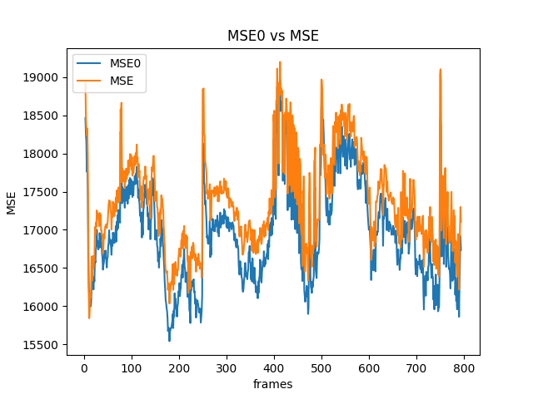
Illustration 6: Mean Square Error of vtest
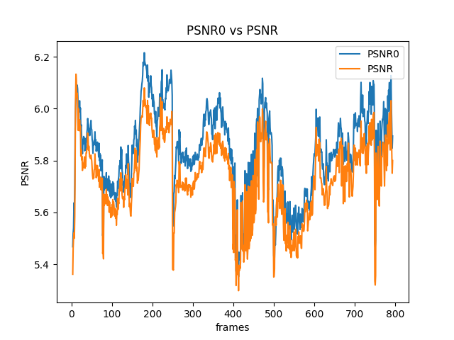
Illustration 7: Peak Signal-to-Noise Ratio of vtest
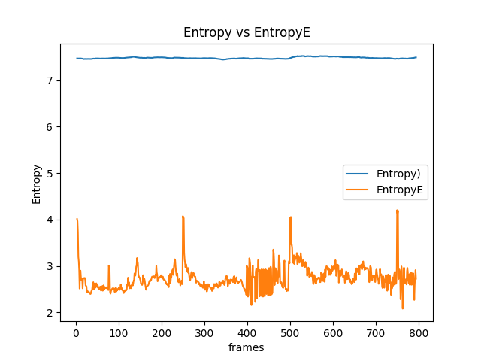
Illustration 8: Entropy graph of vtest

