**Introduction**

The Kaggle competition I pick for my capstone project is the BNP Paribas Cardif Claims Management. The duration of this competition was from February 3rd to April 18th 2016. This competition is supported by an insurance company called BNP Paribas Cardif. The company receives many claims from its customers every day, and the claims need different levels of check. So that the company wants to build a system which can automatize the process of determining to which level a claim belongs.

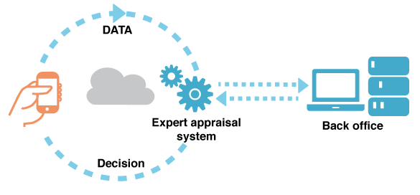

<https://www.kaggle.com/c/bnp-paribas-cardif-claims-management>

**I choose this for a project because it was my first contact with Kaggle and my struggles were my motivators to start the MLND. I want to see how much I have improved.**

**The Data**

The data in this challenge was health care data related to claims. It is an anonymized dataset with two categories of claims is provided by BNP Paribas Cardif. The objective was to use the 133 predictors to determine if a claim needed further work or not. The set was much larger than anything I had ever used with over 160,000 observations. The predictors were unlabeled. Additionally, there were thousands of missing values in the data set as well.

The output is the probability for a sample to be in the first category. The training set is consisted of 114322 samples, and the test set has 114394 samples.

**Metrics**

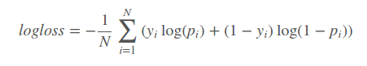 **The evaluation metric for this competition is** Log Loss

where N is the number of observations, log is the natural logarithm, yi is the binary target, and pi is the predicted probability that yi equals 1.

Note: the actual submitted predicted probabilities are replaced with max(min(p,1−10−15),10−15).

**The submission file should contain two columns: ID and PredictedProb. The file should contain a header and have the following format:**

**ID, PredictedProb**

0,0.5

1,0.5

2,0.5

7,0.5

etc.

**This error metric suits well our problem because it is used when we have**

**to predict a binary class with a probability (likelihood) ranging from definitely true (1) to equally true (0.5) to definitely false(0).** The use of log on the error provides extreme punishments for being both confident and wrong.   
Source : <https://www.kaggle.com/wiki/LogarithmicLoss>

**The Plan**

To get experience, my plan is to use ensemble techniques to try a top 10%. Ensemble methods seems mandatory to work with in Kaggle competitions nowadays and I need to understand the concepts. I will do a quick data exploration and try to create at least 2 distinct datasets. Then each of these dataset will be use with a series of few different models with Kfold. Predictions obtained will be gathered and use in a final model to create the final submission file. I will use the test set given by Kaggle to benchmark my models with the logloss metric.

**Data exploration**

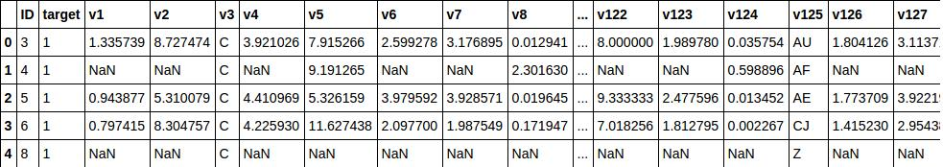Our dataset look likes that :

These are the basic description of the training dataset:

* Total: 114,393 observations (rows) x 133 features (columns)
* Data Types: float, integer, string
* Column "ID": the ID of each row, not being used as predictor
* Column "target": the target of each row, not being used as predictor
* Numbers of Text-based Predictors: 112 Numbers of Numeric
* Predictors: 19
* Numbers of Columns with missing value: 119

As shown in the correlation matrix plot, some variables are highly correlated (not just 1-to-many but also many-to-many). Correlation values are between -1 and 1. Red color means positive correlation while blue color means negative correlation.

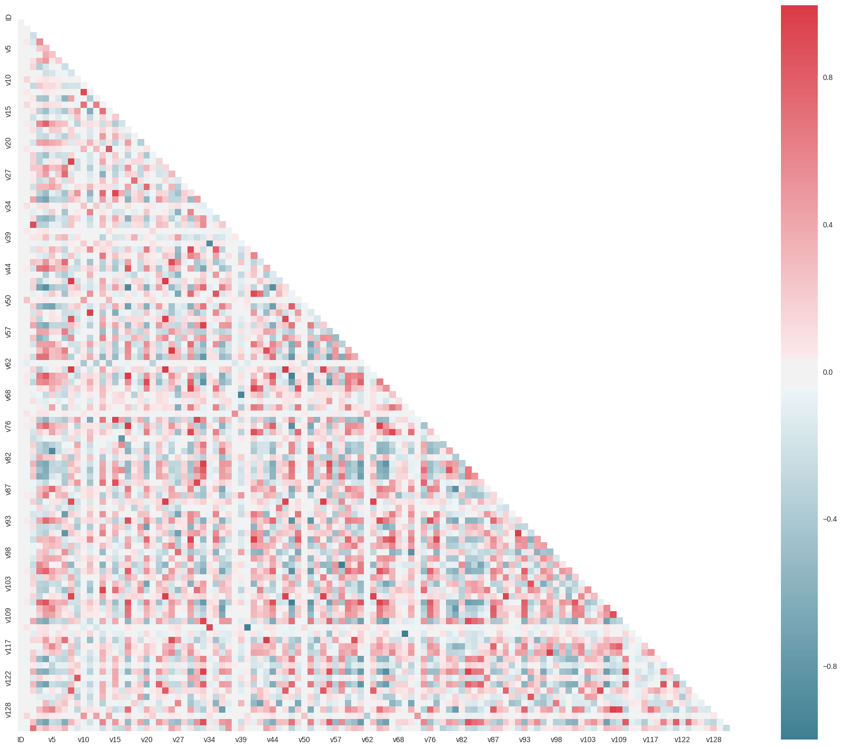 Correlation Matrix Plot

We can notice that there are a lot of missing values. 96565 rows contain at least one. Here is a map showing the missingness in the dataset :

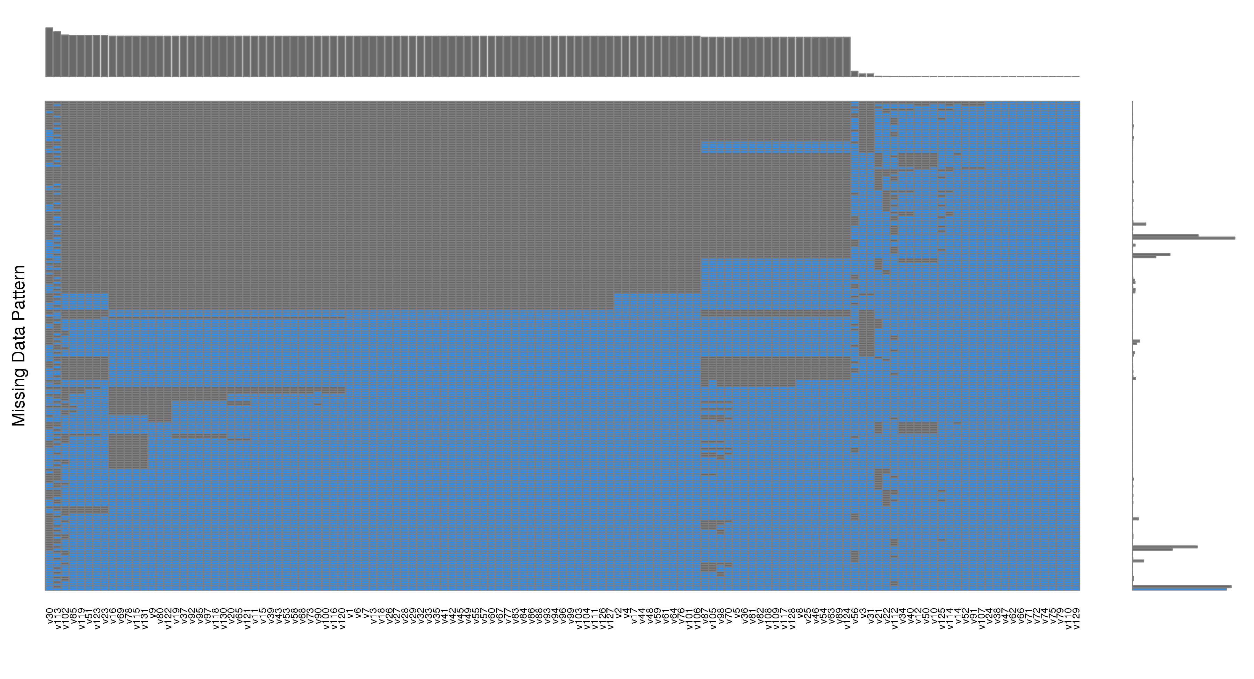We can see that approximately 40% of data is missing.

Source : https://www.kaggle.com/jpmiller/bnp-paribas-cardif-claims-management/visualizing-the-nas/code

**Algorithms and Techniques**

I decided to create multiple datasets from the one given. Each of these datasets is the product of severals transformations. These transformations are:

* Label encoding for categorical variables
* One hot encoding
* Transform NaNs to 999
* Transform NaNs to the mean of each column
* Only keep continuous variables and label encoding on categoric variables
* ...

I tried severals techniques. Considering my computer I only kept 4 datasets with these combinations of transformation: label encoding + NaN means, label encoding + NaN at 999, only categorical + NaN means and only categorical variables with label encoding.

Label encoding is a technique consisting of encoding labels with value between 0 and n_classes-1.LabelEncoder can be used to normalize labels. It can also be used to transform non-numerical labels (as long as they are hashable and comparable) to numerical labels.

One hot encoding on the other hand consists of encoding categorical integer features using a one-hot aka one-of-K scheme. The input to this transformer should be a matrix of integers, denoting the values taken on by categorical (discrete) features. The output will be a sparse matrix where each column corresponds to one possible value of one feature. It is assumed that input features take on values in the range [0, n_values).

Source : [http://scikit-learn.org](http://scikit-learn.org/)

Transforming NaNs is a common technique to use the maximum of data available. To give a “high score” like 999 is a trick to labelize missing values. Choosing the mean is just a way to extrapolate and ignore missing values in our datasets.

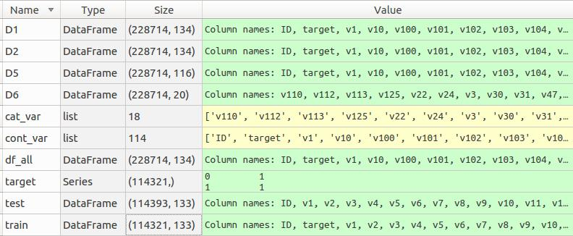 Summary of datasets created

My goal is to use the common Kaggle technique of models ensembling (see mlwave). After testing and tuning a set of models, I will the method called “blending”. I choose this method it seems to be the more elegant to me and I want to be able to use in different context.

Blending has been introduced during the Netflix prize, and has since then spread out to many of the winning solutions in Kaggle competitions. The concept is as follow:

* Split the training dataset in k folds  
* For each of the k folds, use the (k-1) other folds to output probabilities on the k-th fold. Stack these to output probabilities on the whole training dataset without predicting the training data.  
* Iterate over all models and concatenate the probabilities provided by each model together. In doing so, we recreate a set of p features, where p is this time the number of models we trained and cross-validated.  
* Use these new features to train a new model.

Source: <http://mlwave.com/kaggle-ensembling-guide/>

I went through these steps and built a logistic regression, an XGBOOST classifier and a Gradient Boosting classifier on top of our 8 previous models. Then I choose the one giving the best results in regards of the loss function.

All the well-known algorithms I used can be described as follow:

**Random forest classifier**

Random forests are an ensemble learning method that use random subsets of observations and features from the training data to create multiple decision trees. Then, those separate decision trees fit the data separately. The classifier chooses the classification by voting the better class.

**Pros:**

* Prevent from overfitting (by random subset of trees)
* Good with very large data set (also due to random subset of trees)
* No transformation needed
* Robust against outliers
* Can work in parallel

**Cons:**

* Slow due to construction of multiple classifier for subset trees.
* Difficult to interpret
* Biased in multiclass problems toward more frequent classes

**eXtreme Gradient Boosting (XGBoost)**

XGBoost (eXtreme Gradient Boosting) is an advanced implementation of gradient boosting algorithm. It has definitely boosting capabilities and additional components overcoming the weakness of GBM.

**Pros :**

* Regularization: it reduces overfitting (
* Parallel processing: XGBoost is also said a parallelized gradient boosting model. This makes the model faster than GBM (sequential)
* XGBoost do not required feature engineering (handle missing values, scaling and normalization)
* Can be used for classification, ranking or regression
* Built-in Cross Validation

**Cons:**

* Only work with numeric features
* Hyperparameters must be tuned properly or it will lead to overfitting

For XGB, we were tuning the following parameters.

* learning_rate: learning rate (not going to be tune at the beginning)
* max_depth: depth of the trees
* n_estimators: Number of boosted trees to fit.

**Extra Tree Classifier**

Similarly to to Random Forest, a Extra Tree Classifier fits a number of randomized decision trees on random subsets of observations and features. When looking for the best split to separate the samples of a node into two groups, random splits are drawn for each of the max_features randomly selected features and the best split among those is chosen. When max_features is set 1, this amounts to building a totally random decision tree.

**Pros:**

* The same as Random Forest
* More random thus lower variance

**Cons:**

* The same as Random Forest
* Computation can grow much bigger

**Logistic Regression**

Use regression to solve binary classification problems by fitting a sigmoid function to calculate the probabilities

**Pros:**

* Intrinsically simple and fast (runs in constant time)
* Easy to interpret
* Less prone to overfitting
* Low variance

**Cons:**

* Unable to model complex relationships (non linear ?)
* Doesn't perform well with large number of features

My understanding of pros and cons is largely due to http://www.kdnuggets.com/2015/07/good-data-science-machine-learning-cheat-sheets.html

**Results**

So I finally performed predictions. If we look at the test score for each models for the round we have:

dataBLEND_ExtraTreesClassifier_tr-val_0.0806-0.4578  
dataBLEND_ExtraTreesClassifier_tr-val_0.0806-0.4578

dataBLEND_RandomForestClassifier_tr-val_0.1625-0.4645  
dataBLEND_RandomForestClassifier_tr-val_0.1714-0.4648

dataBLEND_XGBClassifier_tr-val_0.2299-0.4636  
dataBLEND_XGBClassifier_tr-val_0.2299-0.5381  
dataBLEND_XGBClassifier_tr-val_0.2299-0.5425

So the Extra Tree Classifier is surprinsily our best model here. I was expecting that the XGBC to score better. I think its probably due to my data preparation. My method was a bit brutal and with a proper matrix score should be higher.

Anyway with these probabilities, I ready to launch my blender. I tried 3 differents algorithms for blending : simple logistic regression, a XGBC and a GBM. Here are the results :

dataBLENDED_LogisticRegression_tr-val_0.4580-0.4581  
dataBLENDED_XGBClassifier_tr-val_0.3010-0.4589  
dataBLENDED_GradientBoostingClassifier_tr-val_0.4532-0.4574

So the blending was succeful only with the GBM, we went from 0.4578 to 0.4574. It’s not a lot but it’s enough to win severals rank in a Kaggle competition. Plus, more importantly, it validates the method.

So I compare my score to the public leaderboard, my rank is 1187/2926. My result is good enough because I consider my code to be a «starter kit» for futur competitions. Of course my score is certainly beaten by a single model with propre features engineering. Next time I will this starter code and focus directly on variables.

What can be done to score higher

By taking a more classical approach, I could have done a lot better at transforming variables. For instance I have checked the correlation factor between variables but I haven’t removes any. For instance I can remove a variable of a pair when the factor is superior is close to 1.

Also, many tree-based methods provides feature importance, which can be used to discard the irrelevant features. I used ExtraTrees classifier and I could have coupled it with «SelectFromModel» in the scikit-learn package "feature_selection". SelectFromModel can be used along with any model that has a coef_ or feature_importances_ attribute after fitting. It also allows us to set the threshold for feature selection. Features whose importance is greater or equal are kept while the others are discarded. A similar method can be used with XGBoost estimate the «feature importance». These techniques can be considered pretty easy to set up.

See: <https://www.kaggle.com/mmueller/liberty-mutual-group-property-inspection-prediction/xgb-feature-importance-python>

I could have also use all the work shared on the forum by the kaggler to improve drastically my score. For instance this post seems to had a large impact on the leaderboard:

<https://www.kaggle.com/trottefox/bnp-paribas-cardif-claims-management/nearest-neighbour-linear-features/comments>

And of course the blending method, to be truly effective, needs to be used with a lot more models. Ideally I could have created a few more datasets and adapt it to a lot more models. Competition winners claim to use thousands of different models.

Lastly I could have done some grid-search to select some of the parameters. I did’nt because it was too costly in time and ressource for me, but I used this technique in another project.

**Conclusion**

The BNP Paribas Cardif Claims Management competition is challenging due to its anonymous variables and high amount of missing data. To answer this challenge I used different method of data cleaning and imputation. Different machine learning classifiers such as Logistics Regression, ExtraTrees, XGBoost, Random Forest and GBM were used for training and predictions. Finally I used a model ensembling method called blending, which slightly improve the score from one of combinations.  
More importantly I wrote the code as a starter code for my next competitions. I also have identified what could be done to improve my result on this specific competition.

Many of the Kagglers in the competition have used the similar methods that I did. The best kaggler used ensembling method with a lot of models and really advanced features engineering. My futur work in a incomming competition will certainly be related to look deeper on the data and do more feature engineering.

All-in-all, a lot of efforts for a little gain, which surely makes sense in the context of Kaggle competitions, and probably less in real time contexts. I am still really happy with the experiment.