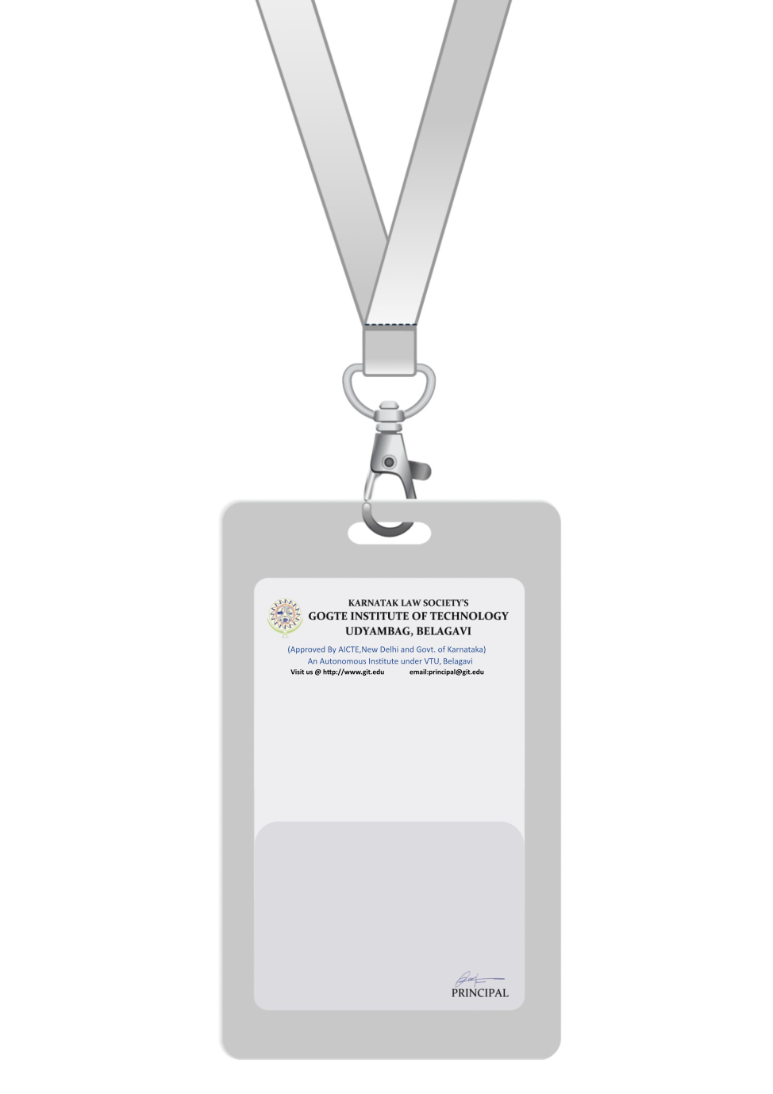

|  |
| --- |
| PHOTO  O +ve |
| **John Bosco** |
| **Human Resources** |
| **BARCODEHR Manager** |
| **1001** |
| **EMERGENCY NUMBER** |
|  |

IF FOUND RETURN TO RESPECTIVE DEPARTMENT