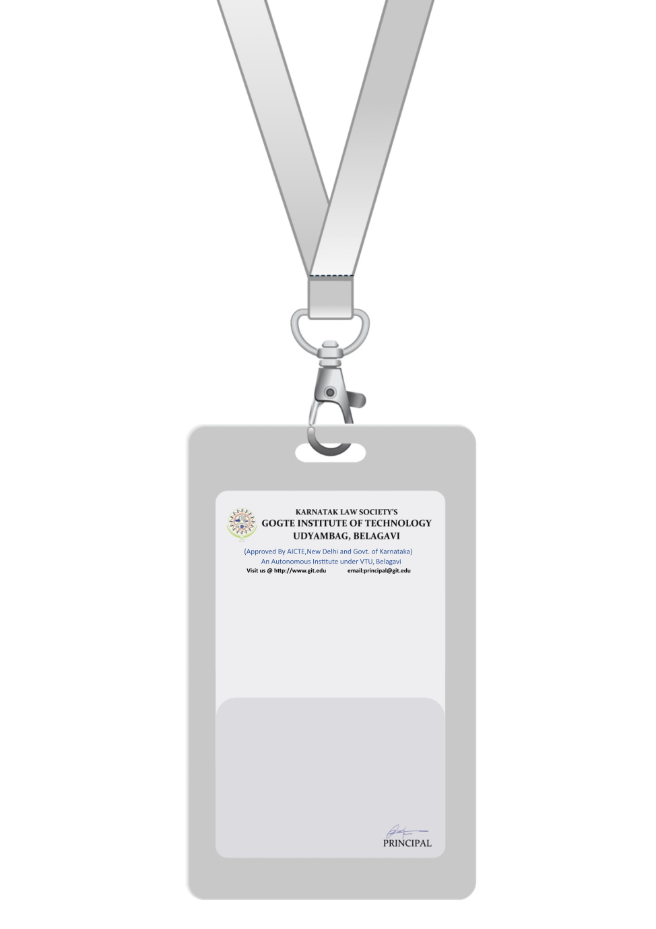

|  |
| --- |
| PHOTO  A +ve |
| **JANE DOE** |
| **MARKETING** |
| BARCODE**MARKETING SPECIALIST** |
| **1002** |
| **EMERGENCY NUMBER** |
|  |

IF FOUND RETURN TO RESPECTIVE DEPARTMENT