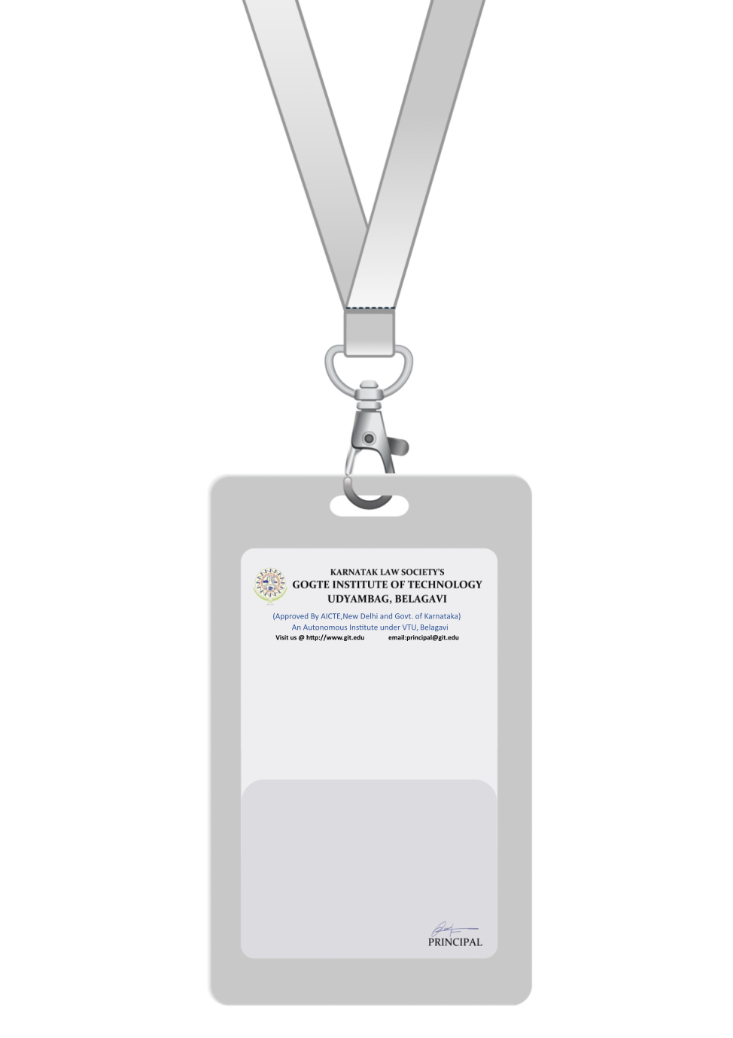

|  |
| --- |
| PHOTO  A +ve |
| **MICHAEL JOHNSON** |
| **FINANCE** |
| BARCODE**FINANCIAL ANALYST** |
| **1003** |
| **EMERGENCY NUMBER** |
|  |

IF FOUND RETURN TO RESPECTIVE DEPARTMENT