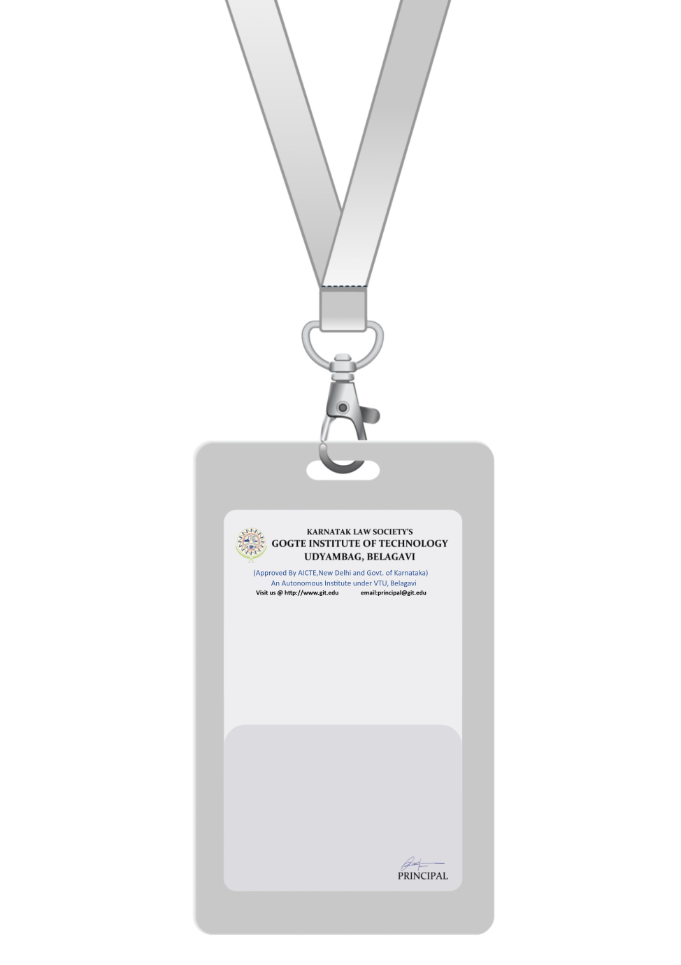

|  |
| --- |
| PHOTO  O +ve |
| **EMILY BROWN** |
| **SALES** |
| BARCODE**SALES REPRESENTATIVE** |
| **1004** |
| **EMERGENCY NUMBER** |
|  |

IF FOUND RETURN TO RESPECTIVE DEPARTMENT