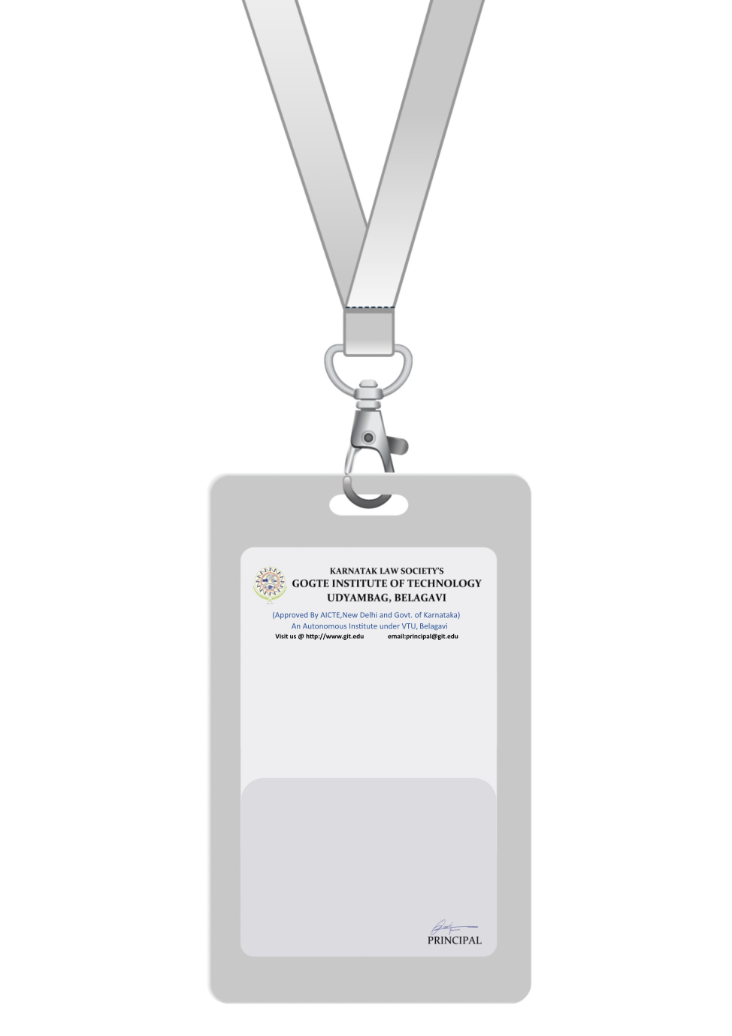

|  |
| --- |
| PHOTO  AB +ve |
| **DAVID WILSON** |
| **INFORMATION TECHNOLOGY** |
| BARCODE**IT SPECIALIST** |
| **1005** |
| **EMERGENCY NUMBER** |
|  |

IF FOUND RETURN TO RESPECTIVE DEPARTMENT