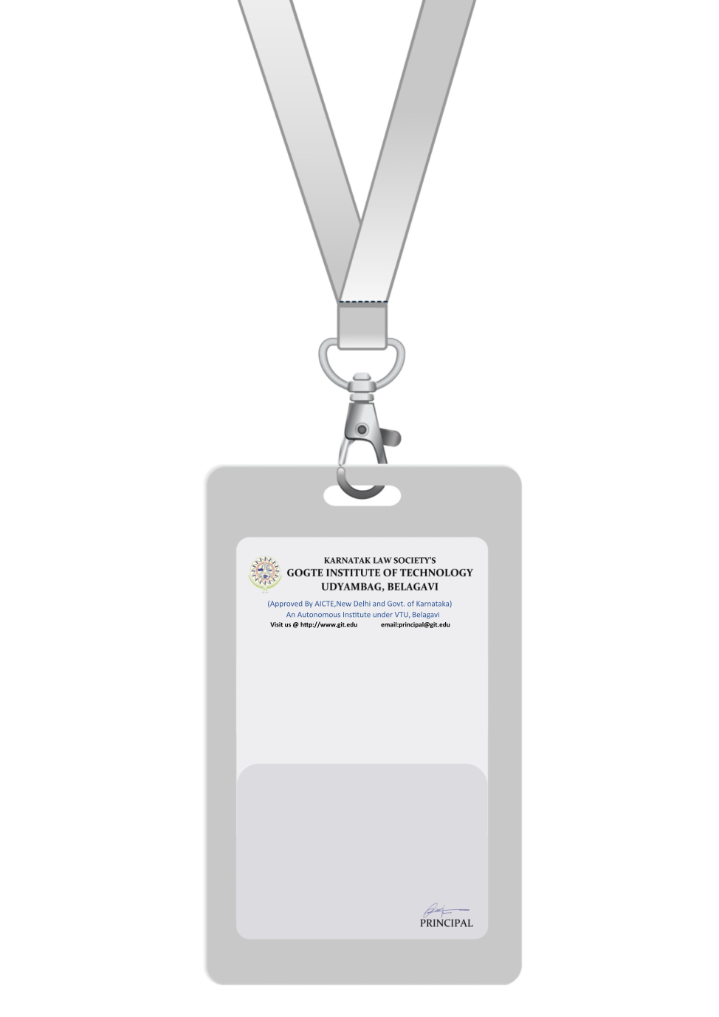

|  |
| --- |
| PHOTO  O +ve |
| **LISA TAYLOR** |
| **OPERATIONS** |
| BARCODE**OPERATIONS MANAGER** |
| **1006** |
| **EMERGENCY NUMBER** |
|  |

IF FOUND RETURN TO RESPECTIVE DEPARTMENT