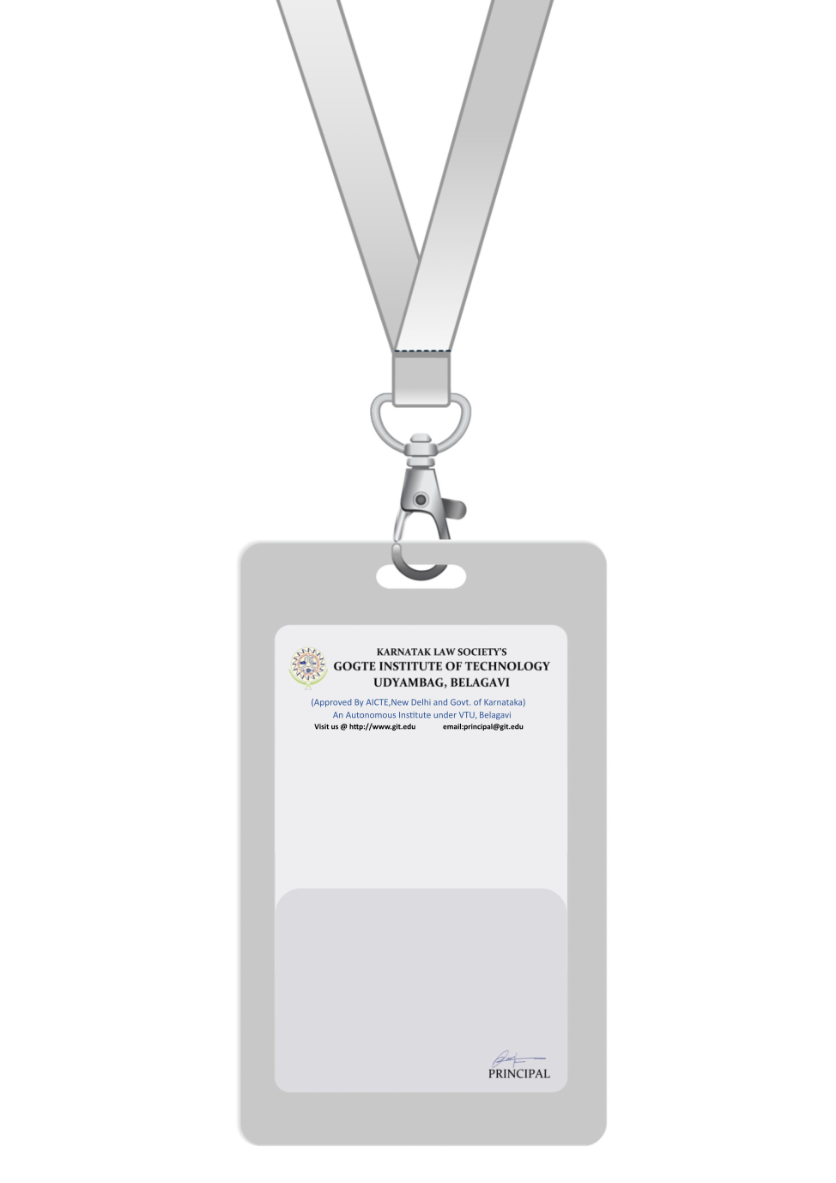

|  |
| --- |
| PHOTO  O +ve |
| **DANIEL MARTINEZ** |
| **CUSTOMER SERVICE** |
| BARCODE**CUSTOMER SERVICE REPRESENTATIVE** |
| **1007** |
| **EMERGENCY NUMBER** |
|  |

IF FOUND RETURN TO RESPECTIVE DEPARTMENT