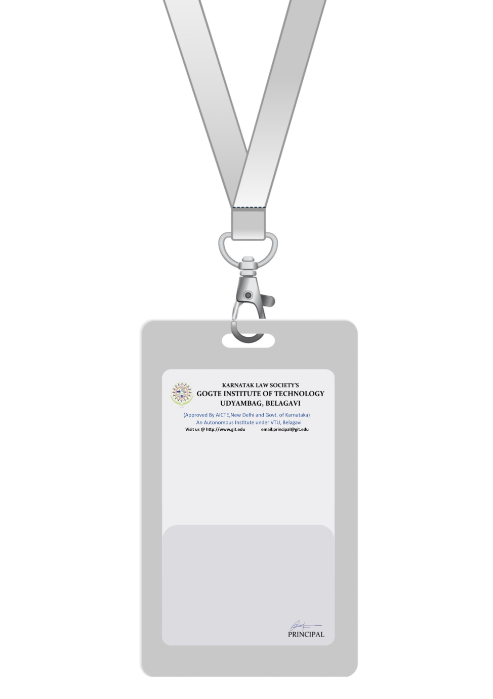

|  |
| --- |
| PHOTO  A -ve |
| **SARAH ANDERSON** |
| **RESEARCH AND DEVELOPMENT** |
| BARCODE**R&D ENGINEER** |
| **1008** |
| **EMERGENCY NUMBER** |
|  |

IF FOUND RETURN TO RESPECTIVE DEPARTMENT