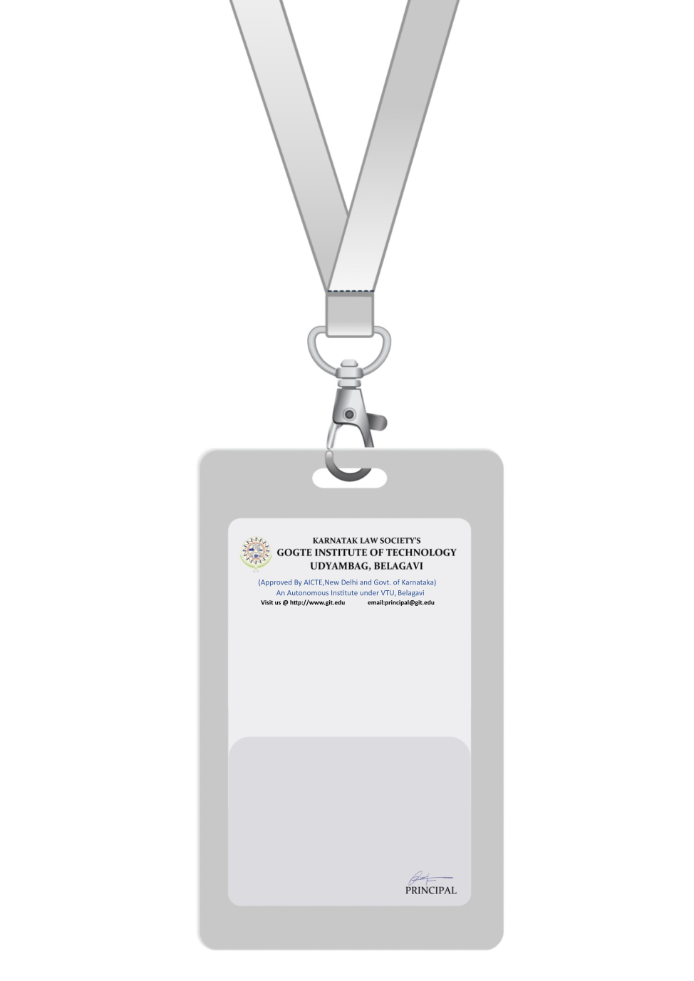

|  |
| --- |
| PHOTO  O -ve |
| **CHRISTOPHER THOMAS** |
| **PRODUCTION** |
| BARCODE**PRODUCTION SUPERVISOR** |
| **1009** |
| **EMERGENCY NUMBER** |
|  |

IF FOUND RETURN TO RESPECTIVE DEPARTMENT