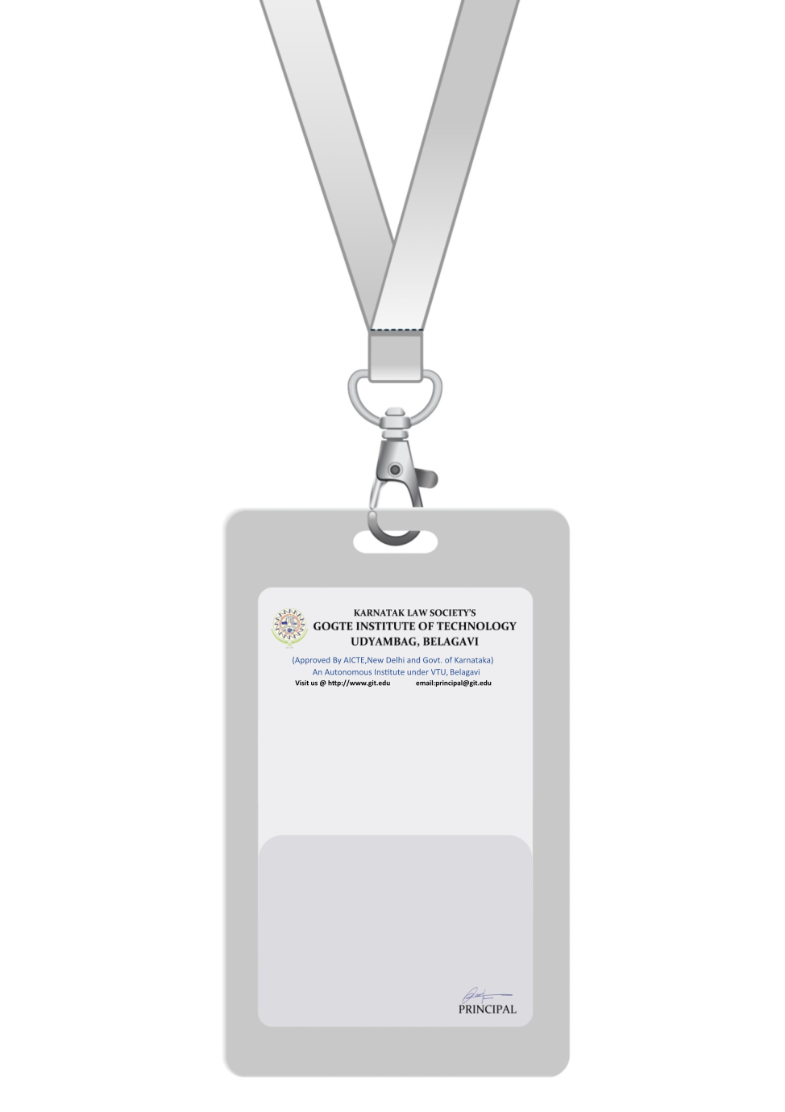

|  |
| --- |
| PHOTO  O+ve |
| **Kimberly Garcia** |
| **Quality Assurance** |
| **BARCODEQA Analyst** |
| **1010** |
| **EMERGENCY NUMBER** |
|  |

IF FOUND RETURN TO RESPECTIVE DEPARTMENT