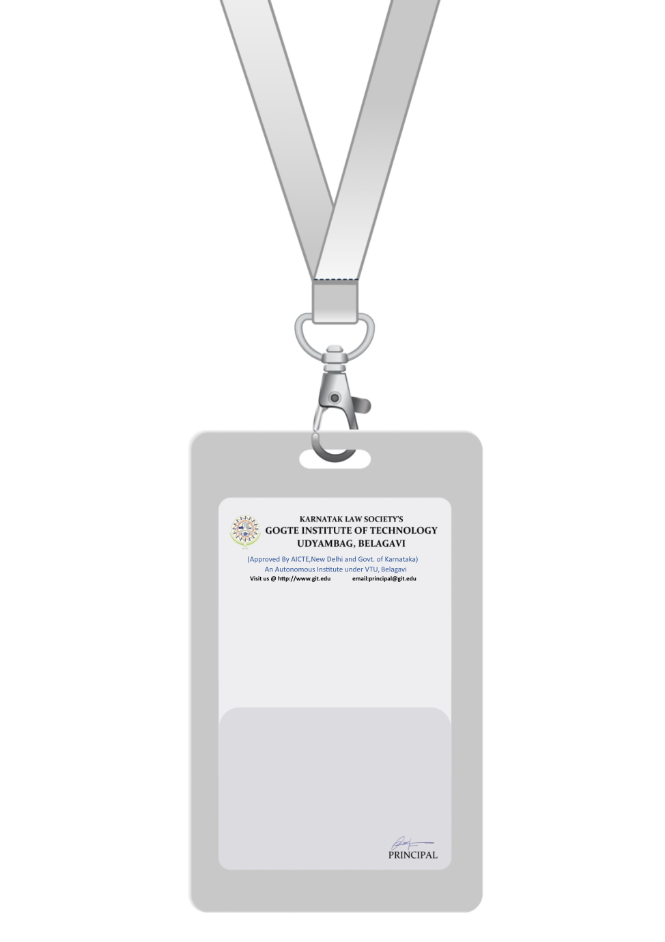

|  |
| --- |
| User with solid fill  bg |
| **Name** |
| **dept** |
| **BARCODEdesg** |
| **uid** |
| **EMERGENCY NUMBER** |
|  |

IF FOUND RETURN TO RESPECTIVE DEPARTMENT