**MindSpark-AI-Powered Empathetic Chatbot**

Team Name**:** **Team BotStronauts**

**1. Problem Statement**

In today’s fast-paced and digitally driven lifestyle, many individuals face emotional challenges such as stress, anxiety, burnout, and loneliness. While there are apps for meditation, journaling, or motivational content, they often lack empathy, personalization, and real-time support. Users end up with generic solutions that fail to adapt to their moods. This gap highlights the need for a system that can check in with users, understand their emotions, and respond in a supportive, meaningful, and engaging way.

**2. Proposed Solution**

We propose an **AI-powered chatbot** designed to act as an empathetic companion for users. The system detects the user’s emotional state through their text interactions, and then responds with appropriate emotional support. It provides motivational tips, calming advice, music, quotes, or visuals depending on the mood.

Over time, the assistant builds a simple dashboard that tracks mood trends, enabling users to reflect on their mental well-being and see progress. By combining **emotion detection, empathetic responses, and personalized media generation**, the solution becomes more than a chatbot — it’s a wellness partner.

Key capabilities include:

* AI-driven text.
* Emotion-aware empathetic responses.
* Mood-based suggestions (audio, quotes, visuals).
* Long-term mood tracking with charts.

**3. Key Features**

* **Chatbot**  – Seamless interaction through text.
* **Emotion Detection** – Identifies mood from text input.
* **Empathetic Responses** – Suggests supportive advice, motivational words, or relaxation guidance.
* **Personalized Media Recommendations** – Plays calming/energizing audio, generates motivational quotes, or produces simple visuals.
* **Mood Tracking Dashboard** – Displays simple, interactive charts showing mood trends over time.
* **Customizable Experience** – Users can request specific content such as quotes or calming visuals on demand.
* **Lightweight & Accessible** – Runs on free, open-source tools ensuring scalability without limits.

**4. Process Flow**

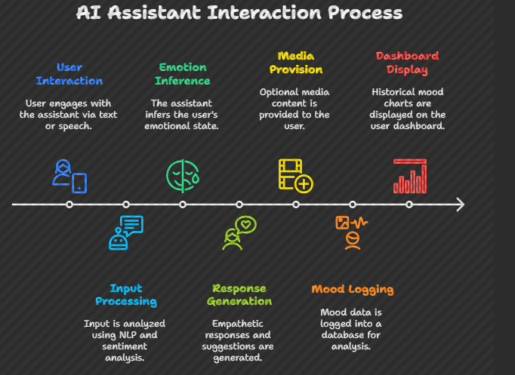

1. User interacts with the assistant via text.
2. Input is processed through NLP + sentiment/emotion analysis.
3. Emotion state is inferred (e.g., stressed, happy, low-energy).
4. Assistant generates empathetic responses + suitable suggestions.
5. Optional media content (music, visuals, quotes) is provided.
6. Mood data is logged into a simple database for trend analysis.
7. User dashboard displays historical mood charts.

**5. Use Cases**

1. **Students under academic stress**
   * Assistant offers calming tips and motivational quotes.
   * Tracks emotional ups/downs during exam periods.
2. **Working professionals facing burnout**
   * Detects stress through late-night check-ins.
   * Plays calming music or energizing audio for breaks.
3. **Individuals battling loneliness**
   * Provides empathetic conversations, reminders of self-worth.
   * Suggests positive activities to uplift mood.
4. **Fitness enthusiasts**
   * Tracks motivational patterns and boosts morale.
   * Generates quotes or energizing audio to stay consistent.
5. **General well-being**
   * Everyday users receive mood-based tips, creating awareness of emotional health.

**6. Technical Implementation**

* **Frontend**: Streamlit (for quick prototyping, colorful and interactive UI).
* **Backend**: Python with Flask/FastAPI for logic orchestration.
* **NLP/AI Models**: Hugging Face Transformers for chatbot + sentiment/emotion detection.
* **Deployment**: Streamlit Cloud for frontend + backend integration, GitHub for version control.

**7. Architecture Diagram**

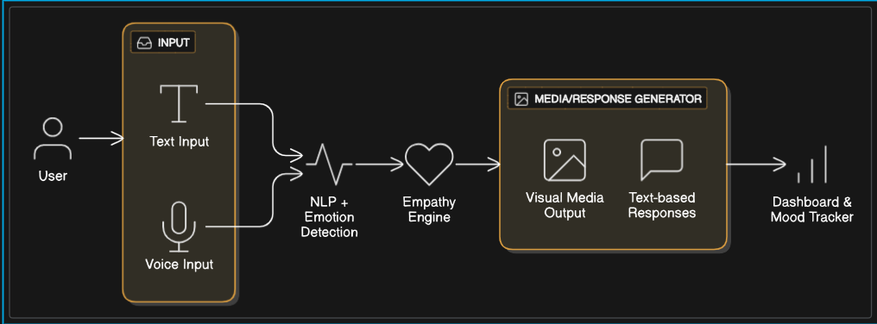

**8. Impact & Benefits**

* **Promotes Mental Wellness** – Encourages emotional check-ins and self-care.
* **Personalized Support** – Empathy-driven responses tailored to individual moods.
* **Free & Accessible** – Built with open-source tools, removing barriers of cost or API limits.
* **Awareness & Reflection** – Mood tracking helps users identify emotional trends.
* **Scalable Across Domains** – Can be adapted for students, professionals, fitness users, or general audiences.

1. **Future Enhancements**

* Multi-language support for inclusivity.
* Speech to text integration.
* Advanced emotion recognition using voice tone + facial expressions.
* Integration with wearable devices (heart rate, sleep patterns).
* Community support groups (anonymous peer-to-peer chat).
* Gamification to encourage consistent emotional check-ins.

**10. Conclusion**

The AI-powered chatbot is designed to go beyond generic well-being apps by offering **empathetic, personalized, and real-time emotional support**. By integrating mood detection, empathetic responses, and wellness content into one assistant, it creates a supportive digital companion for users.

This project not only addresses stress, loneliness, and motivation challenges but also empowers individuals to reflect on their emotional journey through mood tracking. It is **scalable, socially impactful, and future-ready**, making it a powerful tool for enhancing emotional well-being in modern life.