Linux lab exercise:

Name: Tejsai

Regno:17mis1021

Using sl command:

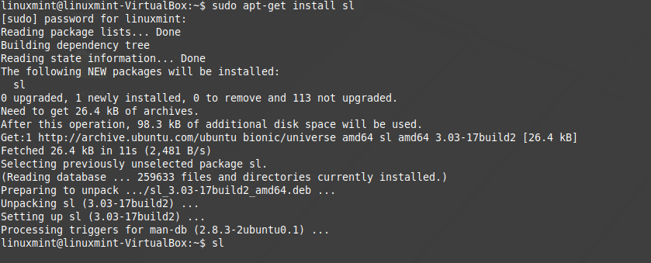

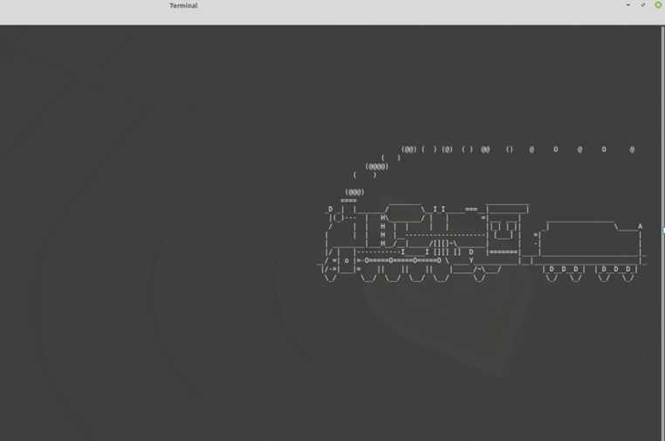

Using rev command:

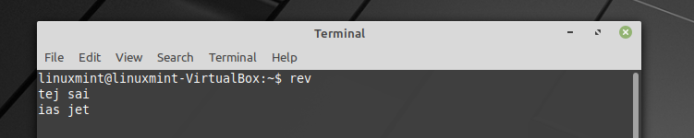

Using factor command:

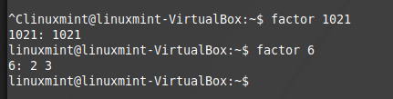

Using yes command:



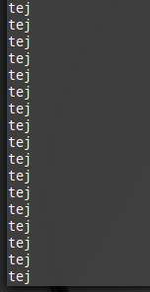

Hot question:

Write a bash shell script to monitor the health of your system. let the details be stored and archived in any folder of your choice.

After downloading file “tecmint_monitor.sh” from : <https://tecmint.com/wp-content/scripts/tecmint_monitor.sh>.

And change mode and use the execute that file . finally the output is redirected to file “tej.txt”



