Industry Project Title | Customer Profitability Analysis
Name of the Company | Tata Consultancy Services (TCS)
Name of the Institute | JNTUH University College of Engineering, Manthani

Start Date | End Date | Total Effort (hrs.) | Project Environment | Tools used
06-10-2025 | 10-11-2025 | 70 hrs | Windows 10/11  8GB (minimum)  256 GB SSD  MySQL 8.0  DBeaver  Power BI | Python, MySQL,  Power BI,  DBeaver,  VS Code,  Git & Github

TABLE OF CONTENT
- Acknowledgements
- Objective & Scope
- Problem Statement
- Methodology
- Tools & Technologies
- Implementation
- Dashboard Screenshots
- Results & Analysis
- Conclusion
- Link to Code and Executable File

Acknowledgements
I would like to express my heartfelt gratitude to Tata Consultancy Services (TCS) for giving me the opportunity to work on the 'Customer Profitability Analysis' project. I also extend my appreciation to my faculty & mentors for their guidance and support throughout this journey.
Finally, I thank my family and friends for their constant support and encouragement throughout the project development period.

Objective & Scope
The main objective of this project is to design and implement a Customer Profitability Analysis system that leverages data processing, transformation, and analytics to identify profitable telecom customers and segments. The system enables decision-makers to gain insights into customer revenue, churn trends, and profitability metrics through dynamic Power BI dashboards.
Scope includes: Data preprocessing, ETL processing, Data Mart creation, KPI calculation, and Power BI dashboard development.

Problem Statement
Telecom operators manage millions of customers whose profitability varies significantly based on their service usage. Traditional reporting systems are manual, time-consuming, and lack actionable insights. This project automates the process by creating a scalable data pipeline and visualization platform to derive KPIs such as CLV, CPI, and Profitability Score, enabling strategic decisions for retention and revenue growth.

Methodology
The project follows a four-step structured approach:
- Data Collection & Pre-processing: Clean and prepare raw telecom customer data (CSV to SQL).
- Data Mart Loading: Design and populate dimension and fact tables (star schema).
- KPI Derivation: Calculate profitability metrics using SQL and DAX.
- Dashboard Development & Deployment: Create interactive Power BI dashboards for insights.

Tools & Technologies
Layer | Tool/Technology | Use
ETL Layer | Python (pandas), SQL | Data cleaning and transformation
Database Layer | MySQL | Data Mart and KPI storage
Visualization Layer | Power BI | Dashboard creation and KPI visualization
Development Environment | DBeaver, Power BI Desktop | Data modeling and report building

Implementation

6.1 Data Collection & Preprocessing
The implementation began with collecting the raw dataset “ Telco Customer Churn” in CSV format. The dataset included details about customer demographics, subscription plans, internet and phone services, tenure, charges, and churn information.The raw data was analyzed for inconsistencies, missing values, and incorrect data types.
- Tools Used: Python (pandas, NumPy), Excel for initial inspection
- Key Steps :
  - Removed duplicate records on customerID
  - Converted blank TotalCharges values into NaN and imputed them using MonthlyCharges × tenure.
  - Standardized text values (e.g., converted “No internet service” to “No”).
  - Verified numeric conversions for fields like SeniorCitizen, tenure, and MonthlyCharges.
  - Added derived columns: ProfitabilityScore, CPI (Customer Profitability Index), and CLV (Customer Lifetime Value) using defined business rules.
Finally, the cleaned dataset was exported as telco_cleaned_for_sql.csv for integration into the MySQL database.

6.2 Database Design and ETL Implementation

Database Schema
- A star schema model was adopted for simplicity, scalability, and optimized analytical querying. The database was implemented in MySQL 8.0, and designed to contain three primary layers:
- Staging Table (stg_telco_clean)
  - Holds raw or cleaned input data before transformation.
  - Columns include customer demographics, plan details, and billing information.
- Dimension Table (dim_customer)
  - Contains master data for customers such as gender, senior citizen status, dependents, region, and country.
  - Surrogate key: Customer_SK (Auto Increment).
- Fact Table (fact_profitability)
  - Stores aggregated metrics and KPIs for profitability analysis.
  - References dim_customer using Customer_SK as a foreign key.
  - Fields include: tenure, MonthlyCharges, TotalCharges, Contract, InternetService, Churn, ProfitabilityScore, CPI, and CLV.

ETL (Extract, Transform, Load) Process
The ETL process was executed through a combination of Python and SQL scripts.
Extract:
- Source: telco_cleaned_for_sql.csv
- Imported via DBeaver into MySQL staging schema (stg_telco_clean).
Transform:
- Derived new columns (ProfitabilityScore, CPI, CLV).
- Standardized region and country fields for segmentation.
- Validated contract types and churn consistency.
Load:
- Inserted cleaned and transformed data into dim_customer and fact_profitability tables using SQL joins and mapping logic.
- Ensured referential integrity through foreign key constraints.

INSERT INTO fact_profitability (Customer_SK, tenure, MonthlyCharges, TotalCharges, Contract, InternetService, Churn, ProfitabilityScore, CPI, CLV)
SELECT
dc.Customer_SK,
s.tenure,
s.MonthlyCharges,
s.TotalCharges,
s.Contract,
s.InternetService,
s.Churn,
s.ProfitabilityScore,
s.CPI,
s.CLV
FROM stg_telco_clean s
JOIN dim_customer dc ON s.customerID = dc.customerID;

6.3 KPI Derivation and Business Rules
The Profitability Metrics (KPIs) were derived using SQL and DAX measures in Power BI.
KPI | Formula | Purpose
Total Revenue | SUM(TotalCharges) | Total earnings across all customers
Average CLV | AVERAGE(CLV) | Indicates long-term customer value
Average CPI | AVERAGE(CPI) | Measures profitability index per customer
Churn Rate | (Churned Customers / Total Customers) × 100 | Identifies retention challenges
Average Profitability Score | AVERAGE(ProfitabilityScore) | Determines customer segment performance

Additionally, a Profitability Bucket was created to segment customers:
Profitability Bucket =
SWITCH(
TRUE(),
fact_profitability[ProfitabilityScore] < 40, "Low",
fact_profitability[ProfitabilityScore] < 70, "Medium",
"High"
)

6.4 Power BI Report Development
The Power BI report was built over the MySQL data mart using a Direct Query connection for real-time updates.
Page 1: Profitability Overview
- Donut chart: Profitability by contract type.
- Line chart: Revenue and churn rate by tenure bucket.
- Bar chart: Revenue distribution by region.
This page helps management get a quick snapshot of overall customer health and performance.
Page 2: Customer Insights
- Scatter plot: Monthly Charges vs. CLV with Profitability Score as color.
- Matrix table: Churn rate by contract and tenure group.
- Bar charts: Average CLV and churn rate by region and senior citizen status.
This page helps identify which customer groups or regions are more profitable and which ones are at higher risk of churn.
Page 3: Profitability Segmentation
- Histogram: Distribution of customers by Profitability Score.
- Scatter chart: CLV and Total Charges by customer ID.
- Line chart: Churn rate and CLV by tenure and profitability bucket.
Page 4: Strategic Insights
- Customer information (ID, region, contract, internet service).
- Financial metrics such as Monthly Charges, Total Charges, Profitability Score, and CLV.
This view enables analysts to filter and compare customers easily, supporting deeper investigations or campaign targeting.

6.5 Testing and Validation
Testing was conducted across three levels:
- Data Validation: Ensured record counts between CSV, MySQL tables, and Power BI matched.
- Relationship Testing: Verified active links between fact and dimension tables.
- KPI Verification: Cross-checked DAX results with SQL aggregate outputs for accuracy.
Test scenarios included:
- Verifying churn rate matches dataset statistics.
- Checking region-based filters update all visuals dynamically.
- Ensuring total revenue calculations reflect actual sum of TotalCharges.
- Dashboard Screenshots
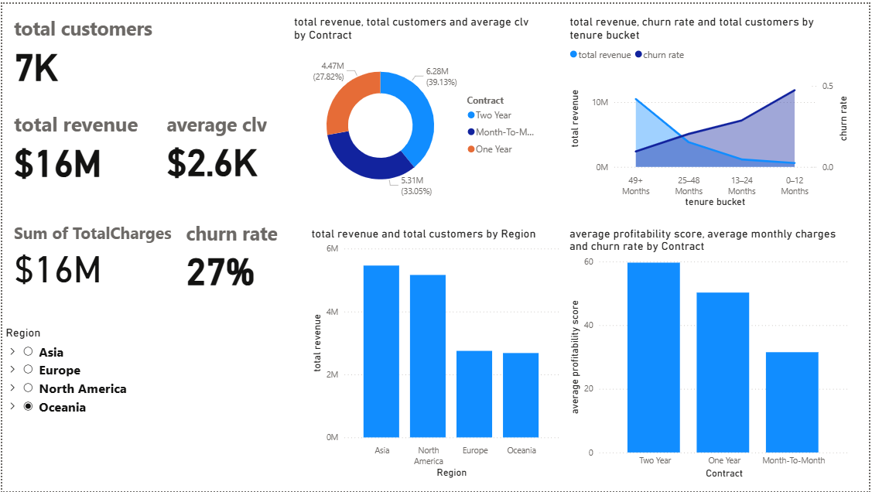
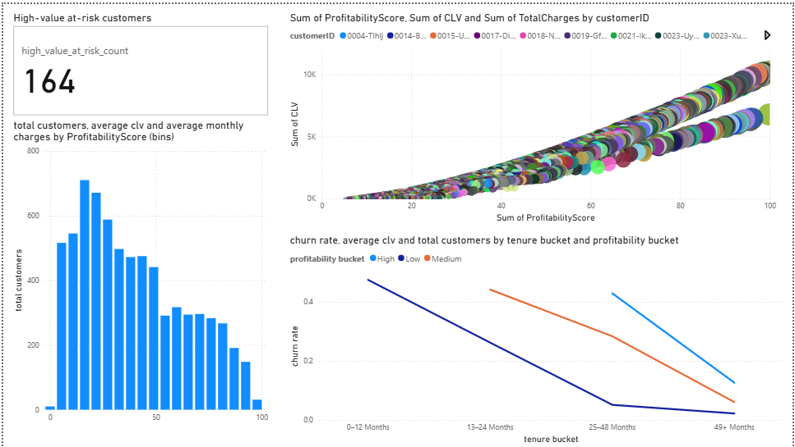

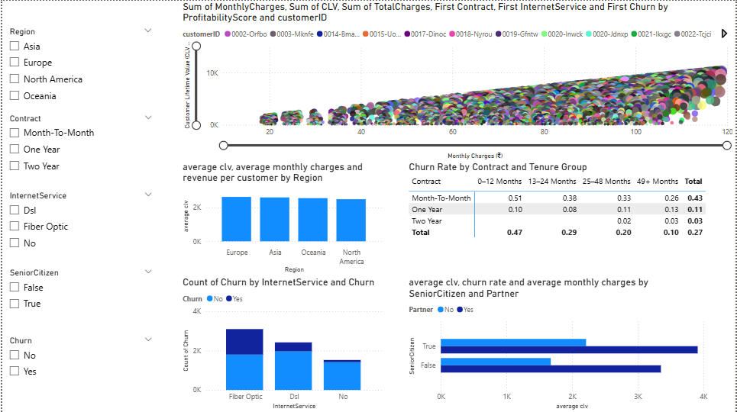
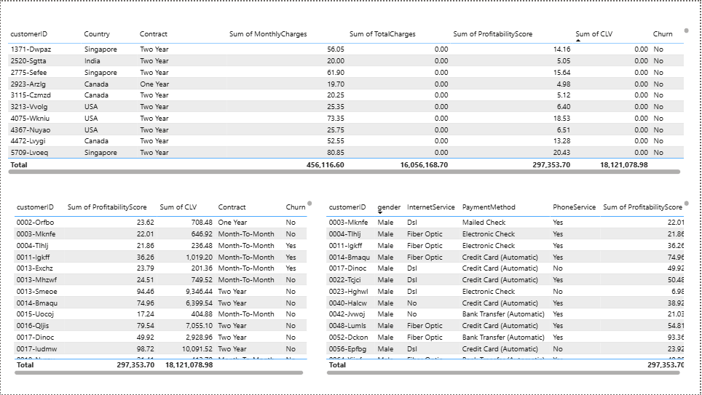

- Results & Analysis

8.1Overview
The Customer Profitability Analysis dashboard provides a comprehensive view of customer behavior, profitability, and churn patterns for the telecom service providers. The data mart, integrated with Power BI, enables business users to interactively explore profitability drivers and identify key customer segments contributing to or detracting from overall business value.

8.2 Key Metrics
KPI | Insight
Total Customers | ~7K customers analyzed
Total Revenue | $16M total charges generated
Average CLV | $2.6K per customer
Average Profitability Score | ~50 (moderate-high)
Churn Rate | 27% overall

8.3 Insights by Contract and Tenure

Month-to-Month customers have high churn (~43%) and lower profitability.

1-Year and 2-Year contracts show higher CLV and stronger retention.

Churn reduces steadily with increasing tenure, confirming that longer relationships yield greater profitability.

Action: Focus retention campaigns on early-tenure and short-contract customers

8.4 Regional and Service Insights

Asia and North America are top revenue regions.

Europe and Oceania show lower revenue but stronger customer loyalty.

Fiber Optic customers pay higher charges but churn more — likely due to pricing or service issues.

Action: Adjust region-specific and service-specific pricing strategies.

8.5 Customer Demographics

Senior citizens and non-partnered customers have lower CLV and higher churn.

Younger, partnered users generate consistent profits.

Action: Introduce senior-friendly plans and loyalty benefits.

8.6 Profitability Correlation

A clear positive correlation exists between Monthly Charges and CLV, but not all high-charge customers are profitable.

Around 164 high-value customers are identified as at risk, combining high CLV with churn tendencies.

Action: Personalized retention strategies should target these customers.

8.7 Summary Table
Insight Area | Key Finding | Recommendation
Contract | Month-to-Month churns fastest | Promote long-term contracts
Tenure | Early-tenure churn highest | Offer onboarding incentives
Region | Asia, N. America high revenue | Localized campaigns
Internet Service | Fiber users churn more | Review pricing & support
Demographics | Seniors churn more | Targeted retention offers

8.8 Business Impact

The analysis enables the telecom provider to:

Identify and retain high-value customers.

Optimize revenue through contract and pricing adjustments.

Build a data-driven retention strategy using Power BI for continuous monitoring.

Conclusion
The “Customer Profitability Analysis” project helped me understand how data can be used to make smarter business decisions in the telecom industry. By collecting, cleaning, and transforming customer data into a structured data mart, and then visualizing it using Power BI, I was able to clearly see how different customer segments contribute to the overall profitability.
Throughout the process, I built a complete pipeline starting from data cleaning and ETL, to data modeling , and finally to interactive dashboards. These dashboards made it easier to analyze customer behavior across contracts, tenure, regions, and internet services. This showed how long-term customers tend to be more profitable and loyal, while short-term or month-to-month users are more likely to churn.
The analysis also releaved that Asia and North America bring out the most revenue, while Fiber Optic users have higher churn rates compared to other internet service users. Another key finding was that senior citizens and single customers usually have lower lifetime value, implying that targeted offers or loyalty plans could help improve retention. Identifying high-value customers who are at risk of leaving was one of the most valuable outcomes of this project.
Overall, this project showed how combining data engineering, analytics, and visualization can turn raw data into meaningful business insights. The dashboards not only track key metrics like revenue, churn, and CLV, but also help the business take timely action to retain customers and improve profitability.
In the future, this project can be expanded by adding predictive analytics, campaign tracking, or even real-time data updates to make it more dynamic. Working on this project gave me hands-on experience in both the technical and business sides of data analysis showing how insights can truly drive better customer relationships and smarter strategic decisions.

10. Link to Code and Executable File

10.1 Source Code Repository
GitHub Repository:

10.2 Project Structure

Teja-Customer_Profitability_Analysis/
│
├── data/
│ ├── raw/
│ │ └── WA_Fn-UseC_-Telco-Customer-Churn.csv
│ └── cleaned data/
│ └── telco_cleaned_for_sql.csv
├── sql/
│ └── sql-file-for-DataMart
│
├── code logic/
│ ├── DAX MEASURES.txt
│ └── dpython-script-for-ETL.py # Python preprocessing (pandas)
│
├── reports/
│ ├── Customer_Profitability_Analysis_Report.docx
│ └── Customer_Profitability_Analysis_Report.pdf
│
└── dashboards/
├── Customer_Profitability_Analysis.pbix
└── Dashboard_Screenshots/
├── Page1_Overview.png
├── Page2_CustomerInsights.png
├── Page3_ProfitabilitySegmentation.png
└── Page4_ChurnTrends.png

Document Prepared By: Ambati Teja
Submitted on : 09 OCT 2025
Institution: JNTUH University College of Engineering, Manthani

