**TEAM NIKE: PROJECT DELIVERABLE 1**

**Step 1:** Choose a publicly traded company: NIKE

**Step 2:** Develop a set of questions about the company

**Step 3:** Sources and references

**1. Describe the company and the services it provides:**

**About Nike:**

The largest athletic clothing company in the world, Nike is best recognized for its footwear, clothes, and equipment. It operates in roughly 170 countries. After the Greek Goddess's win in 1971, the company, which had been founded in 1964 as Blue Ribbon Sports, changed its name to Nike. The Nike, Jordan, and Converse brands work together as Nike, Inc. with the goal of leaving a lasting impression. LeBron James, Serena Williams, Rafael Nadal, and Alex Morgan are just a few of the world's top players and sports teams that are sponsored by the organization. The business operates more than 30 prominent sports and consumer lifestyle brands.

Customers frequently purchase Nike because the brand offers them value and high-quality goods. Since 2005, the corporation has derived more than half of its revenue from sources outside of the US. The business is at the top of both mature markets like China and Brazil and developing ones like Western Europe and the US.

**Mission:**

Bring creativity and innovation to all athletes worldwide.

**Purpose:**

The Nike Company's mission is to advance humankind. They take action by improving access to sport, fostering community development, and preserving the environment.

**Services:**

Athletic footwear

Apparel

Equipment

Accessories

**2. What is the financial trajectory?**

- In the last five years, Nike’s revenue has gradually increased. Since 2018, Nike’s revenue has increased about 28%. In comparison to the revenue increment, Nike’s bottom line (Net Income) has tripled.

**3. What are the annual sales for the past 5 years?**

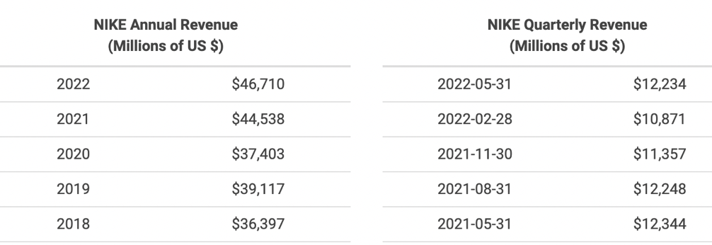

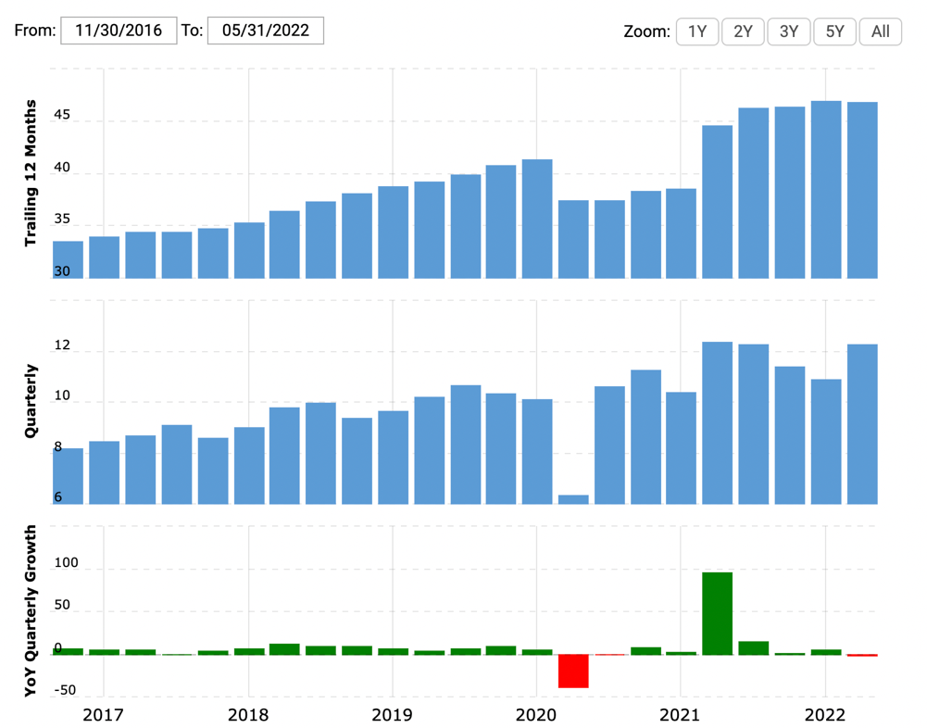

Source: <https://www.macrotrends.net/stocks/charts/NKE/nike/revenue>

**4. What is the nature of the competition in the industry?**

- Nike competes with other large-scale footwear and apparel manufacturing companies, the most prominent being Adidas, VF Corp and Skechers. Since Nike manufactures both sports and lifestyle products, it has competitors in both categories. Nike’s revenue is the highest comparatively- being $46.7 billion in 2022. The other 3 main competitors have revenues amounting to less than half of Nike’s annual revenue in 2022. This could be because Nike is very well-established in the market and has a good brand image. Nike is also promoting sustainability by using 20% recycled material to make its shoes.

**5. How much revenue does Nike generate yearly by selling shoes alone?**

**6. How much does Nike invest annually in the sports ambassadors, for the sponsoring and advertising?**

**7. Which country brings maximum sales to Nike?**