AI TOOLS ASSIGNMENT

Generate an Image Using an AI Tool

1. Aim
To generate an image from a text prompt using an AI image-generation tool and present the prompt and generated result in a Word document.

2. AI Tool Used
DALL·E-style AI image generation

3. Prompt Used
“A peaceful lakeside cabin at sunset, surrounded by mountains, flowers, and warm lantern lights. The calm lake reflects the orange and pink sky, with a winding stone path through a colorful garden. Create a cinematic, high-resolution landscape image with realistic lighting and no people.”

4. Generated Image
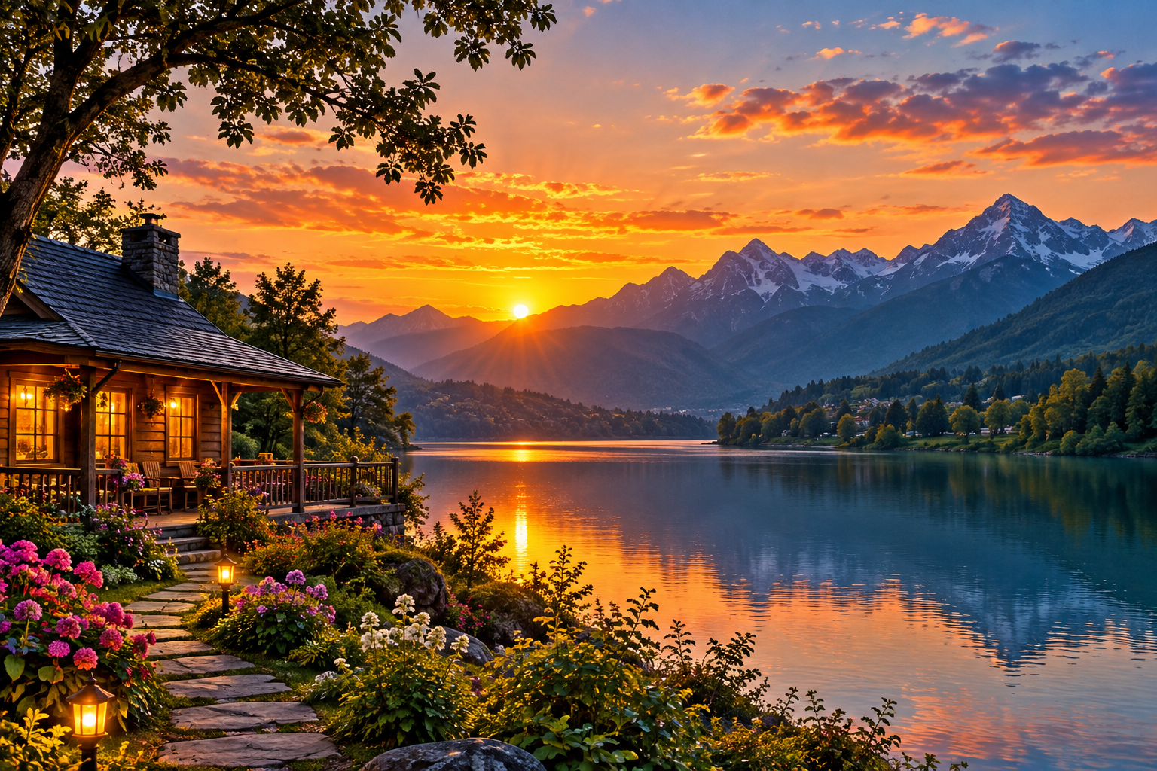
Figure 1: AI-generated scenic landscape of a lakeside cabin at sunset.

5. Procedure
- Open an AI image-generation tool.
- Enter a clear text prompt describing the subject, setting, lighting, and style.
- Generate the image and review whether it matches the prompt.
- Insert the generated image into the Word document and add a caption.

6. Result
The AI tool generated a scenic image based on the text prompt. The image and the prompt are included in this document.

7. Conclusion
AI image-generation tools can transform written descriptions into visual content. A specific prompt with details about the subject, environment, lighting, and style can help produce a more relevant result.

