AI TOOLS ASSIGNMENT

Create a Poster Using AI-Generated Content

1. Aim
To create an informative poster using AI-generated text and visuals, organized in a clear and attractive design.

2. Tool Used
AI image-generation tool; poster design inspired by Canva/Figma layouts.

3. AI-Generated Content
Main heading: ARTIFICIAL INTELLIGENCE
Tagline: Smart Technology, Brighter Tomorrows
Definition: Artificial Intelligence (AI) refers to the ability of machines to perform tasks that normally require human intelligence, such as learning, reasoning, problem-solving, and decision-making.
Applications: Healthcare, Education, Transportation, Business, and Environment.
Benefits: Increased efficiency and automation; data-driven decision-making; support for complex problems; saving time and resources.
Responsible use: Protect privacy and security, avoid bias, promote fairness, and develop AI ethically and sustainably.

4. Generated Poster
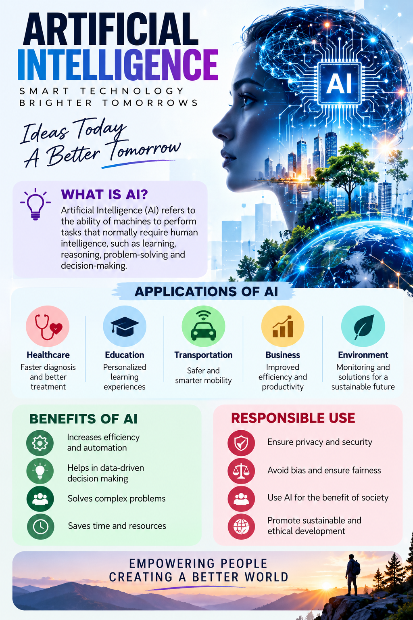
Figure 1: AI-generated poster about Artificial Intelligence.

5. Procedure
- Choose a topic for the poster.
- Use an AI tool to draft the heading, tagline, definition, and key points.
- Generate a visual that matches the topic and intended audience.
- Arrange the content into clear sections with readable typography, suitable colors, and icons.
- Review the poster for clarity, accuracy, and spelling before sharing.

6. Result
A poster about Artificial Intelligence was generated with a clear heading, explanatory content, application areas, benefits, and responsible-use guidelines.

7. Conclusion
AI tools can help create poster content and visual concepts quickly. The final design should be checked for factual accuracy, legibility, and suitability before printing or publishing.

