Create a React Application named “cricketapp” with the following components:
1. ListofPlayers
Declare an array with 11 players and store details of their names and scores using the
map feature of ES6
2. IndianPlayers
Display the Odd Team Player and Even Team players using the Destructuring
features of ES6

App.js
import React from 'react';
import ListofPlayers from './ListofPlayers';
import { OddPlayers } from './OddPlayers';
import { EvenPlayers } from './EvenPlayers';
import { MergedPlayers } from './MergedPlayers';

function App() {
const flag = false; // Set to true or false to switch view

const team = ['Sachin1', 'Dhoni2', 'Virat3', 'Rohit4', 'Yuvraj5', 'Raina6'];

return (
<div className="App">
{flag ? (
<ListofPlayers />
) : (
<div>
<OddPlayers players={team} />
<EvenPlayers players={team} />
<MergedPlayers />
</div>
)}
</div>
);
}

export default App;

ListofPlayers.js
import React from 'react';

const ListofPlayers = () => {
const players = [
{ name: "Jack", score: 50 },
{ name: "Michael", score: 70 },
{ name: "John", score: 40 },
{ name: "Ann", score: 61 },
{ name: "Elisabeth", score: 61 },
{ name: "Sachin", score: 95 },
{ name: "Dhoni", score: 100 },
{ name: "Virat", score: 84 },
{ name: "Jadeja", score: 64 },
{ name: "Raina", score: 75 },
{ name: "Rohit", score: 80 }
];

const lowScorers = players.filter(player => player.score < 70);

return (
<div>
<h2>List of Players</h2>
<ul>
{players.map((item, i) => (
<li key={i}>Mr. {item.name} <span>{item.score}</span></li>
))}
</ul>

<h2>List of Players having Scores Less than 70</h2>
<ul>
{lowScorers.map((item, i) => (
<li key={i}>Mr. {item.name} <span>{item.score}</span></li>
))}
</ul>
</div>
);
};

export default ListofPlayers;

EvenPlayers.js

import React from 'react';

export function EvenPlayers({ players }) {
const [, second, , fourth, , sixth] = players;

return (
<div>
<h2>Even Players</h2>
<ul>
<li>Second : {second}</li>
<li>Fourth : {fourth}</li>
<li>Sixth : {sixth}</li>
</ul>
</div>
);
}

OddPlayers.js

import React from 'react';

export function OddPlayers({ players }) {
const [first, , third, , fifth] = players;

return (
<div>
<h2>Odd Players</h2>
<ul>
<li>First : {first}</li>
<li>Third : {third}</li>
<li>Fifth : {fifth}</li>
</ul>
</div>
);
}

MergedPlayers.js

import React from 'react';

export function MergedPlayers() {
const T20Players = ['First Player', 'Second Player', 'Third Player'];
const RanjiPlayers = ['Fourth Player', 'Fifth Player', 'Sixth Player'];

const merged = [...T20Players, ...RanjiPlayers];

return (
<div>
<h2>List of Indian Players Merged:</h2>
<ul>
{merged.map((player, index) => (
<li key={index}>Mr. {player}</li>
))}
</ul>
</div>
);
}

When flag = true
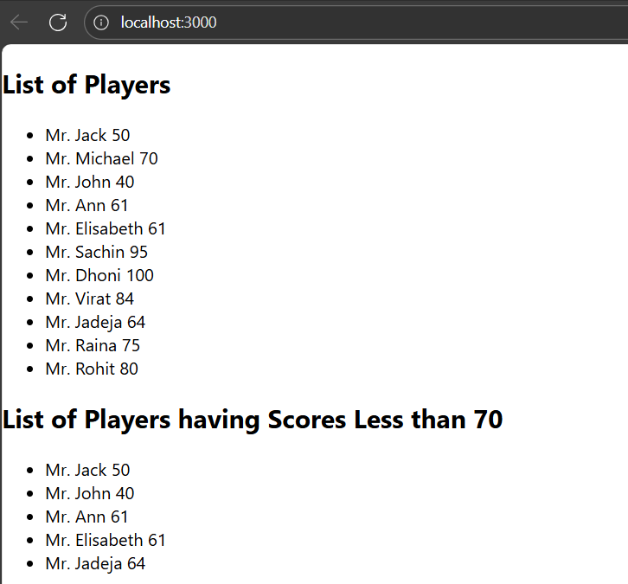S

When flag = false
