22104013 TEJAS GOEL B14

OSS LAB EVALV – 1

Q1.

def common_un_characters(s1, s2):

common_chars = []
un_chars_s1 = []
un_chars_s2 = []

iter_s2 = iter(s2)
common_chars = [char for char in s1 if char in iter_s2]

set_s1 = set(s1)
set_s2 = set(s2)

un_chars_s1 = ''.join([char for char in s1 if char not in set_s2])
un_chars_s2 = ''.join([char for char in s2 if char not in set_s1])

return ''.join(common_chars), un_chars_s1 + un_chars_s2

s1 = input("Enter String1:")
s2 = input("Enter String2:")
common, uncommon = common_un_characters(s1, s2)

print("Common Characters:", common)
print("Uncommon Characters:", uncommon)
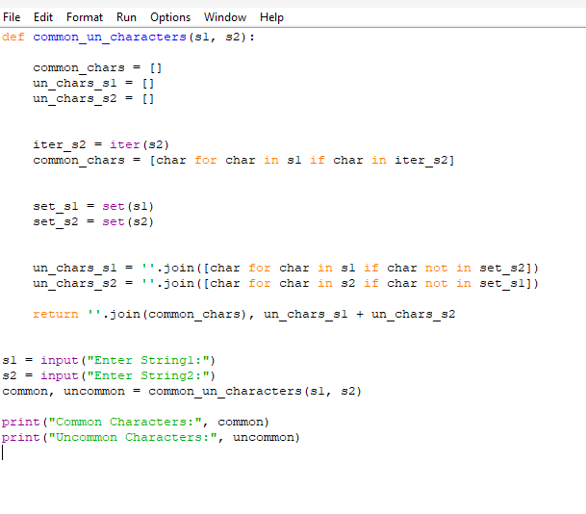
OUTPUT

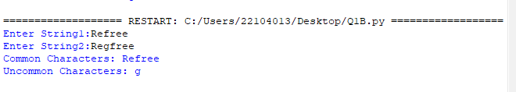

Q2.

def reverse_words_string(s):

words = s.split()

reversed_words = words[::-1]

reversed_string = ' '.join(reversed_words)

return reversed_string

input_string = input("Type the string:")
reversed_string = reverse_words_string(input_string)
print("Original String:", input_string)
print("Reversed Words String:", reversed_string)

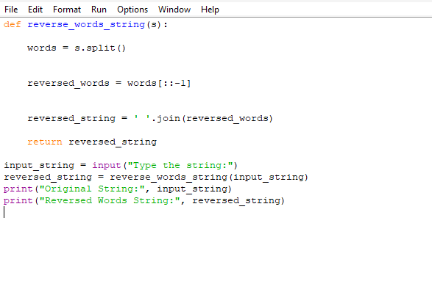

OUTPUT

