AAPN substitution V3.5 perf testing 10102025
Aggregated Summary Report
1.Started with 50TPS, #of threads 50, ramp up speed 5. Started at 07:40 to 08:20 UTC
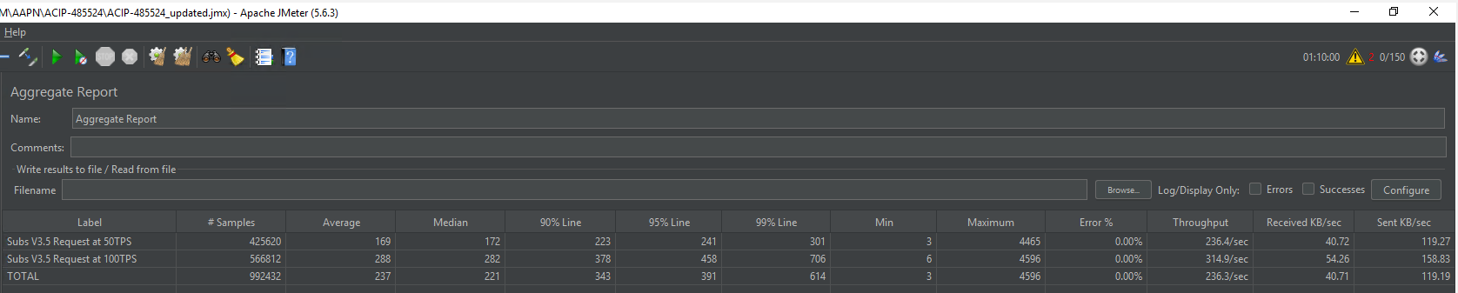
Grafana
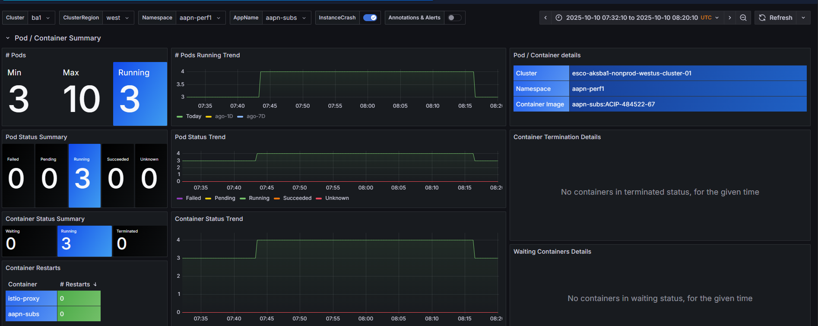
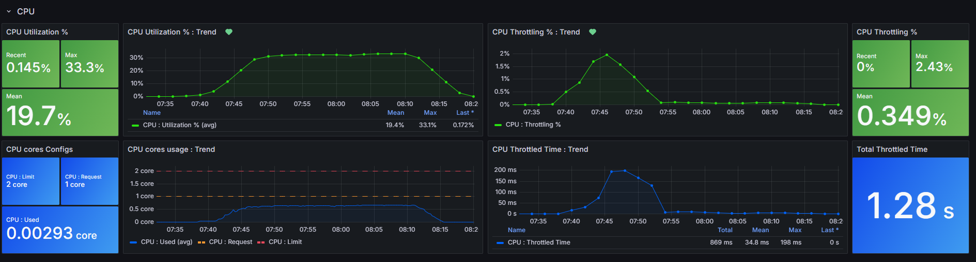
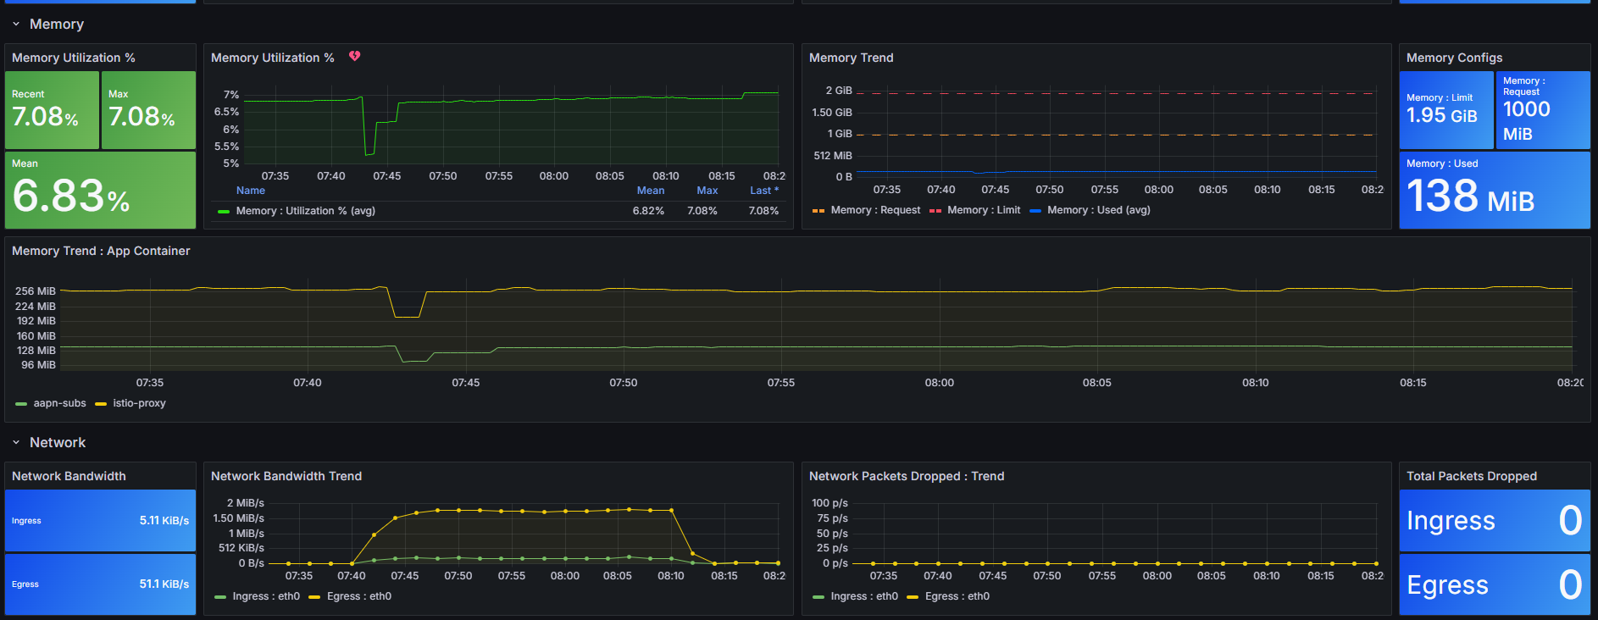
2. Started with 100TPS, #of threads 100, ramp up speed 5. Started at 08:20 to 09:00 UTC
Grafana
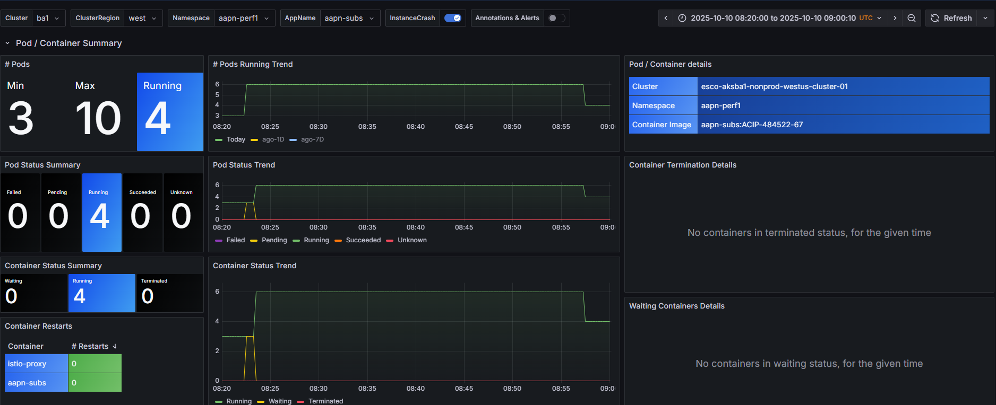
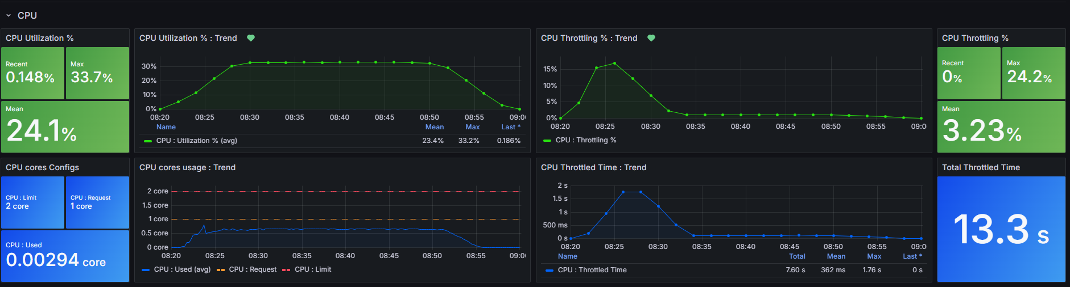
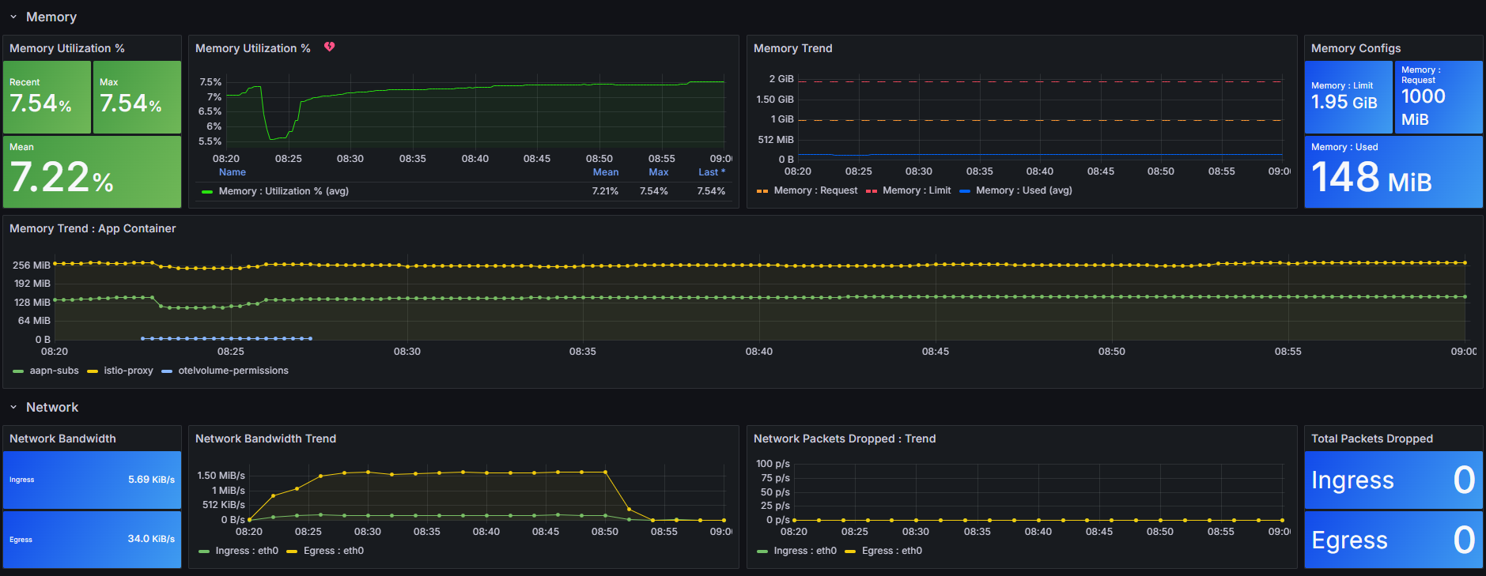

AKS-App-Infrastructure-Health - Digital-DevOps - Dashboards - Grafana

