**Event Management System - User Manual**

|  |  |
| --- | --- |
| **NAME** | **ROLL NO** |
| **N. TEJA** | **B221046CS** |
| **K. PRAMOD** | **B220365CS** |
| **Y. VENKATESWARA RAO** | **B2201297CS** |

**Table of Contents**

1. Introduction
2. Getting Started
   * System Requirements
   * Accessing the System
3. Features
   * User Features
   * Administrator Features
4. User Guide
   * Creating an Account
   * Logging In
   * Viewing Events
   * Booking an Event
   * Making Payments
5. Admin Guide
   * Managing Events
   * Viewing Bookings

# Introduction

The **Event Management System** is a comprehensive, web-based application built to streamline event management processes for both users and administrators. With a user-friendly interface, this system provides an easy and efficient way for users to browse, book, and make payments for events online. Whether it's a conference, concert, workshop, or any other gathering, the system allows users to explore available events, view detailed information, and reserve their spot with a few simple steps.

On the administrative side, the system equips event organizers and administrators with essential tools to manage events and track bookings. Administrators can add new events, update existing ones, monitor attendance, and oversee payment statuses — all from a centralized dashboard. This functionality enables organizers to handle logistics efficiently and focus on delivering a successful event experience.

# Getting Started

**System Requirements:**

* A modern web browser (e.g., Chrome, Firefox, Edge)
* Internet connection
* Valid user credentials (for user and admin access)

**Accessing the System:**

Open a web browser and go to the application's URL.

1. For first-time users, click on **Register** to create a new account.
2. If you already have an account, click **Login** to sign in.

# Features

**User Features**

* Register and create a user account.

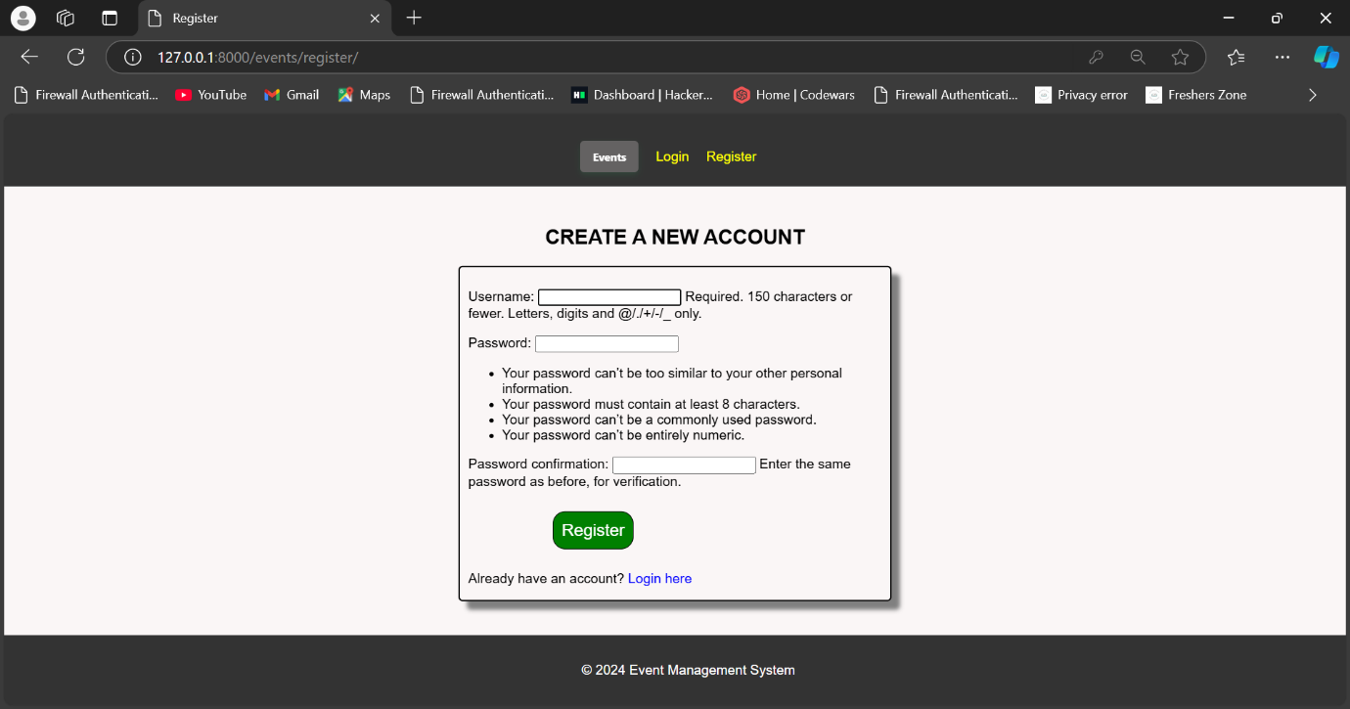

* View available events with details.

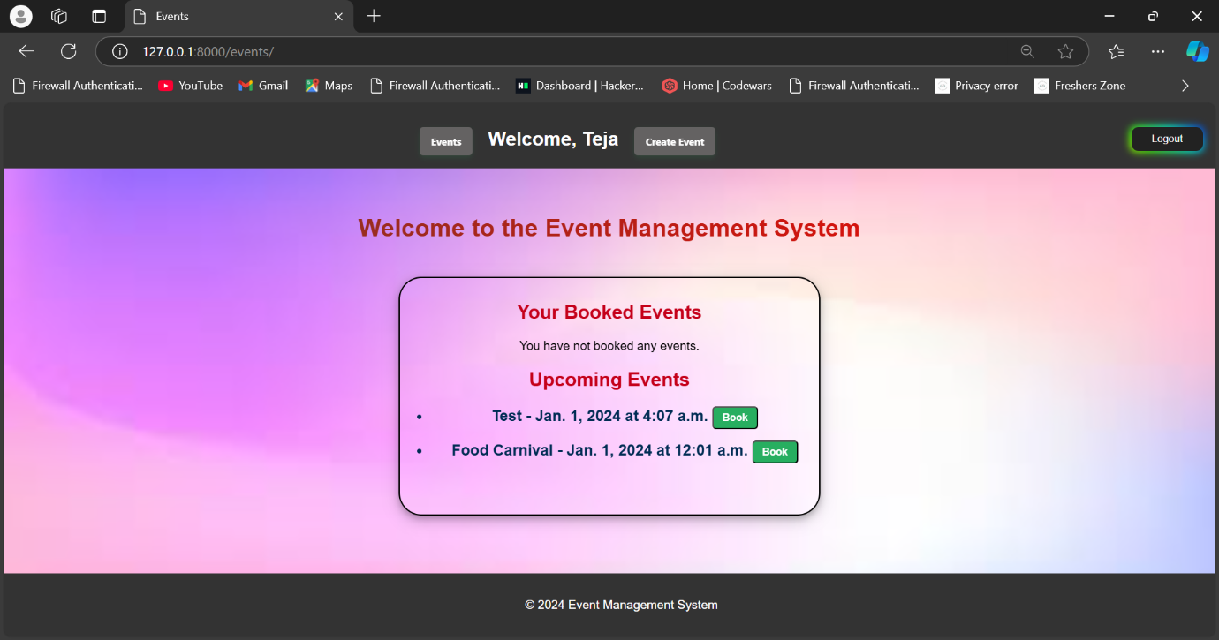

* Book an event.

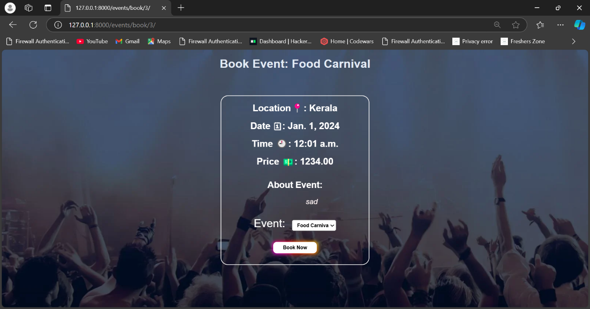

* Make payments for bookings (using Stripe).

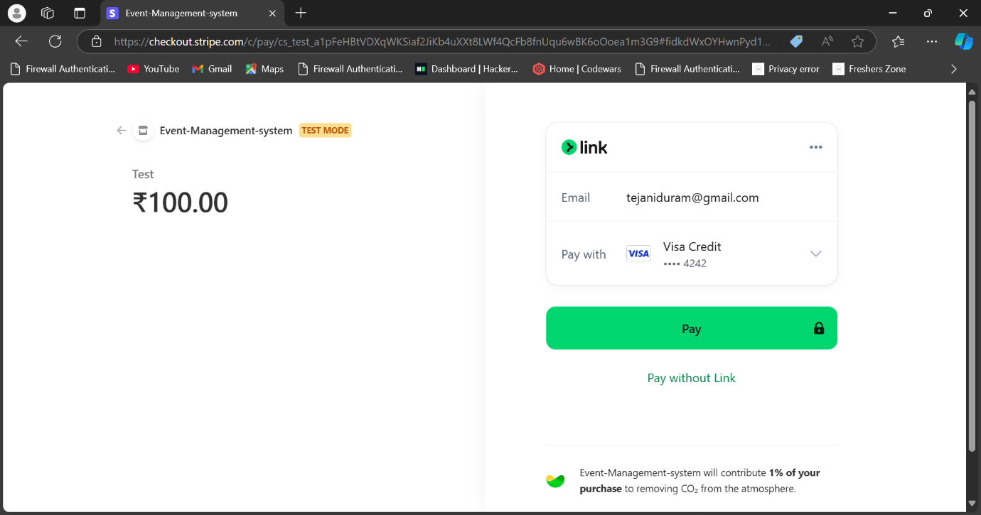

**Administrator Features**

* Add, update, and delete events.
* View all bookings and payment statuses.
* Manage event bookings.

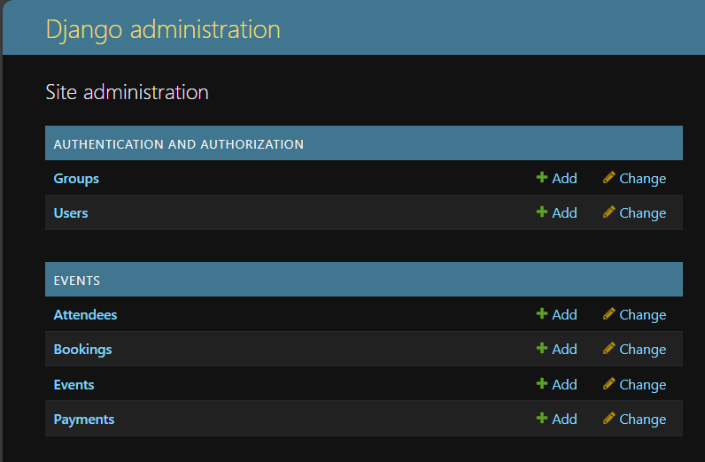

# User Guide

**Creating an Account**

1. Click **Register** on the homepage.
2. Fill out the registration form with your details and click **Submit**.
3. Upon successful registration, you can log in to your account.

**Logging In**

1. Enter your username and password on the **Login** page.
2. Click **Login** to access your account.

**Viewing Events**

1. Once logged in, go to the **Events** page.
2. Browse through the list of available events, each displaying details such as date, time, location, and description.

**Booking an Event**

1. Click on an event you wish to attend.
2. On the event page, click **Book Now**.
3. You will be directed to the payment page to complete your booking.

**Making Payments**

1. On the **Book Now** page, click **Pay Now**.
2. Enter your payment information in the payment gateway.
3. Upon successful payment, you will be redirected back to the booking confirmation page.

# Admin Guide

**Managing Events**

1. Log in as an administrator.
2. Go to the **Admin Dashboard** and select **Manage Events**.
3. Here, you can add new events, update details, or delete events.

**Viewing Bookings**

1. In the **Admin Dashboard**, select **View Bookings**.
2. You can view all user bookings, including payment status and booking details.