

Milgard School of Business, MSBA

White Be Boundless tagline graphic­­­­­DOCUMENT APPROVAL SHEET

TBANLT 510

MODULE 5-IN CLASS EXERCISE

DIMENSIONALMODELING

gold boundless bar

**DOCUMENT IDENTIFICATION:**

MSBA AY 21-22/TBANLT510/ASSIGNMENTS/EXERCISE-3

**DOCUMENT AUTHOR:**

|  |  |  |  |  |  |
| --- | --- | --- | --- | --- | --- |
| **AUTHORED BY/ ID** | **DEPT./ ROLE** | **COHORT** | **DATE** | **CHECKED BY** | **DATE** |
| Shephali Jain  (2110257) | MSBA/ Student | 2021-2022 | 06-Nov-2021 | Teja Alluru  (1150077) | 06-Nov-2021 |
| Teja Alluru  (1150077) | MSBA/ Student | 2021-2022 | 06-Nov-2021 | Shephali Jain  (2110257) | 06-Nov-2021 |

**DOCUMENT APPROVAL:**

|  |  |  |  |  |
| --- | --- | --- | --- | --- |
| **APPROVED BY/ ID** | **DEPT.** | **SCHOOL** | **SIGNATURE** | **DATE** |
| Teja Alluru (1150077) | MSBA/ Student | University of Washington, Tacoma, Milgard School of Business |  | 06-Nov-2021 |

**GRADED BY:**

|  |  |  |  |  |
| --- | --- | --- | --- | --- |
| **GRADED BY** | **Role/DEPT.** | **SCHOOL** | **SIGNATURE** | **DATE** |
| Micheal Turek | Faculty/  MSBA | University of Washington, Tacoma, Milgard School of Business |  | 06-Nov-2021 |

*AUTHORED BY: Authored by mean of a person/entity responsible for the creation of the document.*

*APPROVED BY: Approval means a person/entity responsible for the approval of the document content.*

*AUTHORISED BY: Graded by means a person/entity having the authority to grade the assignment.*

*COPYRIGHT: This document was released for the viewing of the MSBA department only.*

INDEX OF CONTENTS

gold boundless bar

DOCUMENT APPROVAL SHEET 1

INDEX OF CONTENTS 3

1 EXECUTIVE SUMMARY 4

1.1 Assignment Tasks 4

2 BUSINESS SUBJECT/REQUIREMENT 4

2.1 Total Dosage 4

2.2 Total Revenue 4

2.3 Total Appointment Duration 4

3 LIST OF DIMENSIONS 5

4 LIST OF FACTS 6

5 DIMENSIONAL MODELING STAR SCHEMA 7

6 APPENDIX - RELATIONAL SCHEMA(ERD-LDO) 8

# EXECUTIVE SUMMARY

gold boundless bar

## Assignment Tasks

The following tasks were the point of focus for the in-class assignment on dimensional modeling discussed in module 5

1. Make a list of your subjects of analysis (fact tables), a minimum of 2
2. Make a list of dimensions
3. Make a list of facts (fact columns)
4. Use [https://erdplus.com/ (Links to an external site.)](https://erdplus.com/) for data modeling
5. Create a star schema data model (use New Diagram/Star Schema)

# BUSINESS SUBJECT/REQUIREMENT

As the business analyst consultant for the LDO dental office, we would like to measure the following.

## Total Dosage

The dosage administered to the patients is monitored to make sure there is no overdose to any patients and to calculate the future dosage requirements on the procedure performed.

## Total Revenue

The total revenues of LDO are monitored.

## Total Appointment Duration

The appointment duration is monitored to refine the appointment process and make the operations efficient and effective in utilizing the employees.

# LIST OF DIMENSIONS

The dimensional tables used are listed below

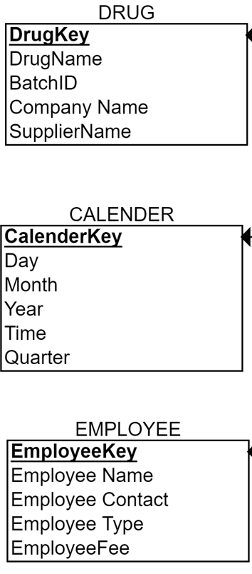 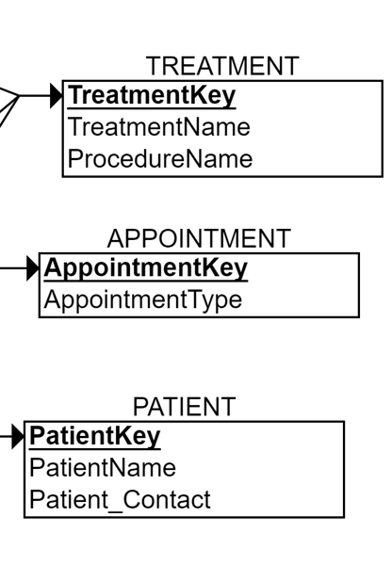

# LIST OF FACTS

The three facts used are dosage administered, cost, and duration. the facts tables are listed below.

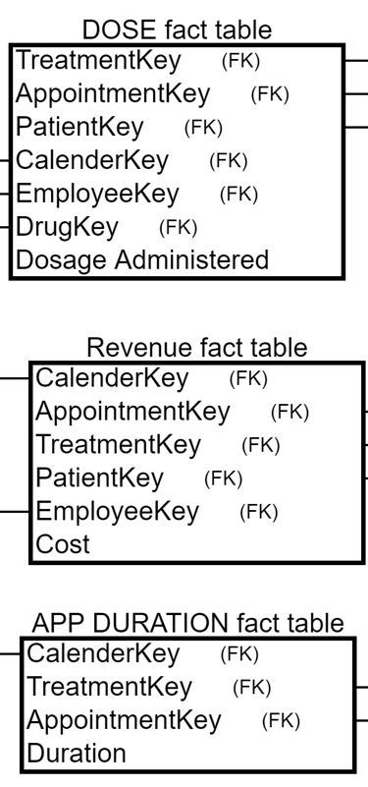

# DIMENSIONAL MODELING STAR SCHEMA

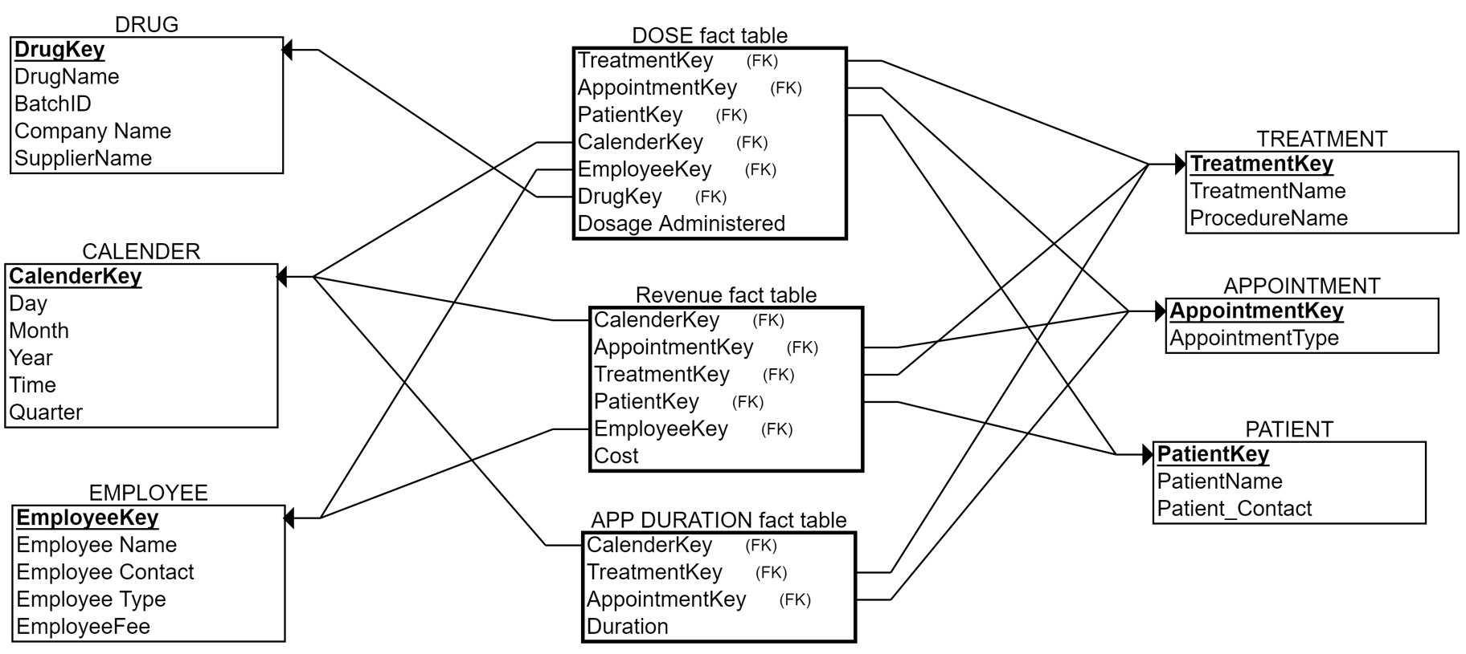

# APPENDIX - RELATIONAL SCHEMA(ERD-LDO)

gold boundless bar

