Bulk:
To get all products
Endpoint: /easmo-dev/products/search – Post
Post body:
{
"sort" : [ {
"field" : "name",
"language" : "en",
"order" : "desc"
} ],
"limit" : 100,
"offset" : 0
}

Sample response
{
"total":1095
"offset":0
"limit":100
"facets":[]
"results":[
0:{
"id":"91ee7851-4c51-45f1-b246-0dde666fd1b7"
}
1:{
"id":"3d6034c2-3a48-4460-953d-e0a9d03ee9b8"
}
2:{
"id":"6b957832-e2f7-49f2-90a7-719dff7419d7"
}
3:{
"id":"8870ed97-cae1-4fd8-a9a2-7c669188fac2"
}

Get product selection by product id – contracted scope validation
Endpoint : /easmo-dev/products/91ee7851-4c51-45f1-b246-0dde666fd1b7/product-selections?expand=productSelection.id%3Bobj.custom.supplier – Get
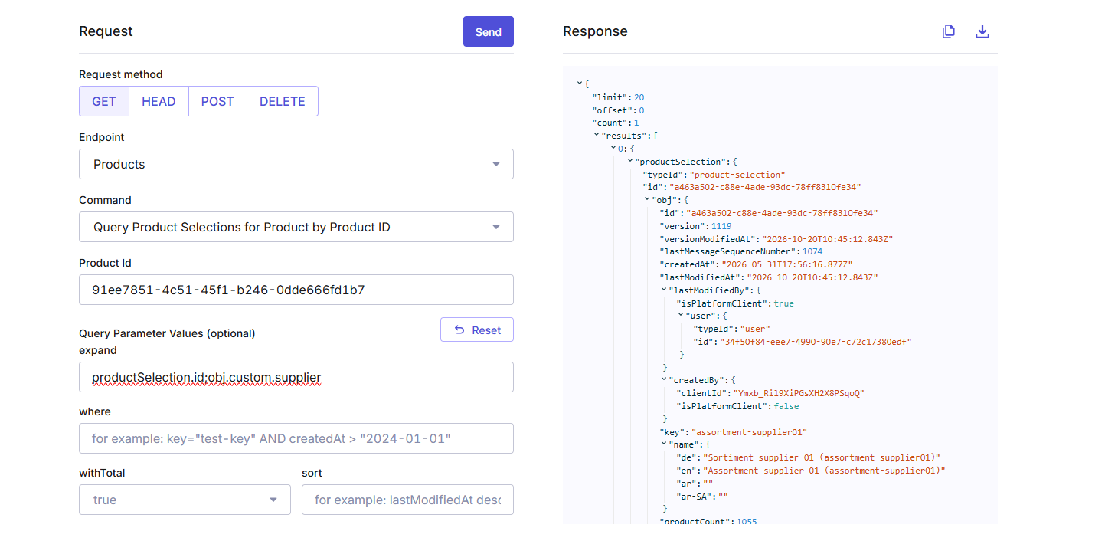
Conditions to check: validUntil>=todays date and active is true

Step3: Extract product details by passing product id:
Endpoint: /easmo-dev/products/91ee7851-4c51-45f1-b246-0dde666fd1b7?expand=masterData.current.categories%5B*%5D.ancestors%5B*%5D - Get

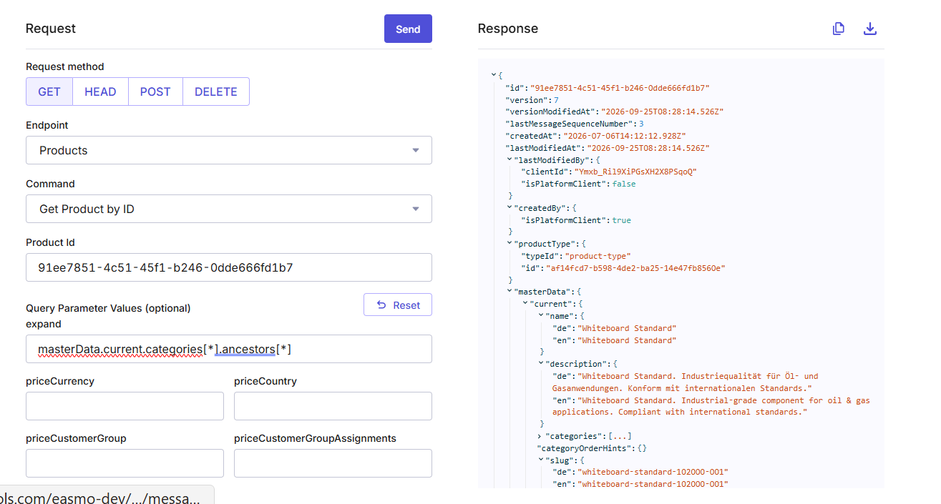

Fields:
Product title: masterData.current.name.en
Product Description: masterData.current.decription.en
Category:
Category_name: categories[0].obj. ancestors[0].obj.name.en
Category_id: categories[0].obj. ancestors[0].obj.id
Category_slug: categories[0].obj. ancestors[0].obj.slug.en
Category_description: categories[0].obj. ancestors[0].obj.description.en
Category_key: categories[0].obj. ancestors[0].obj.key

Subcategory
Sub_category_name: categories[0].obj. ancestors[1].obj.name.en
Sub_Category_id: categories[0].obj. ancestors[1].obj.id
Sub_Category_slug: categories[0].obj. ancestors[1].obj.slug.en
Sub_Category_description: categories[0].obj. ancestors[1].obj.description.en
Sub_Category_key: categories[0].obj. ancestors[1].obj.key

Product type
Product_type_name: categories[0].obj. ancestors[2].obj.name.en
Product_type_id: categories[0].obj. ancestors[2].obj.id
Product_type_slug: categories[0].obj. ancestors[2].obj.slug.en
Product_type _description: categories[0].obj. ancestors[2].obj.description.en
Product_type _key: categories[0].obj. ancestors[2].obj.key

Mastervariant details
Sku_key: masterData.masterVariant.key
Sku_id: masterData.masterVariant.sku
Sku_image_url: masterData.masterVariant.images[0].url

Step : Get seller details
Endpoint: /easmo-dev/standalone-prices?where=sku%3D%22102000-001-office%22&expand=channel.id
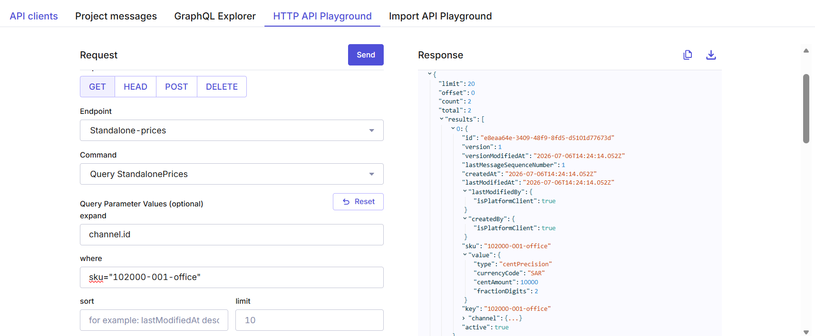
Seller details
Seller_id: results[0].channel.obj.id
Seller_name: results[0].channel.obj.name.en
Price: results[0].value. centAmount (based on digit)
Currency_type: results[0].value.currency_code
Lead_time: results[0].custom.fields. leadTimeDays
MOQ: results[0].custom.fields. moq
Unit_type: results[0].custom.fields. unit_type
temporary_unavialable
isBlockedForDeletion

asmo material number

aramco material number

product selection
contract id and sku – need to get the seller details

Query for standalone price : custom(fields(contractId="CONTRACT-327")) AND custom(fields(isBlockedForDeletion!="L")) AND sku="159500-001-services"
Expand by channel id

- I checked product is part of purchase agreement – week

Product id with multiple purchase agreements: 0867bab5-858a-4500-b3d3-2d0adb513bc0

