MACHINE LEARNING LAB
SUPPORT VECTOR MACHINE
WEEK-10

NAME: B TEJA DEEP SAI KRISHNA
SRN: PES2UG23CS135
SECTION: 5C

Moons Dataset Questions:
- Inferences about the Linear Kernel's performance.
- Linear kernel performs poorly on the Moons dataset (accuracy ~87%)
- Cannot capture the non-linear relationship between the two interlocking half-moons
- Creates a straight-line decision boundary that cannot properly separate the curved moon shapes
- Struggles with the non-linearly separable nature of this synthetic dataset
- Demonstrates the limitation of linear kernels when data has complex, curved patterns
- Comparison between RBF and Polynomial kernel decision boundaries.
- RBF kernel (accuracy ~97%) creates smooth, curved boundaries that naturally follow the moon shapes
- Polynomial kernel (accuracy ~89%) creates more angular, polynomial-shaped boundaries
- RBF captures the data shape more naturally because it can create smooth curves and circles
- RBF is more flexible in adapting to the specific curvature of the moons
- Polynomial kernel tends to create more rigid, mathematical curve patterns that don't fit as well

Banknote Dataset Questions:
1.Which kernel was most effective for this dataset?
- RBF kernel was most effective (accuracy ~93%)
- Linear kernel performed well (accuracy ~88%) but not as good as RBF
- Polynomial kernel underperformed (accuracy ~84%)
- RBF kernel was able to capture the subtle non-linear patterns in the banknote features
2. Why might the Polynomial kernel have underperformed here?
- Banknote data is more linearly separable than the Moons dataset
- Polynomial kernel may be overfitting to the training data with its complex polynomial curves
- The data doesn't have the same curved structure as the Moons dataset
- Polynomial kernel's complexity is unnecessary for this relatively simple separation task
- RBF kernel's smooth boundaries work better for the banknote feature space

Hard vs. Soft Margin Questions:
1. Which margin (soft or hard) is wider?
- Soft margin (C=0.1) produces a wider margin
- Hard margin (C=100) produces a narrower margin
- Soft margin allows more space between the decision boundary and support vectors
- Hard margin tries to maximize the margin while still classifying all points correctly
2. Why does the soft margin model allow "mistakes"?
- Primary goal is better generalization, not perfect training accuracy
- Trades some training accuracy for better performance on new data
- More robust to outliers and noise in the dataset
- Prevents overfitting by not forcing perfect classification of every training point
- Creates a more stable decision boundary that's less sensitive to individual data points
3. Which model is more likely to be overfitting and why?
- Hard margin model (C=100) is more likely to overfit
- Tries to classify every training point perfectly, including outliers
- Creates a very specific decision boundary that may not generalize well
- Sensitive to noise and outliers in the training data
- Less regularization means it can memorize the training data patterns

SCREENSHOTS:

MOONS DATASET:

LINEAR KERNEL:
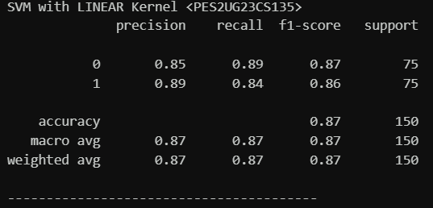
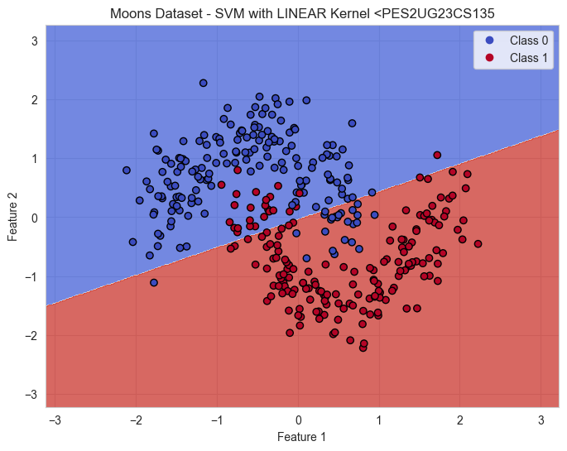

RBF KERNEL:
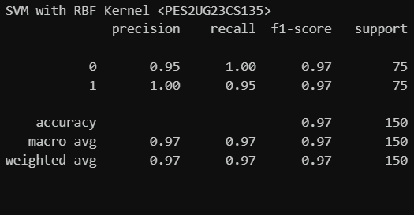

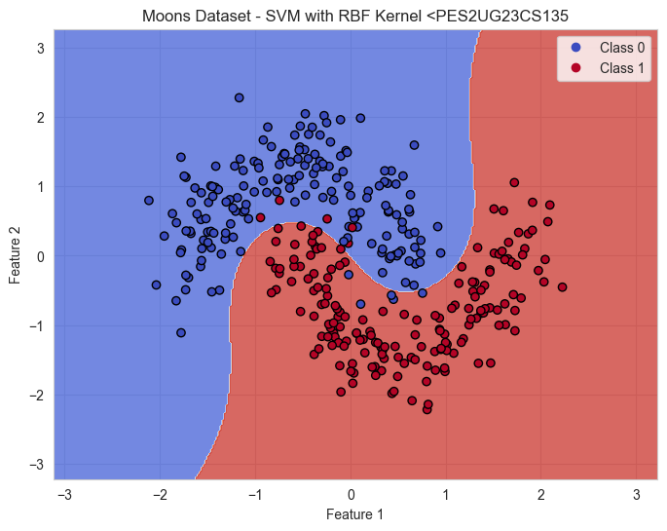

POLYNOMIAL KERNEL:
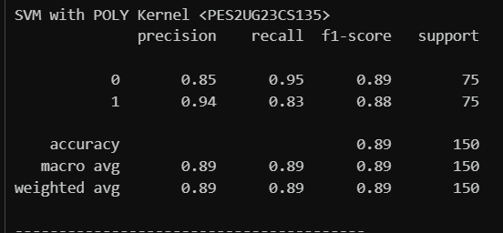
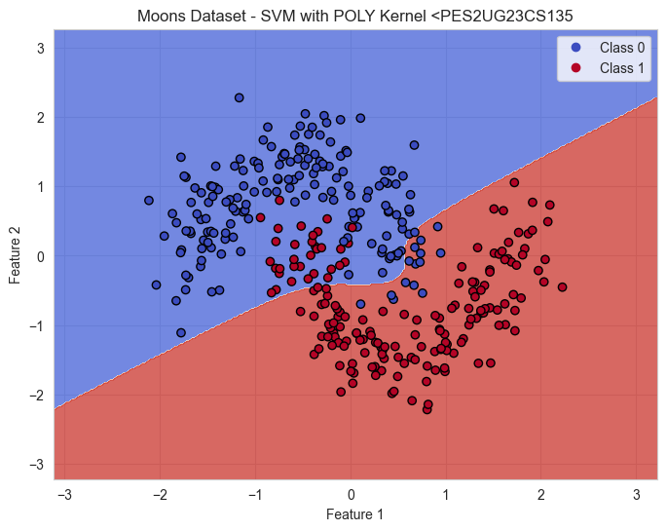

Banknote Dataset:

Linear Kernel:
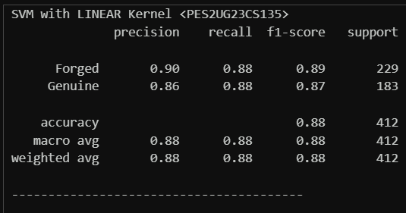
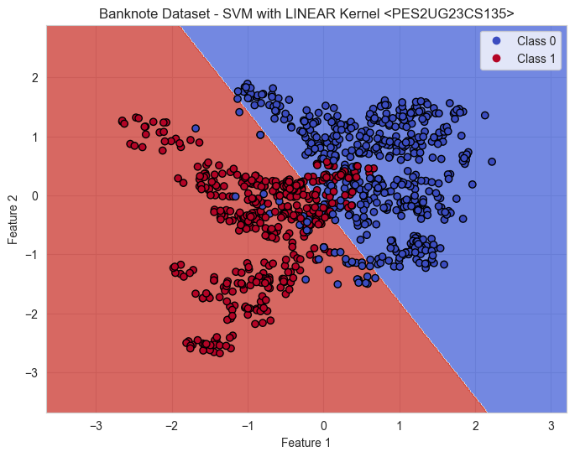

Polynomial kernel:
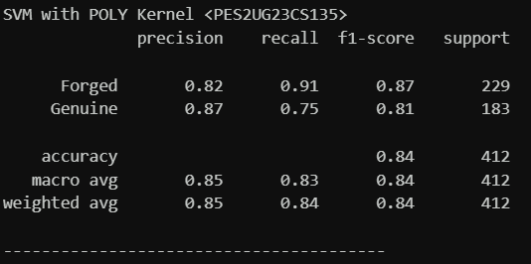
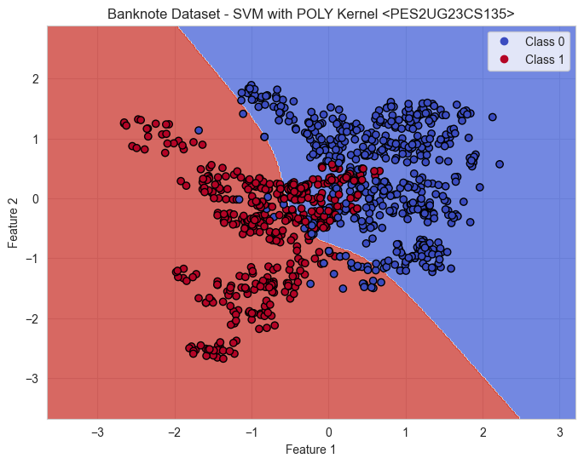

RBF Kernel:
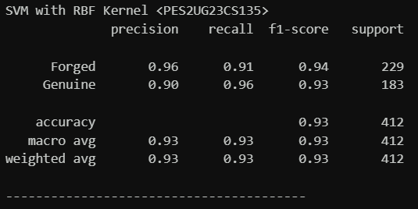
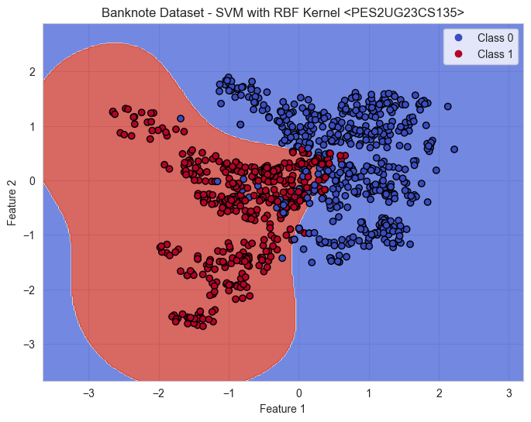

SOFT-MARGIN:
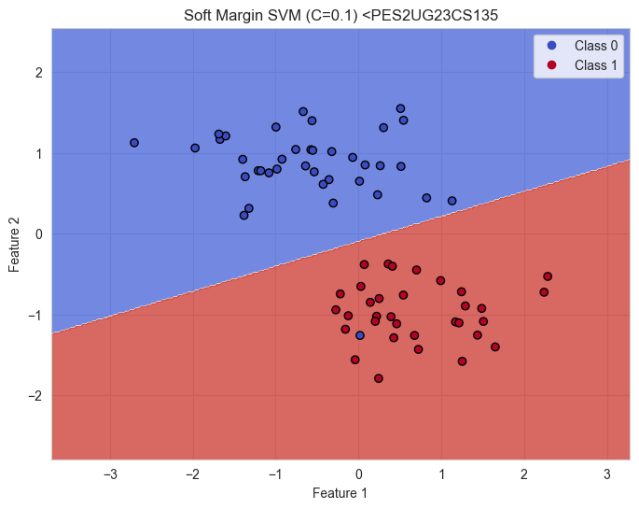
HARD-MARGIN:
