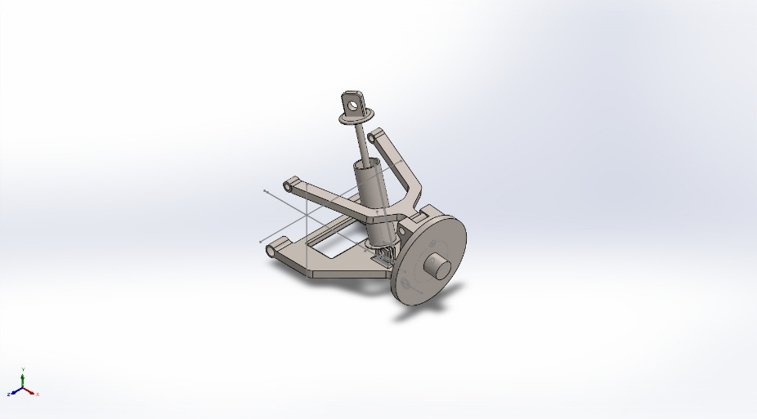 | Simulation of tests_2 - Copy  Date: 28 November 2025  Designer: Solidworks  Study name: Test_1_static  Analysis type: Static  Table of Contents  Description 1  Assumptions 2  Model Information 3  Study Properties 6  Units 6  Material Properties 7  Loads and Fixtures 8  Connector Definitions 9  Interaction Information 12  Mesh information 13  Sensor Details 15  Resultant Forces 15  Beams 15  Study Results 16  Conclusion 19

Description
No Data

Assumptions

Model Information

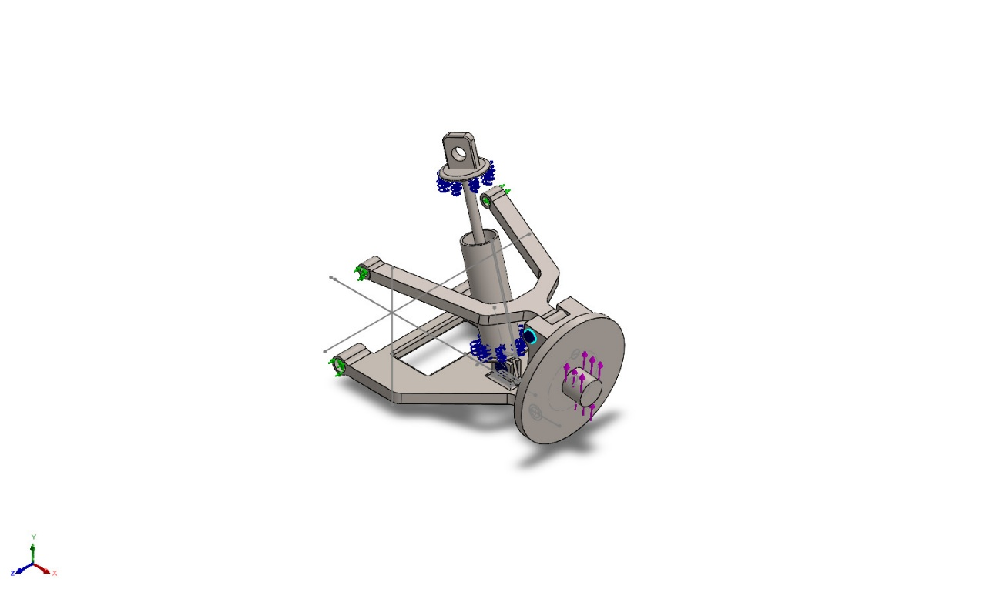
Model name: tests_2 - Copy
Current Configuration: Default
Solid Bodies
Document Name and Reference | Treated As | Volumetric Properties | Document Path/Date Modified
Boss-Extrude7[1]  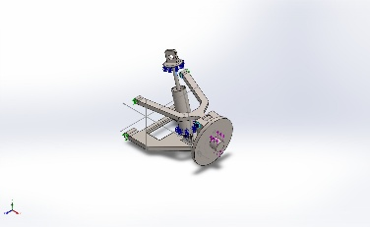 | Solid Body | Mass:0.00462 kg  Volume:6e-07 m^3  Density:7,700 kg/m^3  Weight:0.045276 N | D:\Dome_assignment\DoME project\my\version_1\base_2.SLDPRT  Nov 17 12:33:01 2025
Cut-Extrude2  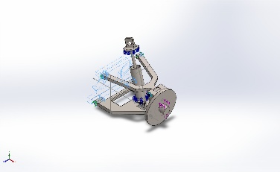 | Solid Body | Mass:0.741422 kg  Volume:9.62885e-05 m^3  Density:7,700 kg/m^3  Weight:7.26593 N | D:\Dome_assignment\DoME project\my\version_1\base_2.SLDPRT  Nov 17 12:33:01 2025
Revolve2  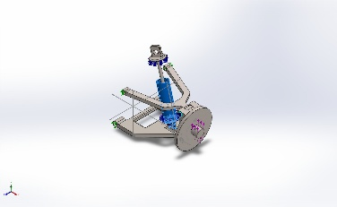 | Solid Body | Mass:0.161137 kg  Volume:2.09269e-05 m^3  Density:7,700 kg/m^3  Weight:1.57914 N | D:\Dome_assignment\DoME project\my\version_1\damper_pipe.SLDPRT  Nov 27 22:18:26 2025
Cut-Extrude1  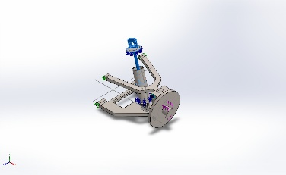 | Solid Body | Mass:0.0996239 kg  Volume:1.29382e-05 m^3  Density:7,700 kg/m^3  Weight:0.976314 N | D:\Dome_assignment\DoME project\my\version_1\damper_rod.SLDPRT  Nov 28 00:48:46 2025
Fillet1  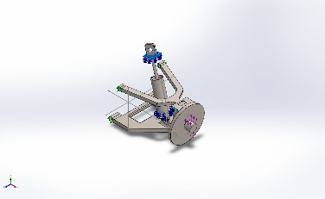 | Solid Body | Mass:0.0174824 kg  Volume:2.27044e-06 m^3  Density:7,700 kg/m^3  Weight:0.171327 N | D:\Dome_assignment\DoME project\my\version_1\damper_rod.SLDPRT  Nov 28 00:48:46 2025
Fillet16  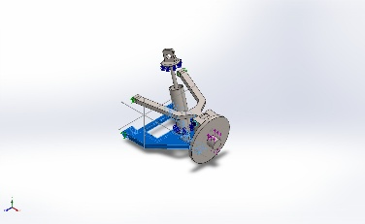 | Solid Body | Mass:0.854805 kg  Volume:0.000111014 m^3  Density:7,700 kg/m^3  Weight:8.37709 N | D:\Dome_assignment\DoME project\my\version_1\lower_2 - Copy.SLDPRT  Nov 17 13:17:45 2025
Cut-Extrude1  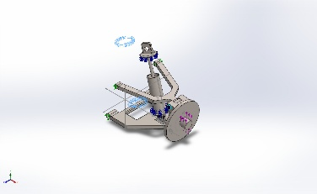 | Solid Body | Mass:0.312714 kg  Volume:4.06231e-05 m^3  Density:7,697.92 kg/m^3  Weight:3.06459 N | D:\Dome_assignment\DoME project\my\version_1\spring - Copy (2).SLDPRT  Nov 28 02:52:23 2025
Boss-Extrude4  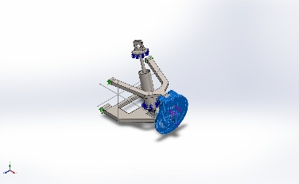 | Solid Body | Mass:1.26652 kg  Volume:0.000164483 m^3  Density:7,700 kg/m^3  Weight:12.4119 N | D:\Dome_assignment\DoME project\my\version_1\tyre hub - Copy.SLDPRT  Nov 27 22:33:03 2025
Fillet4  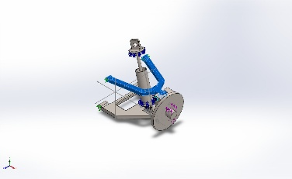 | Solid Body | Mass:0.331277 kg  Volume:4.30229e-05 m^3  Density:7,700 kg/m^3  Weight:3.24651 N | D:\Dome_assignment\DoME project\my\version_1\upper_2 - Copy.SLDPRT  Nov 27 21:55:36 2025

Study Properties
Study name | Test_1_static
Analysis type | Static
Mesh type | Solid Mesh
Thermal Effect: | On
Thermal option | Include temperature loads
Zero strain temperature | 298 Kelvin
Include fluid pressure effects from SOLIDWORKS Flow Simulation | Off
Solver type | Automatic
Inplane Effect: | Off
Soft Spring: | Off
Inertial Relief: | Off
Incompatible bonding options | Automatic
Large displacement | Off
Compute free body forces | On
Friction | Off
Use Adaptive Method: | Off
Result folder | SOLIDWORKS document (D:\Dome_assignment\DoME project\my\version_1)

Units
Unit system: | SI (MKS)
Length/Displacement | mm
Temperature | Kelvin
Angular velocity | Rad/sec
Pressure/Stress | N/m^2

Material Properties
Model Reference | Properties | Components
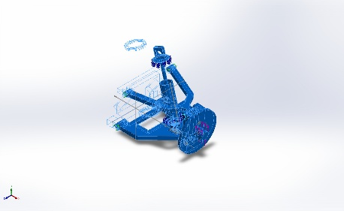 | Name: Alloy Steel  Model type: Linear Elastic Isotropic  Default failure criterion: Max von Mises Stress  Yield strength: 6.20422e+08 N/m^2  Tensile strength: 7.23826e+08 N/m^2  Elastic modulus: 2.1e+11 N/m^2  Poisson's ratio: 0.28  Mass density: 7,700 kg/m^3  Shear modulus: 7.9e+10 N/m^2  Thermal expansion coefficient: 1.3e-05 /Kelvin | SolidBody 1(Boss-Extrude7[1])(base_2-2),  SolidBody 2(Cut-Extrude2)(base_2-2),  SolidBody 1(Revolve2)(damper_pipe-1),  SolidBody 1(Cut-Extrude1)(damper_rod-1),  SolidBody 2(Fillet1)(damper_rod-1),  SolidBody 1(Fillet16)(lower_2 - Copy-1),  SolidBody 1(Cut-Extrude1)(spring - Copy (2)-1),  SolidBody 1(Boss-Extrude4)(tyre hub - Copy-1),  SolidBody 1(Fillet4)(upper_2 - Copy-1)
Curve Data:N/A

Loads and Fixtures
Fixture name | Fixture Image | Fixture Details
Fixed Hinge-1 | 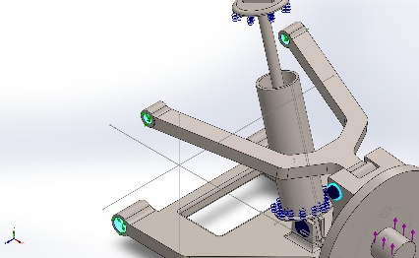 | Entities: 4 face(s)  Type: Fixed Hinge
Resultant Forces
Components | X | Y | Z | Resultant
Reaction force(N) | -60.9249 | -596.9 | 1.20401e-05 | 600.001
Reaction Moment(N.m) | 0 | 0 | 0 | 0

Load name | Load Image | Load Details
Force-1 | 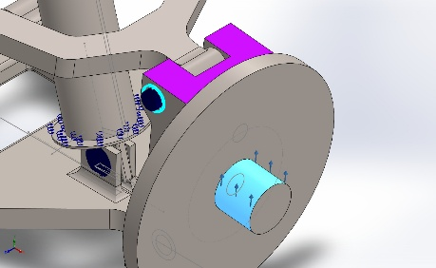 | Entities: 1 face(s)  Reference: Face< 1 >  Type: Apply force  Values: ---, ---, -,600 N

Connector Definitions

Connector Name | Connector Details | Connector Image
Spring Connector-1 | Entities: 2 face(s)  Type: Spring(Flat parallel faces)(Compression & Extension)  Normal stiffness value: 8,108.16 N/m  Tangential Stiffness: 0 N/m | 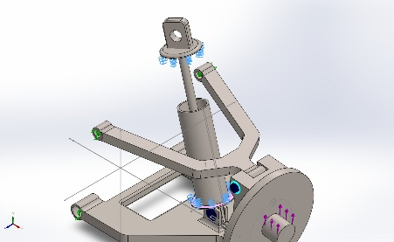  Spring Connector-1

Pin/Bolt/Bearing Connector
Model Reference | Connector Details | Strength Details
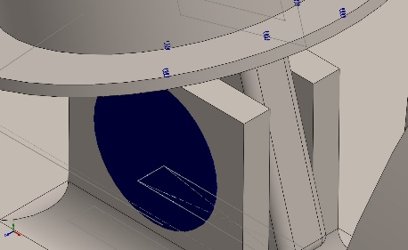  Pin Connector-1 | Entities: 3 face(s)  Type: Pin  With retaining ring (No translation): Yes  With key (No rotation): No  Connection Type: Rigid  Units: SI  Rotational stiffness value: 0 | No Data
Connector Forces Joint 1
Type | X-Component | Y-Component | Z-Component | Resultant
Axial Force (N) | 0 | 0 | 10.955 | -10.955
Shear Force (N) | 6.9449 | -6.2763 | 0 | 9.3607
Torque (N.m) | 0 | 0 | 1.7213e-11 | -1.7213e-11
Bending moment (N.m) | -0.0595 | -0.0048362 | 0 | 0.059696

Connector Forces Joint 2
Type | X-Component | Y-Component | Z-Component | Resultant
Axial Force (N) | 0 | 0 | 10.955 | -10.955
Shear Force (N) | 6.9449 | -6.2763 | 0 | 9.3607
Torque (N.m) | 0 | 0 | 1.7211e-11 | -1.7211e-11
Bending moment (N.m) | 0.085459 | 0.033561 | 0 | 0.091813

Connector Forces Joint 3
Type | X-Component | Y-Component | Z-Component | Resultant
Axial Force (N) | -0 | -0 | -10.798 | 10.798
Shear Force (N) | 1.4845 | -6.2238 | 0 | 6.3984
Torque (N.m) | 0 | 0 | 1.7213e-11 | -1.7213e-11
Bending moment (N.m) | 0.059799 | 0.017382 | 0 | 0.062274

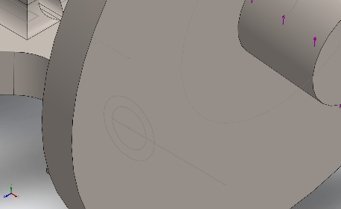  Pin Connector-4 | Entities: 3 face(s)  Type: Pin  With retaining ring (No translation): Yes  With key (No rotation): No  Connection Type: Rigid  Units: SI  Rotational stiffness value: 0 | No Data
Connector Forces Joint 1
Type | X-Component | Y-Component | Z-Component | Resultant
Axial Force (N) | 0 | 0 | -0.51797 | -0.51797
Shear Force (N) | 569.04 | 1,198.2 | 0 | 1,326.4
Torque (N.m) | 0 | 0 | -1.9454e-12 | -1.9454e-12
Bending moment (N.m) | 6.7217 | -1.5449 | 0 | 6.8969

Connector Forces Joint 2
Type | X-Component | Y-Component | Z-Component | Resultant
Axial Force (N) | 0 | 0 | -0.51797 | -0.51797
Shear Force (N) | 569.04 | 1,198.2 | 0 | 1,326.4
Torque (N.m) | 0 | 0 | -1.5469e-12 | -1.5469e-12
Bending moment (N.m) | 14.252 | -8.4158 | 0 | 16.551

Connector Forces Joint 3
Type | X-Component | Y-Component | Z-Component | Resultant
Axial Force (N) | -0 | -0 | 17.493 | 17.493
Shear Force (N) | 410.21 | 1,098.3 | 0 | 1,172.4
Torque (N.m) | 0 | 0 | -1.944e-12 | -1.944e-12
Bending moment (N.m) | -6.1258 | 0.40365 | 0 | 6.1391

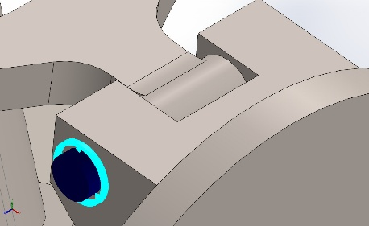  Pin Connector-5 | Entities: 3 face(s)  Type: Pin  With retaining ring (No translation): Yes  With key (No rotation): No  Connection Type: Rigid  Units: SI  Rotational stiffness value: 0 | No Data
Connector Forces Joint 1
Type | X-Component | Y-Component | Z-Component | Resultant
Axial Force (N) | -0 | -0 | 37.484 | 37.484
Shear Force (N) | -262.15 | 90.807 | 0 | 277.43
Torque (N.m) | 0 | 0 | -2.5977e-12 | -2.5977e-12
Bending moment (N.m) | -0.83893 | -0.29251 | 0 | 0.88846

Connector Forces Joint 2
Type | X-Component | Y-Component | Z-Component | Resultant
Axial Force (N) | -0 | -0 | 65.881 | 65.881
Shear Force (N) | 354.56 | 22.88 | 0 | 355.3
Torque (N.m) | 0 | 0 | -2.4312e-12 | -2.4312e-12
Bending moment (N.m) | -2.176 | -5.6127 | 0 | 6.0197

Connector Forces Joint 3
Type | X-Component | Y-Component | Z-Component | Resultant
Axial Force (N) | 0 | 0 | -65.881 | -65.881
Shear Force (N) | -354.56 | -22.88 | 0 | 355.3
Torque (N.m) | 0 | 0 | -2.5868e-12 | -2.5868e-12
Bending moment (N.m) | 2.5751 | -0.57265 | 0 | 2.638

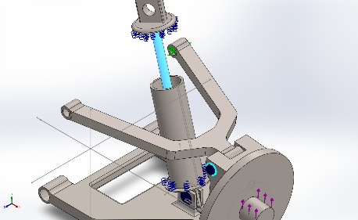  Pin Connector-6 | Entities: 2 face(s)  Type: Pin  With retaining ring (No translation): Yes  With key (No rotation): No  Connection Type: Distributed  Units: SI  Rotational stiffness value: 0 | No Data
Connector Forces Joint 1
Type | X-Component | Y-Component | Z-Component | Resultant
Axial Force (N) | 0.0016637 | -0.0059329 | -0 | 0.0061618
Shear Force (N) | 0.00068609 | 0.00019239 | -6.5077e-05 | 0.00071552
Torque (N.m) | 2.6322e-14 | -9.3867e-14 | -0 | 9.7488e-14
Bending moment (N.m) | -4.2029e-06 | -1.1786e-06 | -5.4881e-05 | 5.5055e-05

Connector Forces Joint 2
Type | X-Component | Y-Component | Z-Component | Resultant
Axial Force (N) | -0.0016637 | 0.0059329 | 0 | -0.0061618
Shear Force (N) | -0.00068609 | -0.00019239 | 6.5077e-05 | 0.00071552
Torque (N.m) | -2.1816e-13 | 7.7799e-13 | 0 | -8.08e-13
Bending moment (N.m) | -2.4233e-06 | -6.7954e-07 | -2.0471e-05 | 2.0625e-05

Interaction Information

Interaction | Interaction Image | Interaction Properties
Global Interaction | 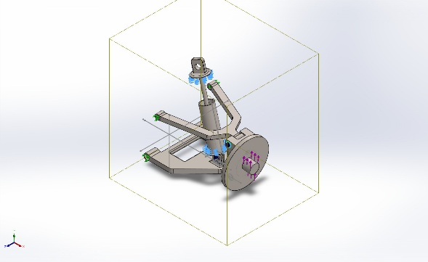 | Type: Bonded  Components: 1 component(s)  Options: Independent mesh

Mesh information
Mesh type | Solid Mesh
Mesher Used: | Blended curvature-based mesh
Jacobian points for High quality mesh | 16 Points
Maximum element size | 10.215 mm
Minimum element size | 0.51075 mm
Mesh Quality | High
Remesh failed parts independently | Off
Reuse mesh for identical parts in an assembly (Blended curvature-based mesher only) | Off

Mesh information - Details
Total Nodes | 265399
Total Elements | 159451
Maximum Aspect Ratio | 50.794
% of elements with Aspect Ratio < 3 | 95.5
Percentage of elements with Aspect Ratio > 10 | 0.074
Percentage of distorted elements | 0
Time to complete mesh(hh;mm;ss): | 00:00:38
Computer name: | TEJADURGAM

Mesh Control Information:
Mesh Control Name | Mesh Control Image | Mesh Control Details
Control-1 | 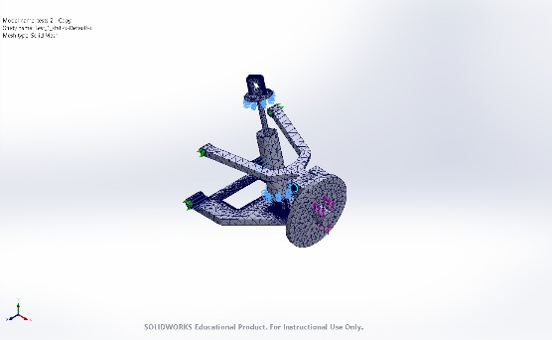 | Entities: 4 face(s)  Units: mm  Size: 0.5  Ratio: 0.5
Control-2 | 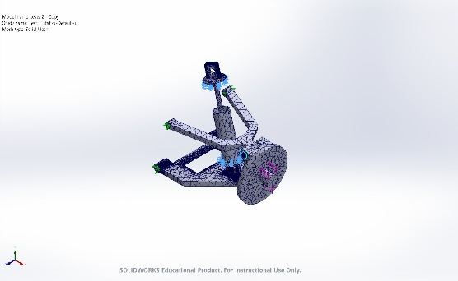 | Entities: 8 face(s)  Units: mm  Size: 1  Ratio: 1
Control-3 | 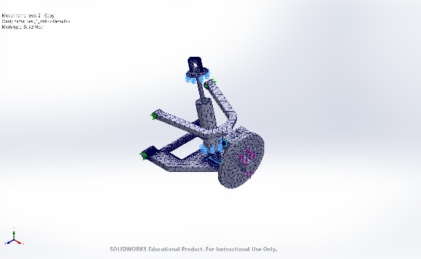 | Entities: 8 face(s)  Units: mm  Size: 0.5  Ratio: 0.5

Mesh Quality Plots
Name | Type | Min | Max
Quality1 | Mesh | - | -
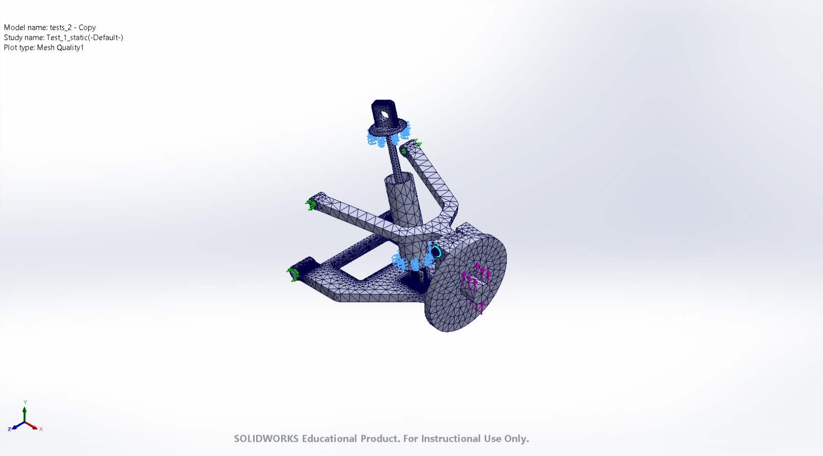
tests_2 - Copy-Test_1_static-Quality-Quality1

Sensor Details
No Data

Resultant Forces

Reaction forces
Selection set | Units | Sum X | Sum Y | Sum Z | Resultant
Entire Model | N | -60.9249 | -596.9 | 1.20401e-05 | 600.001

Reaction Moments
Selection set | Units | Sum X | Sum Y | Sum Z | Resultant
Entire Model | N.m | 0 | 0 | 0 | 0

Free body forces
Selection set | Units | Sum X | Sum Y | Sum Z | Resultant
Entire Model | N | 0.00122065 | 0.00772102 | -0.00320676 | 0.0084491

Free body moments
Selection set | Units | Sum X | Sum Y | Sum Z | Resultant
Entire Model | N.m | 0 | 0 | 0 | 1e-33

Beams
No Data

Study Results

Name | Type | Min | Max
Stress1 | VON: von Mises Stress | 4.769e-01N/m^2  Node: 59681 | 4.849e+08N/m^2  Node: 183649
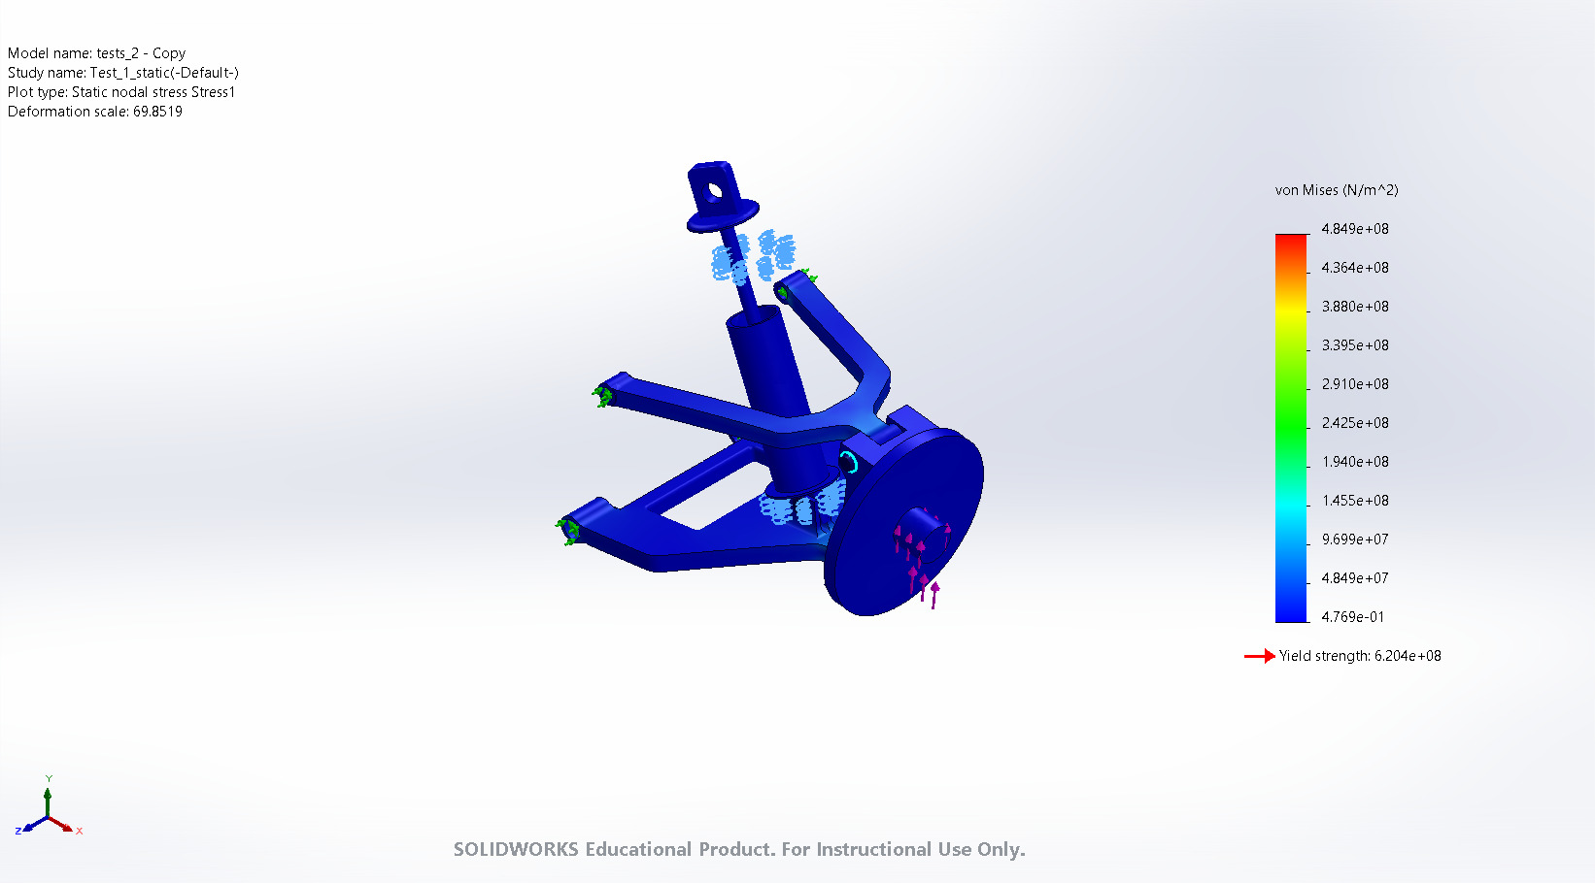
tests_2 - Copy-Test_1_static-Stress-Stress1

Name | Type | Min | Max
Displacement1 | URES: Resultant Displacement | 4.133e-04mm  Node: 663 | 3.852e-01mm  Node: 60662
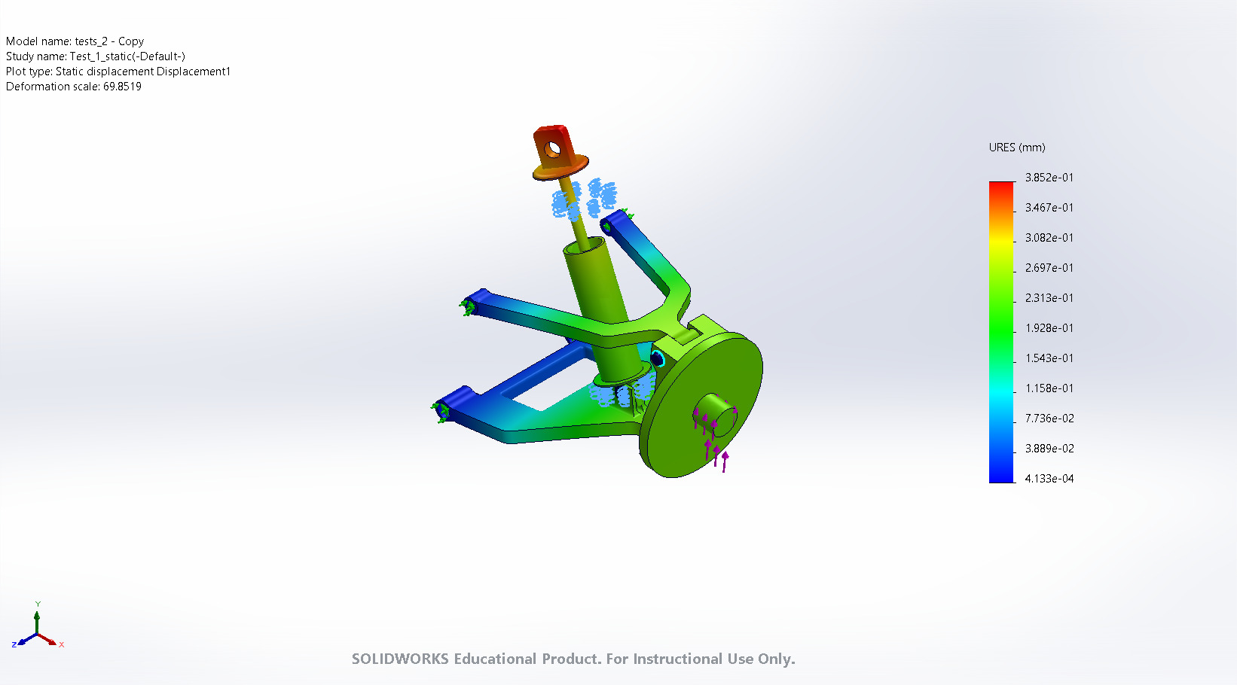
tests_2 - Copy-Test_1_static-Displacement-Displacement1

Name | Type | Min | Max
Strain1 | ESTRN: Equivalent Strain | 1.762e-12  Element: 146391 | 9.967e-04  Element: 81942
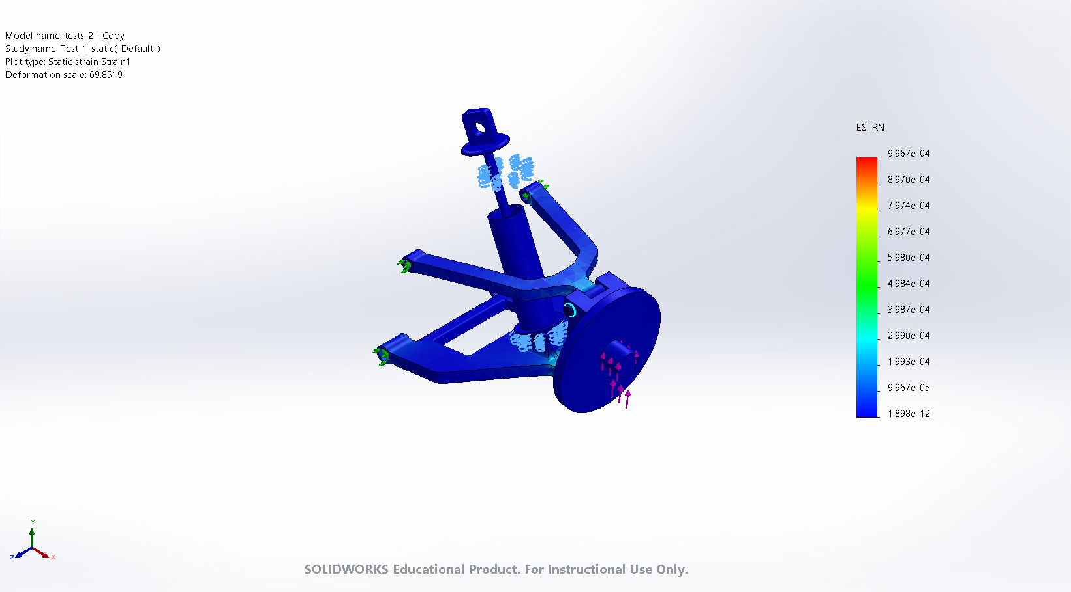
tests_2 - Copy-Test_1_static-Strain-Strain1

Name | Type | Min | Max
Factor of Safety1 | Automatic | 1.279e+00  Node: 183649 | 1.301e+09  Node: 59681
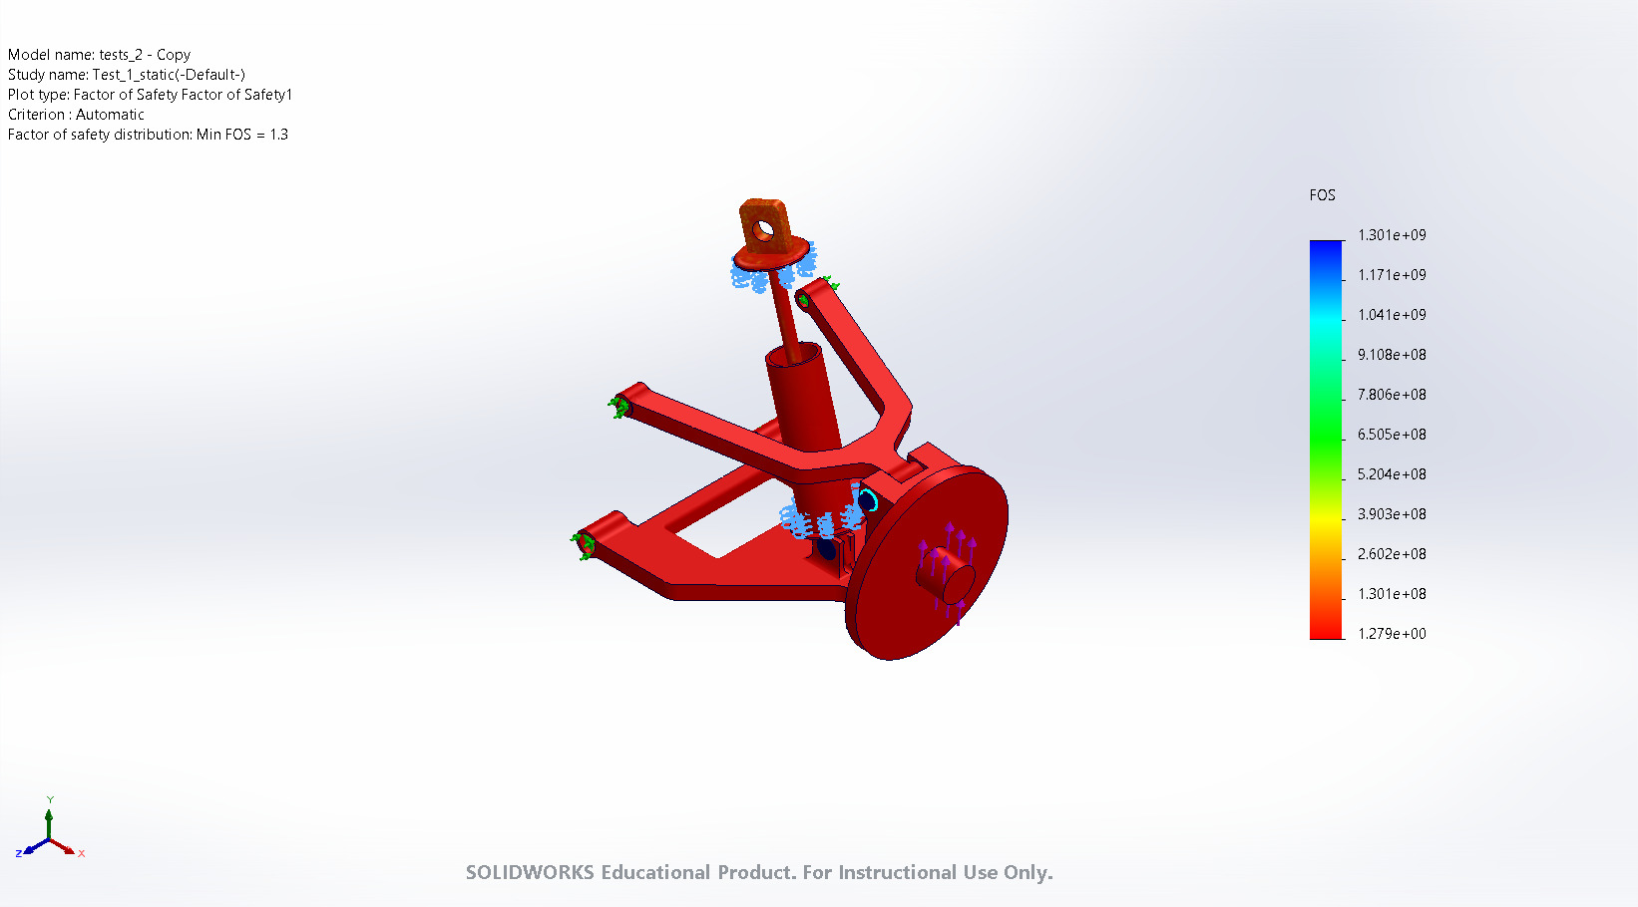
tests_2 - Copy-Test_1_static-Factor of Safety-Factor of Safety1

Conclusion

