Taj Lake Palace: India's Floating Palace Honored with the MICHELIN Guide Three Keys Distinction
By Founder Yashodar
5–7 Min Read.

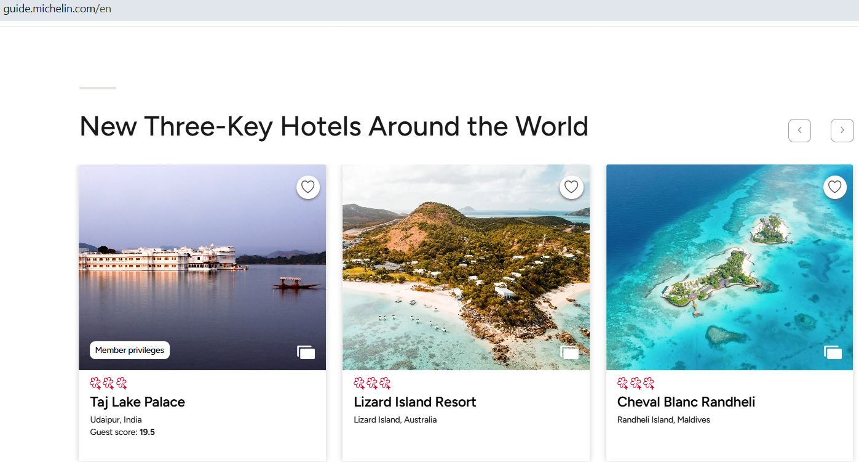

SEO Title: Taj Lake Palace: Why India's Iconic Palace Hotel Earned the MICHELIN Guide Three Keys Distinction
Meta Description: Discover why Taj Lake Palace in Udaipur has been awarded the prestigious MICHELIN Guide Three Keys distinction. Explore its royal heritage, luxury experiences, architecture, and why it remains one of the world's most extraordinary hotels.
URL Slug:
/blog/taj-lake-palace-michelin-guide-three-keys

Some hotels offer a luxurious stay. A rare few become the destination itself.
Rising gracefully from the calm waters of Lake Pichola in Udaipur, Taj Lake Palace is one of those extraordinary places. Surrounded entirely by water and framed by the Aravalli Hills, the white marble palace appears to float effortlessly, creating a view that has captivated royalty, world leaders, celebrities and travelers for generations.
Its timeless elegance has now received one of the highest honors in luxury hospitality The MICHELIN Guide Three Keys distinction.
Unlike restaurant stars, which celebrate culinary excellence, the MICHELIN Keys recognize hotels that deliver truly exceptional stays. Receiving Three Keys places a hotel among the world's finest, acknowledging not only its luxury but also its ability to create unforgettable memories through exceptional design, service, atmosphere and guest experience.
For travelers seeking more than just premium accommodation, this distinction confirms that Taj Lake Palace is not simply a place to spend the night, it is a destination where history, culture and world-class hospitality come together in perfect harmony.

A Palace Built for Royalty
Long before it welcomed international travelers, Taj Lake Palace was the pleasure palace of the royal family of Mewar.
Constructed in 1746 by Maharana Jagat Singh II, the palace was originally known as Jag Niwas. Built entirely from white marble on the tranquil waters of Lake Pichola, it served as a secluded summer retreat where the royal family could escape the intense Rajasthan heat while enjoying spectacular views of the surrounding hills and the City Palace.
Its architecture reflects the artistic brilliance of the Mewar kingdom. Delicately carved marble facades, graceful courtyards, ornate fountains, intricate stonework and elegant arches showcase centuries of craftsmanship that continue to define the palace today.
Following extensive restoration, the property was transformed into one of India's most celebrated luxury hotels under the Taj Hotels portfolio. While modern comforts have been thoughtfully integrated, the palace has preserved the heritage, grandeur and authenticity that make it one of the country's most iconic landmarks.
Today, arriving at Taj Lake Palace is an experience unlike any other. Since the hotel is situated on an island in the middle of Lake Pichola, guests are welcomed at a private jetty before boarding an exclusive boat that transports them across the shimmering lake to the palace entrance. The journey itself creates a sense of anticipation, making every arrival feel ceremonial and unforgettable.

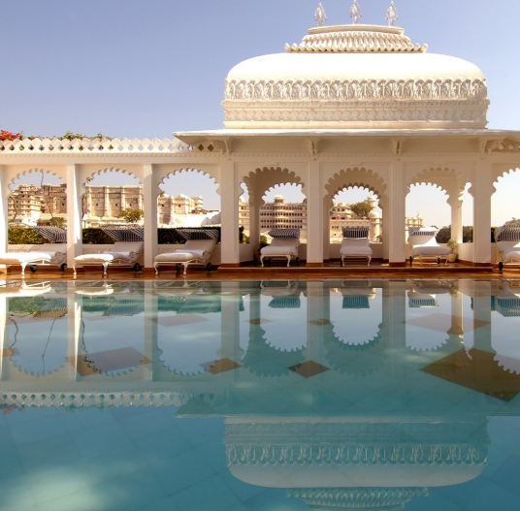

Why This Recognition Matters to Travelers
Luxury travelers today are no longer searching only for larger suites or lavish amenities. They increasingly value authenticity, meaningful experiences and destinations that offer a genuine sense of place.
The MICHELIN Guide Three Keys distinction serves as an independent endorsement that helps travellers make informed decisions with confidence.
For guests considering Taj Lake Palace, the recognition reinforces that they are choosing a hotel celebrated not only for its beauty but also for its exceptional hospitality and enduring legacy.
Whether you're planning a once-in-a-lifetime honeymoon, celebrating a milestone anniversary, organizing a destination wedding or simply fulfilling a dream of staying in a royal palace, the Three Keys distinction provides reassurance that the experience has been recognized among the world's finest.
Unlike trends that fade with time, Taj Lake Palace has remained relevant for centuries. Its heritage, architecture and personalized service continue to set a benchmark in luxury hospitality, proving that true excellence is timeless.

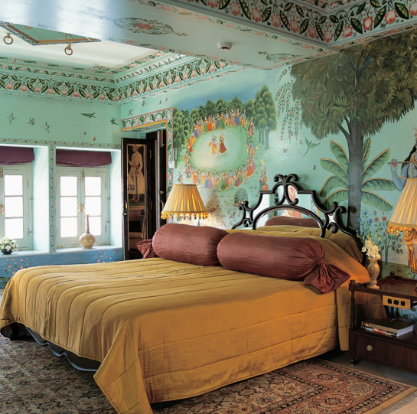

Living Like Royalty: The Taj Lake Palace Experience
Stepping into Taj Lake Palace is unlike checking into a conventional luxury hotel. From the moment guests board the private boat across Lake Pichola, the outside world begins to fade away. The sounds of city traffic are replaced by gentle waves, palace courtyards echo with birdsong, and every detail reflects centuries of royal heritage.
It is this immersive experience rather than luxury alone that distinguishes Taj Lake Palace from many of the world's finest hotels.

A Stay Surrounded by Water
Very few hotels in the world can claim to occupy an entire island, and even fewer are former royal palaces. Taj Lake Palace offers both.
Every room, terrace and courtyard enjoys changing views throughout the day. Sunrise casts a golden glow across the white marble walls, while evenings transform the palace into a shimmering landmark reflected on Lake Pichola. As the City Palace, Jag Mandir and surrounding hills light up after sunset, guests witness one of India's most spectacular urban landscapes.
Unlike modern high-rise luxury hotels, the palace has an intimate atmosphere. Guests are encouraged to slow down, wander through peaceful gardens, relax beside ornate fountains and admire handcrafted details that have survived for nearly three centuries.
The result is an experience that feels deeply personal rather than commercial.

Elegant Rooms and Suites Inspired by Royal Heritage
No two rooms at Taj Lake Palace are exactly alike.
Each accommodation has been thoughtfully designed to preserve the palace's original character while providing the comfort expected by today's luxury traveller. Intricately carved marble, traditional Rajasthani artwork, handcrafted furniture and elegant fabrics create interiors that feel authentic rather than recreated.
Many rooms overlook the tranquil waters of Lake Pichola, while others offer views of the City Palace or the surrounding Aravalli Hills. Natural light fills the spaces throughout the day, adding warmth to the palace's iconic white marble interiors.
For guests seeking the highest level of exclusivity, the palace suites provide expansive living areas, refined décor and personalized hospitality that reflects the traditions of Indian royal families.
Rather than overwhelming guests with excessive opulence, the accommodation focuses on timeless elegance, privacy and comfort qualities that continue to define true luxury.

Dining That Celebrates Rajasthan
Dining at Taj Lake Palace extends beyond exceptional cuisine. Every meal is enhanced by the palace's remarkable setting.
Restaurants overlook the lake, candlelit courtyards create romantic evenings, and every table enjoys an atmosphere shaped by history and architecture.
Guests can experience a carefully curated selection of culinary styles, including authentic Rajasthani dishes, classic Indian cuisine and international favorites prepared using premium seasonal ingredients.
Traditional recipes passed down through generations sit comfortably alongside contemporary presentations, offering both familiarity and innovation.
The emphasis is not simply on fine dining, but on creating memorable occasions that match the significance of the destination itself.

Wellness in a Palace Setting
Luxury today is increasingly defined by wellbeing, and Taj Lake Palace embraces this philosophy with experiences designed to restore both body and mind.
Guests can enjoy signature spa therapies inspired by traditional Indian wellness practices, complemented by personalized treatments delivered in serene surroundings.
The peaceful atmosphere created by the lake naturally encourages relaxation. Morning walks through quiet courtyards, yoga overlooking the water and tranquil seating areas throughout the palace allow guests to disconnect from busy schedules and reconnect with themselves.
Unlike large resort destinations filled with endless activities, Taj Lake Palace encourages a slower rhythm of travel one where every experience is intentional and unhurried.

Service That Reflects Indian Hospitality
Beautiful architecture may attract visitors, but exceptional service is what inspires them to return.
One of the defining characteristics of Taj Hotels has always been its commitment to personalized hospitality, and Taj Lake Palace exemplifies this tradition.
From remembering guest preferences to arranging customized celebrations and private experiences, the staff consistently deliver service that feels genuine rather than scripted.
Many visitors describe their stay not only in terms of luxurious surroundings but also the warmth, professionalism and attention shown by every member of the team.
This human connection plays an important role in the MICHELIN Guide's evaluation process. Outstanding hotels are measured not only by facilities but also by the emotional experience they create for guests.
At Taj Lake Palace, hospitality is not treated as a service it is treated as an art.

More Than a Hotel, A Stage for Life's Greatest Celebrations
Few destinations evoke romance quite like Taj Lake Palace.
Its spectacular location has made it one of India's most sought-after venues for honeymoons, destination weddings, anniversary celebrations and milestone birthdays.
Over the years, the palace has welcomed royalty, world leaders, celebrated personalities and discerning travelers from across the globe. Yet every guest is made to feel equally valued through thoughtful service and personalized experiences.
The setting itself contributes to this sense of occasion. Ceremonies overlooking Lake Pichola, intimate proposals beneath historic arches and private dinners illuminated by candlelight create memories that extend far beyond the stay itself.
For many traveler’s, Taj Lake Palace is not simply where they celebrate life's important moments it becomes part of those memories forever.

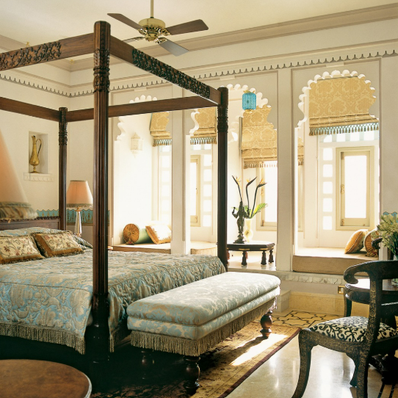

Why the Experience Feels Different
Many luxury hotels offer elegant rooms, premium dining and attentive service.
What sets Taj Lake Palace apart is its authenticity.
It is not a palace inspired by history; it is history.
Every corridor, balcony and courtyard tells a story that cannot be replicated through modern design. Guests are not merely visiting a luxury hotel they are living within one of India's most treasured royal residences.
This seamless blend of heritage, culture, architecture and personalized hospitality is precisely why Taj Lake Palace continues to stand among the world's most celebrated luxury hotels.
More importantly, it explains why the MICHELIN Guide recognized it with the prestigious Three Keys distinction a recognition reserved for hotels that transform a stay into an unforgettable journey.
Why Taj Lake Palace Deserves the MICHELIN Guide Three Keys
The MICHELIN Guide's Three Keys distinction is awarded to hotels that offer an extraordinary experience not just through luxury, but through a complete guest experience.
Taj Lake Palace stands out because it brings together everything that defines a world-class hotel:
- A unique location in the middle of Lake Pichola
- Nearly 300 years of royal history
- Beautiful marble architecture
- Personalised Taj hospitality
- Fine dining with spectacular views
- An experience that cannot be replicated anywhere else
Rather than simply offering luxury, the palace tells a story that every guest becomes part of.

Who Should Stay Here?
Taj Lake Palace is ideal for travellers looking for memorable experiences rather than just premium accommodation.
It is particularly suited for:
- Honeymoon couples
- Anniversary celebrations
- Destination weddings
- Luxury leisure travellers
- Families celebrating special occasions
- International visitors exploring Rajasthan
- Photography and heritage enthusiasts
If your goal is to experience India's royal heritage with exceptional hospitality, few hotels compare.

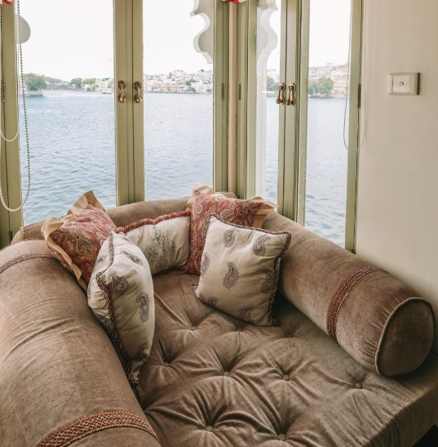

Best Time to Visit
The most pleasant time to visit Udaipur is October to March, when temperatures are comfortable for sightseeing, boat rides and outdoor dining.
traveler’s visiting during festivals such as Diwali or local cultural celebrations can enjoy an even more vibrant atmosphere, though booking well in advance is recommended.

Frequently Asked Questions
What is the MICHELIN Guide Three Keys?
The Three Keys are the highest hotel recognition awarded by the MICHELIN Guide, celebrating properties that provide an exceptional and unforgettable experience.
Is Taj Lake Palace a heritage hotel?
Yes. Originally built in 1746 as the royal summer palace of the Mewar dynasty, it has been carefully restored and now operates as a luxury hotel managed by Taj Hotels.
How do guests reach the hotel?
Guests arrive by a private boat from the Taj Lake Palace jetty on the shores of Lake Pichola.
Is Taj Lake Palace suitable for honeymooners?
Absolutely. Its romantic setting, private experiences and personalized service make it one of India's most sought-after honeymoon destinations.
How many MICHELIN Keys has Taj Lake Palace received?
Taj Lake Palace has been recognized with the prestigious Three MICHELIN Keys, the highest distinction awarded by the MICHELIN Guide for hotels.

Final Thoughts
Some hotels impress you while you're there.
A select few stay with you long after you've returned home.
Taj Lake Palace belongs in that rare category.
Its remarkable history, stunning lakeside setting, timeless architecture and warm hospitality create an experience that goes beyond luxury. The MICHELIN Guide Three Keys distinction simply reinforces what travelers have known for years it is one of India's most extraordinary places to stay.
Whether you're planning a romantic escape, celebrating a milestone or fulfilling a lifelong dream of living in a royal palace, Taj Lake Palace promises an experience that is both timeless and unforgettable.

Reserve Your Stay with Antravi
At Antravi, we believe exceptional hotels deserve exceptional journeys.
Whether you're planning a honeymoon, anniversary, destination wedding or a bespoke luxury holiday in Rajasthan, our travel specialists can curate every detail from your stay at Taj Lake Palace to private experiences, luxury transfers and personalized itineraries.
Ready to experience one of India's finest hotels?
Contact Antravi today and let us design a journey that's as memorable as the destination itself.

Author: Founder Yashodar
Published on: Antravi General Blog
Category: Luxury Hotels | India | MICHELIN Guide | Rajasthan | Heritage Hotels

