Oaga Art Resort Reimagined: A Colorful New Chapter Begins in the Maldives (2026)
By Founder Yashodar Reddy.
Oaga Art Resort Reimagined: What Travelers Can Expect from August 2026
When people dream about the Maldives, they usually picture turquoise lagoons, white sandy beaches and luxurious overwater villas.
But Oaga Art Resort offers something refreshingly different.
Instead of focusing only on luxury, Oaga celebrates the heart and soul of the Maldives through art, storytelling, music, creativity and authentic island culture. Every villa, restaurant and public space has been designed to tell a story inspired by local traditions and Maldivian artists, creating an experience that goes far beyond a typical beach holiday.
Now, the resort is entering an exciting new chapter.
Beginning 1 August 2026, Oaga Art Resort will unveil the first phase of its latest enhancements, introducing refreshed guest experiences, upgraded facilities and new accommodation options. The transformation reflects the resort's commitment to evolving while staying true to its identity as one of the Maldives' most creative and homegrown luxury resorts.

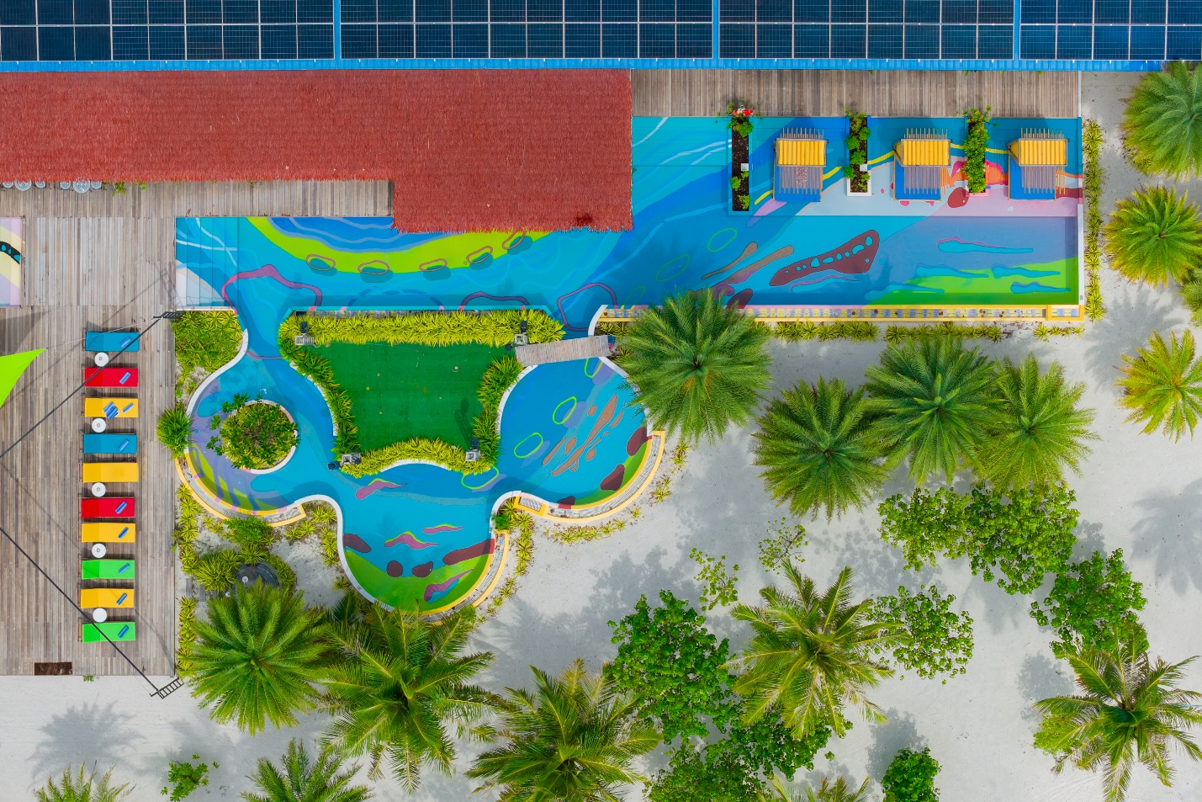

A Homegrown Maldivian Resort
Unlike many international luxury brands operating in the Maldives, Oaga proudly describes itself as a contemporary homegrown Maldivian brand.
Its philosophy is built around authenticity, local creativity and heartfelt hospitality delivered by a passionate Maldivian team. Rather than recreating international luxury, Oaga embraces Maldivian culture and invites guests to become part of it.
From the moment guests arrive, they are introduced to colorful artwork, folklore, music and immersive storytelling that continues throughout their stay.
This makes Oaga particularly appealing to travelers looking for experiences rather than simply another luxury resort.
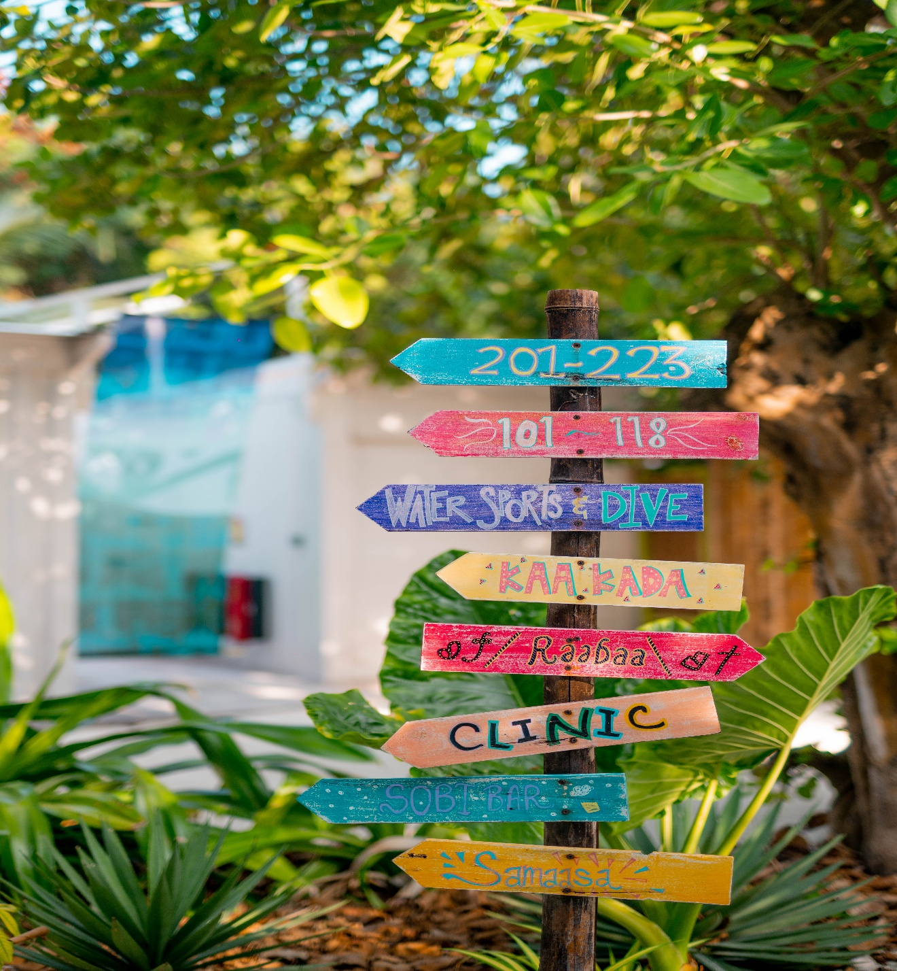
Easy Access from Velana International Airport
Oaga Art Resort is located in North Malé Atoll, approximately 51 kilometres from Velana International Airport.
Guests can reach the island in around 45 minutes by speedboat, with transfers arranged according to international flight schedules and available throughout the day.
This convenient location allows travellers to begin their holiday quickly without requiring a domestic flight or seaplane transfer.

What's New from 1 August 2026?
The August 2026 reopening marks the beginning of several enhancements across the island.
According to the latest resort presentation, guests can expect:
- Refreshed public spaces
- Enhanced dining experiences
- Expansion of the main restaurant
- New sunrise overwater villas
- Conversion of selected beach villas into larger two-bedroom accommodations
- Additional overwater villas with both sunrise and sunset views
- Continued expansion throughout 2026, including a new overwater restaurant planned for early 2027.
These developments are designed to provide more accommodation choices for couples, families and groups while maintaining the intimate atmosphere that guests appreciate.
Rather than changing the identity of the resort, Oaga is expanding the ways guests can experience its artistic vision.
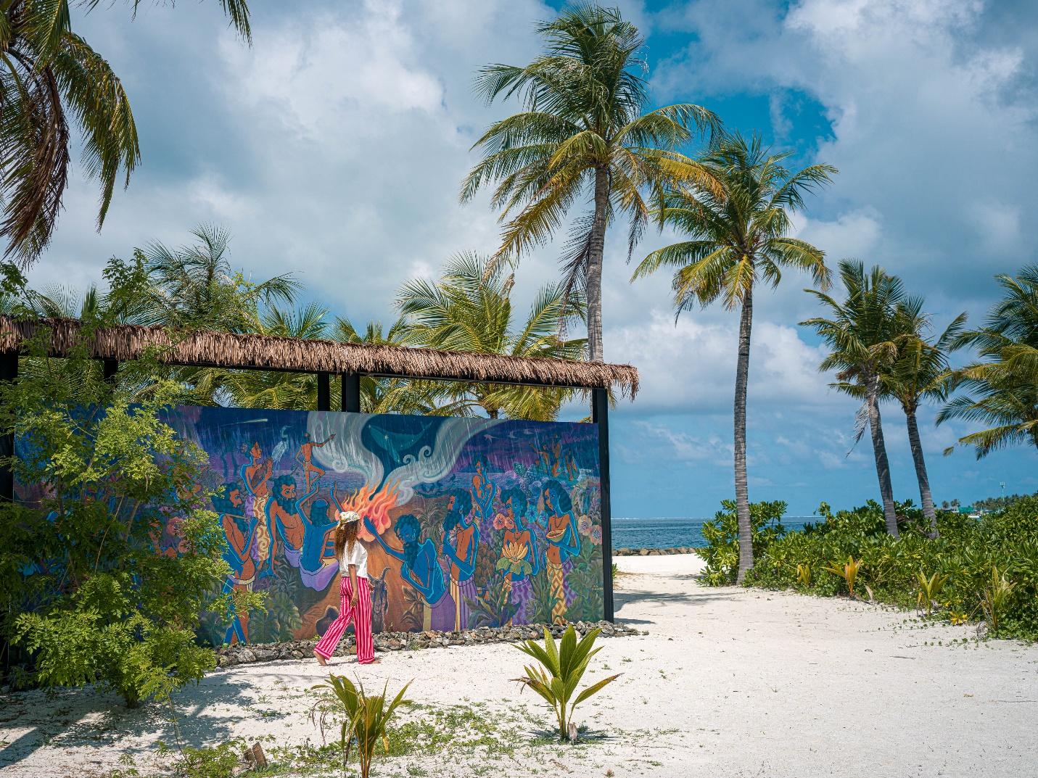

More Than Just a Luxury Stay
Many Maldives resorts impress guests with beautiful villas.
Oaga aims to leave a lasting emotional connection.
Throughout the island, local legends, traditional folklore and contemporary Maldivian art are woven into the guest experience. Every space has been thoughtfully designed to spark curiosity, encourage creativity and celebrate the country's cultural heritage.
Stay in Villas That Tell a Story
At Oaga Art Resort, accommodation is more than a place to sleep. Every villa has been designed as a piece of art inspired by Maldivian culture, folklore and island life. Hand-drawn murals and creative interiors make each stay feel unique rather than identical. The resort's signature Mural Walls and Mural Pools extend these stories from the villa interiors into the private pools, creating an artistic experience throughout the property. The refreshed designs will debut with the August 2026 enhancements.
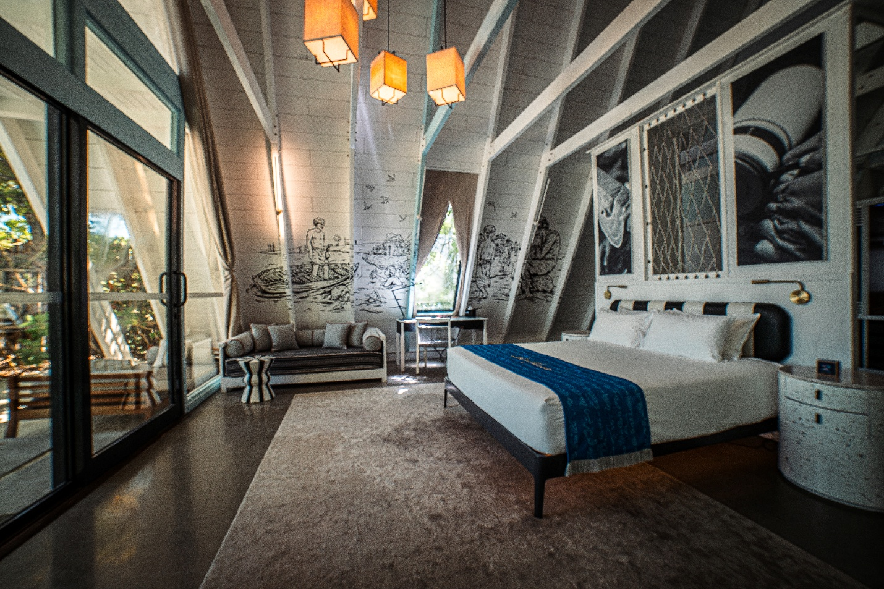

New Villas and More Space for Every Traveler
The 2026 expansion introduces more accommodation options, giving guests greater flexibility when planning their Maldives holiday.
Highlights include:
- New sunrise overwater villas
- Additional overwater villas with both sunrise and sunset views
- Selected Haruge Beach Villas converted into spacious two-bedroom villas for families and groups
- More overwater inventory planned throughout 2026, with a total of 30 new overwater villas being introduced by the end of the year.
These additions allow Oaga to welcome more couples, families and friends without losing the boutique atmosphere that has made the resort popular.

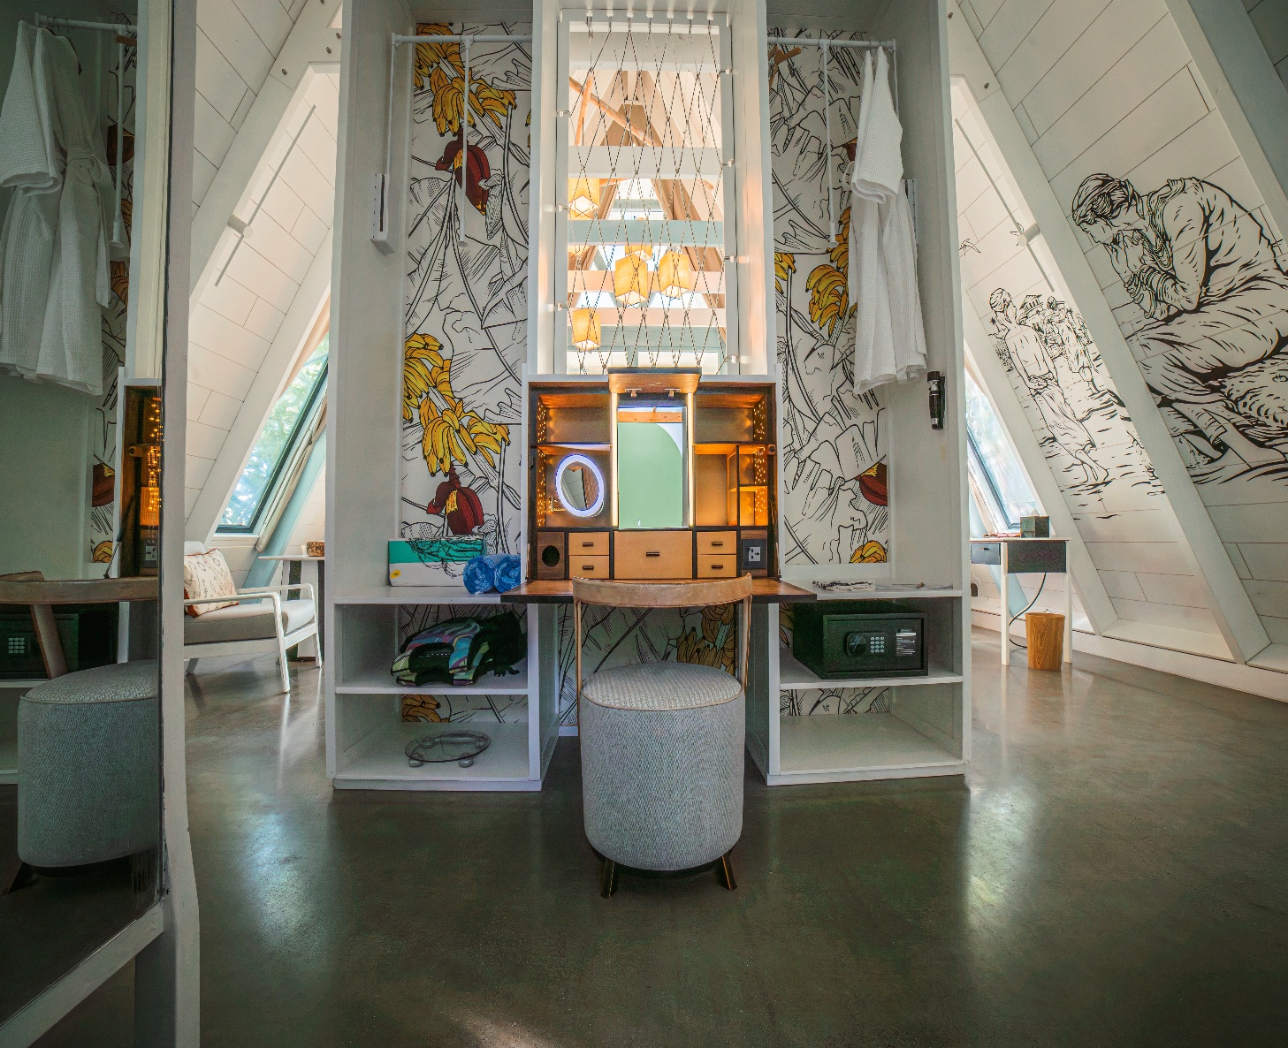
Designed for Couples, Families and Groups
The resort now offers accommodation for different styles of travel.
Couples can choose intimate overwater villas with private pools and slides, while families have larger beach villas designed for shared stays. Travellers celebrating special occasions can even stay in the spacious Radhun Residential Suite, a three-bedroom residence with its own private pool and dedicated studio space.
This wider range of villa categories makes Oaga suitable for honeymooners, multi-generational holidays and small group celebrations.
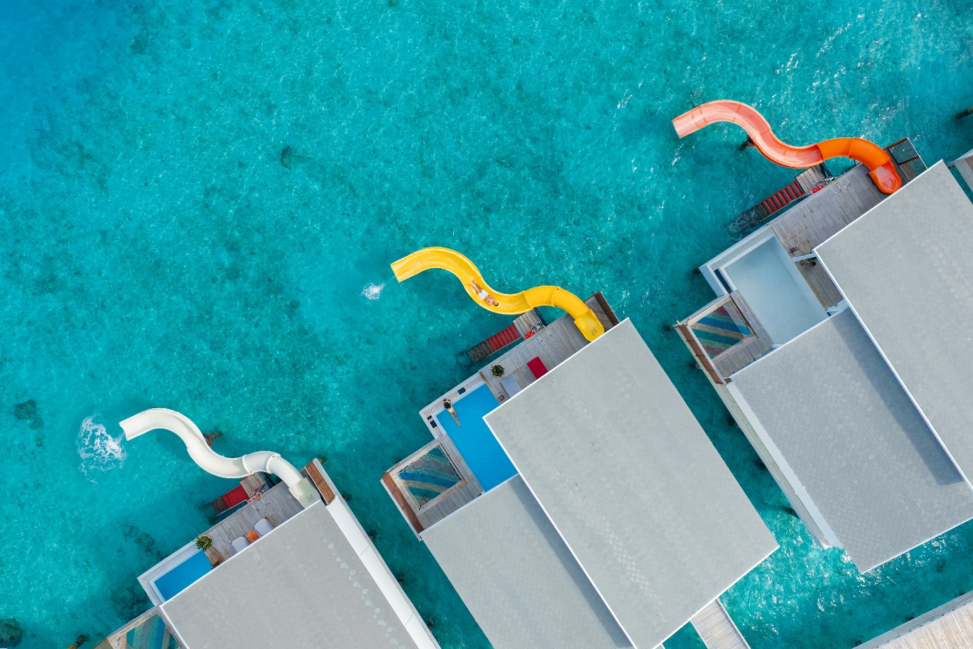

Dining Gets an Upgrade
Food has always been an important part of the Oaga experience, and the resort is investing further in its dining venues.
The presentation highlights:
- Expansion and enhancement of the Kaa Kada main restaurant
- Refreshed arrival experience at Raa Baa
- More indoor seating
- Community lounge spaces
- Enhanced entertainment areas
- A brand-new overwater restaurant planned for early 2027.
Rather than simply adding another restaurant, these improvements are designed to create more spaces where guests can relax, socialize and experience Oaga's creative atmosphere.

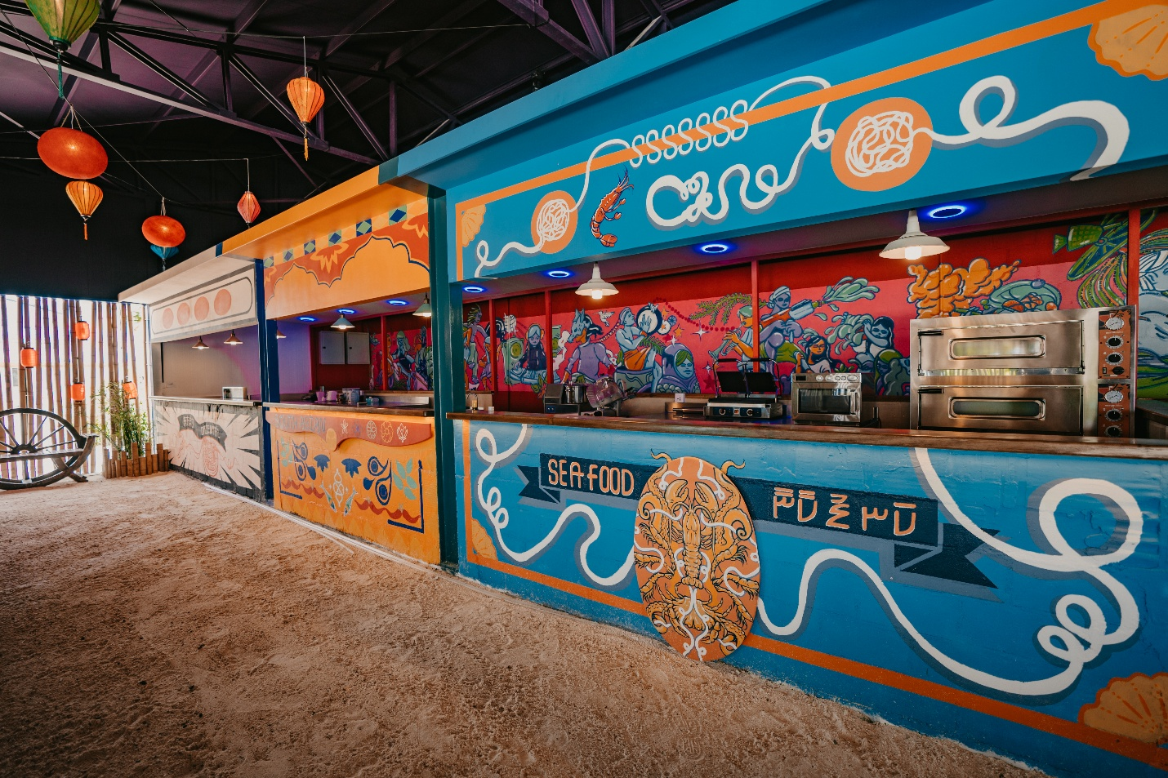

Entertainment Inspired by Maldivian Creativity
Oaga has always positioned itself as a resort where art and entertainment come together.
The refreshed Raa Baa will feature:
- An upgraded Ashi Lounge
- Larger entertainment spaces
- Added deck seating
- A fire pit for bonfire evenings
- An improved open beach stage with movable platforms for performances
- The Maldives' largest mural pool continuing as a signature attraction.
These spaces encourage guests to enjoy live performances, storytelling and community experiences instead of spending every evening inside their villas.

A Resort That Celebrates Local Culture
One of Oaga's biggest strengths is its commitment to Maldivian identity.
From artwork and folklore to music and creative experiences, the resort encourages visitors to connect with the culture of the islands rather than simply enjoying the scenery.
Even unique initiatives such as the resort's creative podcast and collaborations with artists reflect its ambition to support local voices and celebrate Maldivian storytelling.
For travellers looking beyond traditional luxury, this cultural focus creates a stay that feels authentic, memorable and distinctly different from many other resorts in the Maldives.

Discover the Maldives Above and Below the Water
While Oaga Art Resort is known for its artistic identity, it also delivers the natural beauty that travellers expect from the Maldives.
The island is surrounded by a vibrant house reef, making it easy for guests to snorkel and discover colourful coral formations, tropical fish and diverse marine life just steps from their villa. Whether you're an experienced snorkeller or trying it for the first time, the underwater world becomes an unforgettable part of your stay.
For guests looking to explore further, Oaga also offers a range of excursions and experiences that showcase the beauty of the Maldives beyond the island, encouraging travellers to discover more of the destination during their holida
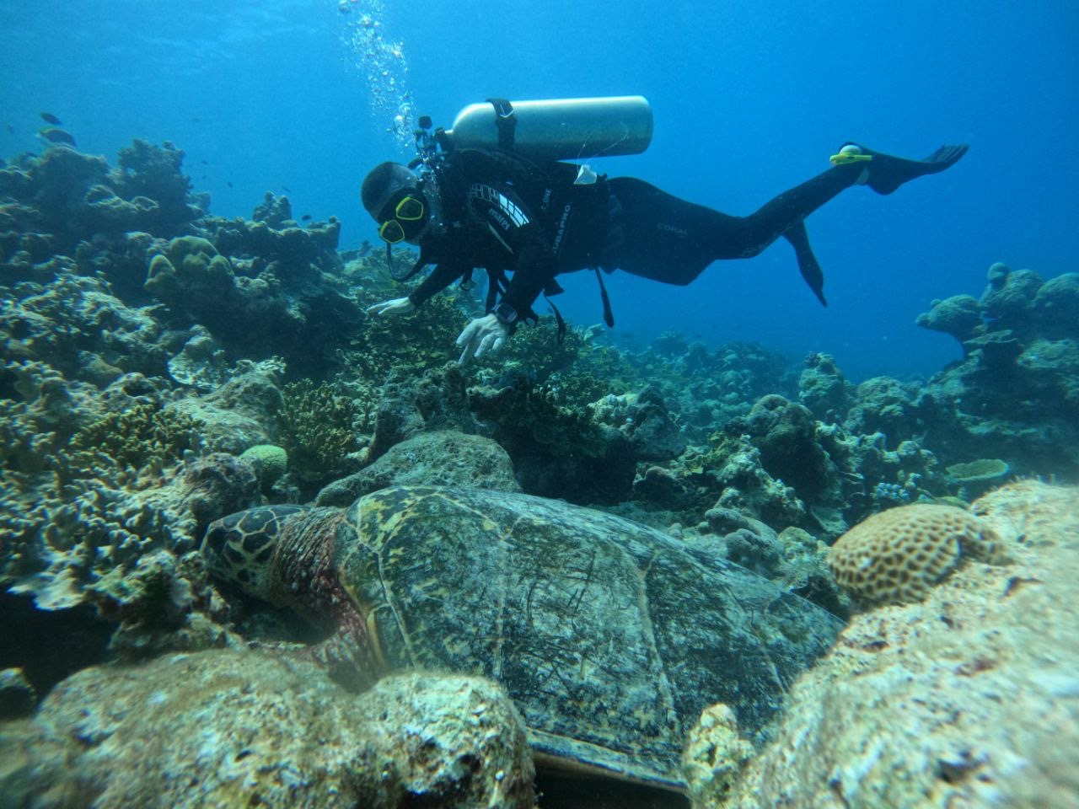

Who Should Choose Oaga Art Resort?
Oaga Art Resort is perfect for travelers who want more than a luxury beach holiday.
It is an excellent choice for:
- Honeymoon couples
- Couples celebrating anniversaries
- Families looking for spacious beach and overwater villas
- Groups travelling together
- Art and culture enthusiasts
- Repeat Maldives travelers seeking a unique experience
- Travelers who appreciate authentic local hospitality
If you're looking for a resort where creativity, storytelling and Maldivian culture are just as important as white-sand beaches and turquoise lagoons, Oaga Art Resort offers a refreshing alternative.

Why the August 2026 Reopening Matters
The 1 August 2026 reopening marks the beginning of Oaga's next chapter.
Guests will experience refreshed villas, upgraded public spaces, enhanced dining venues and new accommodation options, with further additions including more overwater villas and a new overwater restaurant continuing through 2026 and into early 2027.
Rather than changing what guests already love, these enhancements strengthen Oaga's vision of combining luxury hospitality with Maldivian creativity, making the resort an even more compelling choice for future travelers.
Final Thoughts
The Maldives is home to many beautiful resorts, but very few have a personality as distinctive as Oaga Art Resort.
Its colourful design, locally inspired storytelling, artistic villas and genuine Maldivian hospitality create an experience that feels authentic, immersive and memorable. With exciting enhancements launching from 1 August 2026, there has never been a better time to discover one of the Maldives' most original luxury resorts.
If you're looking for a holiday that combines island with culture, creativity and unforgettable experiences, Oaga Art Resort deserves a place on your travel list.
Reserve Your Oaga Escape with Antravi
At Antravi, we specialize in designing personalized Maldives holidays that match your travel style.
Whether you're planning a honeymoon, anniversary, family vacation or a once-in-a-lifetime island escape, we'll help you choose the perfect villa, organize seamless transfers and create a tailor-made itinerary for an unforgettable Maldives experience.
Ready to experience the newly enhanced Oaga Art Resort?
Contact Antravi today and let our travel specialists create your perfect Maldives holiday.

Author: Yashodar Reddy
Founder.

