Travel + Leisure World's Best Awards 2026: Four Maldives Resorts Ranked Among the World's Top 100 Hotels
By Founder Yashodar • 5 Min Read
SEO Title: Travel + Leisure World's Best Awards 2026: Best Maldives Luxury Resorts
Meta Description: Discover why Baros, JOALI, Waldorf Astoria Maldives Ithaafushi and Vakkaru were ranked among the world's best hotels in the Travel + Leisure World's Best Awards 2026, and learn which resort is right for your luxury Maldives holiday.
Primary Keyword: Travel + Leisure World's Best Awards 2026 Maldives
Secondary Keywords: Best Maldives resorts 2026, Luxury Maldives resorts, Baros Maldives, JOALI Maldives, Waldorf Astoria Maldives Ithaafushi, Vakkaru Maldives.

Hero Image Placeholder
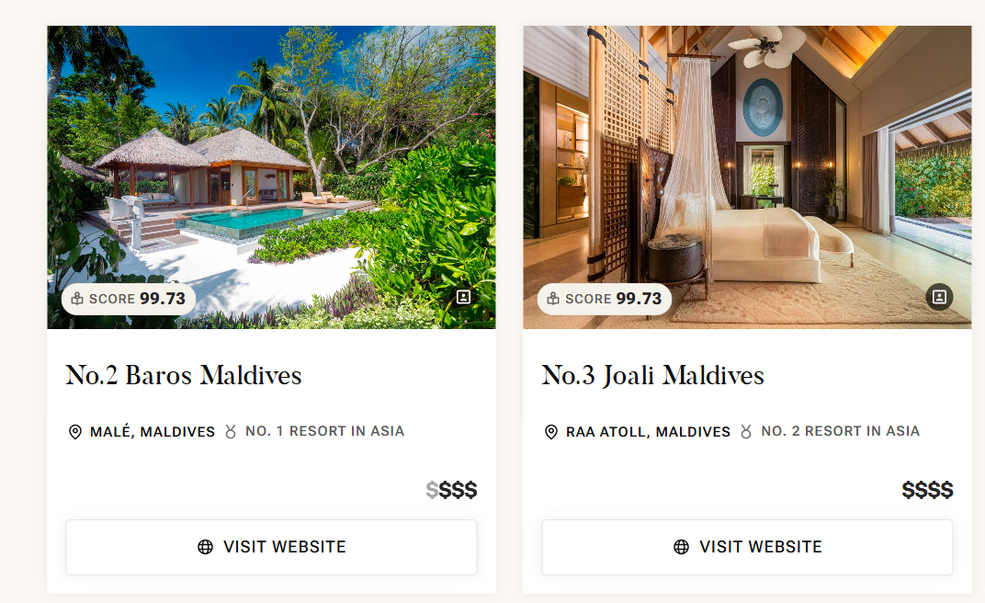

Reference screenshot of the 2026 rankings (provided by the user).

Why This Matters to Luxury Travellers
Planning a Maldives holiday can be overwhelming, with more than a hundred luxury resorts spread across different atolls. The Travel + Leisure World's Best Awards are valuable because they highlight resorts consistently recognized by travelers for outstanding hospitality, design, dining and overall guest experience. If you're investing in a once-in-a-lifetime honeymoon, anniversary or family escape, this shortlist helps you start with some of the world's most respected properties.

What Is the Travel + Leisure World's Best Awards?
The World's Best Awards are among the most recognized travel awards globally. Readers evaluate hotels based on factors such as rooms, service, location, food, facilities and value. While awards should not be the only factor in choosing a resort, they provide an excellent benchmark when comparing luxury destinations.

Maldives Resorts in the World's Top 100 (2026)
World Rank | Resort | Score
2 | Baros Maldives | 99.73
3 | JOALI Maldives | 99.73
8 | Waldorf Astoria Maldives Ithaafushi | 99.58
17 | Vakkaru Maldives | 99.30

Baros Maldives
Best for honeymoon couples, exceptional house reef and timeless luxury.

Who should choose it?
Couples seeking privacy and world-class snorkeling.

Things to know
Consider transfer options, villa category, meal plans and travel season before booking. These factors often have a greater impact on your experience than rankings alone.

Image Placeholder:
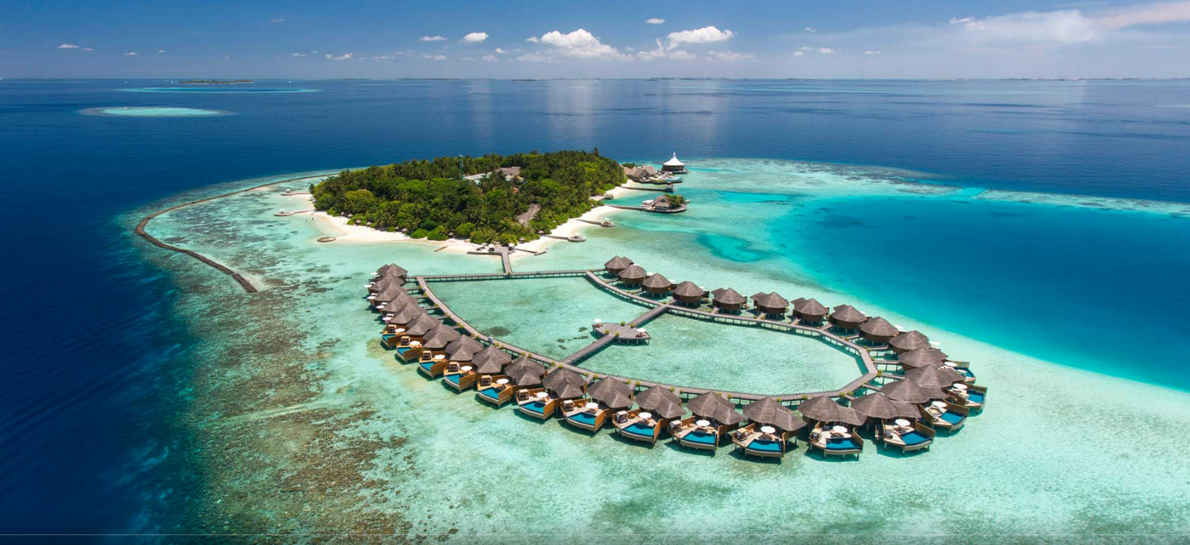

JOALI Maldives
An art-inspired island offering immersive dining, wellness and ultra-luxury.

Who should choose it?
Luxury travellers celebrating milestones.

Things to know
Consider transfer options, villa category, meal plans and travel season before booking. These factors often have a greater impact on your experience than rankings alone.

Image Placeholder:


Waldorf Astoria Maldives Ithaafushi
One of the Maldives' flagship ultra-luxury resorts with expansive villas and multiple dining venues.

Who should choose it?
Families and travellers wanting extensive facilities.

Things to know
Consider transfer options, villa category, meal plans and travel season before booking. These factors often have a greater impact on your experience than rankings alone.

Image Placeholder:
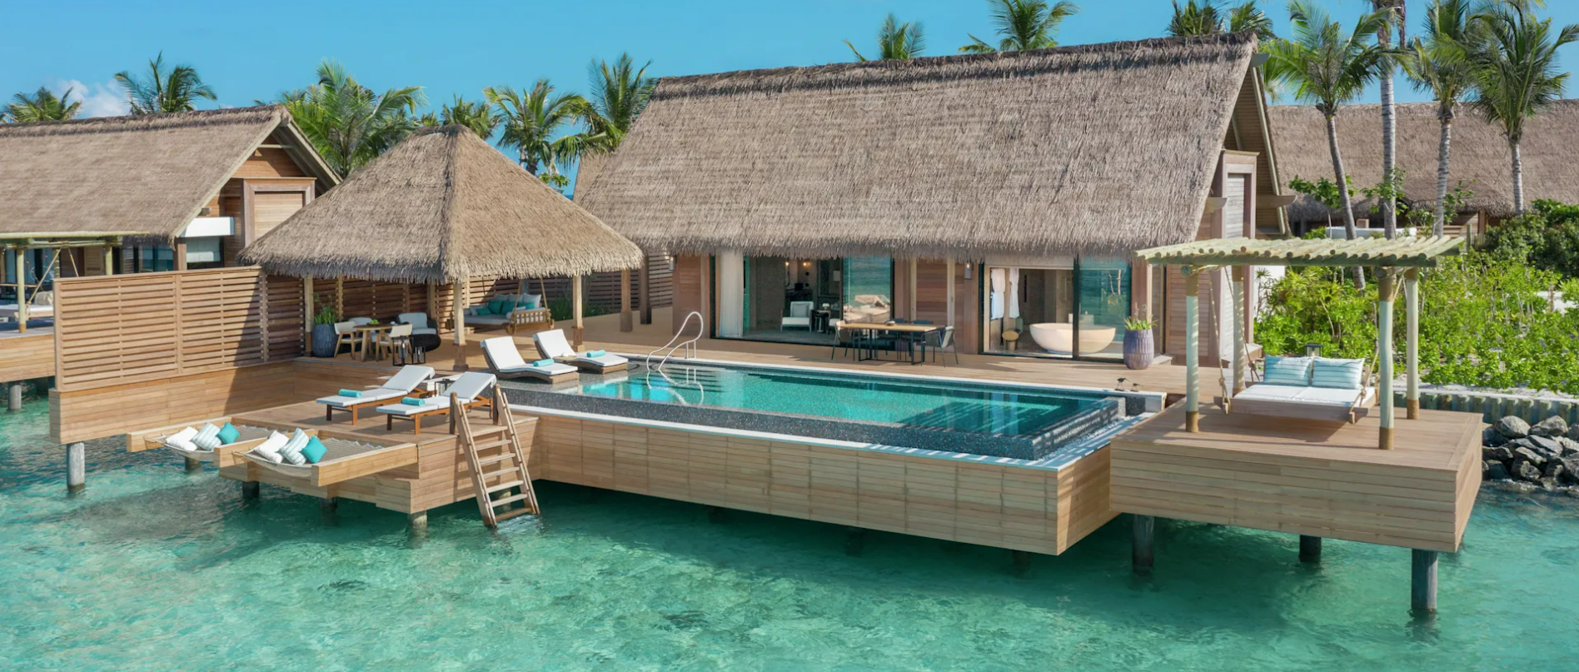

Vakkaru Maldives
Elegant tropical island with spacious villas and a relaxed luxury atmosphere.

Who should choose it?
Couples and families wanting refined luxury.

Things to know
Consider transfer options, villa category, meal plans and travel season before booking. These factors often have a greater impact on your experience than rankings alone.
Image Placeholder:

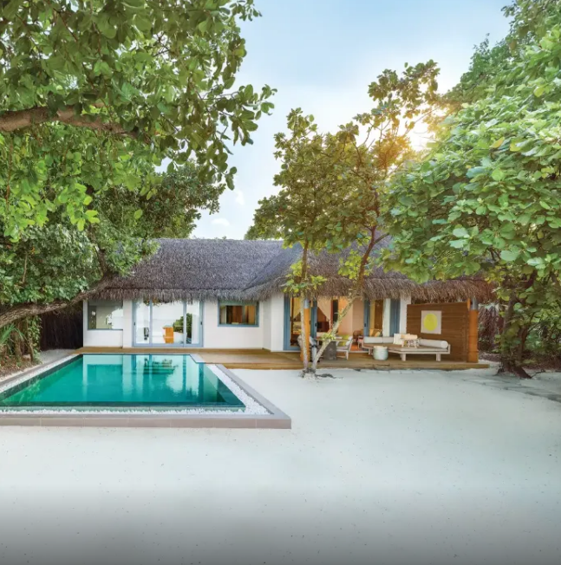

Which Resort Is Right for You?
Travel Style | Baros | JOALI | Waldorf | Vakkaru
Honeymoon | ⭐⭐⭐⭐⭐ | ⭐⭐⭐⭐ | ⭐⭐⭐⭐ | ⭐⭐⭐⭐
Families | ⭐⭐⭐ | ⭐⭐⭐⭐ | ⭐⭐⭐⭐⭐ | ⭐⭐⭐⭐
Dining | ⭐⭐⭐⭐ | ⭐⭐⭐⭐⭐ | ⭐⭐⭐⭐⭐ | ⭐⭐⭐⭐
Privacy | ⭐⭐⭐⭐⭐ | ⭐⭐⭐⭐⭐ | ⭐⭐⭐⭐ | ⭐⭐⭐⭐
Luxury | ⭐⭐⭐⭐⭐ | ⭐⭐⭐⭐⭐ | ⭐⭐⭐⭐⭐ | ⭐⭐⭐⭐

Common Mistakes Luxury Travellers Make
- Choosing a resort based only on social media photos.
- Ignoring transfer costs and timings.
- Booking the wrong meal plan.
- Selecting a villa category without understanding location and privacy.
- Travelling in the wrong season for their expectations.

Founder's Perspective
As someone with a background in hospitality, I've learned that the best resort isn't always the most expensive one. The ideal choice depends on your travel style, budget, expectations and the experiences you value most. Awards are an excellent starting point, but expert guidance helps match the right resort to the right traveller.

Frequently Asked Questions

Are these the best resorts in the Maldives?
They are among the highest-ranked globally, but the best choice depends on your travel goals.

Which is best for honeymooners?
Baros Maldives is a strong choice for privacy and romance.

Which is best for families?
Waldorf Astoria Maldives Ithaafushi offers extensive facilities for families.

Do rankings guarantee the best experience?
No. Your ideal resort depends on budget, travel style and preferences.

Should I book directly?
Compare packages, inclusions and transfers before deciding.

Planning a Maldives vacation?
The awards highlight exceptional resorts. Choosing the one that perfectly fits your honeymoon, family holiday or milestone celebration is where expert planning makes the difference.
At Antravi, we help you compare islands, villa categories, transfers, meal plans and experiences before you book. Instead of simply finding availability, we focus on finding the resort that matches your expectations and budget.
Ready to start? Share your preferred travel dates, budget and travel style, and let Antravi create a personalized Maldives itinerary featuring the world's leading resorts.

