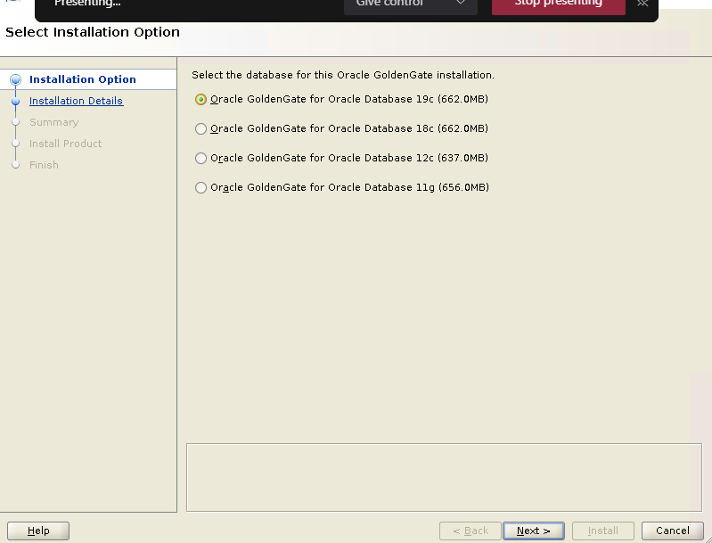

/g01/GGhome/product/ogg19c

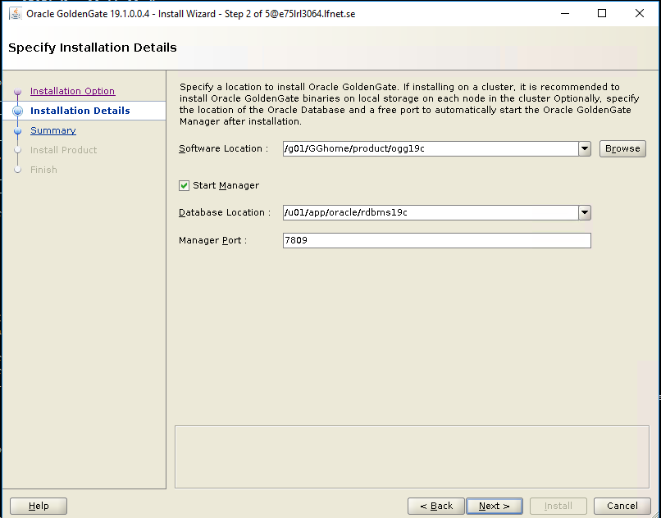

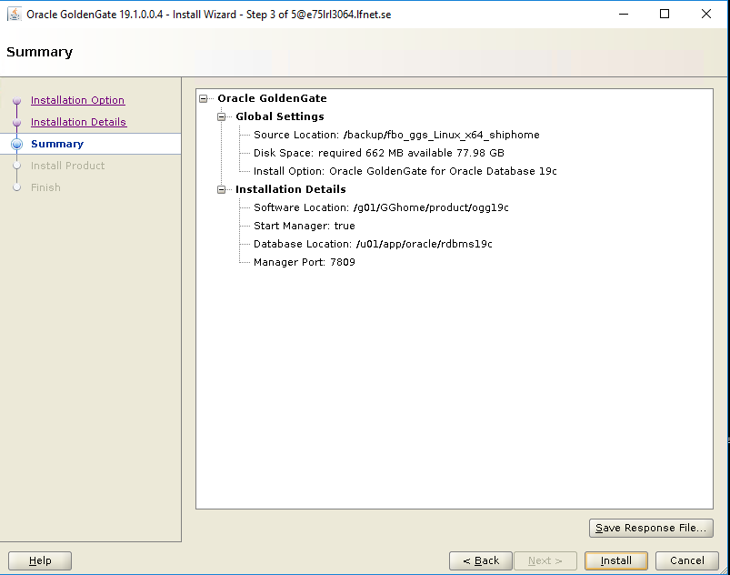

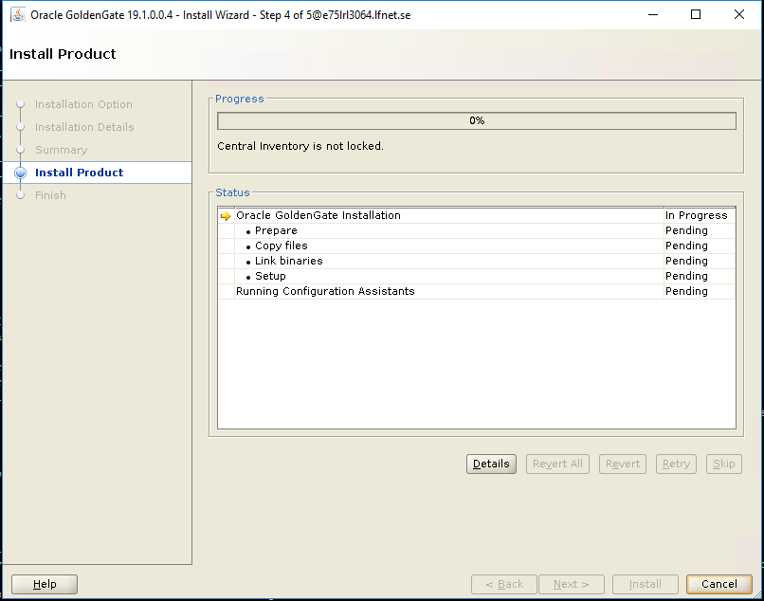

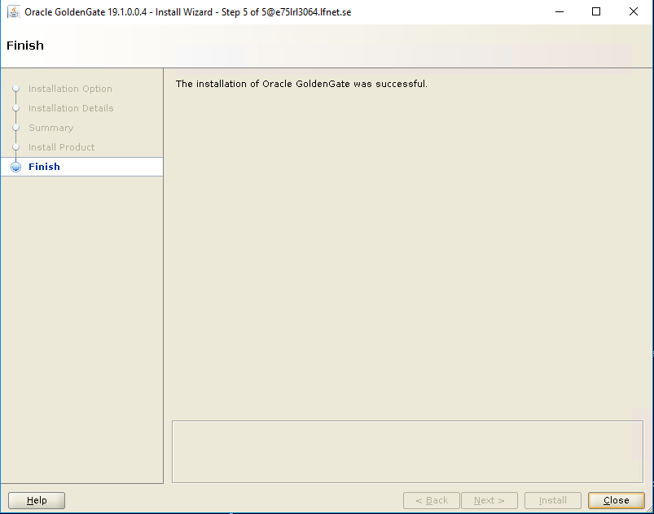

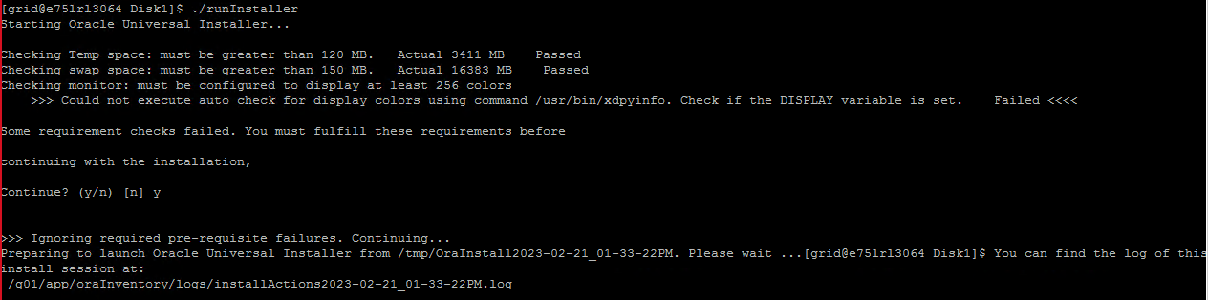
csd
[grid@e75lrl3064 Disk1]$ ./runInstaller
Starting Oracle Universal Installer...

Checking Temp space: must be greater than 120 MB. Actual 3411 MB Passed
Checking swap space: must be greater than 150 MB. Actual 16383 MB Passed
Checking monitor: must be configured to display at least 256 colors
>>> Could not execute auto check for display colors using command /usr/bin/xdpyinfo. Check if the DISPLAY variable is set. Failed <<<<

Some requirement checks failed. You must fulfill these requirements before

continuing with the installation,

Continue? (y/n) [n] y

>>> Ignoring required pre-requisite failures. Continuing...
Preparing to launch Oracle Universal Installer from /tmp/OraInstall2023-02-21_01-33-22PM. Please wait ...[grid@e75lrl3064 Disk1]$ You can find the log of this install session at:
/g01/app/oraInventory/logs/installActions2023-02-21_01-33-22PM.log

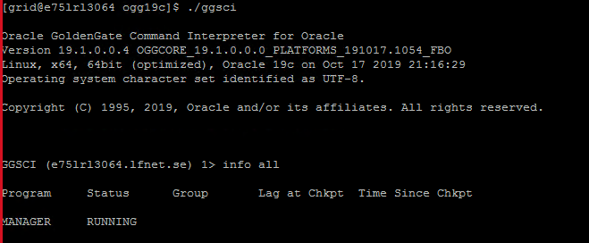

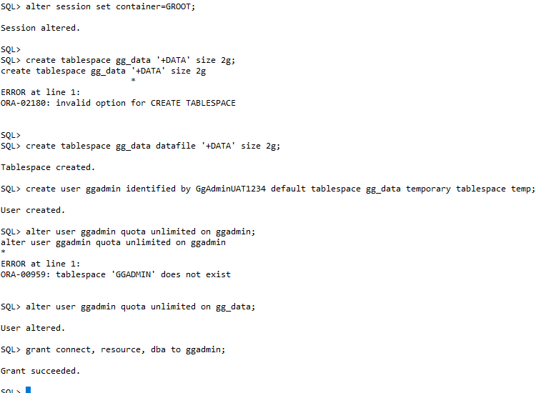

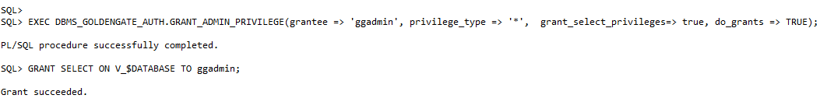

TNS entry in GRID_HOME/net*/admin/tnsnames.ora

GGROOT =
(DESCRIPTION =
(ADDRESS = (PROTOCOL = TCP)(HOST = 10.200.191.11)(PORT = 1521))
(CONNECT_DATA =
(SERVER = DEDICATED)
(SERVICE_NAME = GROOT)
)
)

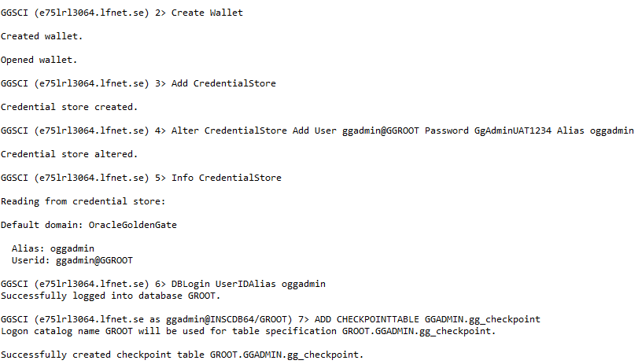

--add GLOBALS before adding HEARTBEATTABLE
[grid@e75lrl3064 ogg19c]$ vi GLOBALS

GGSCHEMA ggadmin
ALLOWOUTPUTDIR /g01/GGhome/product/ogg19c/dirdat
checkpointtable ggadmin.gg_checkpoint
ENABLEMONITORING

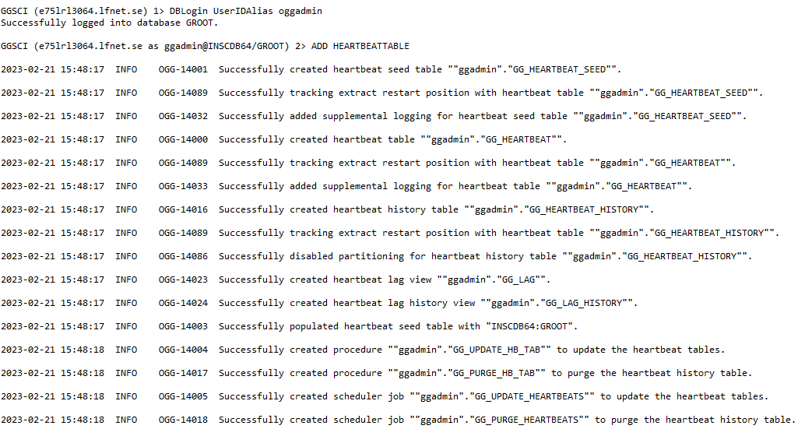

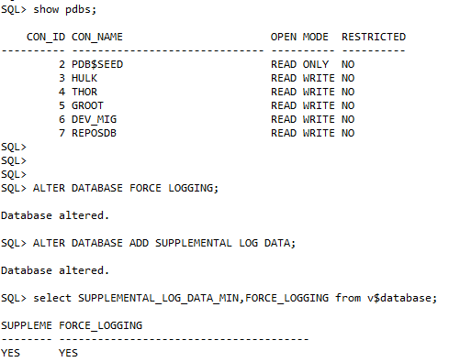

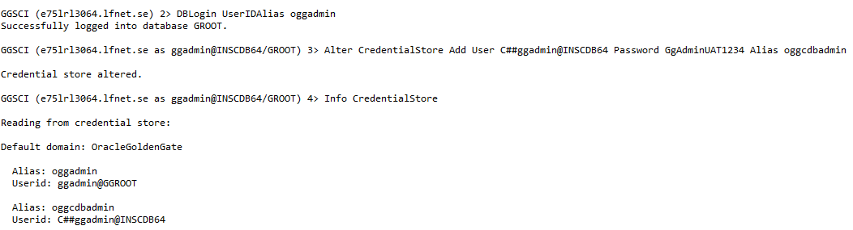

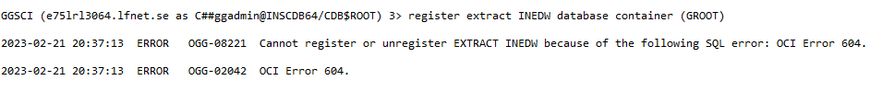

After adding some space in SYSTEM, SYSAUX TS, I can able to register extract

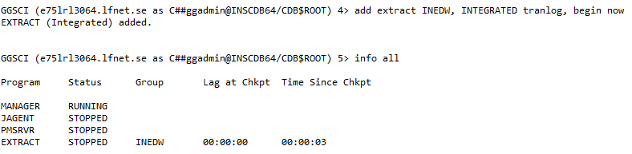

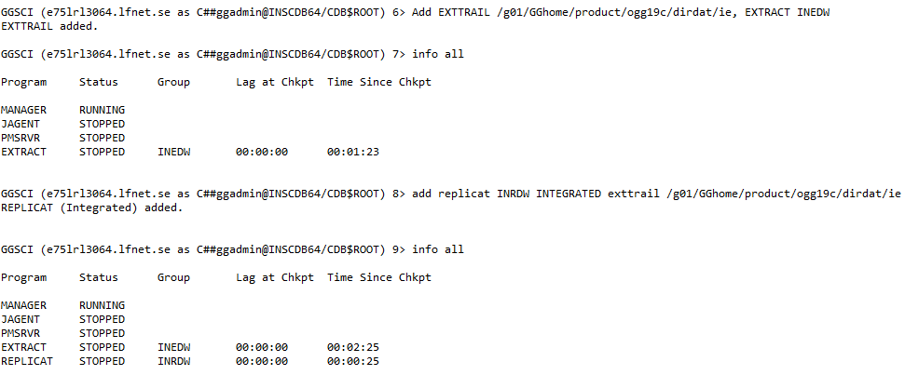

To solve this error, you should use the PDB Name before table name as follows.
Or you can use the SOURCECATALOG parameter in the Extract or Replicate parameter file with PDB NAME as follows.
SOURCECATALOG PDB_NAME

