EttSak DB Installations - Automation
Datum | Version | Beskrivning | Författare
2022-11-01 | 1.0 |  | Rajanikanth Bollam

TOC
1 Introduction 2
2 GIT repository 3
3 Ansible playbooks 3
4 Environment metadata 6
5 19c grid/ASM & RDBMS installation on standalone on Linux 9
5.1 19c grid/ASM & RDBMS installation 9
5.1.1 Ansible playbook roles to 19c grid/ASM & RDBMS installation 9
5.2 Fist time setup 9

Introduction

This is the documentation of 19c grid/ASM & RDBMS installation on standalone server using automation though pipeline.

The main tool is Ansible.

Ansible is an open-source software provisioning, configuration management, and application-deployment tool. The master runs on Linux and can configure both Linux systems as well as Microsoft Windows systems.

Ansible uses SSH or Remote PowerShell to connect to target hosts.

Ansible is “agentless” which means that it is not dependent on an agent process running on the target hosts.

GIT repository

All environment metadata, helper tools and Ansible playbooks are stored in GIT.

https://tfs.lfnet.se/tfs/Ettsak/EttSak/_git/ettsak-db-automation

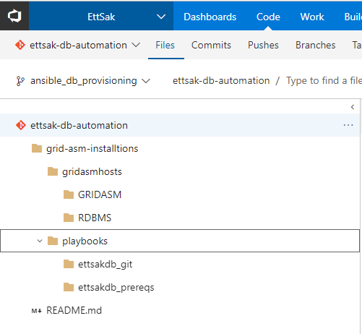

Ansible playbooks

Playbooks are organized in named projects. E.g. ‘ettsakdb_prereqs’

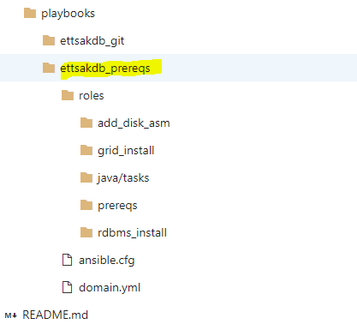

The domain.yml is the main playbook invoking the roles specified.
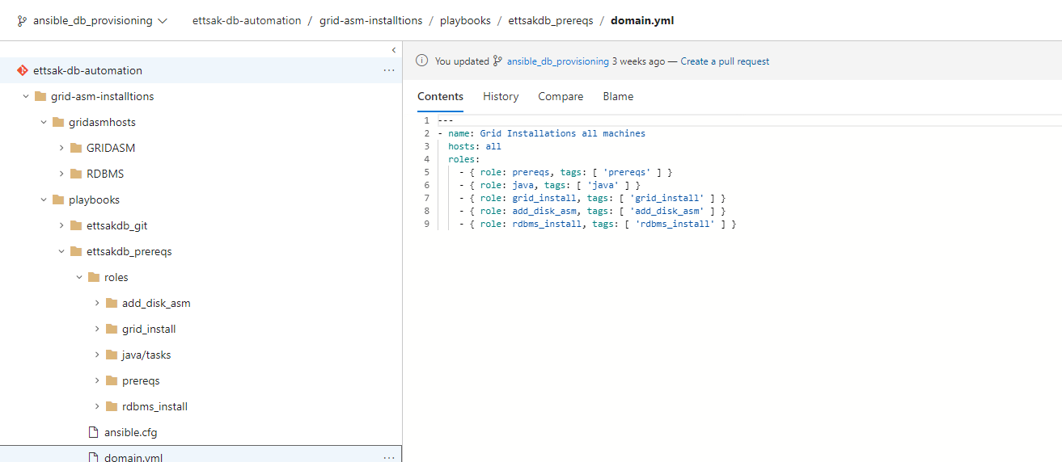

Ansible “tags” are used to select which role to play.

ansible.cfg is the local default setup file for Ansible.
[defaults]
hostfile = hosts
host_key_checking = false

Environment metadata

The Generic Ansible playbooks and the metadata are used to create and manage DB which we are going to install.

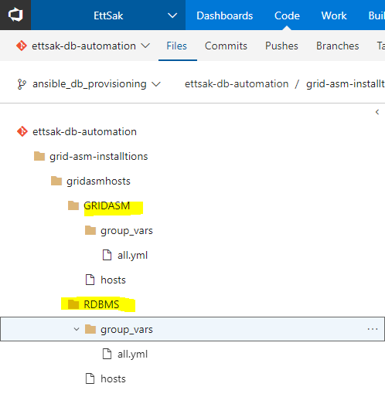

all.yml is the Ansible variables file in GRIDASM and RDBMS.

GRIDASM:

all.yml
# Common paths and names
ga_server_name: 'SERVER1'
ga_version: '1.0.0'
ga_base: '/g01/app/grid'
ga_inventory_loc: '/g01/app/oraInventory'
grid_home: '{{ga_base}}/oracle19c'
oracle_group: 'oinstall'
oracle_user: 'oracle'
grid_user: 'grid'
oracle_user_home: '/g01/oracle'
software_archive: '/g01/oracle/db_software_archive'
ga_installer_folder: '{{ga_base}}/installer'
umask: '022'

# WebLogic deploy tooling installer and target folder
grid_pkg_name: 'LINUX.X64_193000_grid_home.zip'
grid_pkg_src: '{{ software_archive }}/{{ grid_pkg_name }}'

# JDK installer and target folder
ga_jdk_version: 'jdk1.8.0_261'
ga_jdk_folder: '{{ ga_base }}/{{ ga_jdk_version }}'
ga_jdk_pkg_name: '{{ ga_jdk_version }}.tgz'
ga_jdk_pkg_src: '{{ software_archive }}/{{ ga_jdk_pkg_name }}'

# Patch installations
Opatch_pkg_name: 'p6880880_190000_Linux-x86-64.zip'
Opacth_pkg_src: '{{ software_archive }}/{{ Opatch_pkg_name }}'
grid_oh_patch_name: 'p31305339_190000_Linux-x86-64.zip'
grid_oh_patch_src: '{{ software_archive }}/{{ grid_oh_patch_name }}'
bsu_memargs: '-Xms2g -Xmx2g'
opatch_dir: '{{ middleware_home }}/OPatch'

#
ga_install_exec: '{{ grid_home }}/gridSetup.sh'

hosts is the file specifiying which hosts to be targeted- grid user

#
# This is a ansible 'hosts' file in yaml format
#
all:
children:
db_machine:
hosts:
e75lrl2013.lfnet.se:
ansible_user: grid
ansible_port: 22
ansible_ssh_private_key_file: ~/.ssh/ettsak_rsa
vars:
env_home: '{{ inventory_dir }}'

RDBMS:
all.yml
# Common paths and names
rdbms_server_name: 'SERVER1DB'
rdbms_version: '1.0.0'
rdbms_base: '/u01/app/oracle'
rdbms_inventory_loc: '/g01/app/oraInventory'
rdbms_home: '{{rdbms_base}}/rdbms19c'
oracle_group: 'oinstall'
oracle_user: 'oracle'
software_archive: '/g01/oracle/db_software_archive'
rdbms_installer_folder: '{{rdbms_base}}/installer'
umask: '022'

# WebLogic deploy tooling installer and target folder
rdbms_pkg_name: 'LINUX.X64_193000_db_home.zip'
rdbms_pkg_src: '{{ software_archive }}/{{ rdbms_pkg_name }}'

# Patch installations
rdbms_Opatch_pkg_name: 'p6880880_190000_Linux-x86-64.zip'
rdbms_Opacth_pkg_src: '{{ software_archive }}/{{ rdbms_Opatch_pkg_name }}'
rdbms_oh_patch_name: 'p31305339_190000_Linux-x86-64.zip'
rdbms_oh_patch_src: '{{ software_archive }}/{{ rdbms_oh_patch_name }}'
rdbms_bsu_memargs: '-Xms2g -Xmx2g'
rdbms_opatch_dir: '{{ middleware_home }}/OPatch'

#
rdbms_install_exec: '{{ rdbms_home }}/runInstaller'

hosts is the file specifiying which hosts to be targeted - oracle user

#
# This is a ansible 'hosts' file in yaml format
#
all:
children:
db_machine:
hosts:
e75lrl2013.lfnet.se:
ansible_user: oracle
ansible_port: 22
ansible_ssh_private_key_file: ~/.ssh/ettsak_rsa
vars:
env_home: '{{ rdbms_inventory_dir }}'

19c grid/ASM & RDBMS installation on standalone on Linux

19c grid/ASM & RDBMS installation

Ansible playbook roles to 19c grid/ASM & RDBMS installation

The roles can be executed individually as a sequence

- prereqs
- grid_install
- add_disk_asm
- rdbms_install

Fist time setup

Ansible requires that the public key of the private/public key pair used to be distributed to the target hosts and users. The private key used by Ansible is stored in the environment metadata. The public key can also be extracted from the private key.

Build:

Note: Follow the instructions whcih are still required to run through root user or update the response files accordingly to take the execution of root related scripts.

GRIDASM roles:
- prereqs
- grid_install
- add_disk_asm

RDBMS roles:
- rdbms_install

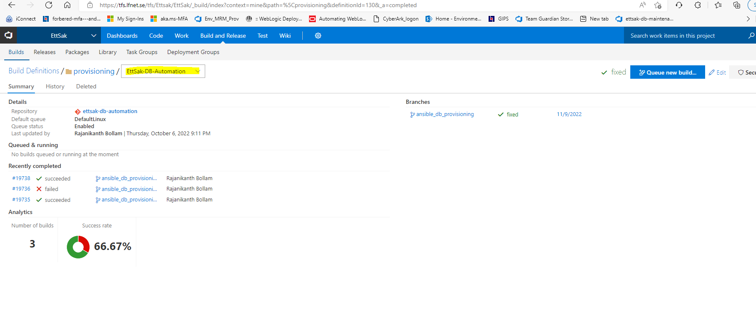

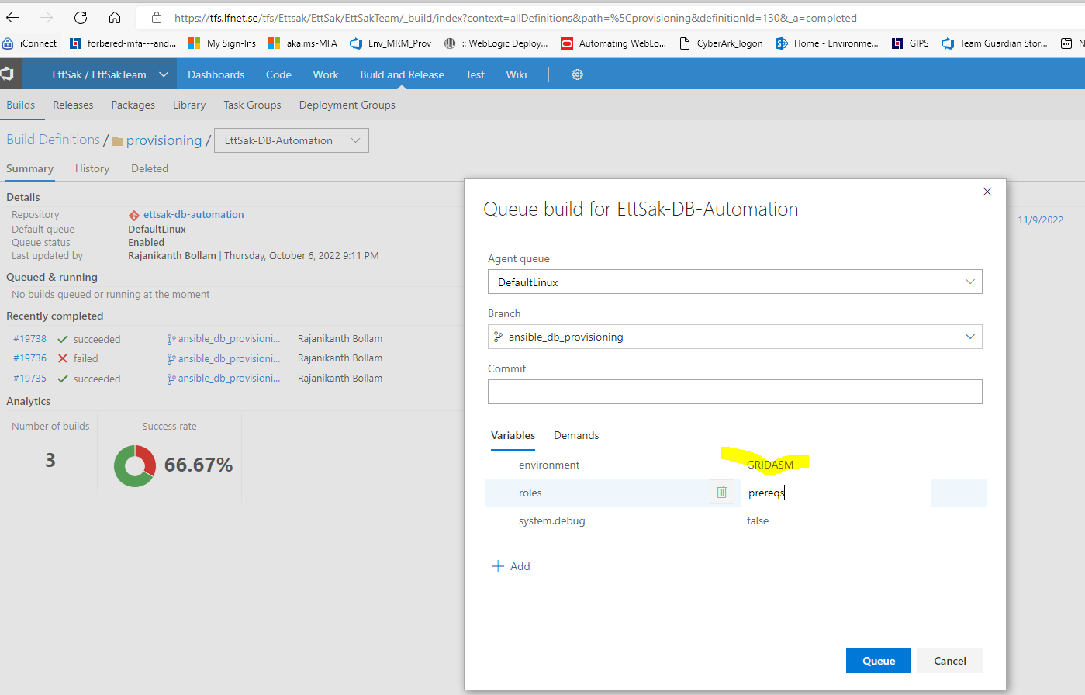

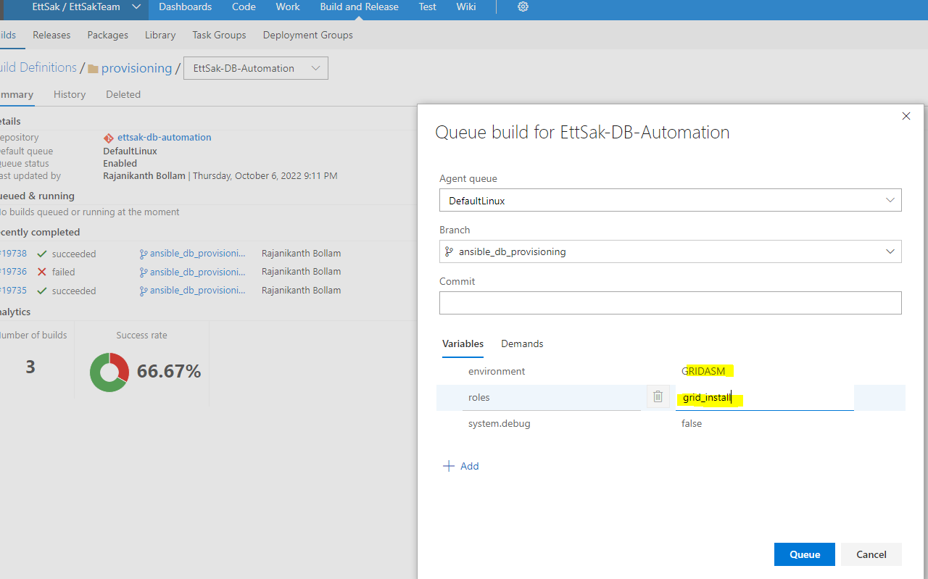
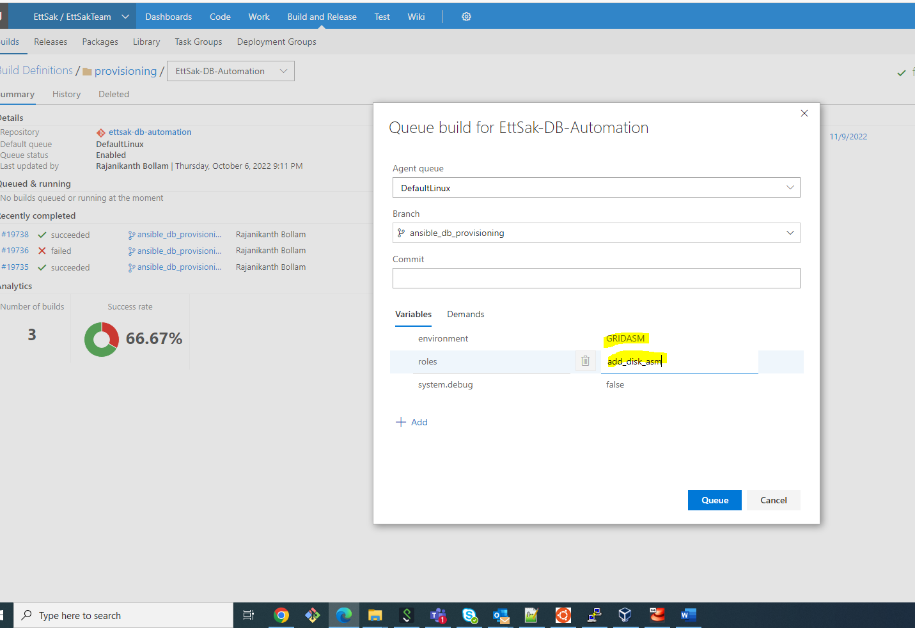

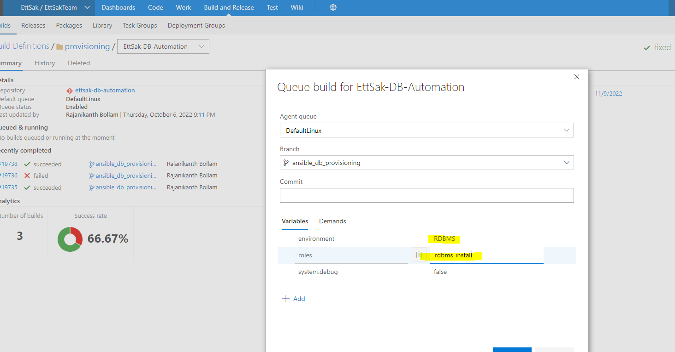

*********************************************End of the Document*************************

