

Goldengate Installation and configuration Document
Oracle Golden Gate 12.2.0

Project



DISCLAIMER

This document is strictly private, confidential and personal to its recipients and should not be copied, distributed or reproduced in whole or in part, nor passed to any third party.

Version history
Date | Version | Description | Author
2016-06-09 | 1.0 | Initial Draft | Sudhakar Murugesapandian
2016-06-14 |  | Reviewed | Mehak Mahajan
2016-06-14 |  | Approver | Krog Lars
2016-06-15 | 1.0 | Update content | Sudhakar Murugesapandian
2019-11-13 |  | Reviewed | Ajithraj Thangaraj

Contents
Version history 3
1. Introduction 4
Purpose 4
How to Use this Document 4
References 4
Document Overview 5
2. Prerequisites 5
3. Pre-Installation Steps 5
3.1 Disk Configuration 5
3.2 Create ACFS File system 11
4. Golden Gate Software Installation 14
5. Configure goldengate process 16
6. Add Goldengate to Cluster 22
7. Common Installation Problems 24
Goldengate process broken due to archivelog unavailable 24

- Introduction

Purpose

This document describes all the installation process for the Oracle Golden gate starting from scratch on a windows 2012 R2 platform. This document covers all aspect of its installation including all various software’s needed.

How to Use this Document

When Installing the Golden Gate from scratch, Readers are encouraged to follow the order of the document

- Readers are encouraged to check the Error Encountered section when they encounter some problems to see if they have already been documented.
- Rest of the sections are compulsory

References

References | Related To
http://www.oracle.com/technetwork/middleware/goldengate/downloads/index.html | Golden Gate Software
http://www.oracle.com/technetwork/database/database-technologies/clusterware/downloads/index.html | XAG software link
http://internwebb.lfnet.se/sites/NyttSaksystem/IT/02%20Infrastructure/Infosys%20Documents/UAT_Database_Installation_1.1/Installation_Database_12C.docx | Asmgtool steps 10 under preinstallation steps
http://internwebb.lfnet.se/sites/NyttSaksystem/IT/02%20Infrastructure/Documents/Infosys%20Documents/Generic_Database_Installation_1.1/GG_Configure_package.zip | Goldengate Configuration Package
http://www.oracle.com/technetwork/database/database-technologies/clusterware/downloads/ogiba-2189738.pdf | Oracle Grid install agent - XAG

Document Overview

The remainder of this document consists of the following sections:

- Section 2: Prerequisites
- Section 3: Pre-installation Steps
- Section 4 :Golden gate Installation
- Section 5: Common Installation Problems - Describe some of the common problems encountered while following section 3 onwards of this document

- Prerequisites

- Get 2 LUN of size 10GB and 300GB for golden gate software installation and trail files.
- Download Oracle Golden gate 12.2.0.1.1 http://www.oracle.com/technetwork/middleware/goldengate/downloads/index.html
- Download Oracle Grid Infrastructure Agent
http://www.oracle.com/technetwork/database/database-technologies/clusterware/downloads/index.html

- Pre-Installation Steps

3.1 Disk Configuration

SN | Activity | Snapshot! | Description
1. | Creating UAT golden gate disk on Node 1  Open a command window by running the diskpart command from a Command Prompt as administrator | 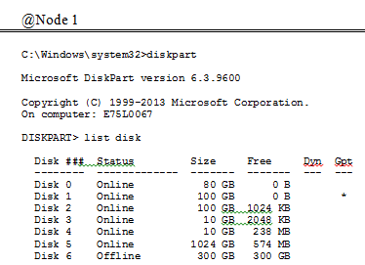 | Lists all the available disks
2. | Determine the disk you are going to modify and bring it online | 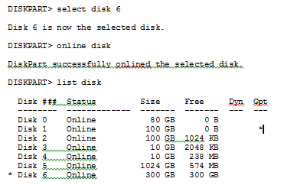 | Select the Disk > online the disk  & List will show if the disk is in online state
3. | clear the read-only/read-only flag/attribute | 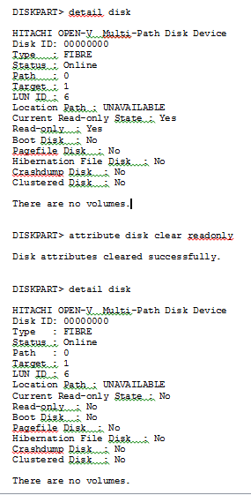 | The disk is no long Read-Only protected  If you would like to set the disk Read-Only again just do the same procedure and write  Warning!  Be sure to do this on the right disk since the diskpart command can do serious damage if you run it on the wrong disk.
4. | Enabled auto mounting of disks on windows | 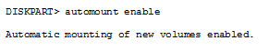 | You must enable auto mounting of ASM disks on windows server for them to be visible to Oracle Grid Infrastructure
5. | Creating Extended Partition | 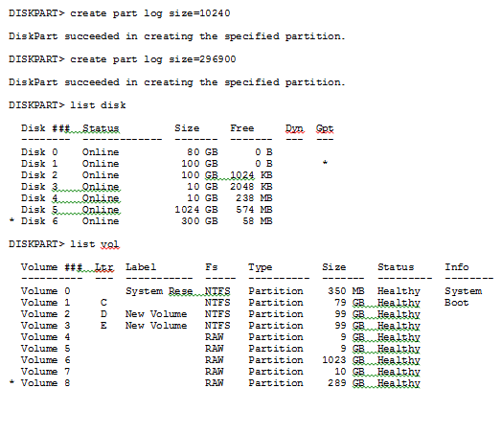 | Assuming the disks you are going to use are completely empty you must create an extended partition and then a logical drive inside of that partition.
6. | Create Logical Drives and marked disk partitions for use by ASM |  | There can be only one extended partition on a hard disk,Within the extended partition, you can create any number of logical drives  Path :  D:\app\grid\BIN  Go to Grid  infrastructure installation media and double click the “asmtoolg.exe” executable, select Add or Change label
7. | Create Logical Disk groups invoking ASMCA Utility | 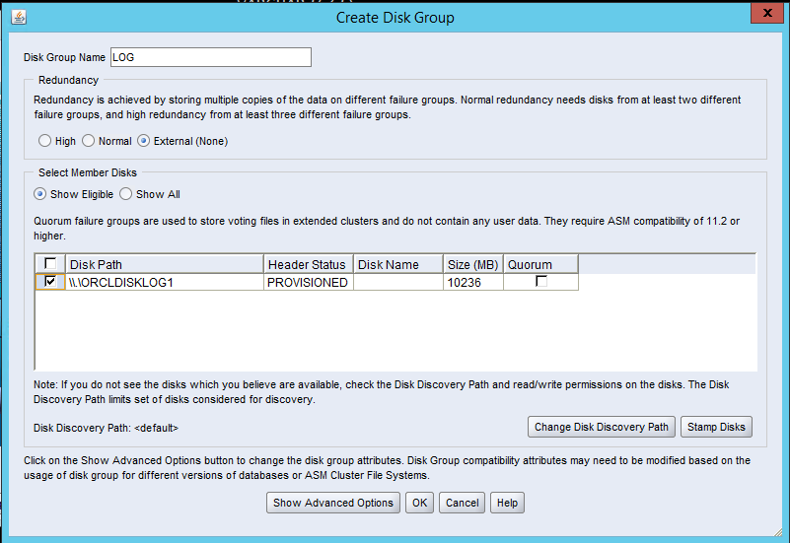  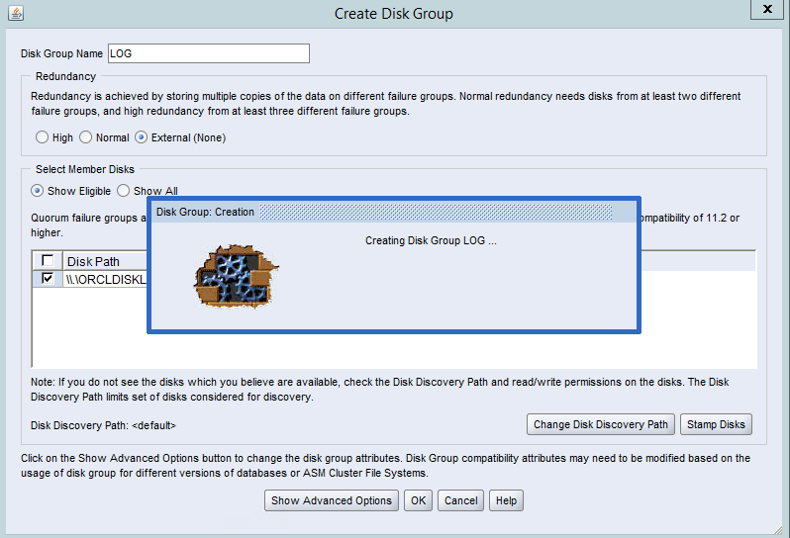 | Right click on cmd prompt and open as administrator  Type ASMCA and this screen pops up  Provide the Disk Group Name and choose the diskpath

3.2 Create ACFS File systems

SN | Activity | Snapshot! | Description
1 | Right click on cmd prompt and open as administrator  Type ASMCA and this screen pops up | 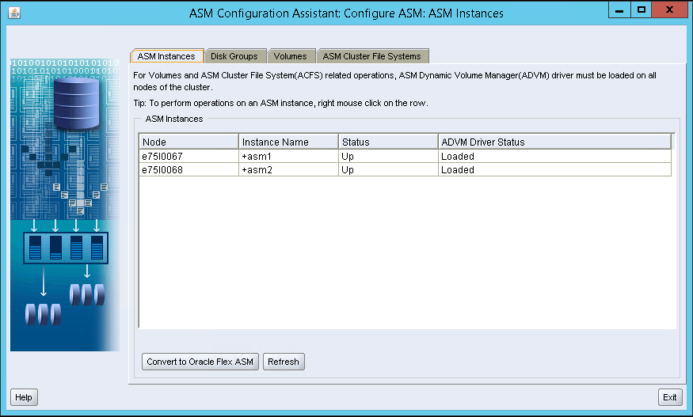 | ASMCA screen
2 |  | 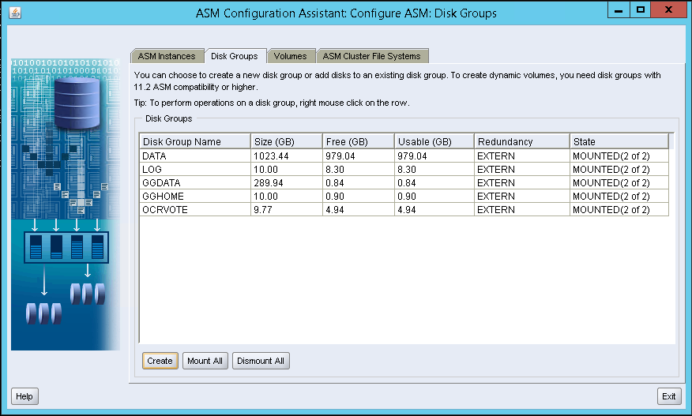 | Select disk groups tab and click create
3 |  | 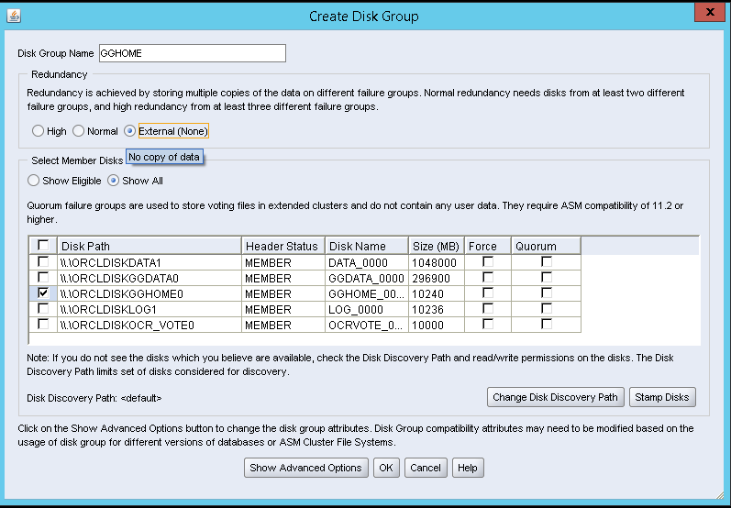 | - Enter Diskgroup name (GGHOME or GGDATA)  - Select “external redundancy”  - Select disk path  Click ok
4 |  | 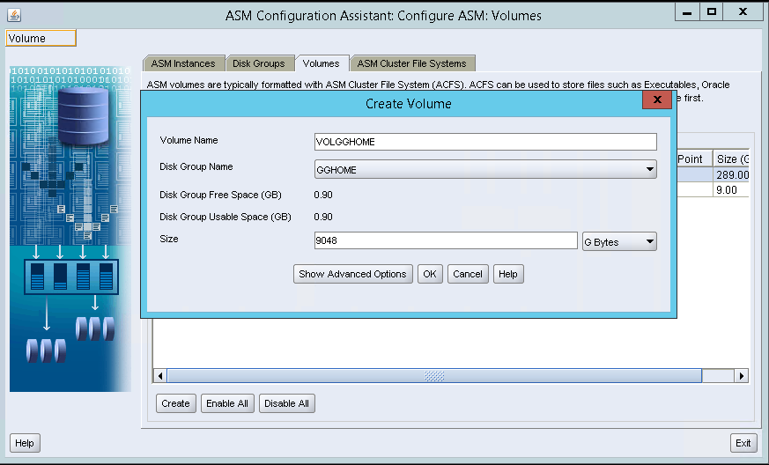 | - Select Volumes tab  - Click create  - Enter Volume name  - Select Diskgroup  - Mention size  - Click ok
5 |  | 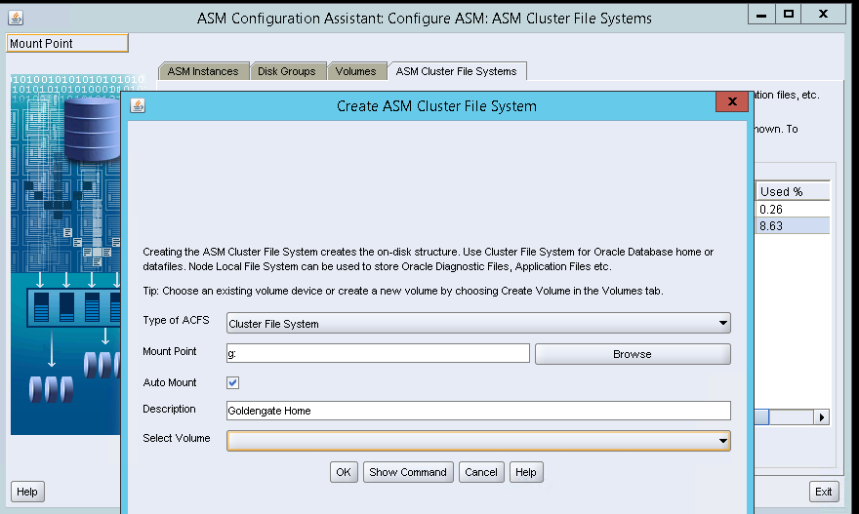 | - Select “ASM cluster File system” tab  - Enter mount point G: for GGHOME and H: for GGDATA  - Enter description  - Select respective volume  - Click ok
6 | ASM cluster File system creation  @Node1 | Create ACFS Command:  D:\app\grid\BIN\acfsformat.exe \\.\asm-volgghome-358  Mount ACFS Command:  D:\app\grid\BIN\srvctl.bat add filesystem -d \\.\asm-volgghome-358 -m G:\ -fstype ACFS -description "Oracle Goldengate installation drive" -autostart ALWAYS  D:\app\grid\BIN\srvctl.bat start filesystem -d \\.\asm-volgghome-358 | ASM Cluster File System created on \\.\asm-volgghome-358 successfully.  Registration of ASM Cluster File System with Oracle Grid Infrastructure succeeded.  Mounting ASM Cluster File System using ACFS resource succeeded.
7 |  | Create ACFS Command:  D:\app\grid\BIN\acfsformat.exe \\.\asm-volggdata-250  Mount ACFS Command:  D:\app\grid\BIN\srvctl.bat add filesystem -d \\.\asm-volggdata-250 -m H:\ -fstype ACFS -description "Oracle Trail file drive" -autostart ALWAYS  D:\app\grid\BIN\srvctl.bat start filesystem -d \\.\asm-volggdata-250 | ASM Cluster File System created on \\.\asm-volggdata-250 successfully.  Registration of ASM Cluster File System with Oracle Grid Infrastructure succeeded.  Mounting ASM Cluster File System using ACFS resource succeeded.
8 | Check Disk creation | 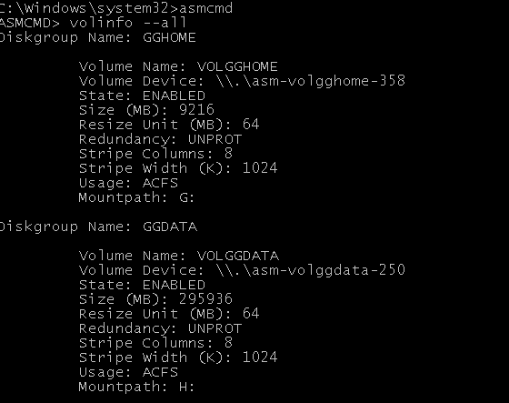 | In CMD prompt set GRID home as Oracle home and type “ASMCMD”  Enter volinfo –all to see the volumne information
9 |  | 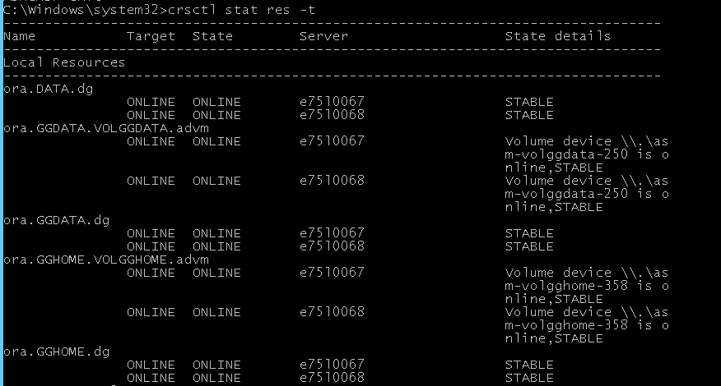 | In CMD prompt Type “crsctl stat res –t” to see services added

- GoldenGate Software Installation

SN | Activity | Snapshot! | Description
1. | Invoke the setup file from the below path  D:\Rashmi\GG\ggs_Windows_x64_shiphome\ggs_Windows_x64_shiphome\Disk1\setup.exe | 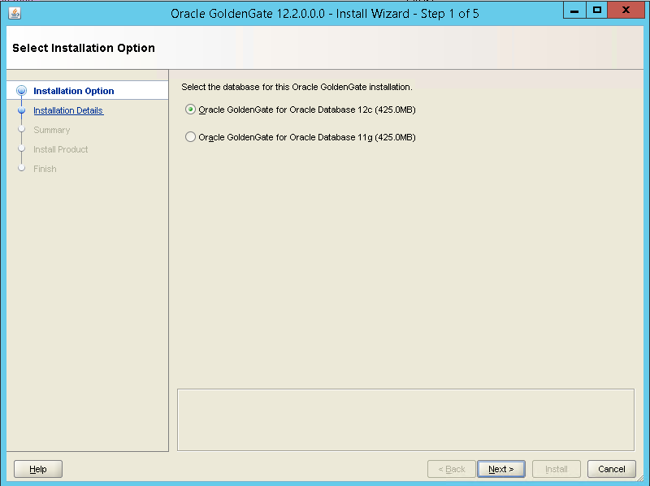 | Choose Oracle golden gate for Oracle Database 12c and click>> Next
2. | Asks for software location, and on checking the start manager check box asks for Database Location & Manager Port | 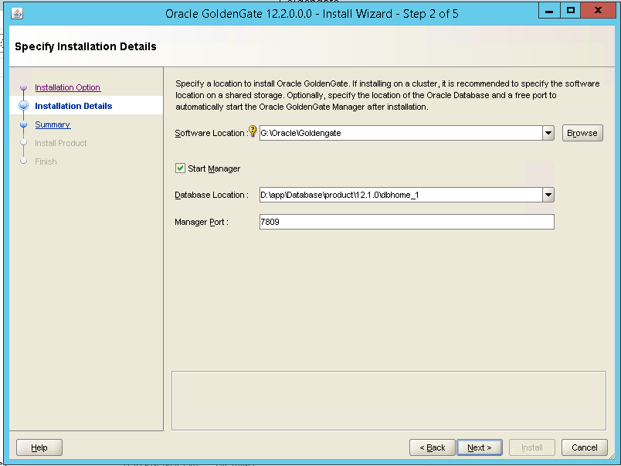 | Provide the details and click on >> Next
3. | Shows the summary of the paths as given above and proceeds to install | 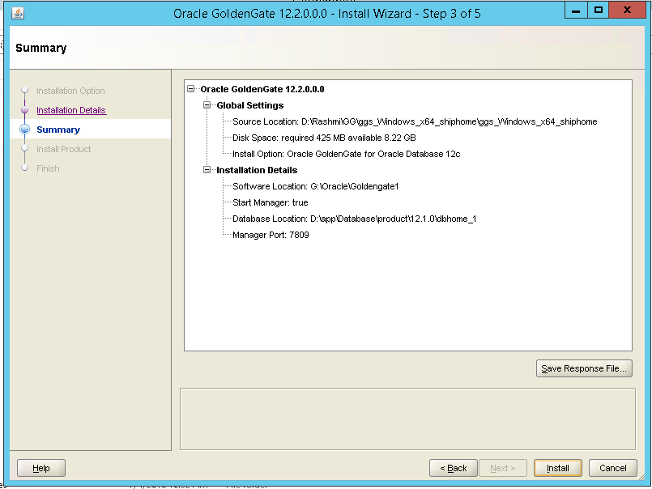 | Click on Install>> Will start the installation
4. | Go to the drive path | 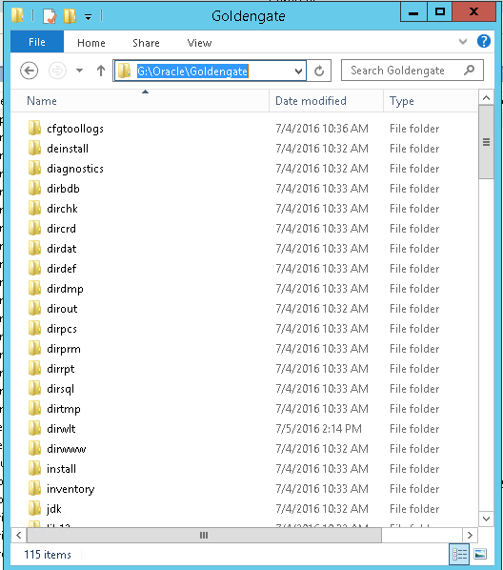 | Gives all the files being installed post installation

- Configure goldengate process

1. | Set Environment variable in the command prompt | set ORACLE_SID=INSISPPD2  set ORACLE_HOME=D:\app\Database\product\12.1.0\dbhome_1  set GRID_HOME=D:\app\grid  set GG_HOME=G:\Oracle\Goldengate  set XAG_HOME=D:\app\xag  set PATH=%ORACLE_HOME%\bin;%GRID_HOME%\bin;%GG_HOME%;C:\Windows\system32;%GG_HOME%;C:\Windows;C:\Windows\System32\Wbem;C:\Windows\System32\WindowsPowerShD:\app  \Database\product\12.1.0\dbhome_1\bin;D:\app\grid\bin;C:\Windows\system32;C:\Windows;C:\Windows\System32\Wbem;C:\Windows\System32\WindowsPowerShell\v1.0\;C:\Program  Files\HDS\Backup and Recovery\Base  set LD_LIBRARY_PATH=%ORACLE_HOME%\lib | To ensure the environment is set up correctly
2. | Update tnsnames.ora In the database network home | ------------------Add below to node 1  GGINSISPPD =  (DESCRIPTION =  (ADDRESS_LIST =  (ADDRESS =  (PROTOCOL = BEQ)(PROGRAM = oracle)  (ARGV0 = oracleINSISPPD1)  (ARGS = '(DESCRIPTION=(LOCAL=YES)(ADDRESS=(PROTOCOL=BEQ)))')  )  )  (CONNECT_DATA = (SID = INSISPPD1))  )  ------------------Add below to node 2  GGINSISPPD =  (DESCRIPTION =  (ADDRESS_LIST =  (ADDRESS =  (PROTOCOL = BEQ)(PROGRAM = oracle)  (ARGV0 = oracleINSISPPD2)  (ARGS = '(DESCRIPTION=(LOCAL=YES)(ADDRESS=(PROTOCOL=BEQ)))')  )  )  (CONNECT_DATA = (SID = INSISPPD2))  ) | This connection string will be used to connect to DB by GG, To ensure smooth failover between nodes
3. | Alter database memory to accomodate Goldengate process and Log mining | Alter system set memory_max_target=16G scope=spfile sid='*';  Alter system set memory_target=12G scope=spfile sid='*';  Alter system set enable_goldengate_replication=true scope=spfile sid='*';;  Alter system set streams_pool_size=2000M scope=spfile sid='*'; | This will ensure GG has enough memory for its operation.  Included in the script AlterDBMemory.sql
4. | Go to the drive path | srvctl stop database -db INSISPPD  srvctl start database -db INSISPPD | Restart the database to make the previous step active
5. | Create required tablespace and users for goldengate and change tracking users | create tablespace gg_data datafile '+DATA' size 100M;  create tablespace INSIS_HIST_DATA datafile '+DATA' size 10G;  create user ggadmin identified by GgAdminUAT1234  default tablespace gg_data  temporary tablespace temp;  create user insishist identified by InsisHistUAT1234  default tablespace insis_hist_data  temporary tablespace temp;  alter user insishist quota unlimited on insis_hist_data ;  alter user ggadmin quota unlimited on gg_data ;  grant connect,resource,dba to ggadmin;  grant connect,resource to insishist;  EXEC DBMS_GOLDENGATE_AUTH.GRANT_ADMIN_PRIVILEGE(grantee => 'ggadmin', privilege_type => '*', grant_select_privileges=> true, do_grants => TRUE);  GRANT SELECT ON V_$DATABASE TO ggadmin;  CREATE USER SQLSVRETL IDENTIFIED BY SQLSVR1234;  GRANT CONNECT TO SQLSVRETL; | Execute this in sqlplus prompt as sysdba to create need Users and tablespace for GG  Included in the script CreateGGUsers.sql
6. | Create required tables for the extract and replication | create directory dbascriptoutput as 'd:\oracle\scripts';  CREATE TABLE "GGADMIN"."EXCEPTIONS_OTHERS"  ( "TABLE_NAME" VARCHAR2(61 BYTE) NOT NULL ENABLE,  "COMMITTIMESTAMP" TIMESTAMP (6) NOT NULL ENABLE,  "REP_NAME" VARCHAR2(8 BYTE),  "ERRNO" NUMBER,  "DBERRMSG" VARCHAR2(4000 BYTE),  "OPTYPE" VARCHAR2(20 BYTE),  "ERRTYPE" VARCHAR2(20 BYTE),  "LOGRBA" NUMBER,  "LOGPOSITION" NUMBER,  "FILENUM" NUMBER,  "FILERBA" NUMBER,  "RESOLUTION_REQUIRED" VARCHAR2(1 BYTE),  "DATE_CREATED" DATE DEFAULT SYSDATE,  "RESOLVED_BY" VARCHAR2(30 BYTE),  "RESOLVED_DATE" DATE,  CONSTRAINT "E_OTH_PK" PRIMARY KEY ("LOGRBA", "LOGPOSITION", "COMMITTIMESTAMP", "FILENUM", "FILERBA")  ) ;  CREATE INDEX "GGADMIN"."E_OTH_RR_IDX" ON "GGADMIN"."EXCEPTIONS_OTHERS" ("RESOLUTION_REQUIRED") ;  CREATE TABLE INSISHIST.GG_TEST_HIST (  SEQNO NUMBER(5, 0),  INCOMMENT VARCHAR2(50 BYTE),  OPERATION VARCHAR2(25 BYTE),  OPTIME TIMESTAMP(6),  DB_OP_TYPE VARCHAR2(20 BYTE),  SRC_COMMIT_TS TIMESTAMP(6),  BFR_AFT_IND VARCHAR2(30 BYTE),  GG_CSN NUMBER,  GG_TFILE_SEQNO NUMBER,  GG_TFILE_RBA NUMBER,  CAPTIME TIMESTAMP(6),  EXT_NAME VARCHAR2(10),  PMPTIME TIMESTAMP(6),  PMP_NAME VARCHAR2(10),  REPTIME TIMESTAMP(6),  REP_NAME VARCHAR2(10),  EDMLDELTASTATS NUMBER,  RDMLDELTASTATS NUMBER  );  CREATE TABLE INSIS_GEN_V10.GG_TEST (  SEQNO NUMBER(5, 0),  INCOMMENT VARCHAR2(50 BYTE),  OPERATION VARCHAR2(25 BYTE),  OPTIME TIMESTAMP(6)  ); | Execute this in sqlplus prompt as sysdba  Create required tables for error handling  Included in the script CreateGGUsers.sql
7. | Creating master table having list of tables to be replicated and used as input for the vbs script below | drop sequence ggadmin.dummy_table_seq;  CREATE sequence ggadmin.dummy_table_seq MINVALUE 1 START WITH 1 MAXVALUE 10000;  drop TABLE GGADMIN.GG_REP_TABLE_LIST purge;  CREATE TABLE GGADMIN.GG_REP_TABLE_LIST  (  REF_TABLE_SEQ NUMBER NOT NULL,  TABLE_OWNER VARCHAR2(30) NOT NULL,  TABLE_NAME VARCHAR2(39) NOT NULL,  DUMMY_TABLE_NAME VARCHAR2(30),  HIST_OWNER_NAME VARCHAR2(30),  HIST_TABLE_NAME VARCHAR2(30),  PART_NAME VARCHAR2(30),  ADDED_ON DATE DEFAULT SYSDATE,  IS_ACTIVE CHAR(1) DEFAULT 'Y',  REMOVED_DATE DATE ,  ADDED_BY VARCHAR2(50) DEFAULT SYS_CONTEXT ('USERENV', 'OS_USER') ,  CONSTRAINT PK_TABLE_NAME PRIMARY KEY(TABLE_OWNER,TABLE_NAME),  CONSTRAINT UK_REF_SEQ UNIQUE (REF_TABLE_SEQ)  );  INSERT INTO GGADMIN.GG_REP_TABLE_LIST(REF_TABLE_SEQ ,TABLE_OWNER , TABLE_NAME) VALUES(ggadmin.dummy_table_seq.NEXTVAL,'INSIS_AMX','AMX_ACTIVITY');  INSERT INTO GGADMIN.GG_REP_TABLE_LIST(REF_TABLE_SEQ ,TABLE_OWNER , TABLE_NAME) VALUES(ggadmin.dummy_table_seq.NEXTVAL,'INSIS_AMX','AMX_ACTIVITY_CFG');  .  .  ..  commit;  UPDATE GGADMIN.GG_REP_TABLE_LIST SET DUMMY_TABLE_NAME = 'TEMP_HIST_' || REF_TABLE_SEQ , HIST_OWNER_NAME='INSISHIST';  UPDATE GGADMIN.GG_REP_TABLE_LIST SET HIST_TABLE_NAME =substr(replace(translate(initcap(translate(lower(table_owner),'_',' ')),'Aabcdefghijklmnopqrstuvwxyz1234567890','A'),' ','')|| '_'|| replace(table_name,'_',''),1,30);  UPDATE GGADMIN.GG_REP_TABLE_LIST SET PART_NAME =substr(replace(translate(initcap(translate(lower(table_owner),'_',' ')),'Aabcdefghijklmnopqrstuvwxyz1234567890','A'),' ','')|| '_'|| replace(translate(initcap(translate(lower(table_name),'_',' ')),'Aabcdefghijklmnopqrstuvwxyz1234567890','A'),' ',''),1,22);  grant select on GGADMIN.GG_REP_TABLE_LIST to SQLSVRETL;  COMMIT; | Execute this in sqlplus prompt as sysdba to create master tablelist requred to replicate  Included in the script CreateMasterTable.sql
8. | Execute this script to generate all required obey, sql and par files | cscript Creategg.vbs  Above script will create below files  INDEFEXT.OB  INEDWTAB.OB  INRDWTAB.OB  fileAddTrandata.ob  INEXP.par  INIMP.par  fileNullLOBafterimport.sql  RenameTableToHist.sql  AlterTableAddCol.sql  DropTempTable.sql  EnableSupplimentalLogging.sql | Execute this in cmd prompt in script directory to create required obey and sqls needed for configuring GG.  Note: 1) Change connection sctring as request  2) change Partition script as required
 |  | sqlplus sys/xxxxxxx as sysdba @D:\Oracle\Scripts\EnableSupplimentalLogging.sql | Enable logging to tables
9. | Copy the required parameter files | cd G:\Oracle\goldengate  copy D:\Oracle\Scripts\INEDW.prm .\dirprm\INEDW.prm  copy D:\Oracle\Scripts\INRDW.prm .\dirprm\INRDW.prm  copy D:\Oracle\Scripts\global.prm .\GLOBALS  copy D:\Oracle\Scripts\mgr.prm .\dirprm\mgr.prm  copy D:\Oracle\Scripts\defgen.prm .\dirprm\defgen.prm
 |  | ggsci paramfile D:\Oracle\Scripts\CreateWallet.obey | Create Database credential wallet
 |  | ggsci paramfile D:\Oracle\Scripts\fileAddTrandata.ob | Add transaction data to redo logs for the replicated tables
 |  | ggsci paramfile D:\Oracle\Scripts\CreateExtRep.obey | Create extract and replicat process
 |  | defgen paramfile G:\Oracle\Goldengate\dirprm\defgen.prm | Generate definition of all tables to be replicated
 |  | sqlplus sys/xxxxx as sysdba @D:\Oracle\Scripts\currentSCN.sql  set /p CURRENTSCN= < currentSCN.txt  expdp 'sys/xxxxx AS SYSDBA' directory=DBASCRIPTOUTPUT parfile=INEXP.par FLASHBACK_SCN=%CURRENTSCN% | Get the current SCN till will data need to be exported and export data from the database for initial loading
 |  | impdp 'sys/lAns45Ins1sAk0ing as sysdba' directory=DBASCRIPTOUTPUT parfile=INIMP.par | Import data back to database under INSISHIST schema
 |  | sqlplus sys/lAns45Ins1sAk0ing as sysdba @D:\Oracle\Scripts\fileNullLOBafterimport.sql | Delete LOB, LONG column values as these are not required
 |  | sqlplus sys/lAns45Ins1sAk0ing as sysdba @D:\Oracle\Scripts\AlterTableAddCol.sql | Add required column to INSISHIST table to have tracking information
 |  | sqlplus insishist/InsisHistUAT1234 @D:\Oracle\Scripts\RenameTableToHist.sql | Rename the table as per required format
 |  | sqlplus insishist/InsisHistUAT1234 @D:\Oracle\Scripts\ DropTempTable.sql | Drop unwanted tables
 |  | echo start extract INEDW >> startER.obey  echo START REPLICAT INRDW AFTERCSN %CURRENTSCN% >> startER.obey  echo exit >> startER.obey  ggsci paramfile D:\Oracle\Scripts\startER.obey | Generate GG startup script and start process

- Add Goldengate to Cluster

SN | Activity | Snapshot! | Description
1 | Install XAG to Oracle GRID. | Create a folder E:\DISTR\xag and unzip the XAG binaries to the path | This tool helps to add the goldengate process with CRS and enable its failover to different nodes easier
 | Run xagsetup.bat | Cd E:\DISTR\xag  Xagsetup --install --directory D:\app\xag -- all_nodes | This step will install the xag In the given path , ensure you don’t give GRID HOME or DB HOME, it is good to have it as a separate HOME %XAG_HOME%
 | Add Goldengate process to the CRS | D:\app\xag\bin  agctl add goldengate GGATE --gg_home G:\Oracle\Goldengate --instance_type dual --nodes e75l0265,e75l0266 --network 1 --ip 10.200.36.173 --user lfad\svclfabettsak --group ORA_INSTALL --filesystems ora.gghome.volgghome.acfs,ora.ggdata.volggdata.acfs, --databases ora.insisdb.db --oracle_home D:\app\Database\product\12.1.0\dbhome_1 --monitor_extracts INEDW --monitor_replicats INRDW | This command will add the goldengate process to CRS and you can view the process in crsctl command
 | Start GG with agctl | agctl start goldengate GGATE | This will start the Goldengate process as cluster services
 | Check if GG is running under CRS | C:\Windows\System32>crsctl stat res -t  --------------------------------------------------------------------------------  Name Target State Server State details  --------------------------------------------------------------------------------  Local Resources  --------------------------------------------------------------------------------  ora.ARCHIVE.dg  ONLINE ONLINE e75l0265 STABLE  ONLINE ONLINE e75l0266 STABLE  ora.DATA.dg  ONLINE ONLINE e75l0265 STABLE  ONLINE ONLINE e75l0266 STABLE  ora.GGDATA.VOLGGDATA.advm  ONLINE ONLINE e75l0265 Volume device \.\as  m-volggdata-374 iso  nline,STABLE  ONLINE ONLINE e75l0266 Volume device\\.\as  m-volggdata-374 is  nline,STABLE  ora.GGDATA.dg  ONLINE ONLINE e75l0265 STABLE  ONLINE ONLINE e75l0266 STABLE  ora.GGHOME.VOLGGHOME.advm  ONLINE ONLINE e75l0265 Volume device \.\as  m-volgghome-1 isonl  ine,STABLE  ONLINE ONLINE e75l0266 Volume device \.\as  m-volgghome-1 isonl  ine,STABLE  ora.GGHOME.dg  ONLINE ONLINE e75l0265 STABLE  ONLINE ONLINE e75l0266 STABLE  ora.LISTENER.lsnr  ONLINE ONLINE e75l0265 STABLE  ONLINE ONLINE e75l0266 STABLE  ora.LOG.dg  ONLINE ONLINE e75l0265 STABLE  ONLINE ONLINE e75l0266 STABLE  ora.OCRVOTE.dg  ONLINE ONLINE e75l0265 STABLE  ONLINE ONLINE e75l0266 STABLE  ora.asm  ONLINE ONLINE e75l0265 Started,STABLE  ONLINE ONLINE e75l0266 Started,STABLE  ora.ggdata.volggdata.acfs  ONLINE ONLINE e75l0265 mountedon H:\,STABL  E  ONLINE ONLINE e75l0266 mountedon H:\,STABL  E  ora.gghome.volgghome.acfs  ONLINE ONLINE e75l0265 mountedon G:\,STABL  E  ONLINE ONLINE e75l0266 mountedon G:\,STABL  E  ora.net1.network  ONLINE ONLINE e75l0265 STABLE  ONLINE ONLINE e75l0266 STABLE  ora.ons  ONLINE ONLINE e75l0265 STABLE  ONLINE ONLINE e75l0266 STABLE  --------------------------------------------------------------------------------  Cluster Resources  --------------------------------------------------------------------------------  ora.LISTENER_SCAN1.lsnr  1 ONLINE ONLINE e75l0265 STABLE  ora.LISTENER_SCAN2.lsnr  1 ONLINE ONLINE e75l0266 STABLE  ora.LISTENER_SCAN3.lsnr  1 ONLINE ONLINE e75l0265 STABLE  ora.MGMTLSNR  1 ONLINE ONLINE e75l0265 10.200.80.66,STABLE  ora.cvu  1 ONLINE ONLINE e75l0266 STABLE  ora.e75l0265.vip  1 ONLINE ONLINE e75l0265 STABLE  ora.e75l0266.vip  1 ONLINE ONLINE e75l0266 STABLE  ora.insisdb.db  1 ONLINE ONLINE e75l0265 Open,STABLE  2 ONLINE ONLINE e75l0266 Open,STABLE  ora.insisliv.db  1 OFFLINE OFFLINE InstanceShutdown,ST  ABLE  2 ONLINE ONLINE e75l0266 Open,STABLE  ora.mgmtdb  1 ONLINE ONLINE e75l0265 Open,STABLE  ora.oc4j  1 ONLINE ONLINE e75l0265 STABLE  ora.reposdb.db  1 ONLINE ONLINE e75l0265 Open,STABLE  2 ONLINE ONLINE e75l0266 Open,STABLE  ora.scan1.vip  1 ONLINE ONLINE e75l0265 STABLE  ora.scan2.vip  1 ONLINE ONLINE e75l0266 STABLE  ora.scan3.vip  1 ONLINE ONLINE e75l0265 STABLE  xag.GGATE-vip.vip  1 ONLINE ONLINE e75l0265 STABLE  xag.GGATE.goldengate  1 ONLINE ONLINE e75l0265 STABLE  --------------------------------------------------------------------------------  C:\Windows\System32> | ___ ASM volume for Goldengate  ___ Goldengate process

- Common Installation Problems

Goldengate process broken due to archivelog unavailable
If the goldengate Process is stopped due to Archivelog unavailability, always restore from atleast 10 to 15 archivelogs prior to the required archivelog. And then start the process to sync.

