INSSIM Dataguard Configuration

Contents
1.Introduction 3
2.SIMPLE ARCHITECTURE DIAGRAM 3
3. PREPARE PFILE & TNS ENtry for PRIMARY & STANDBY 4
4. Start the RMAN HOT sbackup & Duplicate for Standby 5
5. Convert standby db to RAC db 5
6. Register the database with clusterware services 6
7. DG broker configuration and DR SYNC STATUS……………………………………………………………………6

1.Introduction

- Oracle Data Guard ensures high availability, data protection, and disaster recovery for enterprise data. Data Guard provides a comprehensive set of services that create, maintain, manage, and monitor one or more standby databases to enable production Oracle databases to survive disasters and data corruptions. Data Guard maintains these standby databases as copies of the production database.
- Then, if the production database becomes unavailable because of a planned or an unplanned outage, Data Guard can switch any standby database to the production role, minimizing the downtime associated with the outage.

- Data Guard can be used with traditional backup, restoration, and cluster techniques to provide a high level of data protection and data availability.

2.SIMPLE ARCHITECTURE DIAGRAM

- Below is the sample architecture diagram for GoldenGate replication:

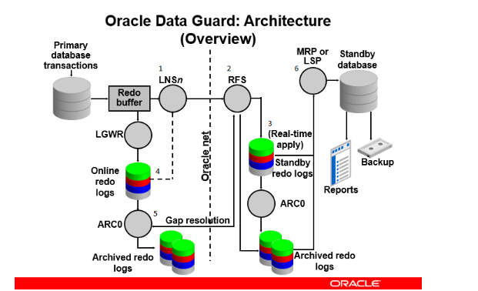
3. PREPARE PFILE & TNS ENTRY PRIMARY & STANDBY
- PRIMARY PFILE:
alter system set db_unique_name='INSISDR' scope=spfile sid='*';
ALTER SYSTEM SET LOG_ARCHIVE_CONFIG='dg_config=(insisdr,insisdb,inssim)' scope=both sid='*';
ALTER SYSTEM SET STANDBY_FILE_MANAGEMENT=AUTO scope=both sid='*';

- STANDBY PFILE:
alter system set db_unique_name=INSSIM scope=both;
alter system set db_name=INSISDB scope=both;
alter system set cluster_database=false scope=spfile;
alter system set fal_client=inssim scope=both;
alter system set fal_server=insisdr scope=both;
alter system set log_file_name_convert='+REDO/INSISDR/ONLINELOG','+LOG/INSSIM/ONLINELOG';
alter system set db_file_name_convert='+DATA/INSISDR/DATAFILE','+DATA/INSSIM/DATAFILE';
alter system set undo_tablespace='UNDO_TBS1' scope=both;

- Add below TNS entry in Primary & Standby Oracle Home TNS
# DR database TNS
INSSIM =
(DESCRIPTION =
(ADDRESS = (PROTOCOL = TCP)(HOST = insispt-scan.lfnet.se)(PORT = 1521))
(CONNECT_DATA =
(SERVER = DEDICATED)
(SERVICE_NAME = INSSIM)
)
)

# PROD database TNS
INSISDR =
(DESCRIPTION =
(ADDRESS_LIST =
(ADDRESS = (PROTOCOL = TCP)(HOST = insis-DR-scan.lfnet.se)(PORT = 1521))
)
(CONNECT_DATA =
(SERVICE_NAME = insisdr)
)
)

4. RMAN HOT Backup & RMAN DUplicate for standby

- Take RMAN Hot Compressed Backup & copy to destination server

Start the RMAN Duplicate for Standby

sqlplus / as sysdba
startup nomount pfile='/backup_temp/INSISDR_RESTORE/initINSSIM.ora';

nohup sh rman_dup.sh &

5. Convert standby db to RAC db

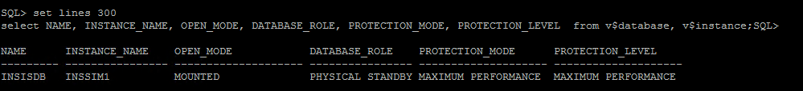
alter system set cluster_database=TRUE scope=spfile;
alter system set undo_tablespace=UNDO_TBS2 sid='INSSIM2' scope=spfile;
alter system set instance_number=1 sid='INSSIM1' scope=spfile;
alter system set instance_number=2 sid='INSSIM2' scope=spfile;
alter system set instance_name='INSSIM1' sid='INSSIM1' scope=spfile;
alter system set instance_name='INSSIM2' sid='INSSIM2' scope=spfile;
alter system set thread=1 sid='INSSIM1' scope=spfile;
alter system set thread=2 sid='INSSIM2' scope=spfile;
alter system set log_archive_format='ARC%S_%R.%T' sid='INSSIM1' scope=spfile;
alter system set log_archive_format='ARC%S_%R.%T' sid='INSSIM2' scope=spfile;
alter system set log_archive_trace=0 sid='INSSIM1' scope=spfile;
alter system set log_archive_trace=0 sid='INSSIM2' scope=spfile;
shut immediate;
startup mount;
select name,open_mode,database_role from v$database;

6. Register the database with clusterware services:

srvctl add database -db INSSIM -oraclehome /u01/app/oracle/rdbms19c -spfile '+DATA/INSSIM/spfileINSSIM.ora'
srvctl modify database -d INSSIM -role PHYSICAL_STANDBY
srvctl modify database -d INSSIM -p '+DATA/INSSIM/spfileINSSIM.ora'
srvctl modify database -d INSSIM -pwfile '+DATA/INSSIM/PASSWORD/pwdinsisdb'
srvctl modify database -db INSSIM -role PHYSICAL_STANDBY -startoption mount -stopoption immediates
srvctl add instance -db INSSIM -instance INSSIM1 -node e75lrl2506
srvctl add instance -db INSSIM -instance INSSIM2 -node e75lrl2507
srvctl start database -db INSSIM
srvctl stop database -db INSSIM
srvctl start database -db INSSIM

7. DG Broker Configuration & dr sync status:
- DG broker configuration:
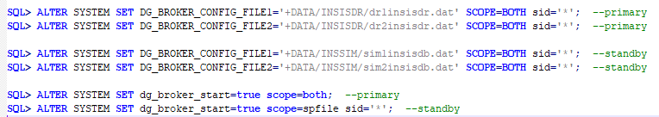
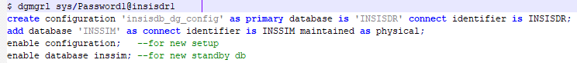
- Check SYNC status
SELECT ARCH.THREAD# "Thread", ARCH.SEQUENCE# "Last Sequence Received", APPL.SEQUENCE# "Last Sequence Applied", (ARCH.SEQUENCE# - APPL.SEQUENCE#) "Difference" FROM
(SELECT THREAD# ,SEQUENCE# FROM V$ARCHIVED_LOG WHERE (THREAD#,FIRST_TIME ) IN (SELECT THREAD#,MAX(FIRST_TIME) FROM V$ARCHIVED_LOG GROUP BY THREAD#)) ARCH,
(SELECT THREAD# ,SEQUENCE# FROM V$LOG_HISTORY WHERE (THREAD#,FIRST_TIME ) IN (SELECT THREAD#,MAX(FIRST_TIME) FROM V$LOG_HISTORY GROUP BY THREAD#)) APPL WHERE ARCH.THREAD# = APPL.THREAD# ORDER BY 1;

