

Managing Guaranteed Restore Points
All higher version of Oracle Database from 10.2

Project



DISCLAIMER

This document is strictly private, confidential and personal to its recipients and should not be copied, distributed or reproduced in whole or in part, nor passed to any third party.

Version history
Date | Version | Description | Author
2019-10-30 | 1.0 | Initial Version | Ashish Kumar Jha

Contents
Version history 3
1. Introduction 4
2. Background info 5
3. Create Guaranteed Restore Points 6
4. Listing Restore Points 8
5. Use Guaranteed Restore Point to Flashback Database 9
6. Drop Restore Point 10
6. Points to Remember 10

Introduction

This document describes the commands used to manage guaranteed restore points.

Background info

To support the use of guaranteed restore points, the database must satisfy the following requirements:
•The COMPATIBLE initialization parameter must be set to 10.2 or greater.
•The database must be running in ARCHIVELOG mode. The FLASHBACK DATABASE operation used to return your database to a guaranteed restore point requires the use of archived redo logs from around the time of the restore point.
•A flash recovery area must be configured. Guaranteed restore points use a mechanism similar to flashback logging, and as with flashback logging, Oracle must store the required logs in the flash recovery area.
•If flashback database is not enabled, then the database must be mounted, not open, when creating the first guaranteed restore point (or if all previously created guaranteed restore points have been dropped).

Create Guaranteed Restore Points

3.1: Pre-requisite
- Compatible parameter is higher than 10.2
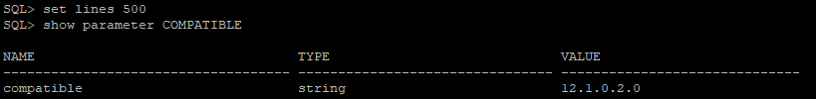
- Database is in archive log mode
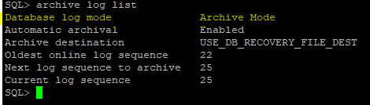

- Fast recovery area configuration
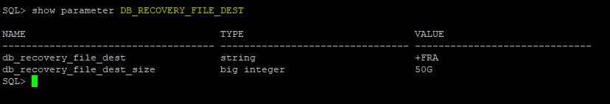

3.2: Create guaranteed restore point using below command.
Syntax: CREATE RESTORE POINT <RES_POINT_NAME> GUARANTEE FLASHBACK DATABASE;
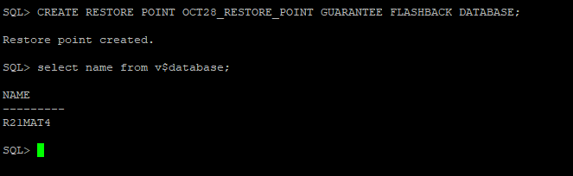

Listing Restore Points

Use below query to list the restore points.
col DB_NAME format a8
col RESPOINT_NAME format a20
set numwidth 15
set lines 500
col GUARANTEE_FLASHBACK_DATABASE format a20
col RES_CREATION_TIME format a20
SELECT vd.NAME AS DB_NAME, rp.NAME AS RESPOINT_NAME, SCN, TO_CHAR(TIME, 'YYYY-MM-DD HH24:MI:SS') As RES_CREATION_TIME, GUARANTEE_FLASHBACK_DATABASE, STORAGE_SIZE FROM V$RESTORE_POINT rp, V$DATABASE vd;
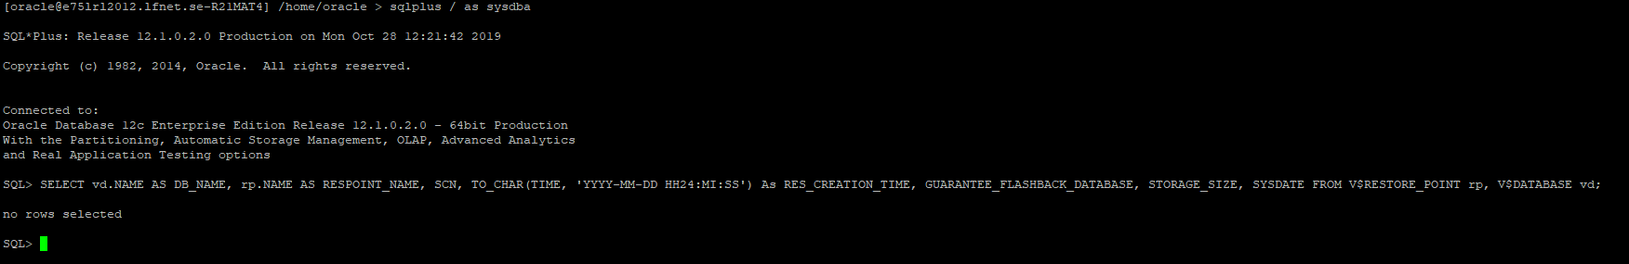

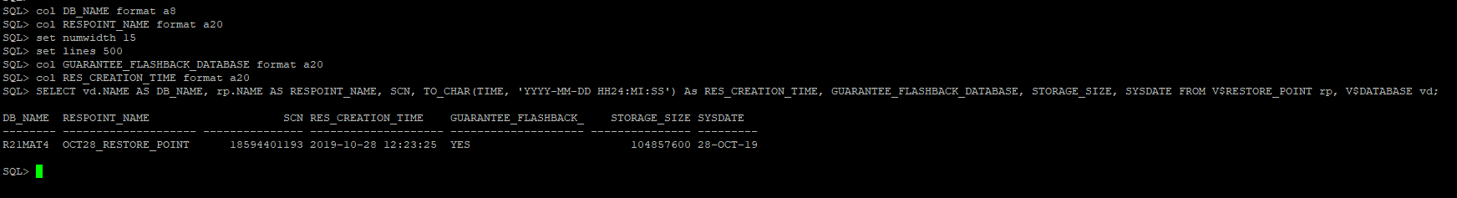

Use Guaranteed Restore Point to Flashback Database

5.1: Start the Database in mount Mode:
STARTUP MOUNT;
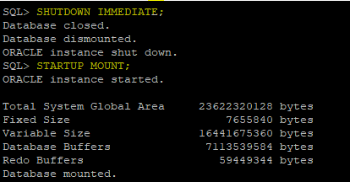

5.2: Use the restore point to flashback the database
Syntax: FLASHBACK DATABASE TO RESTORE POINT <Restore_point_name>;
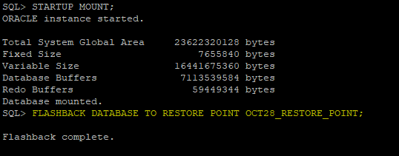

5.3: Open Database with the RESETLOGS Option
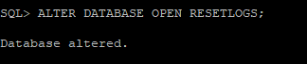

Drop Restore Point

Once completed the flashback of database using guaranteed restore point then drop the restore point.
Syntax: DROP RESTORE POINT <Restore Point Name>;
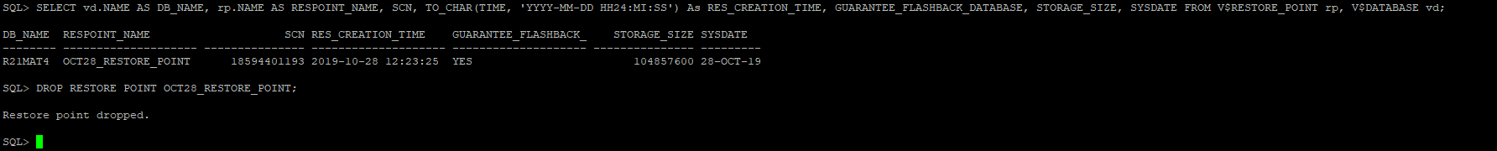

Points to remember

- Guaranteed restore point will create separate location (Flash Recovery Area: DB_RECOVERY_FILE_DEST) to store the log required for database flashback.

- Dropping the restore point will clean the flashback log.
- When guaranteed restore points are created in database, we should monitor the amount of space used in flash recovery area for files required to meet the storage requirement.
- The V$RECOVERY_FILE_DEST and V$FLASH_RECOVERY_AREA_USAGE views can help to determine whether we have allocated/available enough space for flash recovery area.

END OF DOCUMENT

