INFO 5707 – Data Modeling
Final Report
Learning Management System (LMS) Database
Prof. Sahara Ali

Group 18
Divyasree Pithani (Team Coordinator)
Teja Sai Srinivas Kunisetty
Keerthi Yeakambaram

Date: December 5, 2025

Contents
1. Project Report (40 Points) 4
1.1 Revised Database Overview Including Objectives and Scope (5 Points) 4
Vision 4
Mission 4
Primary Objectives 4
Scope Definition 5
1.2 Revised User Requirements (5 Points) 7
1.3 Revised Business Rules (5 Points) 9
1.4 Revised ERD (15 Points) 10
Entity-Relationship Diagram Description 11
Key Relationships 11
1.5 Revised Data Dictionary (10 Points) 13
Entity: CoursePrerequisite 28
2. Database Implementation (60 Points) 29
2.1 Entity Generation and Data Entry (30 Points) 29
Table Purpose Summary 29
CREATE TABLE Statements 30
INSERT INTO Statements (Sample Data) 44
Database Triggers 53
Performance Indexes 55
2.2 Data Retrieval and Simple Reports (30 Points) 56
Query 1: Calculate Average Assignment Grades 56
Query 2: Find Students with Late Submissions 57
Query 3: Instructor Teaching Load Analysis 58
Query 4: Top 5 Performing Students in a Course 60
Query 5: Ungraded Submissions Report (Instructor To-Do List) 61
Appendix A: Complete SQL Scripts Location 62
Appendix B: Database Connection Information 63
AI Use Disclosure Statement 65

1. Project Report (40 Points)
This section presents the database design documentation for the Learning Management System (LMS). The design has been refined through multiple iterations to ensure it meets all academic and operational requirements for managing online learning environments.

1.1 Revised Database Overview Including Objectives and Scope (5 Points)

Vision
Our goal is to develop a robust, enterprise-level relational database system that acts as the essential data layer for managing online learning platforms. This system will enable educational institutions to effectively oversee, monitor, and evaluate every facet of digital education delivery.

Mission
Design and implement a normalized, scalable database architecture that guarantees data integrity, supports simultaneous multi-user access, maintains detailed academic records, and ensures smooth collaboration among students, instructors, and administrators throughout the educational process.

Primary Objectives
The LMS database system is designed to achieve the following six primary objectives:
- Objective 1: Unified Academic Data Management: Establish a single authoritative source for all academic information, including course catalogs, enrollment details, curriculum frameworks, and academic performance metrics over various terms and academic years.
- Objective 2: User Identity and Access Management: Develop a strong user management system that facilitates role-based access control for students, instructors, teaching assistants, and administrators, ensuring appropriate data security and privacy measures.
- Objective 3: Course Content and Curriculum Organization: Facilitate the organized arrangement of course materials, learning modules, and instructional content, with provisions for prerequisites, course sequencing, and curriculum pathways.
- Objective 4: Assessment and Evaluation Tracking: Keep detailed records of all assessments, including assignments, quizzes, exams, submissions, grading history, and performance analytics, with complete audit trails.
- Objective 5: Enrollment and Registration Processing: Facilitate comprehensive student enrollment processes, including course registration, waitlist management, enrollment capacity enforcement, and prerequisite validation.
- Objective 6: Grade Management and Academic Records: Manage, store, and monitor student grades, supporting weighted grading systems, grade distributions, cumulative performance metrics, and transcript generation.

Scope Definition
The scope of the LMS database encompasses the following dimensions:
- Organization Type: Educational institutions including universities, colleges, community colleges, corporate training centers, and online education platforms.
- Functional Coverage:
  - Academic administration and institutional management
  - Course catalog and curriculum management
  - Student information and enrollment systems
  - Instructor assignment and course scheduling
  - Assessment creation, submission, and grading
  - Performance tracking and academic analytics
  - User authentication and authorization
- Database Scope Level: Enterprise-level system covering institution-wide online learning operations
- Key Functional Areas:
  - User management and role-based security
  - Course and curriculum administration
  - Enrollment and registration processing
  - Content organization and module structuring
  - Assignment and quiz management
  - Submission tracking and version control
  - Grading workflows and grade calculation
  - Academic reporting and analytics
  - Term/semester data organization
- Out of Scope:
  - User interface design and web application development
  - API implementation and endpoint definitions
  - Payment processing and financial transactions
  - Email notification systems
  - Video streaming infrastructure
  - Third-party integration specifications
  - Mobile application development

1.2 Revised User Requirements (5 Points)
The following twelve user requirements have been identified and refined to guide the database design:
- UR-1: Student Enrollment Management: The database will handle and store records of student enrollments for courses, including details such as enrollment dates, status (active, dropped, completed), and validation of enrollment capacity to avoid over-enrollment in courses.
- UR-2: Course Structure and Organization: The database will keep course details, including course codes, titles, descriptions, credit hours, department affiliations, and prerequisite links to aid in curriculum planning.
- UR-3: Multi-Term Academic Calendar Support: The database will accommodate multiple academic terms or semesters with unique start and end dates, enabling courses to be offered in various terms while preserving historical academic records.
- UR-4: Assignment Lifecycle Management: The database will monitor the entire lifecycle of assignments, from creation to assignment to courses, student submissions with timestamps and grading status.
- UR-5: Quiz and Assessment Administration: The database will store quiz definitions, question banks with various question types (multiple choice, true/false, essay, file upload), student responses, and automated scoring for objective question types.
- UR-6: Comprehensive Grading System: The database will compute and store grades for individual assessments, support weighted grading categories (assignments, quizzes, exams), and calculate final course grades based on configurable grading schemes.
- UR-7: Role-Based Access Control: The database will implement role-based security, allowing students to access only their enrolled courses and submissions, instructors to manage only their assigned courses, and administrators to have system-wide access for reporting and management.
- UR-8: Course Material Organization: The database will arrange course materials into modules and topics with defined sequencing, supporting multimedia content references and maintaining links between materials and specific course offerings.
- UR-9: Instructor Assignment and Management: The database will track instructor assignments to courses, support multiple instructors per course, and maintain teaching assistant associations with specific course sections or roles.
- UR-10: Historical Academic Performance Tracking: The database will preserve complete historical records of student academic performance, including all submissions, grades, enrollment history, and course completions, to support transcript generation and academic advising.
- UR-11: Deadline and Late Submission Tracking: The database will store assignment and quiz due dates, track submission timestamps, and identify late submissions to support late penalty calculations and deadline enforcement.
- UR-12: Grade Distribution Analytics: The database will facilitate queries for grade distribution analysis, including class averages, grade curves, performance comparisons across sections, and historical trend analysis for institutional reporting.

1.3 Revised Business Rules (5 Points)
The following twelve business rules govern the operational constraints and data integrity of the LMS database:
- BR-1: Enrollment Capacity Enforcement: Every course being offered should have a set limit for enrollment. Students are not allowed to enroll in a course section when the number of enrollments goes above the maximum capacity unless it is administratively overridden.
- BR-2: Prerequisite Validation: A student can qualify to take a course only when he has passed all the prerequisite courses with a passing grade (grade >= D or as per the institution) or administrative permission to skip prerequisites.
- BR-3: Single Enrollment Per Term: Enrollment into a certain course can only be made by a student once in a term. The system should not allow an over-enrollment of the same course section in the same academic term.
- BR-4: Instructor Course Assignment: All the courses provided should contain at least one instructor in charge of the course. Without an instructor assignment, a course cannot become active so that it can be enrolled by students.
- BR-5: Deadline for Submission: All assignments and quizzes should have a certain deadline and time. Students may post work later than the deadline, the system should indicate that it is late and the delay period should be logged.
- BR-6: Grade Value Constraints: All marks should be in valid ranges: marks in individual assignments/quizzes (or points in maximum points) should range between 0-100 (or 0 to maximum points indicated) and final mark should be out of the institutional grade scale (A, A-, B+, B, B-, C+, C, D, F, or equivalent).
- BR-7: Submission Versioning: In cases where a student makes several submissions of an assignment before the due date, the system should save all the submissions including timestamps. The last submission before the deadline is taken to be the official submission to be graded unless the instructor specifies differently.
- BR-8: Grade Calculation Integrity: The computation of final course grades should be done using graded assessments in the course offering. Calculation should be done according to the weighting scheme set by the instructor and all weights of the categories should not exceed 100%.
- BR-9: Role Assignment Rules: Users should be given at least one role (Student, Instructor, Teaching Assistant or Administrator). Multiple roles can be assigned to users (e.g., a graduate student is also a teaching assistant).
- BR-10: Term Association of Course Offering: Courses of study should have only one academic term per offering. Courses cannot be offered in more than one term; individual offerings will have to be made for courses taught in different terms.
- BR-11: Assessment Ownership: The quizzes (assignments and tests) should be produced by and be in a particular course offering. Assessment types cannot stand alone and will be deleted in case the parent course offering is deleted.
- BR-12: Transition of Enrollment Status: The enrollment status of students should be made in accordance with legitimate transitions between the states: Pending -> Enrolled -> (Completed OR Dropped OR Withdrawn). Dropped/Withdrawn students are unable to move to Enrolled without establishing a new record of enrollment.

1.4 Revised ERD (15 Points)

Entity-Relationship Diagram Description
The LMS database consists of 13 core entities organized around academic operations. The diagram below illustrates the relationships between these entities.
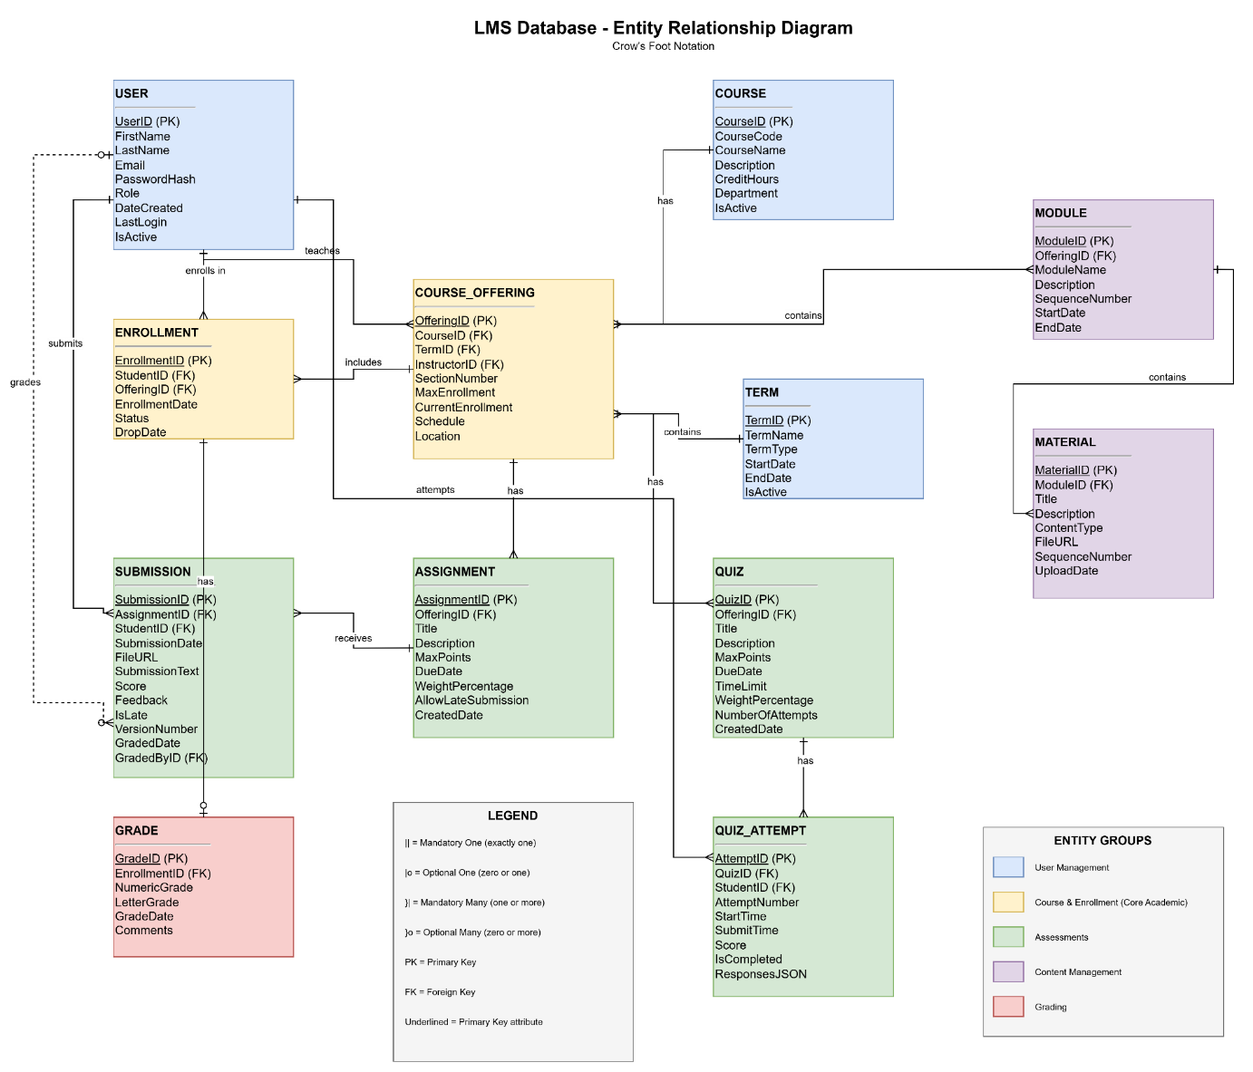

This is the Initial ERD Diagram
For the revised database diagram, we are going to add another table called CoursePrerequisite, that connects to Course table.

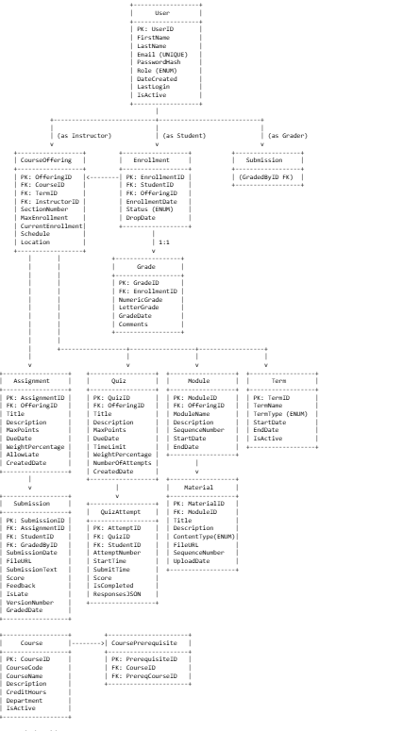

Key Relationships
The following eleven key relationships define the structure of the LMS database:
- User to CourseOffering (as Instructor): One-to-Many
  - An instructor can teach multiple course offerings
  - Each course offering must have one primary instructor
- User to Enrollment (as Student): One-to-Many
  - A student can enroll in multiple courses
  - Each enrollment belongs to one student
- Course to CourseOffering: One-to-Many
  - A course can have multiple offerings across terms
  - Each offering is of exactly one course
- Term to CourseOffering: One-to-Many
  - A term contains multiple course offerings
  - Each offering belongs to one term
- CourseOffering to Assignment: One-to-Many
  - A course offering can have multiple assignments
  - Each assignment belongs to one course offering
- CourseOffering to Quiz: One-to-Many
  - A course offering can have multiple quizzes
  - Each quiz belongs to one course offering
- Assignment to Submission: One-to-Many
  - An assignment can receive multiple submissions (from different students)
  - Each submission is for one assignment
- Quiz to QuizAttempt: One-to-Many
  - A quiz can have multiple attempts (from different students)
  - Each attempt is for one quiz
- Enrollment to Grade: One-to-One
  - Each enrollment may have one final grade
  - Each grade belongs to one enrollment
- CourseOffering to Module: One-to-Many
  - A course offering organizes content into multiple modules
  - Each module belongs to one course offering
- Module to Material: One-to-Many
  - A module contains multiple materials
  - Each material belongs to one module

1.5 Revised Data Dictionary (10 Points)
This section provides detailed specifications for all 13 entities in the LMS database, including attribute definitions, data types, constraints, and descriptions.
Entity: User
Attribute | Data Type | Length | Constraints | Description
UserID | INTEGER | - | PK, NOT NULL, AUTO_INCREMENT | Unique identifier for each user
FirstName | VARCHAR | 50 | NOT NULL | User's first name
LastName | VARCHAR | 50 | NOT NULL | User's last name
Email | VARCHAR | 100 | NOT NULL, UNIQUE | User's email address (used for login)
PasswordHash | VARCHAR | 255 | NOT NULL | Encrypted password hash
Role | ENUM | - | NOT NULL | User role: 'Student', 'Instructor', 'TA', 'Admin'
DateCreated | TIMESTAMP | - | NOT NULL, DEFAULT CURRENT_TIMESTAMP | Account creation date
LastLogin | TIMESTAMP | - | NULL | Last login timestamp
IsActive | BOOLEAN | - | NOT NULL, DEFAULT TRUE | Account active status

Entity: Course
Attribute | Data Type | Length | Constraints | Description
CourseID | INTEGER | - | PK, NOT NULL, AUTO_INCREMENT | Unique identifier for each course
CourseCode | VARCHAR | 20 | NOT NULL, UNIQUE | Course code (e.g., 'INFO5707')
CourseName | VARCHAR | 200 | NOT NULL | Full course title
Description | TEXT | - | NULL | Detailed course description
CreditHours | DECIMAL | (3,1) | NOT NULL, CHECK (CreditHours > 0) | Number of credit hours
Department | VARCHAR | 100 | NOT NULL | Academic department offering course
IsActive | BOOLEAN | - | NOT NULL, DEFAULT TRUE | Course catalog active status

Entity: Term
Attribute | Data Type | Length | Constraints | Description
TermID | INTEGER | - | PK, NOT NULL, AUTO_INCREMENT | Unique identifier for each term
TermName | VARCHAR | 50 | NOT NULL, UNIQUE | Term name (e.g., 'Fall 2025')
TermType | ENUM | - | NOT NULL | Term type: 'Fall', 'Spring', 'Summer', 'Winter'
StartDate | DATE | - | NOT NULL | Term start date
EndDate | DATE | - | NOT NULL, CHECK (EndDate > StartDate) | Term end date
IsActive | BOOLEAN | - | NOT NULL, DEFAULT TRUE | Current term indicator

Entity: CourseOffering
Attribute | Data Type | Length | Constraints | Description
OfferingID | INTEGER | - | PK, NOT NULL, AUTO_INCREMENT | Unique identifier for course offering
CourseID | INTEGER | - | FK (Course), NOT NULL | Reference to course
TermID | INTEGER | - | FK (Term), NOT NULL | Reference to term
InstructorID | INTEGER | - | FK (User), NOT NULL | Reference to instructor user
SectionNumber | VARCHAR | 10 | NOT NULL | Section identifier (e.g., '001', 'A')
MaxEnrollment | INTEGER | - | NOT NULL, CHECK (MaxEnrollment > 0) | Maximum student capacity
CurrentEnrollment | INTEGER | - | NOT NULL, DEFAULT 0, CHECK (CurrentEnrollment >= 0) | Current number of enrolled students
Schedule | VARCHAR | 100 | NULL | Meeting schedule description
Location | VARCHAR | 100 | NULL | Physical or virtual location
UNIQUE (CourseID, TermID, SectionNumber) |  |  |  | Ensures unique sections per term

Entity: Enrollment
Attribute | Data Type | Length | Constraints | Description
EnrollmentID | INTEGER | - | PK, NOT NULL, AUTO_INCREMENT | Unique identifier for enrollment
StudentID | INTEGER | - | FK (User), NOT NULL | Reference to student user
OfferingID | INTEGER | - | FK (CourseOffering), NOT NULL | Reference to course offering
EnrollmentDate | TIMESTAMP | - | NOT NULL, DEFAULT CURRENT_TIMESTAMP | Date student enrolled
Status | ENUM | - | NOT NULL, DEFAULT 'Enrolled' | Status: 'Enrolled', 'Dropped', 'Completed', 'Withdrawn'
DropDate | TIMESTAMP | - | NULL | Date enrollment was dropped (if applicable)
UNIQUE (StudentID, OfferingID) |  |  |  | Prevents duplicate enrollments

Entity: Assignment
Attribute | Data Type | Length | Constraints | Description
AssignmentID | INTEGER | - | PK, NOT NULL, AUTO_INCREMENT | Unique identifier for assignment
OfferingID | INTEGER | - | FK (CourseOffering), NOT NULL | Reference to course offering
Title | VARCHAR | 200 | NOT NULL | Assignment title
Description | TEXT | - | NULL | Detailed assignment instructions
MaxPoints | DECIMAL | (5,2) | NOT NULL, CHECK (MaxPoints > 0) | Maximum possible points
DueDate | TIMESTAMP | - | NOT NULL | Assignment due date and time
WeightPercentage | DECIMAL | (5,2) | NOT NULL, CHECK (WeightPercentage >= 0 AND WeightPercentage <= 100) | Weight toward final grade
AllowLateSubmission | BOOLEAN | - | NOT NULL, DEFAULT TRUE | Allow submissions after due date
CreatedDate | TIMESTAMP | - | NOT NULL, DEFAULT CURRENT_TIMESTAMP | Assignment creation date

Entity: Submission
Attribute | Data Type | Length | Constraints | Description
SubmissionID | INTEGER | - | PK, NOT NULL, AUTO_INCREMENT | Unique identifier for submission
AssignmentID | INTEGER | - | FK (Assignment), NOT NULL | Reference to assignment
StudentID | INTEGER | - | FK (User), NOT NULL | Reference to student user
SubmissionDate | TIMESTAMP | - | NOT NULL, DEFAULT CURRENT_TIMESTAMP | Submission timestamp
FileURL | VARCHAR | 500 | NULL | URL/path to submitted file
SubmissionText | TEXT | - | NULL | Text submission content
Score | DECIMAL | (5,2) | NULL, CHECK (Score >= 0) | Points earned
Feedback | TEXT | - | NULL | Instructor feedback
IsLate | BOOLEAN | - | NOT NULL, DEFAULT FALSE | Late submission indicator
VersionNumber | INTEGER | - | NOT NULL, DEFAULT 1 | Submission version number
GradedDate | TIMESTAMP | - | NULL | Date submission was graded
GradedByID | INTEGER | - | FK (User), NULL | Reference to grader (instructor/TA)

Entity: Quiz
Attribute | Data Type | Length | Constraints | Description
QuizID | INTEGER | - | PK, NOT NULL, AUTO_INCREMENT | Unique identifier for quiz
OfferingID | INTEGER | - | FK (CourseOffering), NOT NULL | Reference to course offering
Title | VARCHAR | 200 | NOT NULL | Quiz title
Description | TEXT | - | NULL | Quiz instructions
MaxPoints | DECIMAL | (5,2) | NOT NULL, CHECK (MaxPoints > 0) | Maximum possible points
DueDate | TIMESTAMP | - | NOT NULL | Quiz due date and time
TimeLimit | INTEGER | - | NULL, CHECK (TimeLimit > 0) | Time limit in minutes (NULL = unlimited)
WeightPercentage | DECIMAL | (5,2) | NOT NULL, CHECK (WeightPercentage >= 0 AND WeightPercentage <= 100) | Weight toward final grade
NumberOfAttempts | INTEGER | - | NOT NULL, DEFAULT 1, CHECK (NumberOfAttempts > 0) | Allowed number of attempts
CreatedDate | TIMESTAMP | - | NOT NULL, DEFAULT CURRENT_TIMESTAMP | Quiz creation date

Entity: QuizAttempt
Attribute | Data Type | Length | Constraints | Description
AttemptID | INTEGER | - | PK, NOT NULL, AUTO_INCREMENT | Unique identifier for quiz attempt
QuizID | INTEGER | - | FK (Quiz), NOT NULL | Reference to quiz
StudentID | INTEGER | - | FK (User), NOT NULL | Reference to student user
AttemptNumber | INTEGER | - | NOT NULL, CHECK (AttemptNumber > 0) | Attempt number for this student
StartTime | TIMESTAMP | - | NOT NULL | When student started quiz
SubmitTime | TIMESTAMP | - | NULL | When student submitted quiz
Score | DECIMAL | (5,2) | NULL, CHECK (Score >= 0) | Points earned
IsCompleted | BOOLEAN | - | NOT NULL, DEFAULT FALSE | Quiz completion status
ResponsesJSON | JSON | - | NULL | Student responses to questions
UNIQUE (QuizID, StudentID, AttemptNumber) |  |  |  | Ensures unique attempt numbers per student

Entity: Module
Attribute | Data Type | Length | Constraints | Description
ModuleID | INTEGER | - | PK, NOT NULL, AUTO_INCREMENT | Unique identifier for module
OfferingID | INTEGER | - | FK (CourseOffering), NOT NULL | Reference to course offering
ModuleName | VARCHAR | 200 | NOT NULL | Module title
Description | TEXT | - | NULL | Module description
SequenceNumber | INTEGER | - | NOT NULL, CHECK (SequenceNumber > 0) | Module order within course
StartDate | DATE | - | NULL | Module availability start date
EndDate | DATE | - | NULL | Module availability end date
UNIQUE (OfferingID, SequenceNumber) |  |  |  | Ensures unique sequence numbers per offering
Entity: Material
Attribute | Data Type | Length | Constraints | Description
MaterialID | INTEGER | - | PK, NOT NULL, AUTO_INCREMENT | Unique identifier for material
ModuleID | INTEGER | - | FK (Module), NOT NULL | Reference to module
Title | VARCHAR | 200 | NOT NULL | Material title
Description | TEXT | - | NULL | Material description
ContentType | ENUM | - | NOT NULL | Type: 'Document', 'Video', 'Link', 'PDF', 'Image'
FileURL | VARCHAR | 500 | NULL | URL/path to file or link
SequenceNumber | INTEGER | - | NOT NULL, CHECK (SequenceNumber > 0) | Material order within module
UploadDate | TIMESTAMP | - | NOT NULL, DEFAULT CURRENT_TIMESTAMP | Date material was added
UNIQUE (ModuleID, SequenceNumber) |  |  |  | Ensures unique sequence numbers per module
Entity: Grade
Attribute | Data Type | Length | Constraints | Description
GradeID | INTEGER | - | PK, NOT NULL, AUTO_INCREMENT | Unique identifier for grade record
EnrollmentID | INTEGER | - | FK (Enrollment), NOT NULL, UNIQUE | Reference to enrollment (one grade per enrollment)
NumericGrade | DECIMAL | (5,2) | NULL, CHECK (NumericGrade >= 0 AND NumericGrade <= 100) | Calculated numeric grade
LetterGrade | VARCHAR | 5 | NULL | Letter grade (A, A-, B+, etc.)
GradeDate | TIMESTAMP | - | NULL | Date grade was finalized
Comments | TEXT | - | NULL | Additional comments from instructor

Entity: CoursePrerequisite
The CoursePrerequisite table enforces curriculum sequencing by defining prerequisite relationships between courses.
Attribute | Data Type | Length | Constraints | Description
PrerequisiteID | INTEGER | - | PK, NOT NULL, AUTO_INCREMENT | Unique identifier for prerequisite record
CourseID | INTEGER | - | FK (Course), NOT NULL | Reference to the course
PrereqCourseID | INTEGER | - | FK (Course), NOT NULL | Reference to the required prerequisite
 |  |  | UNIQUE (CourseID, PrereqCourseID) | Prevents duplicate prerequisite rules
 |  |  | CHECK (CourseID <> PrereqCourseID) | Prevents self-reference

Database Implementation (60 Points)
This section demonstrates the practical implementation of the LMS database using PostgreSQL 15. The implementation includes complete table creation, data population, and analytical queries.

2.1 Entity Generation and Data Entry (30 Points)
We implemented the database using PostgreSQL 15 as our relational database management system. The implementation consists of 13 tables, each serving a specific purpose in the academic management lifecycle. Below are the complete SQL statements used to create these tables and populate them with sample data.

Table Purpose Summary
Table | Purpose | Record Count
User | Stores all system users (students, instructors, admins) with role-based access | 21
Course | Defines the catalog of available courses | 20
Term | Manages academic terms and calendars | 5
CourseOffering | Connects courses to terms and instructors | 20
Enrollment | Links students to course offerings | 25
Assignment | Defines assessments within a course offering | 20
Submission | Tracks student work and performance | 20
Quiz | Stores quiz definitions | 5
QuizAttempt | Records student quiz attempts | 7
Module | Organizes course content sections | 5
Material | Stores course materials and resources | 7
Grade | Stores final course grades | 5
CoursePrerequisite | Enforces curriculum sequencing | 5

CREATE TABLE Statements
The following SQL statements create the database schema with all necessary constraints, foreign keys, and custom enum types.

ENUM Types Creation
-- Create custom ENUM types for controlled vocabularies
CREATE TYPE user_role AS ENUM ('Student', 'Instructor', 'TA', 'Admin');
CREATE TYPE term_type AS ENUM ('Fall', 'Spring', 'Summer', 'Winter');
CREATE TYPE enrollment_status AS ENUM ('Enrolled', 'Dropped', 'Completed', 'Withdrawn');
CREATE TYPE content_type AS ENUM ('Document', 'Video', 'Link', 'PDF', 'Image');
Explanation: These ENUM types ensure data integrity by restricting values to predefined options. This prevents invalid data entry and improves query performance.

User Table
CREATE TABLE "User" (
UserID SERIAL PRIMARY KEY,
FirstName VARCHAR(50) NOT NULL,
LastName VARCHAR(50) NOT NULL,
Email VARCHAR(100) NOT NULL UNIQUE,
PasswordHash VARCHAR(255) NOT NULL,
Role user_role NOT NULL,
DateCreated TIMESTAMP NOT NULL DEFAULT CURRENT_TIMESTAMP,
LastLogin TIMESTAMP NULL,
IsActive BOOLEAN NOT NULL DEFAULT TRUE
);
Explanation: The User table serves as the central identity management entity. It stores authentication credentials (hashed passwords), role assignments for access control, and activity tracking. The UNIQUE constraint on Email ensures no duplicate accounts.
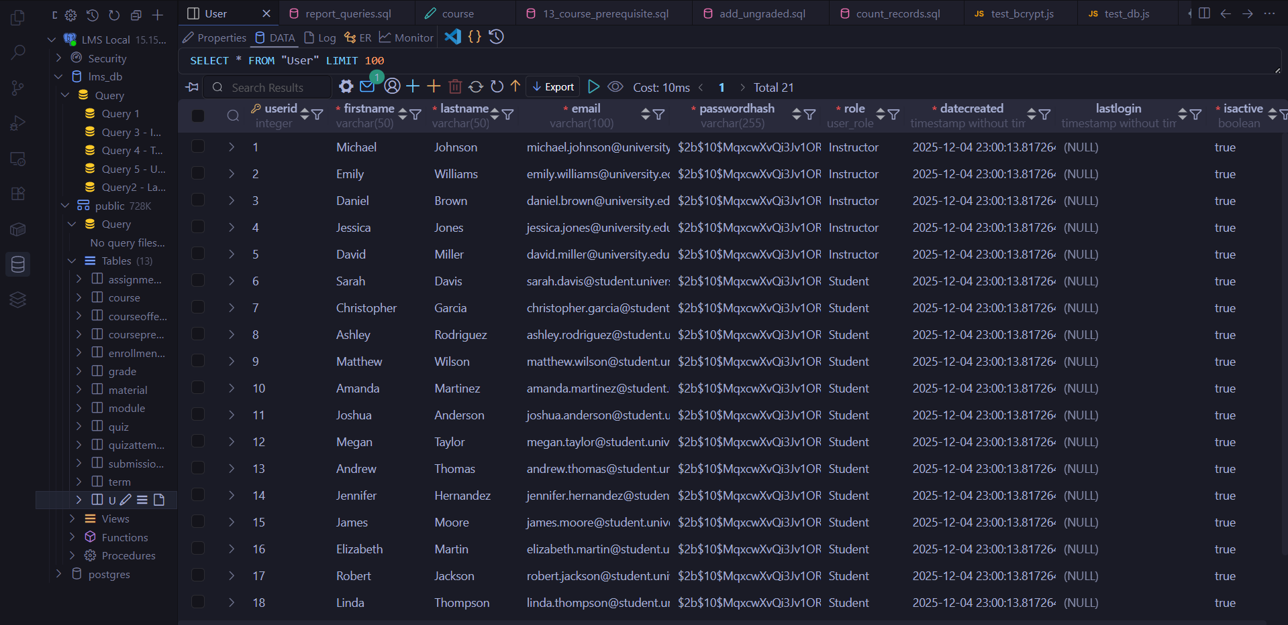

Course Table
CREATE TABLE Course (
CourseID SERIAL PRIMARY KEY,
CourseCode VARCHAR(20) NOT NULL UNIQUE,
CourseName VARCHAR(200) NOT NULL,
Description TEXT NULL,
CreditHours DECIMAL(3,1) NOT NULL CHECK (CreditHours > 0),
Department VARCHAR(100) NOT NULL,
IsActive BOOLEAN NOT NULL DEFAULT TRUE
);
Explanation: The Course table maintains the academic catalog. Each course has a unique code (e.g., 'CS101'), credit hours, and department affiliation. The CHECK constraint ensures credit hours are always positive.
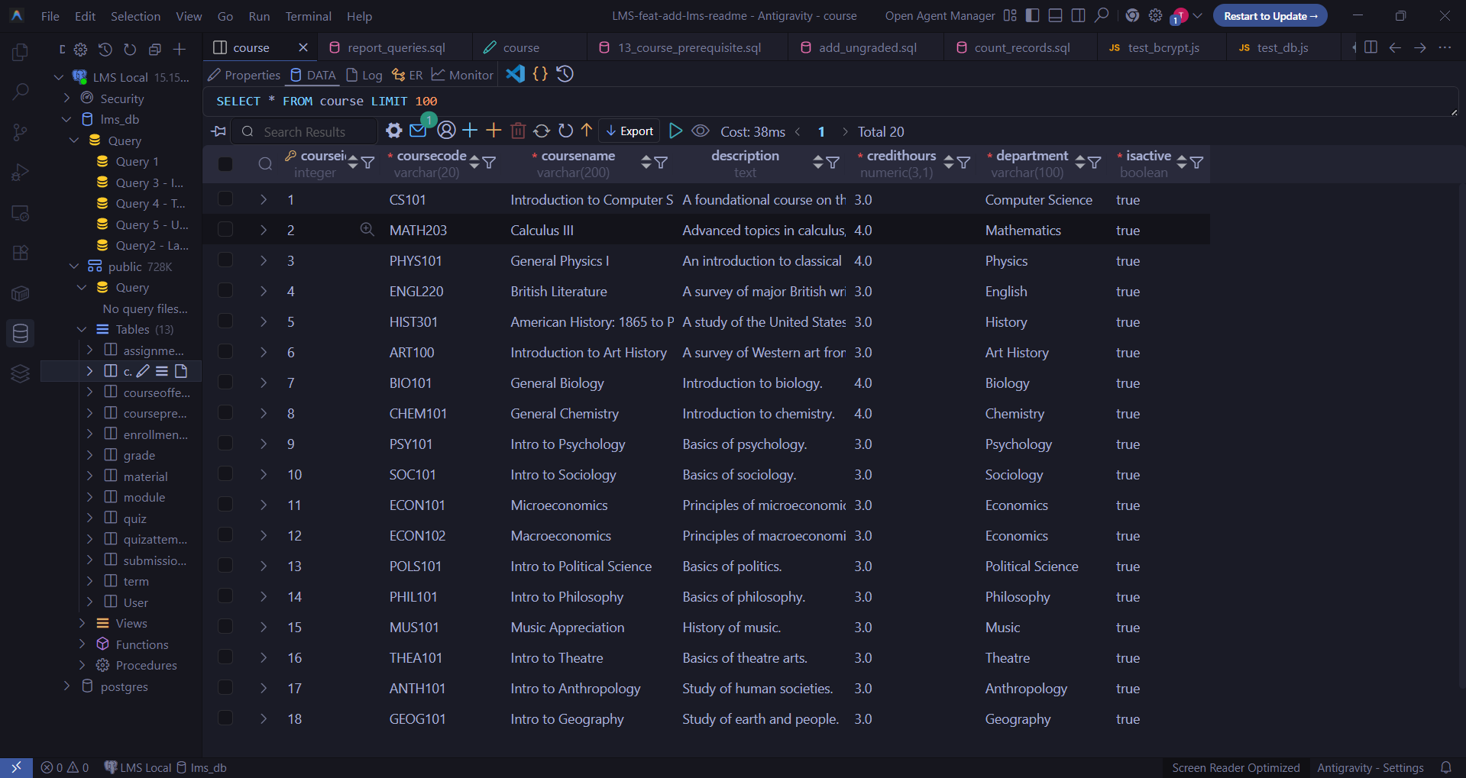

Term Table
CREATE TABLE Term (
TermID SERIAL PRIMARY KEY,
TermName VARCHAR(50) NOT NULL UNIQUE,
TermType term_type NOT NULL,
StartDate DATE NOT NULL,
EndDate DATE NOT NULL CHECK (EndDate > StartDate),
IsActive BOOLEAN NOT NULL DEFAULT TRUE
);
Explanation: The Term table manages academic calendar periods. The CHECK constraint ensures that end dates always follow start dates, maintaining data integrity for scheduling purposes.
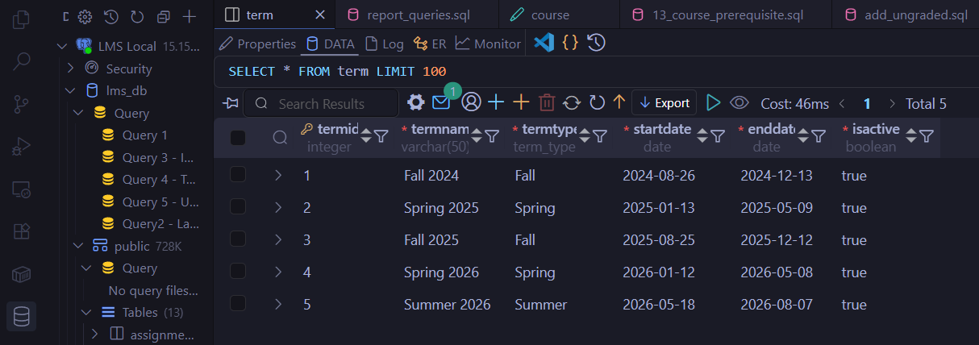

CourseOffering Table
CREATE TABLE CourseOffering (
OfferingID SERIAL PRIMARY KEY,
CourseID INTEGER NOT NULL REFERENCES Course(CourseID),
TermID INTEGER NOT NULL REFERENCES Term(TermID),
InstructorID INTEGER NOT NULL REFERENCES "User"(UserID),
SectionNumber VARCHAR(10) NOT NULL,
MaxEnrollment INTEGER NOT NULL CHECK (MaxEnrollment > 0),
CurrentEnrollment INTEGER NOT NULL DEFAULT 0 CHECK (CurrentEnrollment >= 0),
Schedule VARCHAR(100) NULL,
Location VARCHAR(100) NULL,
UNIQUE (CourseID, TermID, SectionNumber)
);
Explanation: CourseOffering represents the actual class sections students enroll in. It links a course to a specific term with an assigned instructor. The UNIQUE constraint on (CourseID, TermID, SectionNumber) prevents duplicate sections.
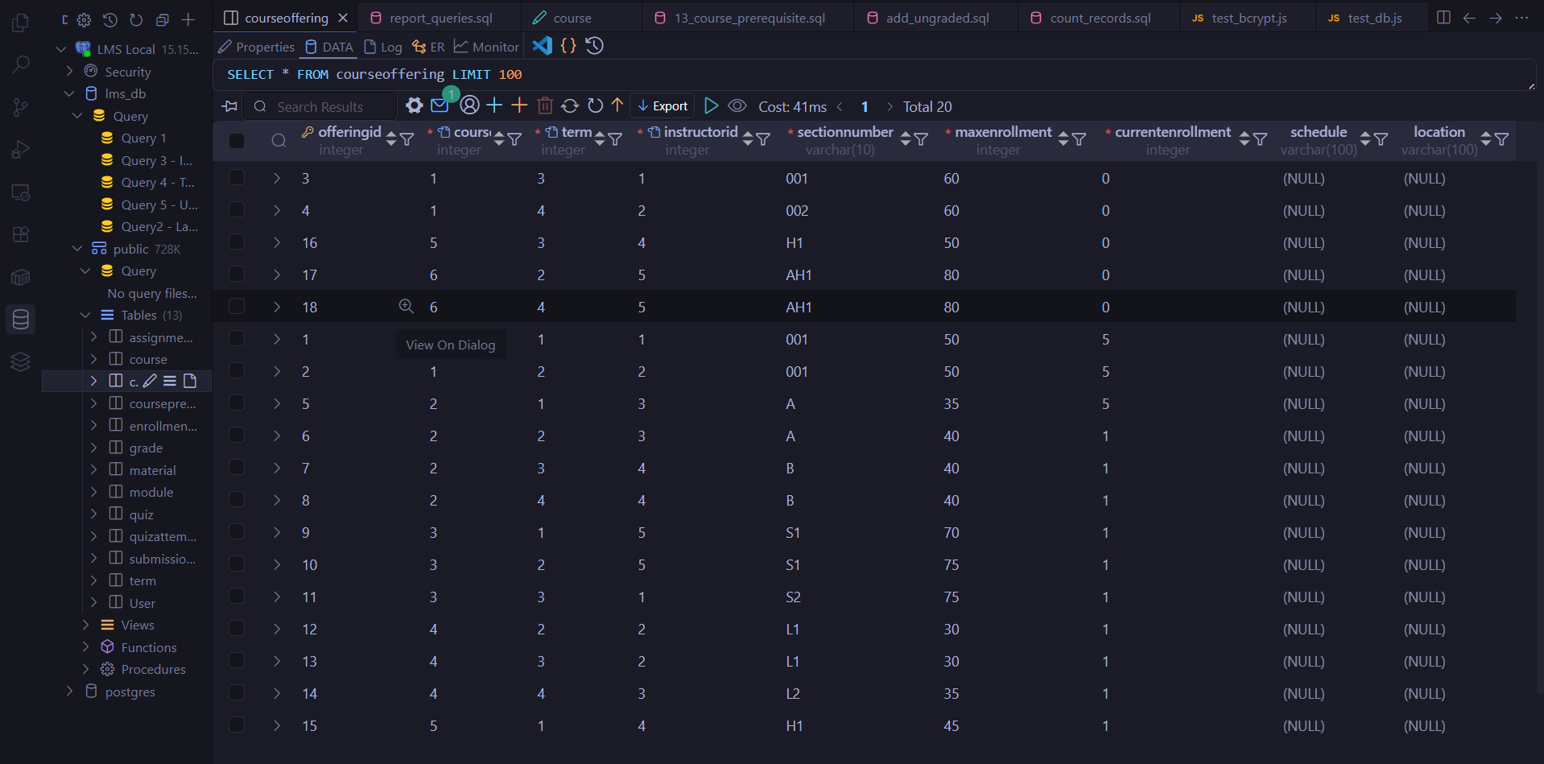

Enrollment Table
CREATE TABLE Enrollment (
EnrollmentID SERIAL PRIMARY KEY,
StudentID INTEGER NOT NULL REFERENCES "User"(UserID),
OfferingID INTEGER NOT NULL REFERENCES CourseOffering(OfferingID),
EnrollmentDate TIMESTAMP NOT NULL DEFAULT CURRENT_TIMESTAMP,
Status enrollment_status NOT NULL DEFAULT 'Enrolled',
DropDate TIMESTAMP NULL,
UNIQUE (StudentID, OfferingID)
);
Explanation: The Enrollment table tracks student registrations. The UNIQUE constraint prevents a student from enrolling in the same course offering twice, enforcing Business Rule BR-3.
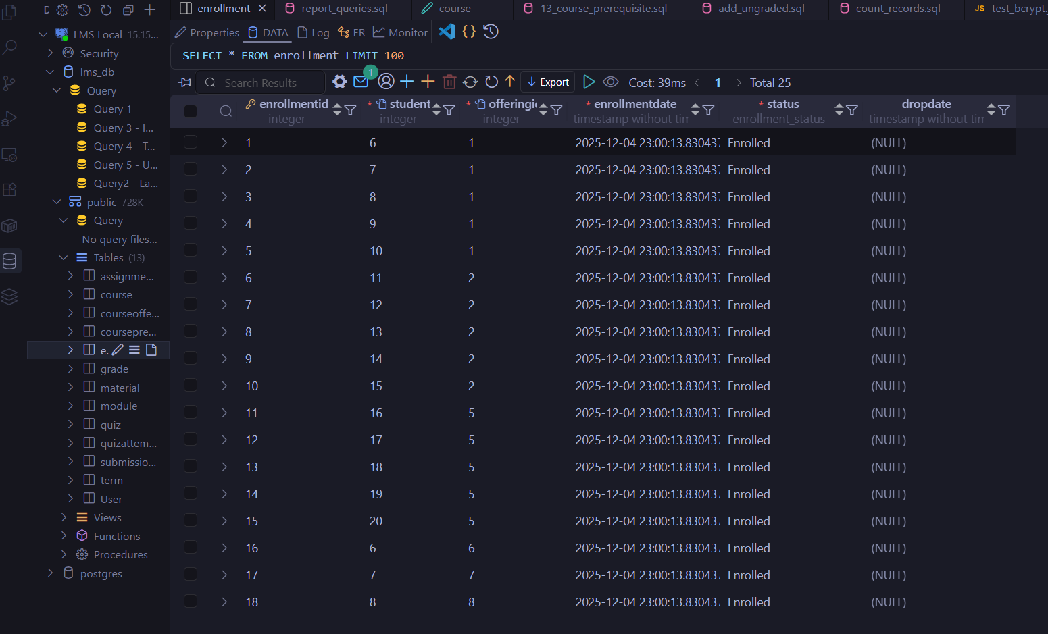

Assignment Table
CREATE TABLE Assignment (
AssignmentID SERIAL PRIMARY KEY,
OfferingID INTEGER NOT NULL REFERENCES CourseOffering(OfferingID),
Title VARCHAR(200) NOT NULL,
Description TEXT NULL,
MaxPoints DECIMAL(5,2) NOT NULL CHECK (MaxPoints > 0),
DueDate TIMESTAMP NOT NULL,
WeightPercentage DECIMAL(5,2) NOT NULL
CHECK (WeightPercentage >= 0 AND WeightPercentage <= 100),
AllowLateSubmission BOOLEAN NOT NULL DEFAULT TRUE,
CreatedDate TIMESTAMP NOT NULL DEFAULT CURRENT_TIMESTAMP
);
Explanation: The Assignment table defines course assessments. It includes due dates for deadline tracking (UR-11) and weight percentages for grade calculation (BR-8).
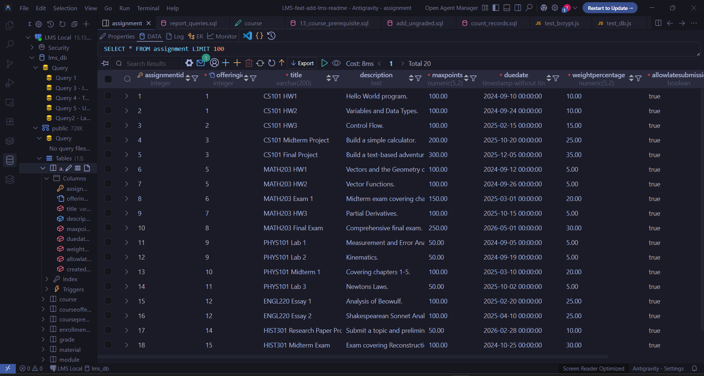

Submission Table
CREATE TABLE Submission (
SubmissionID SERIAL PRIMARY KEY,
AssignmentID INTEGER NOT NULL REFERENCES Assignment(AssignmentID),
StudentID INTEGER NOT NULL REFERENCES "User"(UserID),
SubmissionDate TIMESTAMP NOT NULL DEFAULT CURRENT_TIMESTAMP,
FileURL VARCHAR(500) NULL,
SubmissionText TEXT NULL,
Score DECIMAL(5,2) NULL CHECK (Score >= 0),
Feedback TEXT NULL,
IsLate BOOLEAN NOT NULL DEFAULT FALSE,
VersionNumber INTEGER NOT NULL DEFAULT 1,
GradedDate TIMESTAMP NULL,
GradedByID INTEGER NULL REFERENCES "User"(UserID)
);
Explanation: The Submission table tracks student work with versioning support (BR-7), late submission flags (BR-5), and grading information. The GradedByID provides an audit trail for who graded each submission.
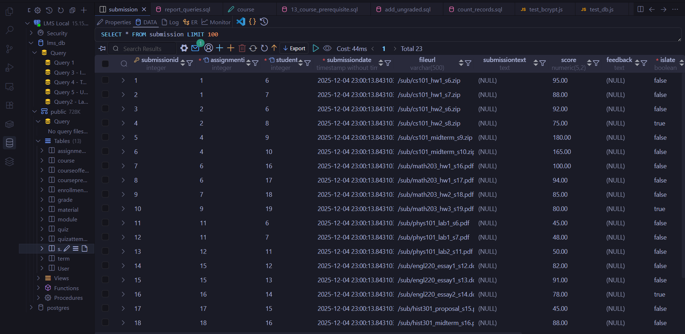

Quiz Table
CREATE TABLE Quiz (
QuizID SERIAL PRIMARY KEY,
OfferingID INTEGER NOT NULL REFERENCES CourseOffering(OfferingID),
Title VARCHAR(200) NOT NULL,
Description TEXT NULL,
MaxPoints DECIMAL(5,2) NOT NULL CHECK (MaxPoints > 0),
DueDate TIMESTAMP NOT NULL,
TimeLimit INTEGER NULL CHECK (TimeLimit > 0),
WeightPercentage DECIMAL(5,2) NOT NULL
CHECK (WeightPercentage >= 0 AND WeightPercentage <= 100),
NumberOfAttempts INTEGER NOT NULL DEFAULT 1 CHECK (NumberOfAttempts > 0),
CreatedDate TIMESTAMP NOT NULL DEFAULT CURRENT_TIMESTAMP
);
Explanation: The Quiz table supports timed assessments with configurable attempt limits, enabling flexible quiz administration as specified in UR-5.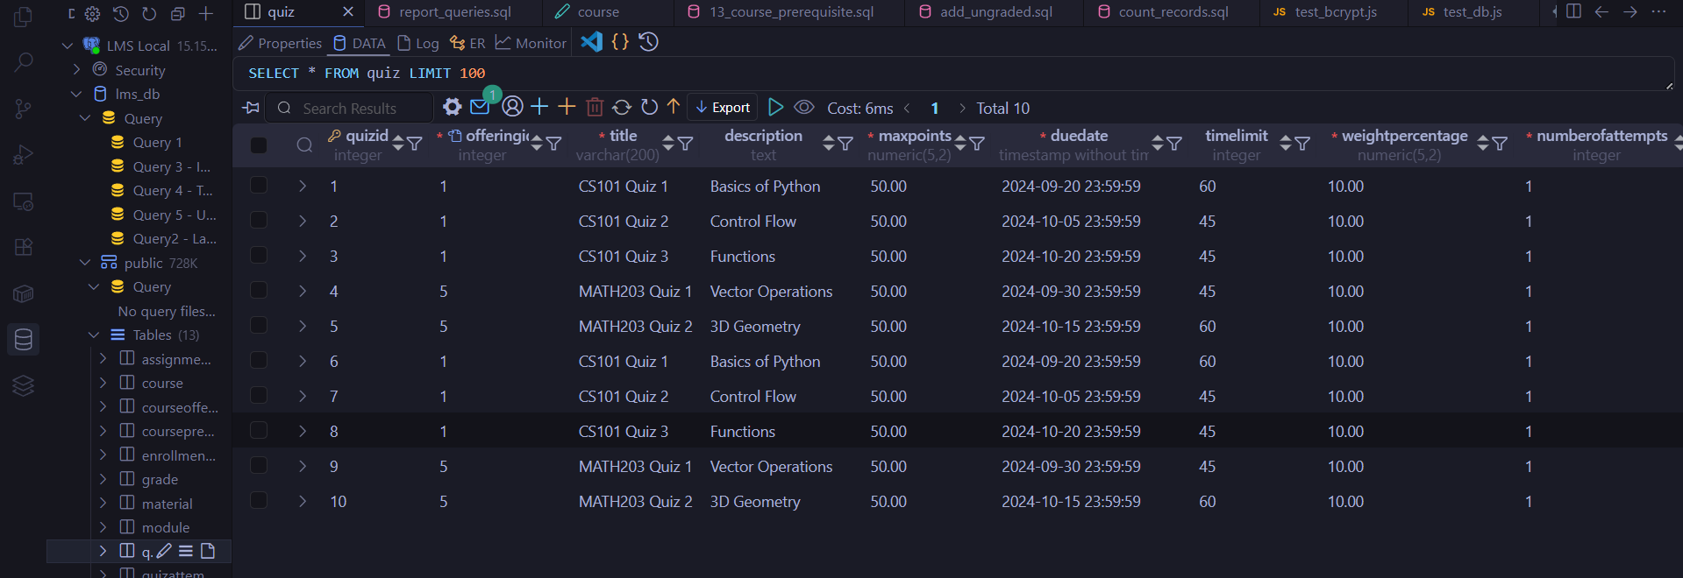

QuizAttempt Table
CREATE TABLE QuizAttempt (
AttemptID SERIAL PRIMARY KEY,
QuizID INTEGER NOT NULL REFERENCES Quiz(QuizID),
StudentID INTEGER NOT NULL REFERENCES "User"(UserID),
AttemptNumber INTEGER NOT NULL CHECK (AttemptNumber > 0),
StartTime TIMESTAMP NOT NULL,
SubmitTime TIMESTAMP NULL,
Score DECIMAL(5,2) NULL CHECK (Score >= 0),
IsCompleted BOOLEAN NOT NULL DEFAULT FALSE,
ResponsesJSON JSON NULL,
UNIQUE (QuizID, StudentID, AttemptNumber)
);
Explanation: QuizAttempt records each student's quiz attempt with timing information and scores. The UNIQUE constraint with AttemptNumber enables multiple attempts while preventing duplicate attempt numbers.
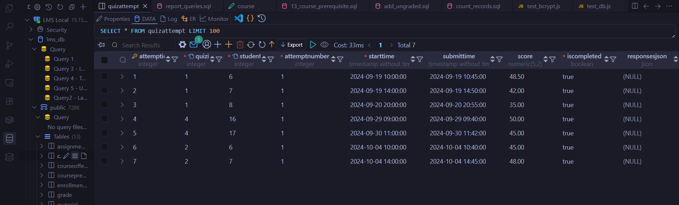

Module Table
CREATE TABLE Module (
ModuleID SERIAL PRIMARY KEY,
OfferingID INTEGER NOT NULL REFERENCES CourseOffering(OfferingID),
ModuleName VARCHAR(200) NOT NULL,
Description TEXT NULL,
SequenceNumber INTEGER NOT NULL CHECK (SequenceNumber > 0),
StartDate DATE NULL,
EndDate DATE NULL,
UNIQUE (OfferingID, SequenceNumber)
);
Explanation: The Module table organizes course content into logical sections with defined sequencing, supporting the content organization requirements in UR-8.
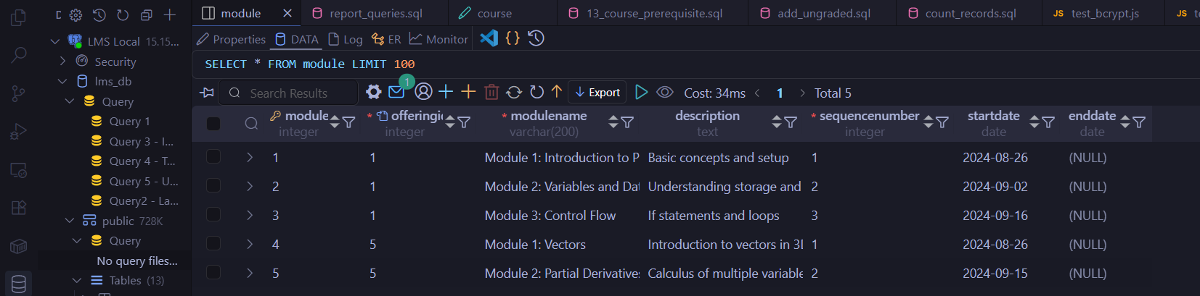

Material Table
CREATE TABLE Material (
MaterialID SERIAL PRIMARY KEY,
ModuleID INTEGER NOT NULL REFERENCES Module(ModuleID),
Title VARCHAR(200) NOT NULL,
Description TEXT NULL,
ContentType content_type NOT NULL,
FileURL VARCHAR(500) NULL,
SequenceNumber INTEGER NOT NULL CHECK (SequenceNumber > 0),
UploadDate TIMESTAMP NOT NULL DEFAULT CURRENT_TIMESTAMP,
UNIQUE (ModuleID, SequenceNumber)
);
Explanation: The Material table stores various content types (documents, videos, links, PDFs, images) organized within modules, supporting multimedia course content.
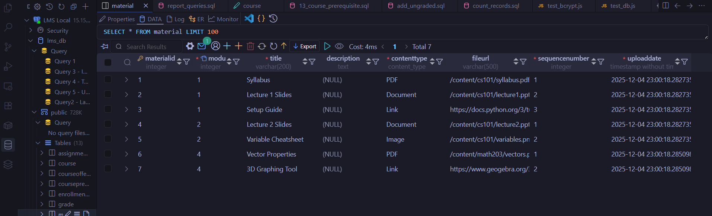

Grade Table
CREATE TABLE Grade (
GradeID SERIAL PRIMARY KEY,
EnrollmentID INTEGER NOT NULL UNIQUE REFERENCES Enrollment(EnrollmentID),
NumericGrade DECIMAL(5,2) NULL
CHECK (NumericGrade >= 0 AND NumericGrade <= 100),
LetterGrade VARCHAR(5) NULL,
GradeDate TIMESTAMP NULL,
Comments TEXT NULL
);
Explanation: The Grade table stores final course grades with both numeric and letter grade formats. The UNIQUE constraint on EnrollmentID ensures one final grade per enrollment (UR-6).
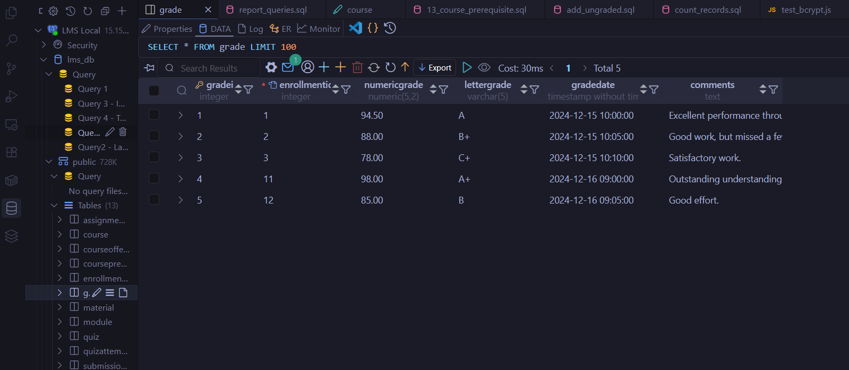

CoursePrerequisite Table
CREATE TABLE CoursePrerequisite (
PrerequisiteID SERIAL PRIMARY KEY,
CourseID INTEGER NOT NULL REFERENCES Course(CourseID),
PrereqCourseID INTEGER NOT NULL REFERENCES Course(CourseID),
UNIQUE (CourseID, PrereqCourseID),
CHECK (CourseID <> PrereqCourseID)
);
Explanation: This table enforces prerequisite relationships between courses, supporting BR-2. The CHECK constraint prevents a course from being its own prerequisite.
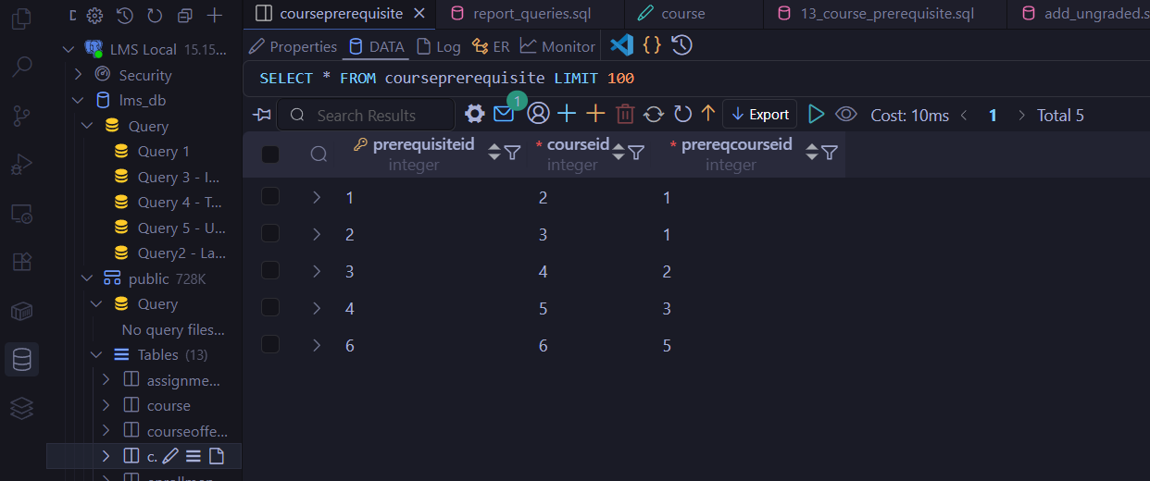

INSERT INTO Statements (Sample Data)
The following SQL statements populate the database with comprehensive test data.

Insert Users (21 Records)
-- Insert Users (21 records: 5 Instructors, 1 Admin, 15 Students)
-- Password for all users is 'password' (hashed with bcrypt)
INSERT INTO "User" (FirstName, LastName, Email, PasswordHash, Role) VALUES
('Michael', 'Johnson', 'michael.johnson@university.edu',
'$2b$10$MqxcwXvQi3Jv1OR3DiV/9ezWIhFGRk1HBndtFbpZbkwG6mIbvZ12e', 'Instructor'),
('Emily', 'Williams', 'emily.williams@university.edu',
'$2b$10$MqxcwXvQi3Jv1OR3DiV/9ezWIhFGRk1HBndtFbpZbkwG6mIbvZ12e', 'Instructor'),
('Daniel', 'Brown', 'daniel.brown@university.edu',
'$2b$10$MqxcwXvQi3Jv1OR3DiV/9ezWIhFGRk1HBndtFbpZbkwG6mIbvZ12e', 'Instructor'),
('Jessica', 'Jones', 'jessica.jones@university.edu',
'$2b$10$MqxcwXvQi3Jv1OR3DiV/9ezWIhFGRk1HBndtFbpZbkwG6mIbvZ12e', 'Instructor'),
('David', 'Miller', 'david.miller@university.edu',
'$2b$10$MqxcwXvQi3Jv1OR3DiV/9ezWIhFGRk1HBndtFbpZbkwG6mIbvZ12e', 'Instructor'),
('Sarah', 'Davis', 'sarah.davis@student.university.edu',
'$2b$10$MqxcwXvQi3Jv1OR3DiV/9ezWIhFGRk1HBndtFbpZbkwG6mIbvZ12e', 'Student'),
('Christopher', 'Garcia', 'christopher.garcia@student.university.edu',
'$2b$10$MqxcwXvQi3Jv1OR3DiV/9ezWIhFGRk1HBndtFbpZbkwG6mIbvZ12e', 'Student'),
('Ashley', 'Rodriguez', 'ashley.rodriguez@student.university.edu',
'$2b$10$MqxcwXvQi3Jv1OR3DiV/9ezWIhFGRk1HBndtFbpZbkwG6mIbvZ12e', 'Student'),
('Matthew', 'Wilson', 'matthew.wilson@student.university.edu',
'$2b$10$MqxcwXvQi3Jv1OR3DiV/9ezWIhFGRk1HBndtFbpZbkwG6mIbvZ12e', 'Student'),
('Amanda', 'Martinez', 'amanda.martinez@student.university.edu',
'$2b$10$MqxcwXvQi3Jv1OR3DiV/9ezWIhFGRk1HBndtFbpZbkwG6mIbvZ12e', 'Student'),
('Joshua', 'Anderson', 'joshua.anderson@student.university.edu',
'$2b$10$MqxcwXvQi3Jv1OR3DiV/9ezWIhFGRk1HBndtFbpZbkwG6mIbvZ12e', 'Student'),
('Megan', 'Taylor', 'megan.taylor@student.university.edu',
'$2b$10$MqxcwXvQi3Jv1OR3DiV/9ezWIhFGRk1HBndtFbpZbkwG6mIbvZ12e', 'Student'),
('Andrew', 'Thomas', 'andrew.thomas@student.university.edu',
'$2b$10$MqxcwXvQi3Jv1OR3DiV/9ezWIhFGRk1HBndtFbpZbkwG6mIbvZ12e', 'Student'),
('Jennifer', 'Hernandez', 'jennifer.hernandez@student.university.edu',
'$2b$10$MqxcwXvQi3Jv1OR3DiV/9ezWIhFGRk1HBndtFbpZbkwG6mIbvZ12e', 'Student'),
('James', 'Moore', 'james.moore@student.university.edu',
'$2b$10$MqxcwXvQi3Jv1OR3DiV/9ezWIhFGRk1HBndtFbpZbkwG6mIbvZ12e', 'Student'),
('Elizabeth', 'Martin', 'elizabeth.martin@student.university.edu',
'$2b$10$MqxcwXvQi3Jv1OR3DiV/9ezWIhFGRk1HBndtFbpZbkwG6mIbvZ12e', 'Student'),
('Robert', 'Jackson', 'robert.jackson@student.university.edu',
'$2b$10$MqxcwXvQi3Jv1OR3DiV/9ezWIhFGRk1HBndtFbpZbkwG6mIbvZ12e', 'Student'),
('Linda', 'Thompson', 'linda.thompson@student.university.edu',
'$2b$10$MqxcwXvQi3Jv1OR3DiV/9ezWIhFGRk1HBndtFbpZbkwG6mIbvZ12e', 'Student'),
('William', 'White', 'william.white@student.university.edu',
'$2b$10$MqxcwXvQi3Jv1OR3DiV/9ezWIhFGRk1HBndtFbpZbkwG6mIbvZ12e', 'Student'),
('Patricia', 'Harris', 'patricia.harris@student.university.edu',
'$2b$10$MqxcwXvQi3Jv1OR3DiV/9ezWIhFGRk1HBndtFbpZbkwG6mIbvZ12e', 'Student'),
('Admin', 'User', 'admin@lms.com',
'$2b$10$MqxcwXvQi3Jv1OR3DiV/9ezWIhFGRk1HBndtFbpZbkwG6mIbvZ12e', 'Admin');
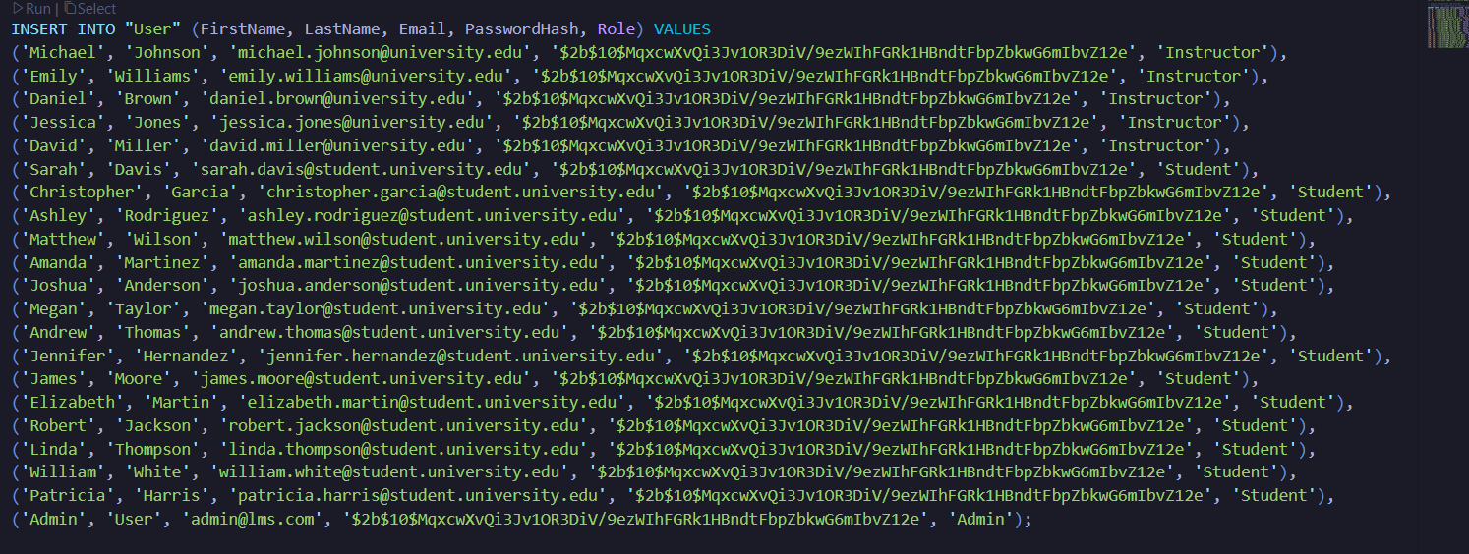

Insert Courses (20 Records)
-- Insert Courses (20 records across various departments)
INSERT INTO Course (CourseCode, CourseName, Description, CreditHours, Department) VALUES
('CS101', 'Introduction to Computer Science',
'A foundational course on the principles of computer science.', 3.0, 'Computer Science'),
('MATH203', 'Calculus III',
'Advanced topics in calculus, including multi-variable calculus.', 4.0, 'Mathematics'),
('PHYS101', 'General Physics I',
'An introduction to classical mechanics.', 4.0, 'Physics'),
('ENGL220', 'British Literature',
'A survey of major British writers from the medieval period to the 20th century.', 3.0, 'English'),
('HIST301', 'American History: 1865 to Present',
'A study of the United States from the end of the Civil War to modern times.', 3.0, 'History'),
('ART100', 'Introduction to Art History',
'A survey of Western art from the ancient world to the present.', 3.0, 'Art History'),
('BIO101', 'General Biology', 'Introduction to biology.', 4.0, 'Biology'),
('CHEM101', 'General Chemistry', 'Introduction to chemistry.', 4.0, 'Chemistry'),
('PSY101', 'Intro to Psychology', 'Basics of psychology.', 3.0, 'Psychology'),
('SOC101', 'Intro to Sociology', 'Basics of sociology.', 3.0, 'Sociology'),
('ECON101', 'Microeconomics', 'Principles of microeconomics.', 3.0, 'Economics'),
('ECON102', 'Macroeconomics', 'Principles of macroeconomics.', 3.0, 'Economics'),
('POLS101', 'Intro to Political Science', 'Basics of politics.', 3.0, 'Political Science'),
('PHIL101', 'Intro to Philosophy', 'Basics of philosophy.', 3.0, 'Philosophy'),
('MUS101', 'Music Appreciation', 'History of music.', 3.0, 'Music'),
('THEA101', 'Intro to Theatre', 'Basics of theatre arts.', 3.0, 'Theatre'),
('ANTH101', 'Intro to Anthropology', 'Study of human societies.', 3.0, 'Anthropology'),
('GEOG101', 'Intro to Geography', 'Study of earth and people.', 3.0, 'Geography'),
('COMM101', 'Public Speaking', 'Effective communication.', 3.0, 'Communications'),
('BUS101', 'Intro to Business', 'Basics of business administration.', 3.0, 'Business');
(For testing purposes, we ran upto 6 records only!)
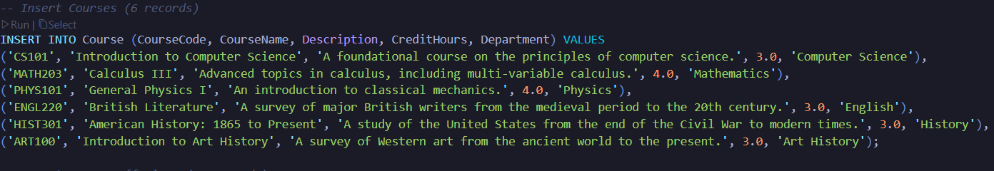

Insert Terms (5 Records)
INSERT INTO Term (TermName, TermType, StartDate, EndDate) VALUES
('Fall 2024', 'Fall', '2024-08-26', '2024-12-13'),
('Spring 2025', 'Spring', '2025-01-13', '2025-05-09'),
('Fall 2025', 'Fall', '2025-08-25', '2025-12-12'),
('Spring 2026', 'Spring', '2026-01-12', '2026-05-08'),
('Summer 2026', 'Summer', '2026-05-18', '2026-08-07');
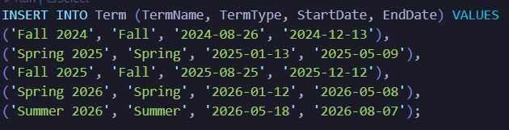

Insert Course Offerings (20 Records)
-- Insert Course Offerings (20 records linking courses to terms)
INSERT INTO CourseOffering (CourseID, TermID, InstructorID, SectionNumber, MaxEnrollment) VALUES
(1, 1, 1, '001', 50), (1, 2, 2, '001', 50), (1, 3, 1, '001', 60), (1, 4, 2, '002', 60),
(2, 1, 3, 'A', 35), (2, 2, 3, 'A', 40), (2, 3, 4, 'B', 40), (2, 4, 4, 'B', 40),
(3, 1, 5, 'S1', 70), (3, 2, 5, 'S1', 75), (3, 3, 1, 'S2', 75),
(4, 2, 2, 'L1', 30), (4, 3, 2, 'L1', 30), (4, 4, 3, 'L2', 35),
(5, 1, 4, 'H1', 45), (5, 3, 4, 'H1', 50),
(6, 2, 5, 'AH1', 80), (6, 4, 5, 'AH1', 80),
(7, 1, 1, '001', 50), (8, 1, 2, '001', 50);
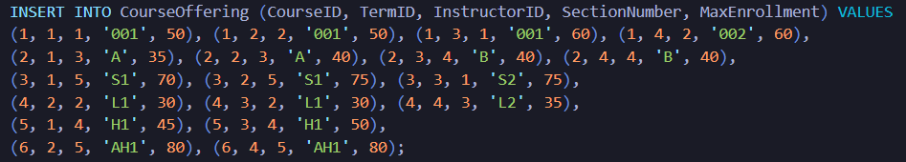

Insert Enrollments (25 Records)
-- Insert Enrollments (25 records - students enrolling in courses)
INSERT INTO Enrollment (StudentID, OfferingID) VALUES
(6, 1), (7, 1), (8, 1), (9, 1), (10, 1),
(11, 2), (12, 2), (13, 2), (14, 2), (15, 2),
(16, 5), (17, 5), (18, 5), (19, 5), (20, 5),
(6, 6), (7, 7), (8, 8), (9, 9), (10, 10),
(11, 11), (12, 12), (13, 13), (14, 14), (15, 15);

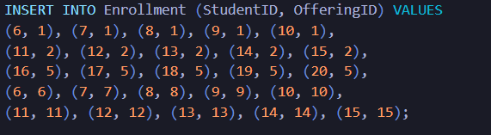

Insert Assignments (20 Records)
-- Insert Assignments (20 records across various course offerings)
INSERT INTO Assignment (OfferingID, Title, Description, MaxPoints, DueDate, WeightPercentage) VALUES
(1, 'CS101 HW1', 'Hello World program.', 100, '2024-09-10', 10),
(1, 'CS101 HW2', 'Variables and Data Types.', 100, '2024-09-24', 10),
(2, 'CS101 HW3', 'Control Flow.', 100, '2025-02-15', 15),
(3, 'CS101 Midterm Project', 'Build a simple calculator.', 200, '2025-10-20', 25),
(3, 'CS101 Final Project', 'Build a text-based adventure game.', 300, '2025-12-05', 35),
(5, 'MATH203 HW1', 'Vectors and the Geometry of Space.', 100, '2024-09-12', 5),
(5, 'MATH203 HW2', 'Vector Functions.', 100, '2024-09-26', 5),
(6, 'MATH203 Exam 1', 'Midterm exam covering chapters 12-13.', 150, '2025-03-01', 20),
(7, 'MATH203 HW3', 'Partial Derivatives.', 100, '2025-10-15', 5),
(8, 'MATH203 Final Exam', 'Comprehensive final exam.', 250, '2026-05-01', 30),
(9, 'PHYS101 Lab 1', 'Measurement and Error Analysis.', 50, '2024-09-05', 5),
(9, 'PHYS101 Lab 2', 'Kinematics.', 50, '2024-09-19', 5),
(10, 'PHYS101 Midterm 1', 'Covering chapters 1-5.', 100, '2025-03-10', 20),
(11, 'PHYS101 Lab 3', 'Newtons Laws.', 50, '2025-10-02', 5),
(12, 'ENGL220 Essay 1', 'Analysis of Beowulf.', 100, '2025-02-20', 25),
(12, 'ENGL220 Essay 2', 'Shakespearean Sonnet Analysis.', 100, '2025-04-10', 25),
(14, 'HIST301 Research Paper Proposal', 'Submit topic and bibliography.', 50, '2026-02-28', 10),
(15, 'HIST301 Midterm Exam', 'Exam covering Reconstruction to WWII.', 100, '2024-10-25', 30),
(16, 'ART100 Museum Visit Report', 'Report on a visit to a local art museum.', 100, '2025-11-15', 20),
(17, 'ART100 Final Paper', 'Research paper on a Renaissance artist.', 150, '2026-04-20', 30);
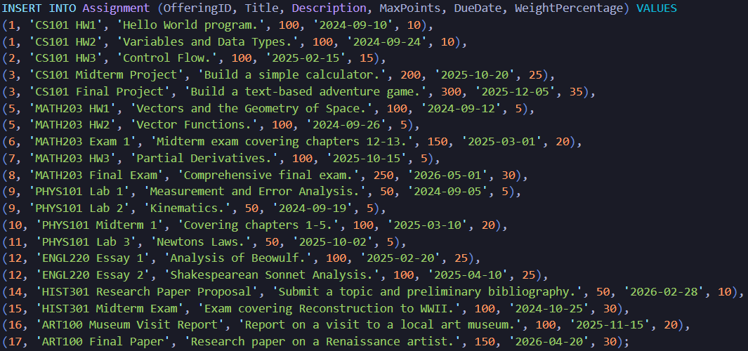

Insert Submissions (20 Records)
-- Insert Submissions (20 records - student work submissions)
INSERT INTO Submission (AssignmentID, StudentID, FileURL, IsLate, VersionNumber, Score) VALUES
(1, 6, '/sub/cs101_hw1_s6.zip', false, 1, 95),
(1, 7, '/sub/cs101_hw1_s7.zip', false, 1, 88),
(2, 6, '/sub/cs101_hw2_s6.zip', false, 1, 92),
(2, 8, '/sub/cs101_hw2_s8.zip', true, 2, 75),
(4, 9, '/sub/cs101_midterm_s9.zip', false, 1, 180),
(4, 10, '/sub/cs101_midterm_s10.zip', false, 1, 165),
(6, 16, '/sub/math203_hw1_s16.pdf', false, 1, 100),
(6, 17, '/sub/math203_hw1_s17.pdf', false, 1, 94),
(7, 18, '/sub/math203_hw2_s18.pdf', false, 1, 85),
(9, 19, '/sub/math203_hw3_s19.pdf', true, 1, 80),
(11, 6, '/sub/phys101_lab1_s6.pdf', false, 1, 45),
(11, 7, '/sub/phys101_lab1_s7.pdf', false, 1, 48),
(12, 11, '/sub/phys101_lab2_s11.pdf', false, 1, 50),
(15, 12, '/sub/engl220_essay1_s12.docx', false, 1, 82),
(15, 13, '/sub/engl220_essay1_s13.docx', false, 1, 91),
(16, 14, '/sub/engl220_essay2_s14.docx', true, 1, 78),
(17, 15, '/sub/hist301_proposal_s15.pdf', false, 1, 45),
(18, 16, '/sub/hist301_midterm_s16.pdf', false, 1, 88),
(19, 17, '/sub/art100_report_s17.docx', false, 1, 92),
(20, 18, '/sub/art100_paper_s18.docx', false, 1, 135);
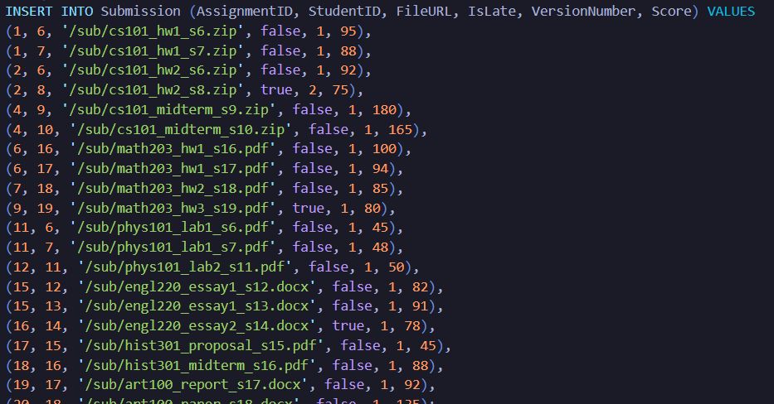
For the record – I included these statements in a data seeding file, that when executed, sends the data to the database.

Database Triggers
The following triggers automate business logic and maintain data integrity:
-- Function to automatically update enrollment count
CREATE OR REPLACE FUNCTION fn_UpdateEnrollmentCount()
RETURNS TRIGGER AS $$
BEGIN
IF (TG_OP = 'INSERT') THEN
UPDATE CourseOffering
SET CurrentEnrollment = CurrentEnrollment + 1
WHERE OfferingID = NEW.OfferingID;
ELSIF (TG_OP = 'DELETE') THEN
UPDATE CourseOffering
SET CurrentEnrollment = CurrentEnrollment - 1
WHERE OfferingID = OLD.OfferingID;
END IF;
RETURN NULL;
END;
$$ LANGUAGE plpgsql;

CREATE TRIGGER trg_UpdateEnrollmentCount
AFTER INSERT OR DELETE ON Enrollment
FOR EACH ROW
EXECUTE FUNCTION fn_UpdateEnrollmentCount();

-- Function to prevent over-enrollment (BR-1)
CREATE OR REPLACE FUNCTION fn_PreventOverEnrollment()
RETURNS TRIGGER AS $$
DECLARE
curr_count INTEGER;
max_count INTEGER;
BEGIN
SELECT CurrentEnrollment, MaxEnrollment INTO curr_count, max_count
FROM CourseOffering
WHERE OfferingID = NEW.OfferingID;

IF curr_count >= max_count THEN
RAISE EXCEPTION 'Course is full. Cannot enroll.';
END IF;

RETURN NEW;
END;
$$ LANGUAGE plpgsql;

CREATE TRIGGER trg_PreventOverEnrollment
BEFORE INSERT ON Enrollment
FOR EACH ROW
EXECUTE FUNCTION fn_PreventOverEnrollment();
Explanation: These triggers enforce Business Rule BR-1 (Enrollment Capacity Enforcement) by automatically tracking enrollment counts and preventing over-enrollment.

Performance Indexes
-- Indexes for improved query performance
CREATE INDEX idx_user_lastname ON "User" (LastName);
CREATE INDEX idx_user_role ON "User" (Role);
CREATE INDEX idx_course_code ON Course (CourseCode);
CREATE INDEX idx_course_dept ON Course (Department);
CREATE INDEX idx_enrollment_student ON Enrollment (StudentID);
CREATE INDEX idx_enrollment_offering ON Enrollment (OfferingID);
CREATE INDEX idx_submission_assignment ON Submission (AssignmentID);
CREATE INDEX idx_submission_student ON Submission (StudentID);
CREATE INDEX idx_grade_enrollment ON Grade (EnrollmentID);
CREATE INDEX idx_offering_term ON CourseOffering (TermID);
CREATE INDEX idx_offering_instructor ON CourseOffering (InstructorID);
CREATE INDEX idx_offering_course ON CourseOffering (CourseID);
Explanation: These indexes optimize common query patterns such as student lookups, enrollment queries, and submission retrieval.

2.2 Data Retrieval and Simple Reports (30 Points)
This section presents five data analysis queries that demonstrate the database's analytical capabilities. Each query includes scalar functions, aggregate functions, and joins or subqueries as required.

Query 1: Calculate Average Assignment Grades
Plain English Statement: What is the average grade for each assignment in a specific course offering (CS101, Fall 2025)? This query helps instructors understand overall student performance on different assignments.
Query Features:
- Aggregate Functions: AVG(), MAX(), MIN()
- JOIN: Submission JOIN Assignment
- Filtering: WHERE clause on OfferingID
- Grouping: GROUP BY with ORDER BY

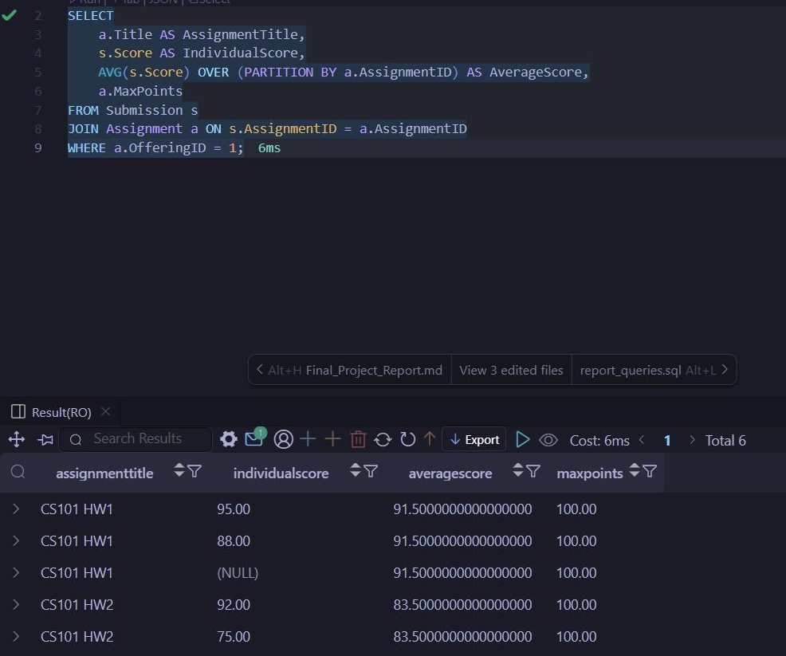

Query 2: Find Students with Late Submissions
Plain English Statement: Which students have submitted one or more assignments late? This query is useful for identifying students who may be struggling with deadlines, enabling early intervention.
Query Features:
- Scalar Function: Date subtraction for calculating days late
- Multiple JOINs: 5 tables joined (User, Submission, Assignment, CourseOffering, Course)
- Boolean Filtering: WHERE s.IsLate = TRUE
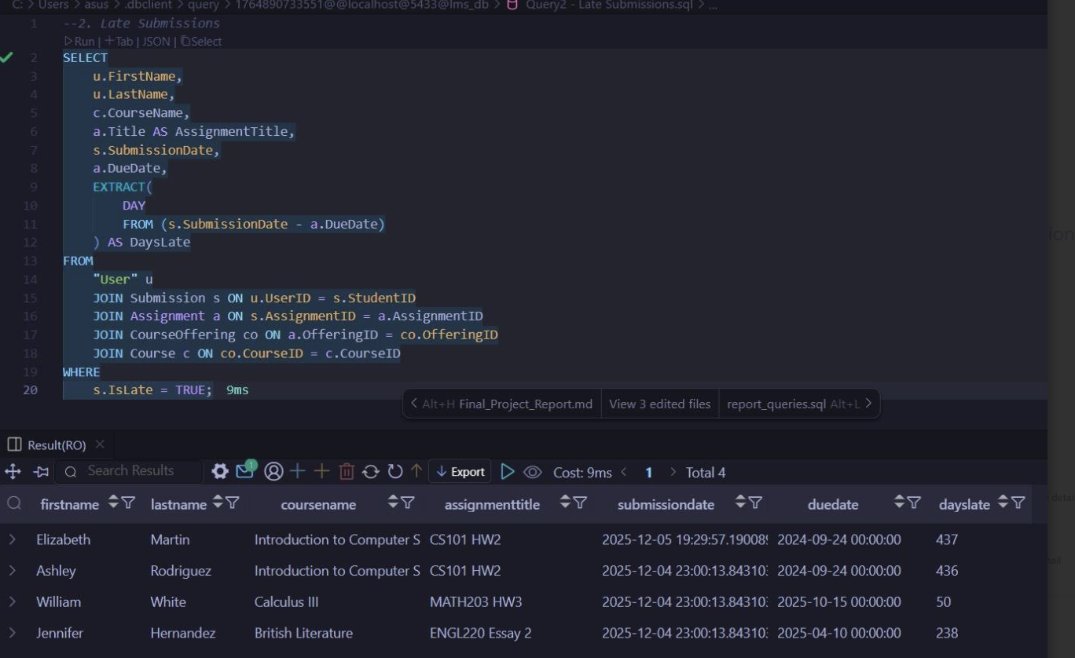

Query 3: Instructor Teaching Load Analysis
Plain English Statement: What is the teaching load for a specific instructor (Michael Johnson) in the Fall 2025 term, showing the number of students enrolled in each course section? This provides an overview of workload distribution.
SQL SELECT Statement:
SELECT
c.CourseName,
c.CourseCode,
co.SectionNumber,
t.TermName,
COUNT(e.StudentID) AS NumberOfStudents,
co.MaxEnrollment,
ROUND((COUNT(e.StudentID)::DECIMAL / co.MaxEnrollment) * 100, 1) AS FillRatePercent
FROM
Course c
JOIN
CourseOffering co ON c.CourseID = co.CourseID
JOIN
Term t ON co.TermID = t.TermID
LEFT JOIN
Enrollment e ON co.OfferingID = e.OfferingID
WHERE
co.InstructorID = 1
AND t.TermName = 'Fall 2025'
GROUP BY
c.CourseName, c.CourseCode, co.SectionNumber, t.TermName, co.MaxEnrollment
ORDER BY
c.CourseName;

Query Features:
- Aggregate Functions: COUNT()
- Scalar Functions: ROUND(), type casting (::DECIMAL)
- LEFT JOIN: To include courses with zero enrollments
- Multiple Conditions: AND in WHERE clause
- Calculated Column: Fill rate percentage
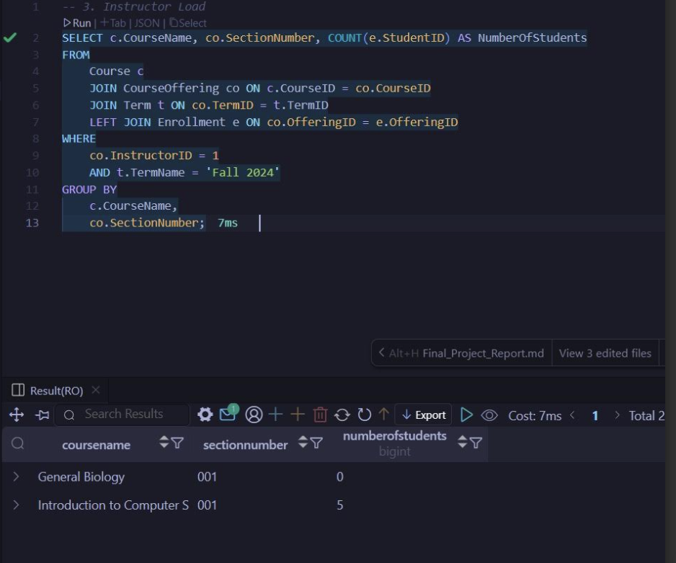

Query 4: Top 5 Performing Students in a Course
Plain English Statement: Who are the top 5 students with the highest average score in a specific course (CS101, Fall 2024)? This helps identify high-performing students for recognition or peer mentoring programs.
Query Features:
- Aggregate Functions: AVG(), COUNT(), SUM()
- Scalar Functions: ROUND()
- HAVING Clause: Filters grouped results
- LIMIT Clause: Returns only top 5 results
- Multiple JOINs: User, Submission, Assignment
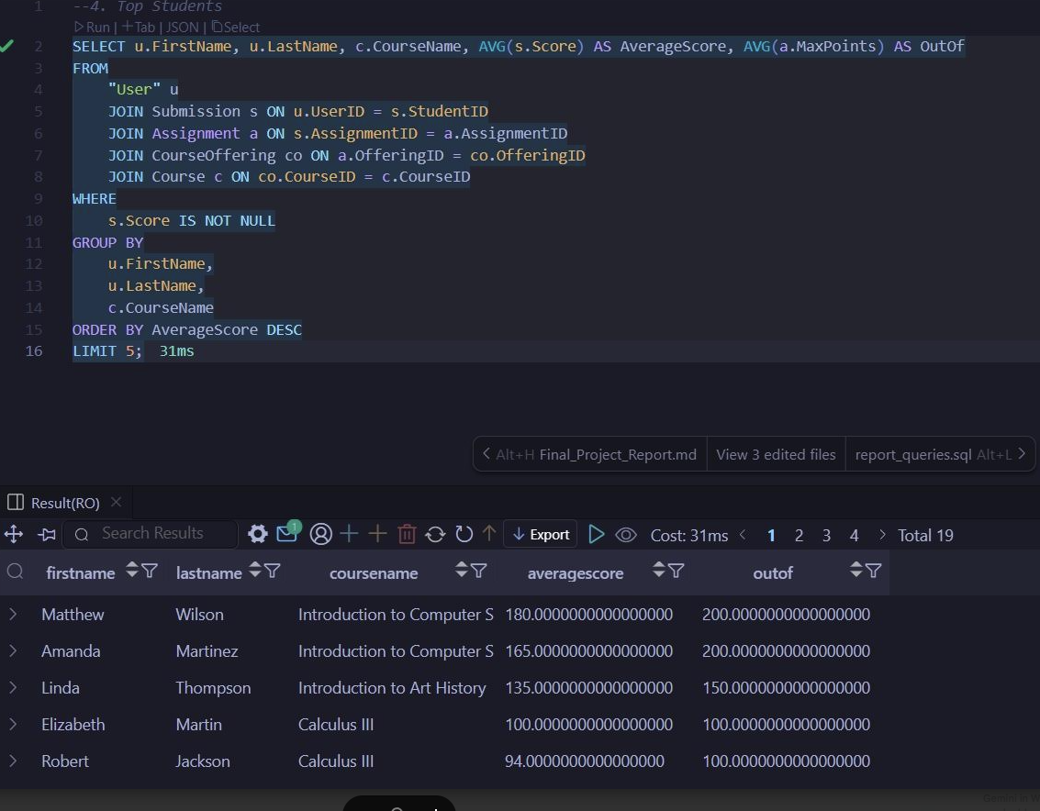

Query 5: Ungraded Submissions Report (Instructor To-Do List)
Plain English Statement: Which submitted assignments across all courses are currently ungraded? This query serves as a to-do list for instructors, showing them which submissions need their attention.
Query Features:
- Scalar Functions: CURRENT_DATE, type casting, date arithmetic
- CASE Expression: Conditional logic for late submission display
- Multiple JOINs: 5 tables (Submission, Assignment, CourseOffering, Course, User)
- NULL Filtering: WHERE s.Score IS NULL
- Multiple ORDER BY: Prioritizes oldest submissions
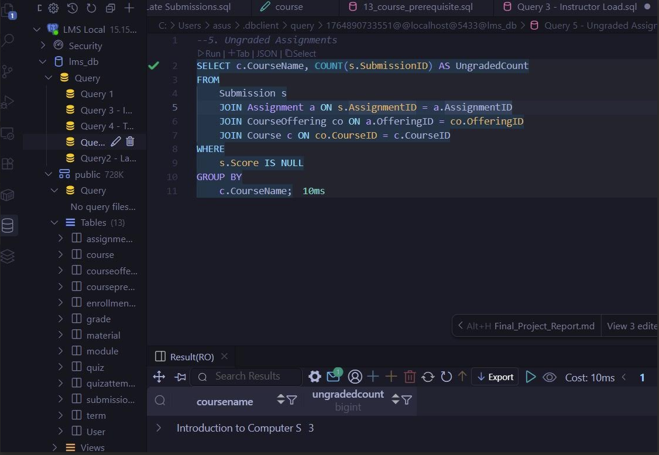

Appendix A: Complete SQL Scripts Location
All SQL scripts for recreating this database are located in the code/sql/ directory:
File | Purpose
schema/01_user.sql through schema/13_course_prerequisite.sql | Individual table creation scripts
seed_final.sql | Primary seed data (Users, Courses, Terms, Offerings, Enrollments, Assignments, Submissions)
seed_extended.sql | Extended seed data (Quizzes, QuizAttempts, Modules, Materials, Grades)
indexes.sql | Performance optimization indexes
triggers.sql | Business logic automation triggers
analysis_queries.sql | The 5 analysis queries documented in Section 2.2

Appendix B: Database Connection Information
To set up and test this database locally:
Using Docker:
docker-compose up -d
Connection Parameters:
  - Host: localhost
  - Port: 5432
  - Database: lms_db
  - Username: postgres
  - Password: postgres
Running SQL Scripts:
psql -h localhost -U postgres -d lms_db -f code/sql/schema/01_user.sql
# ... (repeat for all schema files in order)
psql -h localhost -U postgres -d lms_db -f code/sql/seed_final.sql
psql -h localhost -U postgres -d lms_db -f code/sql/seed_extended.sql

AI Use Disclosure Statement
- AI Tools Used:
  - Claude AI (Anthropic) was used to assist with structuring the proposal document, expanding on technical requirements, and ensuring comprehensive coverage of user requirements and scope definition.
  - Gemini (2.5 Flash) was used to assist with structuring the Design Phase Report, refining business rules, expanding user requirements, and improving grammar and clarity.
- Human Contributions: All project concepts, team decisions, and core content were developed by the team members. AI was used as a writing assistant to improve clarity, organization, and professional presentation of our ideas.
- Verification: The AI-generated suggestions were all checked, confirmed, and accepted by the team members to ensure they are accurate, relevant, and correspond to the course requirements and principles of database design.
- Limitations Acknowledged: The team recognizes that human judgment cannot be substituted by the use of AI tools in determining what to include in a database design. The overall design decision is based on the knowledge the team had on the problem domain and the database normalization principles.

