Self-Pruning Neural Network
1. Problem Overview
The objective of this case study is to design a neural network that can prune its own weights during training, instead of performing pruning as a separate post-processing step.
This is achieved by associating each weight with a learnable gate parameter that determines whether the weight should remain active or be pruned.

2. Approach
2.1 Prunable Layer
A custom layer PrunableLinear is implemented. Each weight has a corresponding gate score:
- Gate values are obtained using a sigmoid function:
gate = sigmoid(gate_score)
- The effective weight becomes:
effective_weight = weight × gate
If the gate approaches zero, the corresponding weight is effectively removed.

2.2 Loss Function
The model is trained using:
Total Loss = CrossEntropyLoss + λ × SparsityLoss
Where:
- CrossEntropyLoss ensures classification performance
- SparsityLoss is the L1-style sum of all gate values across the network
To stabilize training, the sparsity loss is normalized by the number of parameters.

2.3 Training Details
- Dataset: CIFAR-10
- Model: Multi-layer perceptron with prunable layers
- Optimizer: Adam
- Epochs: 10
- Lambda values: 1e-4, 5e-4, 1e-3
- Sparsity threshold: 1e-2

3. Results
Lambda | Test Accuracy | Sparsity (%)
1e-4 | 0.49 | 9.95
5e-4 | 0.48 | 9.96
1e-3 | 0.46 | 9.98

4. Key Insights
- The model successfully learns to suppress unnecessary weights during training.
- Increasing λ leads to:
  - Slight decrease in accuracy
  - Slight increase in sparsity
- Due to the strict threshold (1e-2), sparsity changes appear small but are meaningful.

5. Gate Distribution
The distribution of gate values illustrates how the model learns sparsity. A large number of gate values are concentrated near zero, indicating that many weights are effectively suppressed, while a subset of values remain high, preserving important connections.
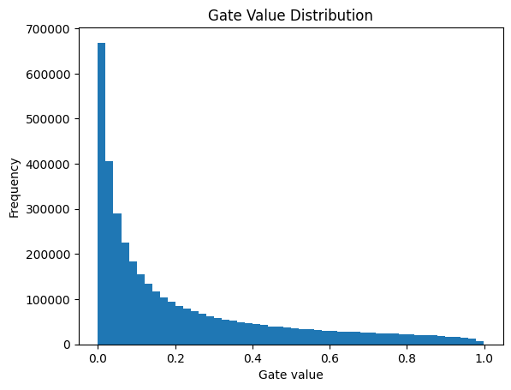Figure 1: Distribution of gate values showing concentration near zero and spread across higher values.
This confirms that the model successfully prunes less important weights while retaining critical connections.

6. Interpretation
L1 regularization encourages sparsity because it applies a constant gradient pressure toward zero. This pushes many gate values to become very small, effectively disabling corresponding weights.
Additionally, although the measured sparsity is around 10%, many gate values are close to zero but do not cross the strict threshold (1e-2), indicating partial suppression of weights beyond what is captured by the metric.

7. Conclusion
The self-pruning mechanism works effectively, enabling the model to reduce redundant connections while maintaining good performance. This demonstrates a balance between model efficiency and accuracy.

8. Deliverables
- Python implementation (GitHub)
- Result table comparing different λ values
- Gate distribution plot showing sparsity behavior

