**Redgate Flyway**

**Why Flyway & What it Solves:**

Flyway is based on the concept of "migrations," which are scripts that modify the database schema. These migrations are versioned and executed in sequence (Incremental order).

* **Migration Scripts**: Each migration script is versioned, usually with a name like V1__Initial_schema.sql, V2__Add_column.sql, etc.
* **Flyway Locations**: The migrations are stored in a specific directory. The default directory is db/migration, but it can be customized.
* **Flyway Metadata Table**: Flyway keeps track of the migrations applied to a database in a table called flyway_schema_history. This table stores the version, description, and checksum of each applied migration.

**Core Flyway commands**

**a. flyway migrate**

**Purpose**: This command applies all the pending migrations to the database.

**Syntax :** flyway migrate

**Description :** Flyway will look at the database and apply any migration scripts that have not yet been executed, based on their version numbers.

**b. flyway clean**

**Purpose**: This command drops all objects (tables, views, etc.) in the schema. **Use with caution** as it can delete all data.

**Syntax** : flyway clean

**Description**: It's usually used in development or testing environments where you want to reset the database. **It's irreversible**, so don't use it in production without proper backups.

**Setting up Flyway Migration on Existing DB Schema :**

To make flyway recognize that the DB has existing schema and need to create a fresh SchemaHistory table we need to keep below parameter to true in conf file.

**flyway.baselineOnMigrate=true**

Below is the screenshot when we keep the parameter to **false**

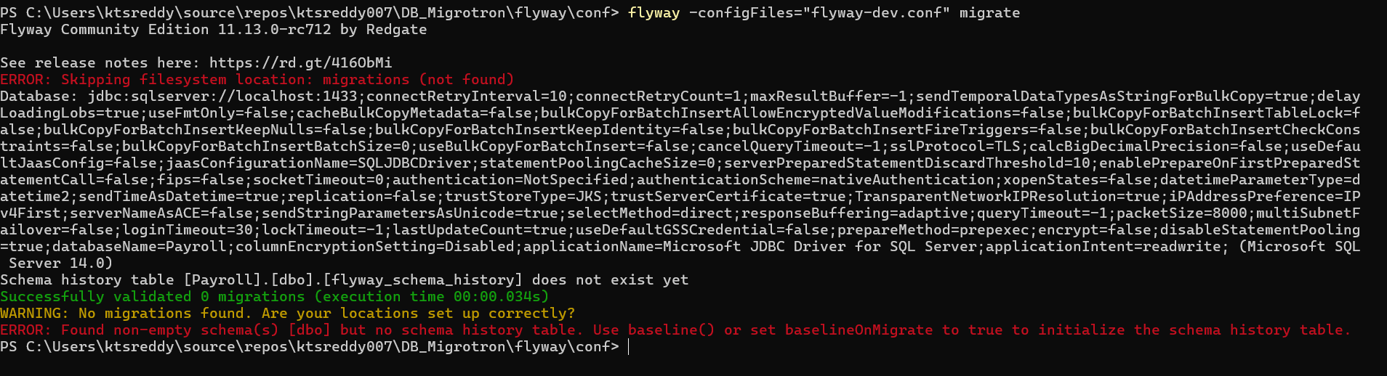

After Setting up to **true** we get below output where its creating schema history table .

