I developed application using RestEasy. I used Eclipse IDE, glassfish server for the development. I implemented a Rest WebService which implements all the atm methods deposit,withdrawl and balance. Defined annotation path “BankApp” for the class Bank and defined annotation paths for each method in Bank class. Used MatrixParam annotation to receive multiple parameters for each method. We can access these methods using urls. Following are the urls used to access the methods and inputs,outputs for each methods in my rest service.

a) http://localhost:8080/Bank/rest/BankApp;accountNumber=1234;pwd=12 is the url to verify account details. I have a default account number 1234 and pwd 12. This method is invoked by deposit,withdraw and balance to verfiy whether the account details received are valid. This is invoked on client side to verify whether user provided valid account number and password, then only he will be given options.

b) http://localhost:8080/Bank/rest/BankApp/deposit;accNum=1234;pwd=12;amount=400 is the url to access deposit method of rest service. The deposit method accepts three parameters account number, password and amount to be deposited. This method checks whether the credentials are valid, if not returns a status code 401 and displays that given information is invalid. If the credentials are correct then returns a string saying that deposit is successful and shows the balance in the account. You have to pass all these parameters through url.

c) http://localhost:8080/Bank/rest/BankApp/withdraw;accNum=1234;pwd=12;amount=400 is the url to access withdraw method of rest service. The withdraw method accepts three parameters account number, password and amount to be deposited. This method checks whether the credentials are valid, if not returns a status code 401 and displays that given information is invalid. If the credentials are correct then returns a string saying that withdraw is successful and shows the balance in the account. You have to pass all these parameters through url.

d)http://localhost:8080/Bank/rest/BankApp/balance;accNum=1234;pwd=12 is the url to access balance method of rest service. The balance method accepts two parameters account number, password. This method checks whether the credentials are valid, if not returns a status code 401 and displays that given information is invalid. If the credentials are correct, shows the balance in the account. You have to pass all these parameters through url.

I implemented a client called BankClient to access the rest service and this has main method. It constructs urls with the required parameters that is given by the user as input. Constructs a request object by passing the url as parameter to HttpGet method. This request object is the parameter for HttpClient which sends the request to rest service and returns response received. The main method on this class asks for account details. When the user enters the details it verfies the results by passing verfiyaccount url to HttpGet method. If the status received from the client response is 200, then it gives the user with options to peform operations like deposit,withdraw and balance. When user selects an option, client invokes the url using HttpClient and receives the Httpresponse.

The following screen shot shows how to run the Rest Service from eclipse

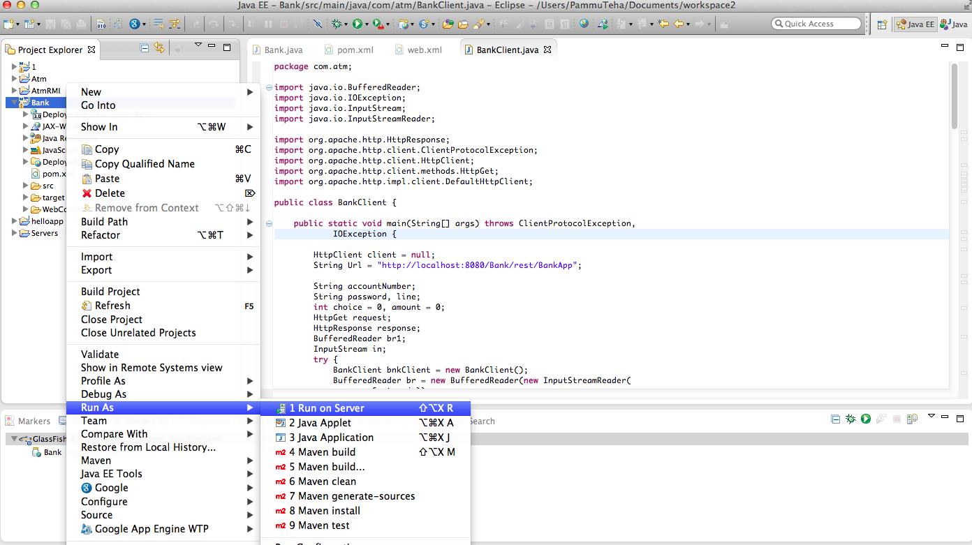

Screen shot showing that glass fish server started and Bank(my project name) application is deployed.

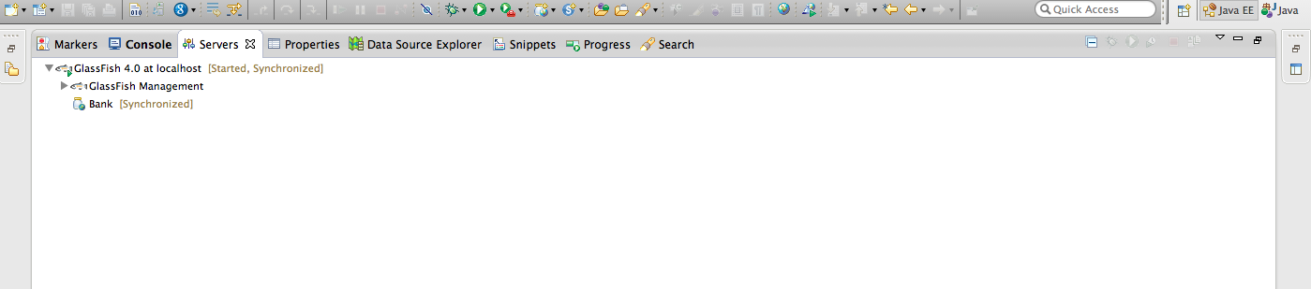

The following screen shows how to run the client (BankClient.java)

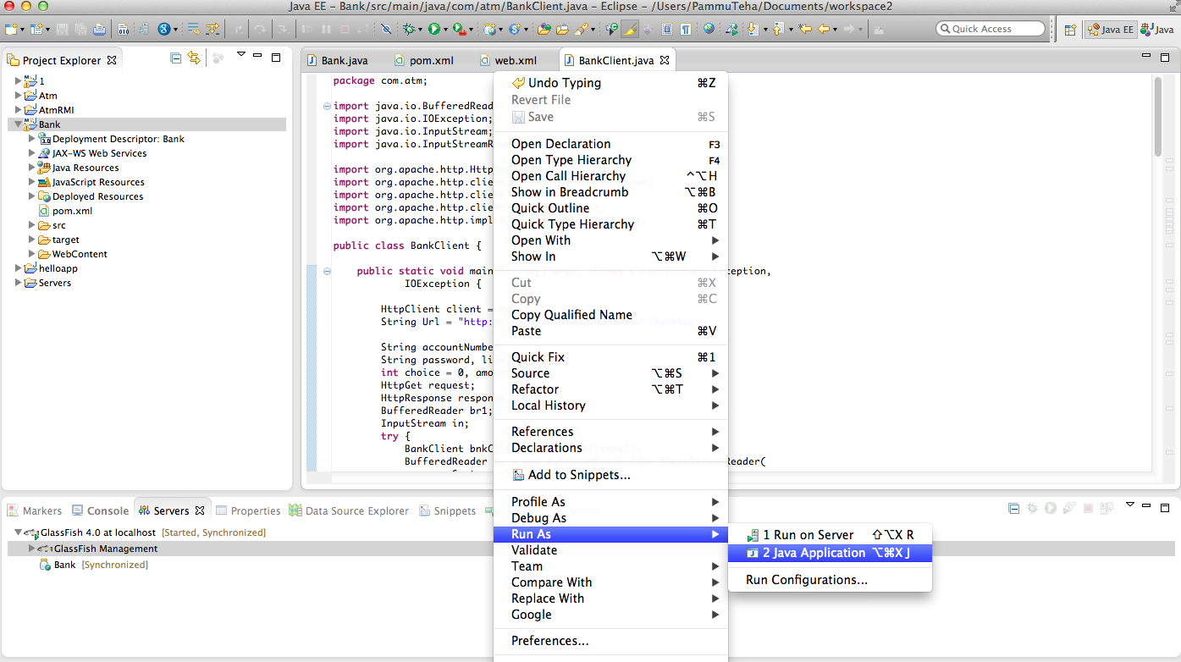

The following screen shows the output of executing the client
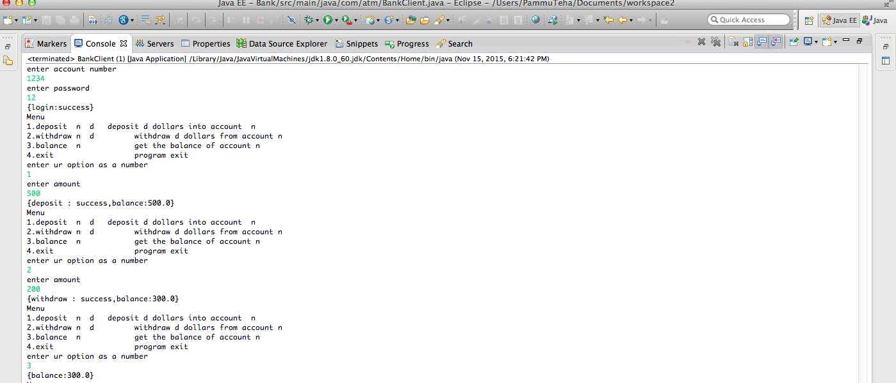

Source code in Bank.java file

package com.atm;

import javax.ws.rs.GET;
import javax.ws.rs.MatrixParam;
import javax.ws.rs.Path;
import javax.ws.rs.Produces;
import javax.ws.rs.core.MediaType;
import javax.ws.rs.core.Response;
/*
* Rest Service which implements deposit,withdraw and balance.
*/
@Path("/BankApp")
public class Bank {
private String accountNum = "1234";
private String password = "12";
static double balance = 0;
int accountError = 1;
int pwdError = 2;
int acctpwdError = 3;
int success = 0;

@GET
@Produces(MediaType.APPLICATION_JSON)
public Response verifyAccount(@MatrixParam("accountNumber") String accountNumber,
@MatrixParam("pwd") String pwd) {
String value = "success";
int status = 200;
if (accountNumber == null || !accountNumber.equals(accountNum) || accountNumber.isEmpty()) {
if (!password.equals(pwd)) {
value = "Invalid account and password";
status = 401;
} else {
value = "Invalid account";
status = 401;
}
}
if (pwd == null || !password.equals(pwd) || pwd.isEmpty()) {
if (!accountNumber.equals(accountNum)) {
value = "Invalid account and password";
status = 401;
} else {
value = "Invalid password";
status = 401;
}
}

return Response.status(status).entity("{login:" + value + "}").build();

}

@GET
@Path("deposit")
@Produces(MediaType.APPLICATION_JSON)
public Response deposit(@MatrixParam("accNum") String accNum,
@MatrixParam("pwd") String pwd, @MatrixParam("amount") double amount) {
Response res = verifyAccount(accNum, pwd);
if (res.getStatus() == 200) {
balance += amount;
return Response.status(200).entity("{" + "deposit : success" + ",balance:" + balance+ "}").build();
} else {
return res;
}
}

@GET
@Path("withdraw")
@Produces(MediaType.APPLICATION_JSON)
public Response withdraw(@MatrixParam("accNum") String accNum,
@MatrixParam("pwd") String pwd, @MatrixParam("amount") double amount) {
Response res = verifyAccount(accNum, pwd);
if (res.getStatus() == 200) {
balance -= amount;
return Response.status(200) .entity("{" + "withdraw : success" + ",balance:" + balance+ "}").build();
} else {
return res;
}
}

@GET
@Path("balance")
@Produces(MediaType.APPLICATION_JSON)
public Response balance(@MatrixParam("accNum") String accNum,
@MatrixParam("pwd") String pwd) {
Response res = verifyAccount(accNum, pwd);
if (res.getStatus() == 200) {
return Response.status(200) .entity("{" + "balance:" + balance + "}").build();
} else {
return res;
}
}
}

Source Code in BankClient.java

package com.atm;

import java.io.BufferedReader;
import java.io.IOException;
import java.io.InputStream;
import java.io.InputStreamReader;

import org.apache.http.HttpResponse;
import org.apache.http.client.ClientProtocolException;
import org.apache.http.client.HttpClient;
import org.apache.http.client.methods.HttpGet;
import org.apache.http.impl.client.DefaultHttpClient;

public class BankClient {

public static void main(String[] args) throws ClientProtocolException,
IOException {

HttpClient client = null;
String Url = "http://localhost:8080/Bank/rest/BankApp";

String accountNumber;
String password, line;
int choice = 0, amount = 0;
HttpGet request;
HttpResponse response;
BufferedReader br1;
InputStream in;
try {
BankClient bnkClient = new BankClient();
BufferedReader br = new BufferedReader(new InputStreamReader( System.in));
System.out.println("enter account number");
try {
accountNumber = br.readLine();
System.out.println("enter password");
password = br.readLine();
String Urlverify = Url + ";accountNumber=" + accountNumber
+ ";pwd=" + password;
request = new HttpGet(Urlverify);
client = new DefaultHttpClient();
response = client.execute(request);
in = response.getEntity().getContent();
br1 = new BufferedReader(new InputStreamReader(in));
while ((line = br1.readLine()) != null) {
System.out.println(line);
}
if (response.getStatusLine().getStatusCode() == 200) {
do {
System.out.println("Menu ");
System.out.println("1.deposit n d deposit d dollars into account n");
System.out.println("2.withdraw n d withdraw d dollars from account n");
System.out.println("3.balance n get the balance of account n");
System.out.println("4.exit program exit");
System.out.println("enter ur option as a number ");
choice = Integer.parseInt(br.readLine());
switch (choice) {
case 1:
System.out.println("enter amount");
client = new DefaultHttpClient();
amount = Integer.parseInt(br.readLine());
if (bnkClient.isValidAmount(amount)) {
String Urldeposit = Url + "/deposit;" + "accNum=" + accountNumber + ";pwd="+ password + ";amount=" + amount;
request = new HttpGet(Urldeposit);
response = client.execute(request); in = response.getEntity().getContent();
br1 = new BufferedReader(new InputStreamReader(in));
while ((line = br1.readLine()) != null) {
System.out.println(line);
}
} else {
System.out.println("invalid amount");
}
break;
case 2:
client = new DefaultHttpClient();
System.out.println("enter amount"); amount = Integer.parseInt(br.readLine());
if (bnkClient.isValidAmount(amount)) {
String Urlwithdraw = Url + "/withdraw;"+ "accNum=" + accountNumber + ";pwd="+ password + ";amount=" + amount;
request = new HttpGet(Urlwithdraw);
response = client.execute(request); in = response.getEntity().getContent();
br1 = new BufferedReader(new InputStreamReader(in));
while ((line = br1.readLine()) != null) {
System.out.println(line);
}
} else {
System.out.println("invalid amount");
}
break;
case 3:
client = new DefaultHttpClient();
String Urlbalance = Url + "/balance;" + "accNum="+ accountNumber + ";pwd=" + password;
request = new HttpGet(Urlbalance)
response = client.execute(request)
in = response.getEntity().getContent();
br1 = new BufferedReader(new InputStreamReader(in));
while ((line = br1.readLine()) != null) {
System.out.println(line);
}
break;
case 4:
return;
}

} while (true);
}

} catch (IOException ie) {
System.out.println(ie.getMessage());
}
} catch (Exception e) {
e.printStackTrace();
}

}
/**
* Validates the amount entered by the user
*
* @param amount
* @return
*/
boolean isValidAmount(int amount) {
if (amount <= 0) {
System.out.println("entered invalid amount");
return false;
}
return true;
}

}

web.xml file
<?xml version="1.0" encoding="UTF-8"?>
<web-app xmlns:xsi="http://www.w3.org/2001/XMLSchema-instance"
xmlns="http://java.sun.com/xml/ns/javaee"
xsi:schemaLocation="http://java.sun.com/xml/ns/javaee http://java.sun.com/xml/ns/javaee/web-app_3_0.xsd"
id="WebApp_ID" version="3.0">
<display-name>Bank</display-name>
<servlet-mapping>
<servlet-name>resteasy-servlet</servlet-name>
<url-pattern>/rest/*</url-pattern>
</servlet-mapping>
<!-- Auto scan REST service -->
<context-param>
<param-name>resteasy.scan</param-name>
<param-value>true</param-value>
</context-param>
<!-- this should be the same URL pattern as the servlet-mapping property -->
<context-param>
<param-name>resteasy.servlet.mapping.prefix</param-name>
<param-value>/rest</param-value>
</context-param>
<listener>
<listener-class>
org.jboss.resteasy.plugins.server.servlet.ResteasyBootstrap
</listener-class>
</listener>
<servlet>
<servlet-name>resteasy-servlet</servlet-name>
<servlet-class>
org.jboss.resteasy.plugins.server.servlet.HttpServletDispatcher
</servlet-class>
</servlet>
</web-app>

pom.xml file

<project xmlns="http://maven.apache.org/POM/4.0.0" xmlns:xsi="http://www.w3.org/2001/XMLSchema-instance" xsi:schemaLocation="http://maven.apache.org/POM/4.0.0 http://maven.apache.org/xsd/maven-4.0.0.xsd">
<modelVersion>4.0.0</modelVersion>
<groupId>com.rest</groupId>
<artifactId>Bank</artifactId>
<version>0.0.1-SNAPSHOT</version>
<repositories>
<repository>
<id>JBoss repository</id>
<url>https://repository.jboss.org/nexus/content/groups/public-jboss/</url>
</repository>
</repositories>
<dependencies>
<dependency>
<groupId>org.jboss.resteasy</groupId>
<artifactId>resteasy-jaxrs</artifactId>
<version>3.0.4.Final</version>
</dependency>
</dependencies>
</project>

