SMART ANALYSIS REPORTER
Statistical Analysis Report
Analysis Documentation
Student Performance Prediction
Prepared by Kavin Ganapathy
Student ID: 100008820
Date: 2026-06-07

Table of Contents
Right-click and ‘Update Field’ to build the table of contents.

1. Introduction

1.1 Purpose of this document
This document presents a structured statistical analysis of the Student Performance Prediction dataset. It is written to be read top-to-bottom: each section poses a concrete question, states the method used to answer it, presents the evidence (a chart or table), and closes with an interpretation. The goal is a defensible, reproducible understanding of what drives student outcomes.

1.2 Problem statement
PROBLEM STATEMENT
Educational institutions need to understand which study-related factors are associated with student exam performance, whether outcomes differ across student groups, and whether performance can be predicted from measurable behaviours. This study interrogates the Student Performance Prediction dataset (10,000 students, 8 variables) to answer those questions.

1.3 Objectives
- Describe the central tendency, spread and shape of the key variables.
- Test whether exam performance differs significantly across categorical groups.
- Measure which factors are most strongly correlated with performance.
- Build and evaluate a predictive linear-regression model.
- Synthesise the findings into an overall understanding of the dataset.

1.4 Methodology & tools
Analyses were produced with the Smart Analysis Reporter toolkit (Python, pandas, SciPy, statsmodels). Descriptive statistics, frequency analysis, correlation, independent-samples t-tests and ordinary-least-squares regression were applied, each with a significance level of α = 0.05.

2. Descriptive Analysis
PROBLEM STATEMENT
What are the typical values, variability and distribution shape of the study habits and performance measures in the dataset?

2.1 Method
Summary statistics (mean, median, mode, variance, standard deviation, quartiles, skewness and kurtosis) were computed for every metric variable.

2.2 Results
 | study_hours | attendance | sleep_hours | internet_usage | assignments_completed | previous_score | exam_score
N | 10000 | 10000 | 10000 | 10000 | 10000 | 10000 | 10000
Mean | 5.9896 | 69.8846 | 6.4985 | 6.0626 | 9.9884 | 64.911 | 86.7042
Median | 6.0 | 70.0 | 6.5 | 6.0 | 10.0 | 65.0 | 92.12
Mode | 10 | 56 | 5 | 5 | 5 | 57 | 100.0
Variance | 10.0083 | 310.3421 | 2.9219 | 9.8481 | 36.4109 | 306.3557 | 226.7549
Std | 3.1636 | 17.6165 | 1.7094 | 3.1382 | 6.0341 | 17.503 | 15.0584
Min | 1 | 40 | 4 | 1 | 0 | 35 | 26.67
Max | 11 | 100 | 9 | 11 | 20 | 95 | 100.0
Range | 10 | 60 | 5 | 10 | 20 | 60 | 73.33
Q1 | 3.0 | 55.0 | 5.0 | 3.0 | 5.0 | 50.0 | 76.7275
Q3 | 9.0 | 85.0 | 8.0 | 9.0 | 15.0 | 80.0 | 100.0
IQR | 6.0 | 30.0 | 3.0 | 6.0 | 10.0 | 30.0 | 23.2725
Skewness | -0.0072 | 0.0178 | 0.0051 | -0.0135 | 0.0178 | 0.0004 | -1.0086
Kurtosis | -1.2218 | -1.2075 | -1.2714 | -1.2008 | -1.1959 | -1.1856 | 0.1475
Missing | 0 | 0 | 0 | 0 | 0 | 0 | 0
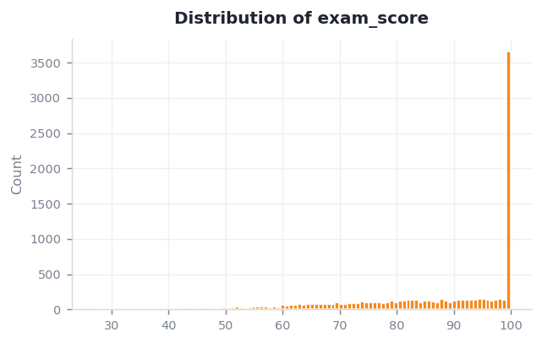
Figure 2.1 — Distribution of the target variable, exam_score.

2.3 Interpretation
exam_score averages 86.70 (median 92.12, SD 15.06), ranging from 26.67 to 100.00. The distribution is left-skewed (skewness -1.01).

3. Categorical Testing
PROBLEM STATEMENT
Do students differ in exam performance across categorical groups — for example, between placement outcomes?

3.1 Group composition
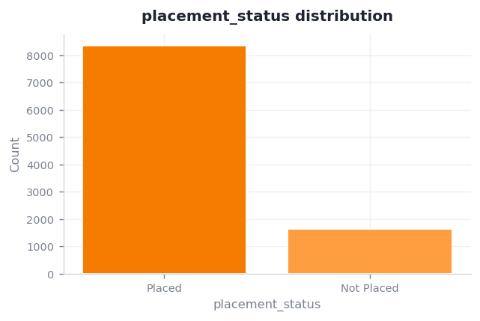
Figure 3.1 — Distribution of placement_status.
placement_status has 2 categories; the most common is "Placed" (83.56% of records).

3.2 Hypothesis test (independent-samples t-test)
H₀: the mean exam_score is equal across placement_status groups. H₁: the means differ.
placement_status | Mean | SD | N
Placed | 91.997 | 9.377 | 8356.000
Not Placed | 59.805 | 8.147 | 1644.000

3.3 Interpretation
Reject H₀ — exam_score differs significantly between "Placed" and "Not Placed" (t = 142.69, p < 0.001, Cohen's d = 3.50, large effect).

4. Correlation & Relationships
PROBLEM STATEMENT
Which variables are most strongly associated with exam performance, and could therefore serve as predictors?

4.1 Method
Pearson correlation coefficients were computed for all metric variable pairs (range −1 to +1).

4.2 Results
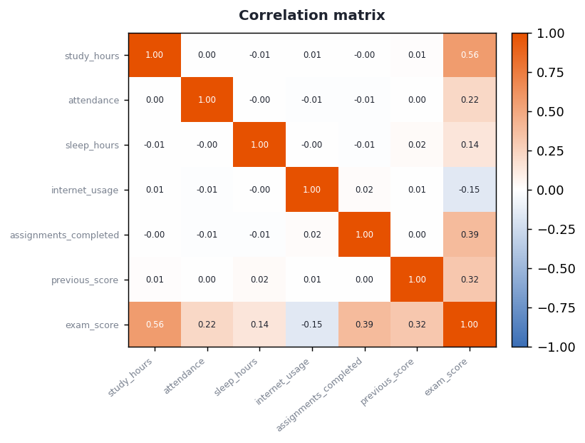
Figure 4.1 — Correlation matrix of the metric variables.

4.3 Interpretation
The strongest linear relationship is between study_hours and exam_score (r = 0.56), a moderate positive association. Variables with high correlation may carry overlapping information.

5. Predictive Trends — Linear Regression
PROBLEM STATEMENT
Can exam performance be predicted from its strongest single factor, and how much of the variation does that factor explain?

5.1 Method
A simple ordinary-least-squares linear regression was fitted, modelling exam_score as a function of study_hours.

5.2 Results
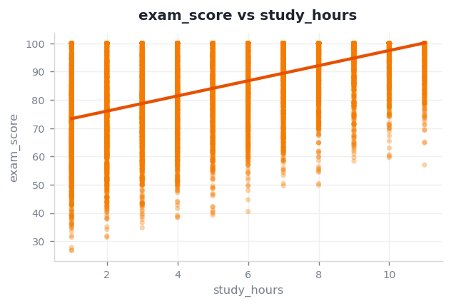
Figure 5.1 — Regression of exam_score on study_hours.

5.3 Interpretation
A simple linear model predicts exam_score from study_hours as Y = 70.667 + 2.678 x study_hours. It explains 31.6% of the variance (R² = 0.316). The slope is statistically significant (p < 0.001), so each one-unit rise in study_hours is associated with a change of 2.678 in exam_score.
As a worked example, a student one standard deviation above the mean study_hours (9.2) is predicted to score 95.2 on exam_score.

6. Synthesis & Conclusions

6.1 Bringing the analysis together
Each section answered one question, and together they form a coherent picture. The descriptive profile set expectations; categorical testing showed where groups genuinely differ; correlation identified the factors that move with performance; and the regression turned the strongest of those into a predictive rule.

6.2 Key findings
- The strongest linear relationship is between study_hours and exam_score (r = 0.56).
- A simple model of exam_score on study_hours explains 31.6% of its variance (R² = 0.32).
- There is a statistically significant difference in exam_score between placement_status groups (p < 0.001).
- exam_score is not normally distributed (Shapiro-Wilk W = 0.8376).

6.3 Limitations & next steps
- A single-predictor model is a baseline — a multiple-regression model using several factors together would likely explain more variance.
- Correlation does not imply causation; a controlled study is needed to confirm drivers.
- Findings describe this sample; external validation on new cohorts is recommended.

