Name: TEJAL SHIMPI

Q 1 wap to demonstrate ternary operator define a variable marks ask its value from user and using ternary operator check if marks > 40 store "Pass" in result variable else store "Fail".

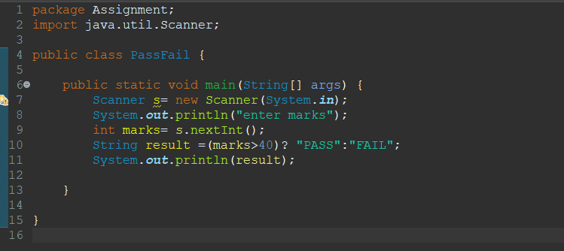

Solution 1

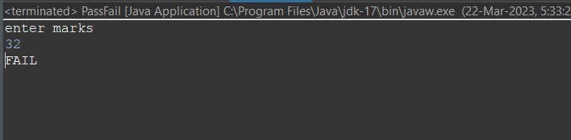

Solution 2

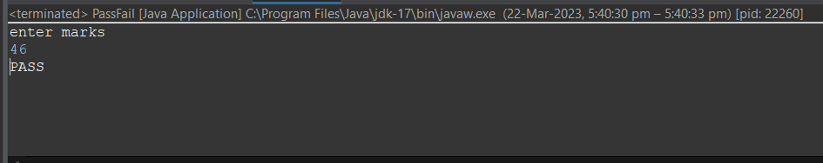

Q 2 using ternary check if number entered by user is positive or negative .  
In case number is positive store "Positive number" else store negative number to Result variable.

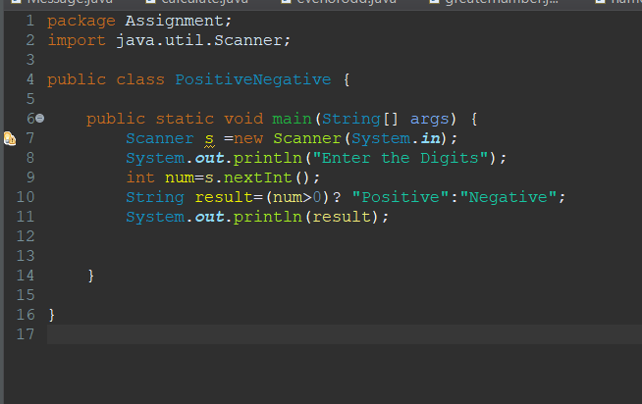

Solution1

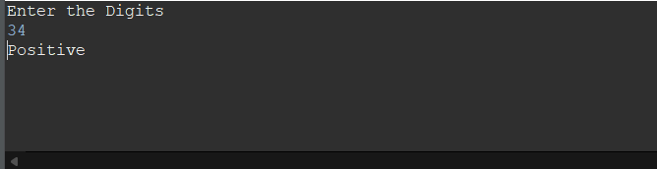

Solution 2

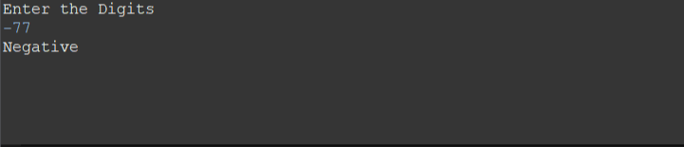

Q 3 WAP to ask name ,age and salary of an employee and print on console.

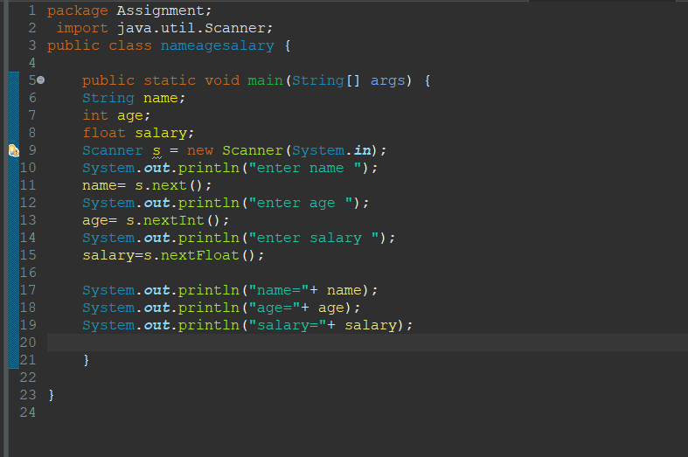

Solution

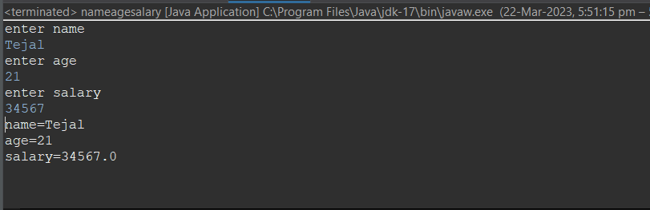

Q 4 wap  that ask two numbers from user and print greater number among two.

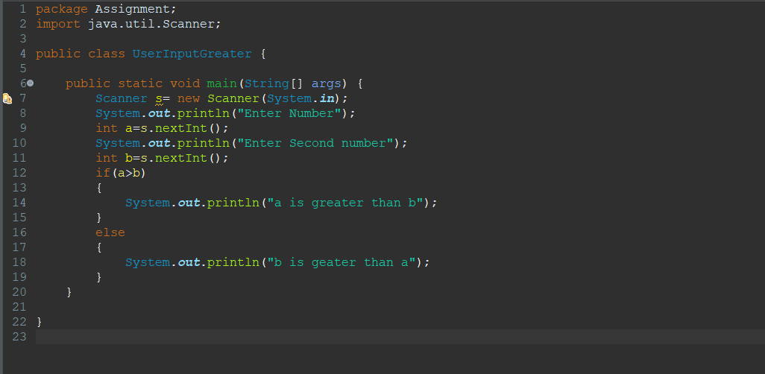

Solution

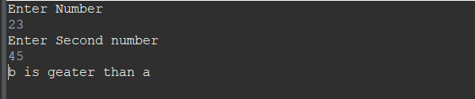

Q 5 wap to ask product name and price of product from user and calculate discount i.e   
if price > 2000 then discount is 10 percent of price   
else   
discount is 7 % of price.

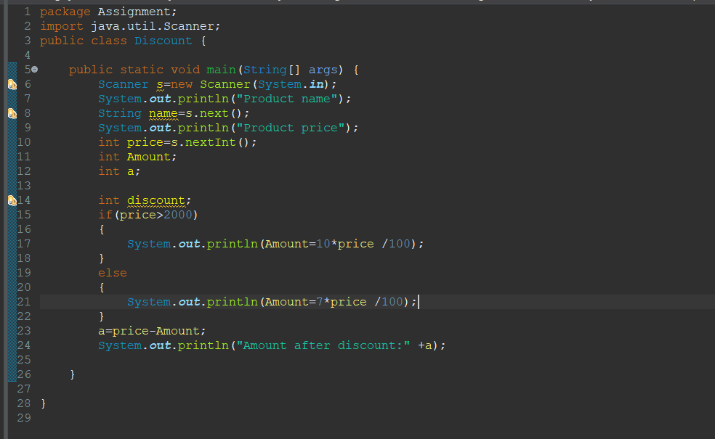

Solution

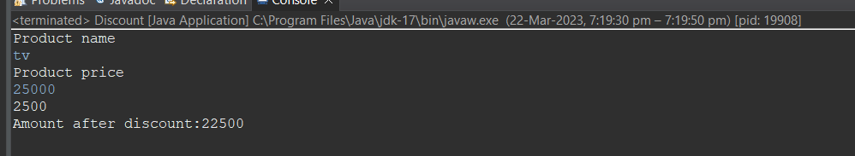

Q 8 wap to check is number is even or odd.

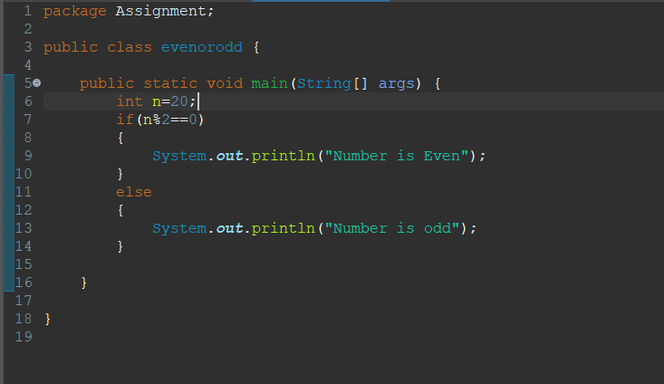

Solution

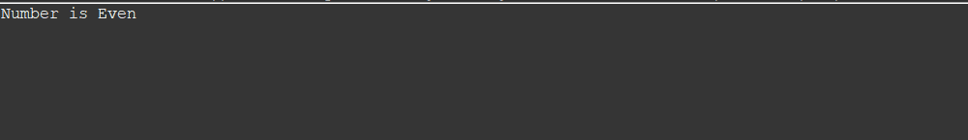

Q 9   A school has following rules for grading system:  
 a. Below 25 - F  
 b. 25 to 45 - E  
 c. 45 to 50 - D  
 d. 50 to 60 - C  
 e. 60 to 80 - B  
 f. Above 80 - A  
 Ask user to enter marks and print the corresponding grade

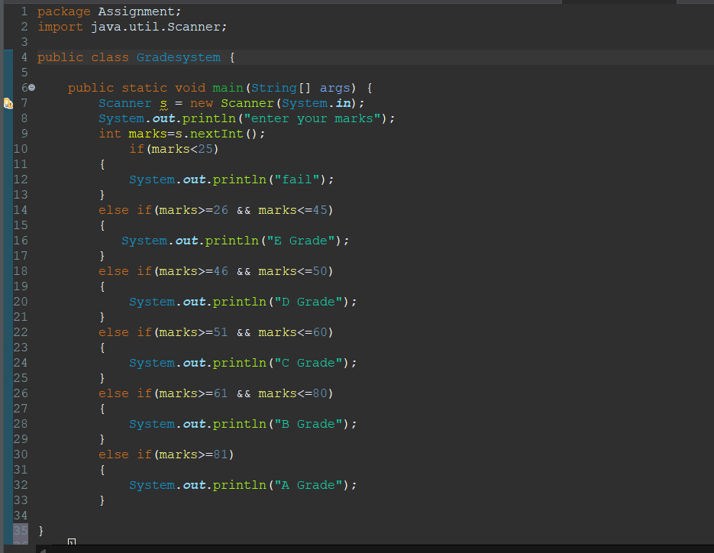

Solution 1

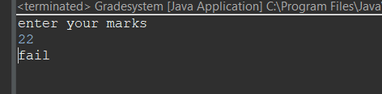

Solution 2

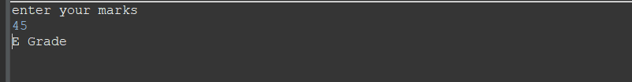

Solution 3

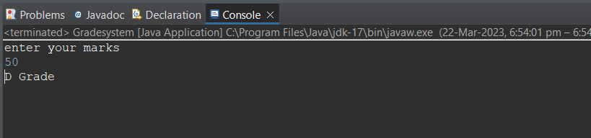

Solution 4

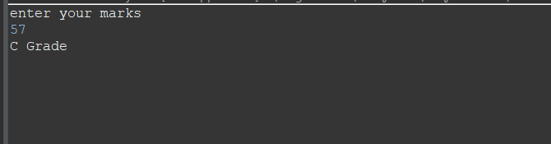

Solution 5

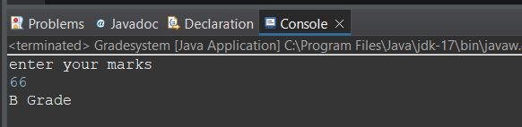

Solution 6

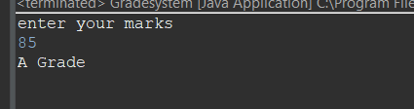

Q  10 wap to check greater number among three numbers

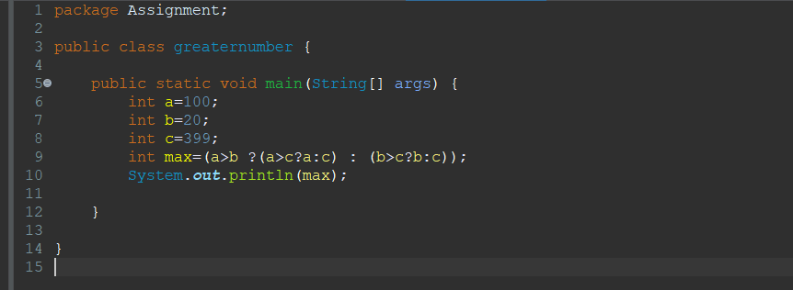

Solution

