Personalized AI-Driven Travel Suggestion Website

Overview
Welcome to the Personalized Travel Suggestion Website! This part of our project complements the mobile application by providing users with a web-based interface to access personalized travel recommendations, plan their trips, and explore exciting destinations. The website is designed to be responsive, making it accessible across various devices.

Features

WEBSITE PART:
User Authentication: Secure user authentication and account creation for a personalized experience.

Dashboard: A personalized dashboard displaying user recommendations, recent trips, and upcoming plans.

Interactive Map: Explore destinations visually through an interactive map with detailed markers and information.

Trip Planning: Plan and organize your trips directly from the website, including itinerary creation and activity recommendations.

Responsive Design: Ensures a seamless user experience across desktops, tablets, and mobile devices.
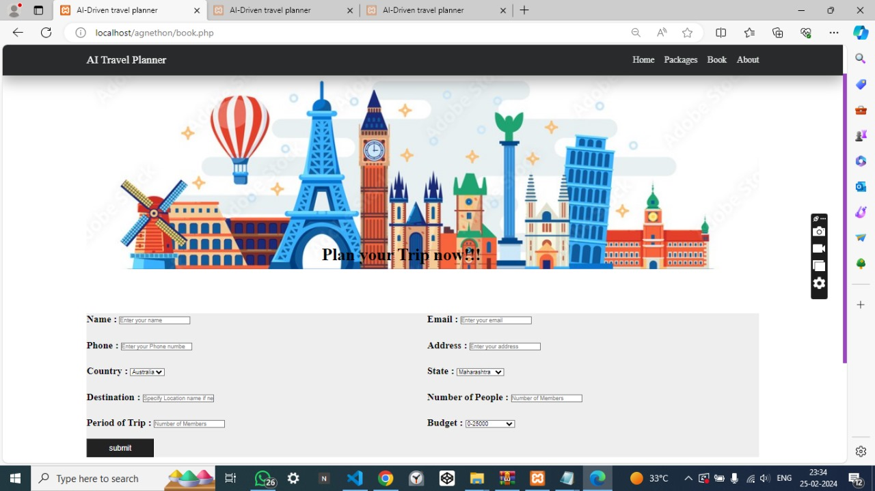
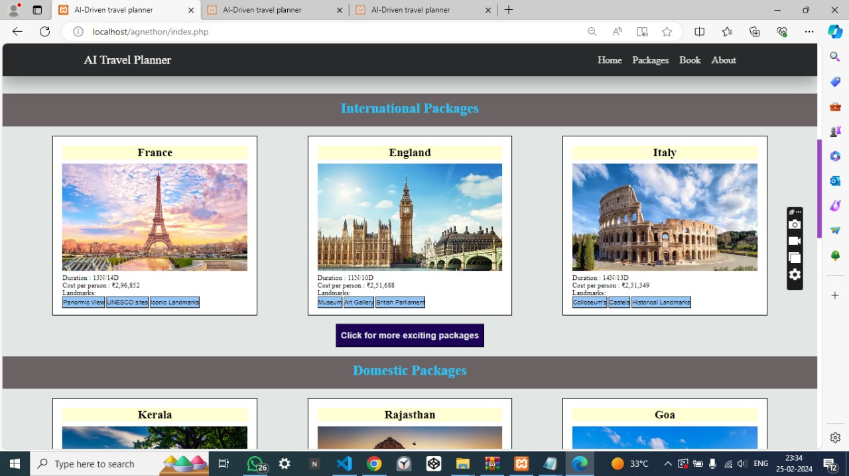

MODEL PART:
This project creates personalized travel plans based on user preferences and budget.
Key functions:
- extract_info(data):
  - Fetches essential details from a JSON file:
    - State
    - Location (optional)
    - Budget
    - Duration
  - Loads a state-specific CSV file containing travel information.
- get_cost(duration, num_people, similar_places):
  - Estimates trip cost within budget for a given duration.
  - Considers estimated expenses per person for recommended places.
- display(place_index):
  - Presents information about a recommended place:
    - Place name
    - Description
    - Activities
    - Rating
    - Reviews
- vect(data):
  - Identifies similar places based on descriptions:
    - Uses TF-IDF (Term Frequency-Inverse Document Frequency) for text analysis.
    - Calculates cosine similarity between place descriptions.
- get_package():
  - Orchestrates trip planning:
    - Extracts information from JSON input.
    - Finds similar places using text analysis.
    - Estimates cost and adjusts duration if needed.
    - Generates a detailed trip plan with estimated cost.
    - Saves the plan to a text file.
Usage:
- Install required libraries: pip install ipynb numpy pandas sklearn nltk
- Place CSV files for each state in the same directory as the code.
- Provide input in a JSON file named "web_output.txt".
- Run the code.
Output:
- A detailed trip plan in a text file, including:
  - Number of people
  - Budget
  - Estimated cost
  - Duration
  - Daily itinerary with places to visit, descriptions, activities, ratings, and reviews
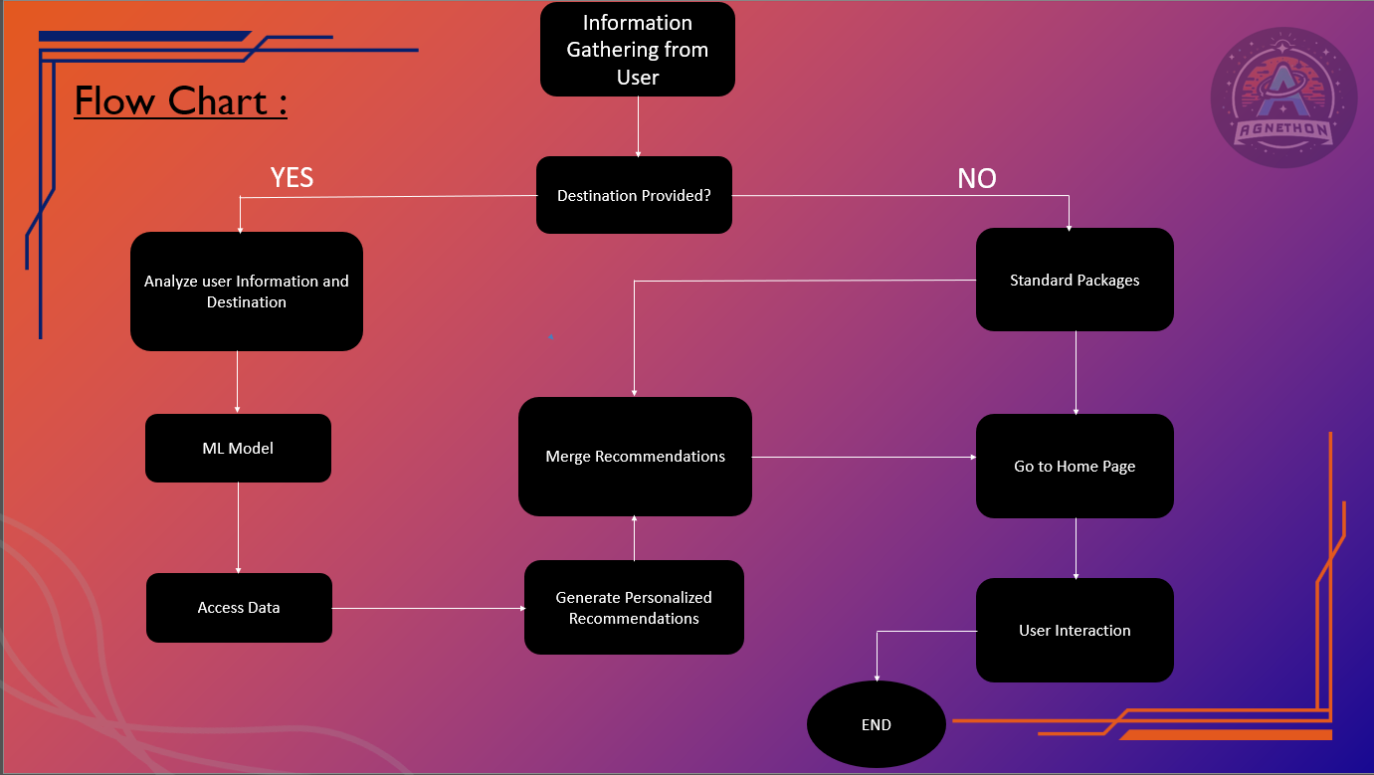

Getting Started
Prerequisites

MongoDB
React.js
Installation
Clone the repository: git clone https://github.com/yourusername/travel-website.git
Install dependencies: npm install
Set up MongoDB and configure the database connection in config.js.
Start the website: npm start
Usage
Navigate to the website URL.
Sign in or create a user account.
Explore personalized recommendations on the dashboard.
Plan and organize your trips using the interactive features.
Enjoy a seamless and responsive web experience.
Contributing
We welcome contributions from the community. If you find any issues or have ideas for improvements, feel free to submit a pull request or open an issue in the repository.

