**OOP PROJECT**

**GAME : CHOMP**

In this game, we have to make the opponent eat the poison cookie, that is, the cookie at the top left.

Also, when a cookie is eaten, all the cookies below it and to its right are eaten.

To run this game, just execute the menu.java file

We have included two modes in the game

* 1vs1 mode
  + 3x3
  + 4x4
  + 40x40
* vs computer mode

The basic idea in the vs computer is that when the computer’s turn ends, then odd number of cookies should be left on the board.

That is, if the user eats cookies such that odd number of cookies are left on the board, then the computer should eat two cookies, the selection of which is achieved through a function called find.

But, if the user eats cookies in such a way that even cookies are left on the board, then the computer eats just one cookie and now it is the user’s turn.

Have fun playing!!



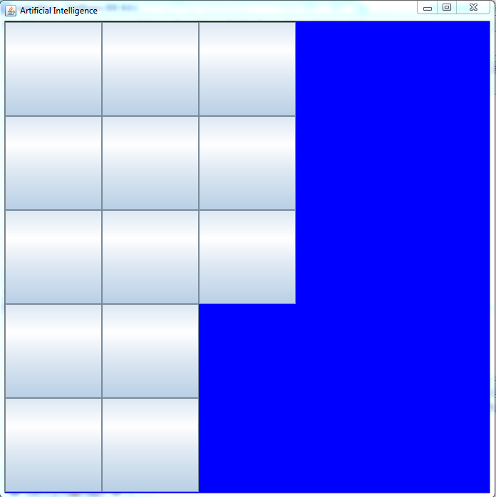

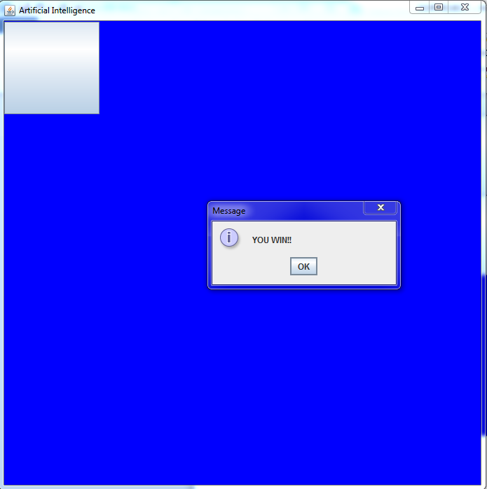

Made by :

Tejas Paranjape(2017140035)

Vineet Paradhi(2017140036)