Introducing our user-friendly and pocket-friendly inter-city taxi riding app, designed to simplify your travel experience while keeping your budget in mind.

With our app, booking a ride between cities has never been easier. Whether you're traveling for business or leisure, our intuitive interface allows you to effortlessly schedule your journey with just a few taps on your smartphone.

Enjoy the convenience of choosing from a range of vehicle options tailored to suit your needs and budget. From economical sedans to spacious SUVs, we have a variety of vehicles available to accommodate your travel preferences.

We understand the importance of transparency, which is why our app provides upfront pricing and fare estimates, ensuring that you know exactly what to expect before confirming your ride. Say goodbye to hidden fees and unexpected charges – with us, what you see is what you pay.

Safety is our top priority, which is why all our drivers undergo rigorous background checks and vehicle inspections to ensure your peace of mind throughout your journey. Rest assured knowing that you're in good hands with our experienced and professional drivers.

Whether you're traveling solo or with a group, our app offers flexible booking options to cater to your specific requirements. Need to make multiple stops along the way? No problem. Our app allows you to customize your itinerary to suit your unique travel itinerary.

Experience the convenience of inter-city travel like never before with our user-friendly and pocket-friendly taxi riding app. Download our app today and embark on your next adventure with ease.

Certainly! Here are some name suggestions for your inter-city taxi-riding app:

1. CityHop

2. InterRide

3. UrbanLink

4. JourneyEase

5. MetroMover

6. TransitConnect

7. TravelEase

8. CityCruise

9. WayFare

10. DriveLink

11. CitySprint

12. UrbanRoute

13. MetroMove

14. CityCabConnect

15. InterCityWay

Choose a name that resonates with your brand identity and reflects the convenience and affordability of your taxi riding app.

Colour palette:

Step 1 Choose a dominant colour

Step 2 Choose a palette from any website (mycolor.space)

Step 3 60/30/10 rule 60% BG 30% main element 10% accent

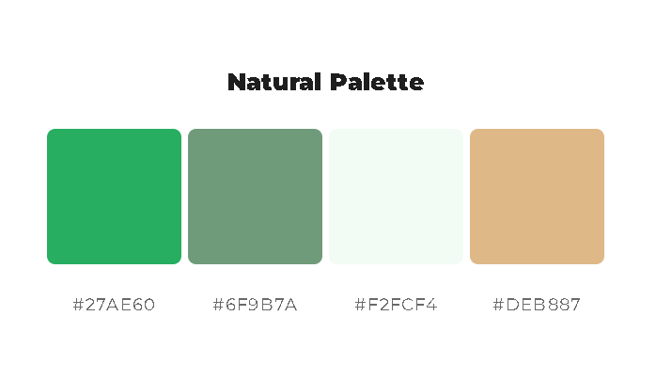

#27AE60

#6F9B7A

#F2FCF4

#DEB887

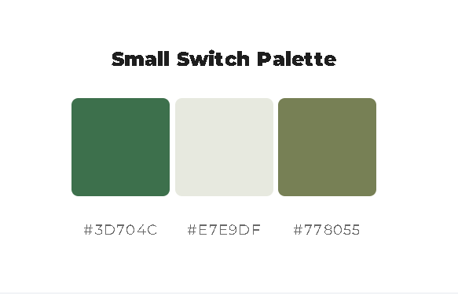

#3D704C

#E7E9DF

#778055