- sum of n natural numbers
Code:-
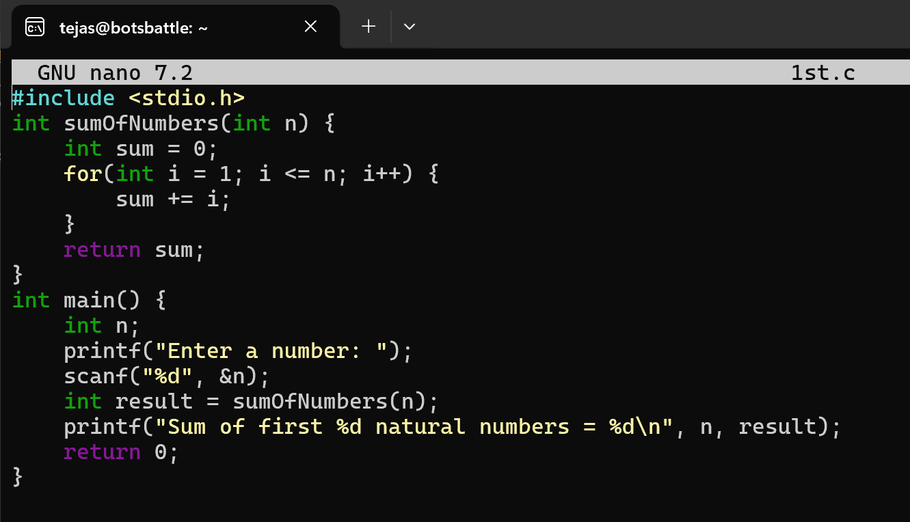
Output:-
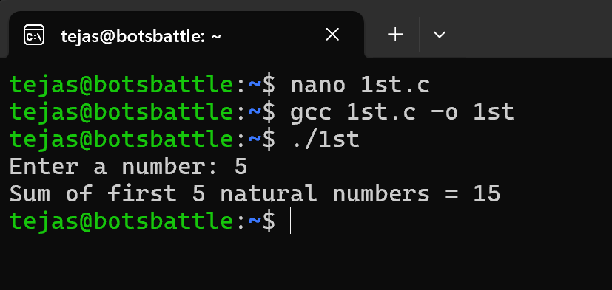
Interpretation:-
I created a user-defined function in C that calculates the sum of the first n natural numbers. I wrote a separate function called sumOfNumbers() to make the program. This function takes the number n as input and uses a for loop to add all the numbers from 1 to n, storing the total in a variable called sum. After the loop finishes, the function returns the final total back to the main program. In the main() function, I asked the user to input a value for n, passed that value to the function, and finally printed the result.

- sum of squares of n natural numbers

Code:-
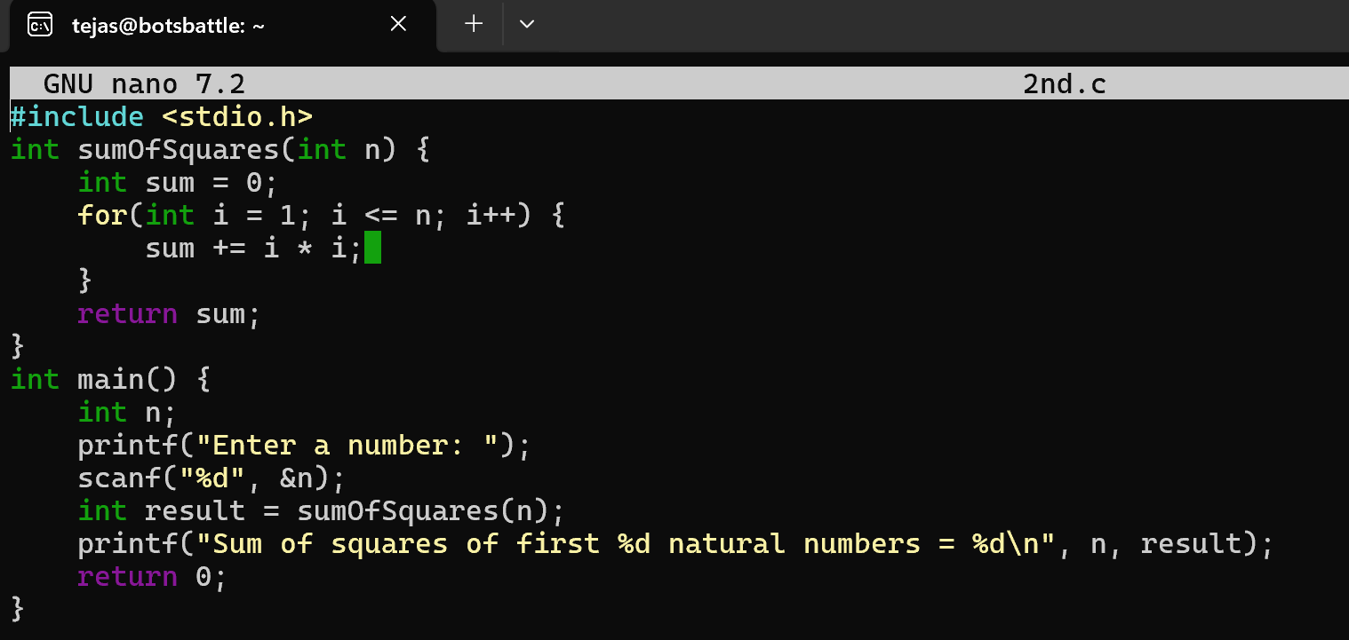
Output:-
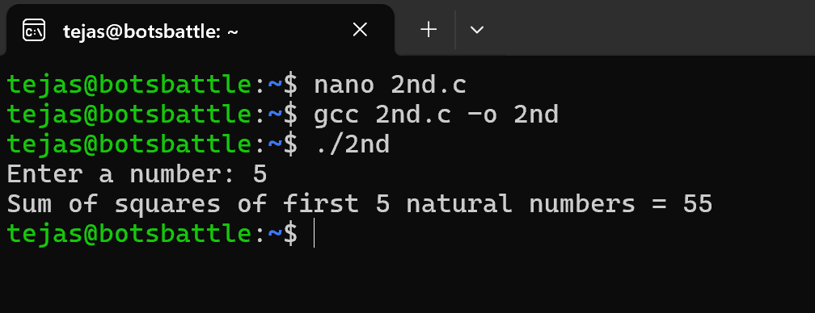
Interpretation:-
I created a user-defined function in C that calculates the sum of squares of the first n natural numbers. I wrote a separate function called sumOfSquares() to make the program. This function takes the number n as input and uses a for loop to square each number from 1 to n and add it to a variable called sum. After the loop finishes, the function returns the final total back to the main program. In the main() function, I asked the user to enter a value for n, passed that value to the function, and then printed the result.
- sum of cubes of n natural numbers
Code:-
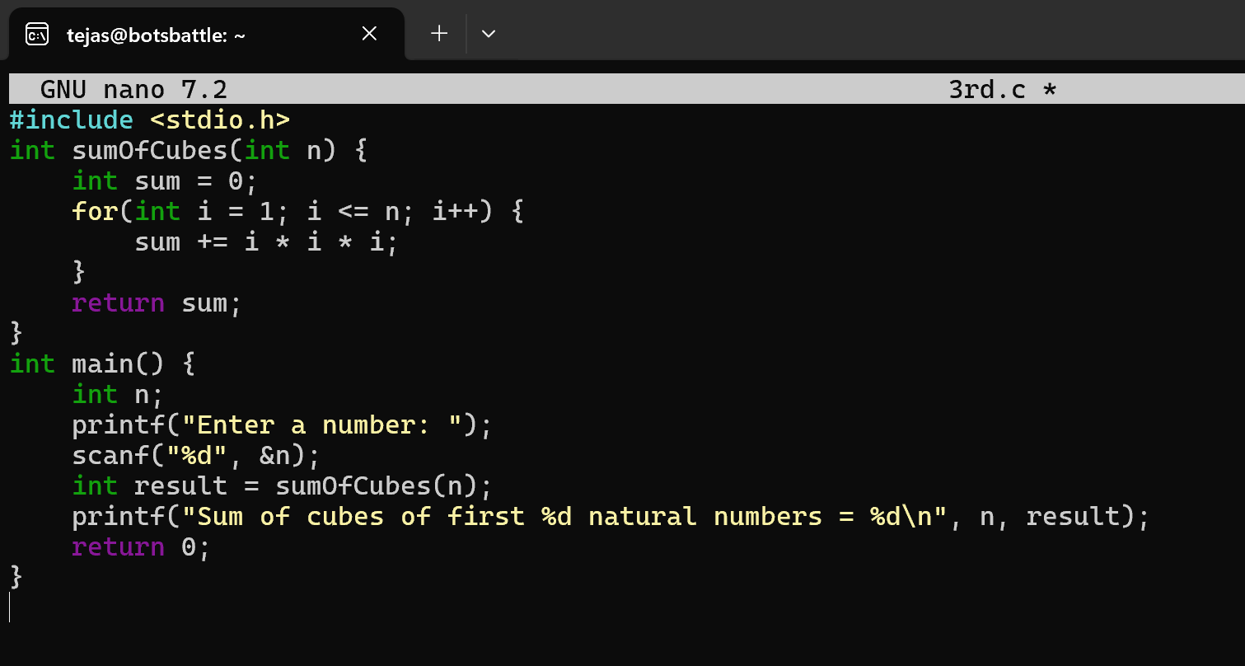
Output:-
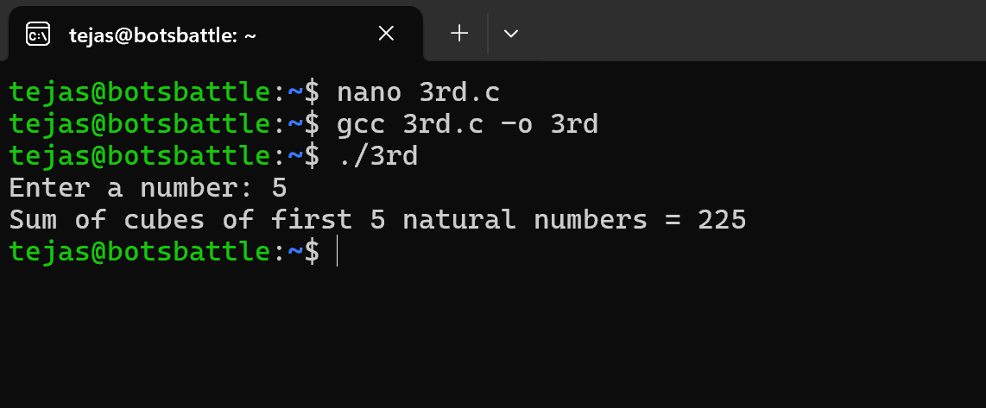
Interpretation:-
I created a user-defined function in C that calculates the sum of cubes of the first n natural numbers. I wrote a separate function called sumOfCubes() to make the program. This function takes n as input and uses a for loop to cube each number from 1 to n and add it to a sum variable. Once the loop completes, the function returns this total back to the main program. In the main() function, I asked the user to enter n, passed it to the function, and printed the final result.
- factorial of a natural number
Code:-
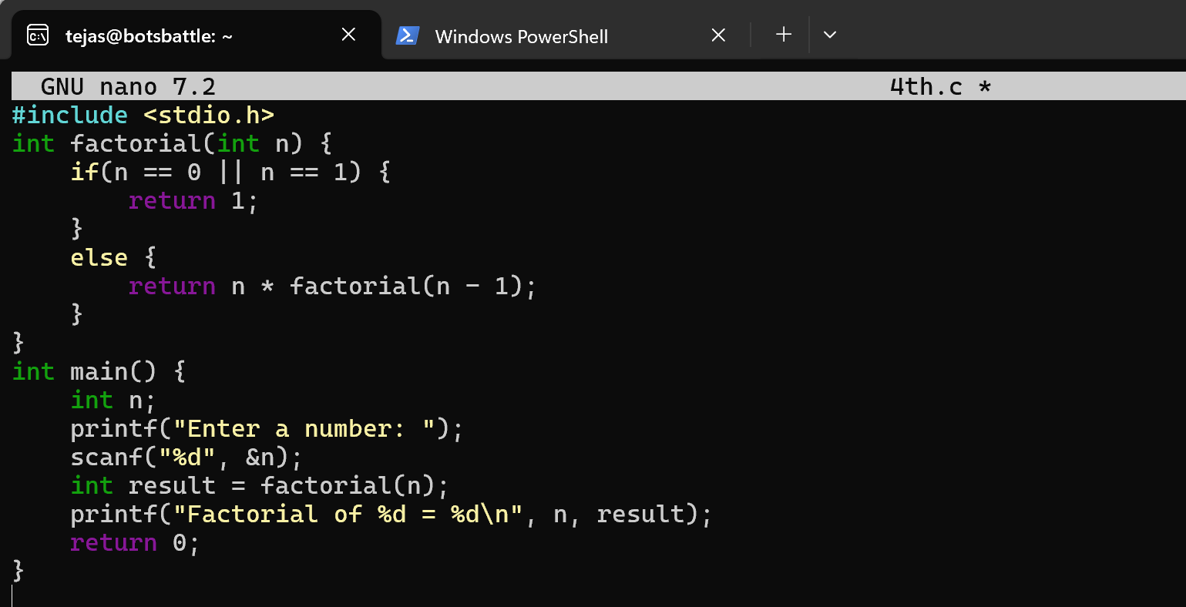
Output:-
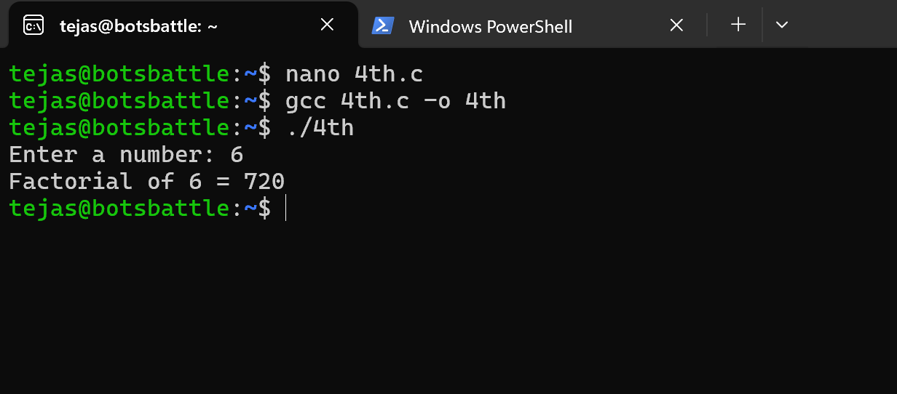
Interpretation:-
I created a user-defined recursive function in C that calculates the factorial of a number. I wrote a function called factorial() that takes n as input and calls itself repeatedly. If n is 0 or 1, the function returns 1, which is the base case. For any other number, it returns n multiplied by factorial(n - 1). This way the problem keeps reducing until it reaches the base case. In the main() function, I took the number from the user, passed it to the recursive function, and printed the factorial result.
- transpose of a matrix
Code:-
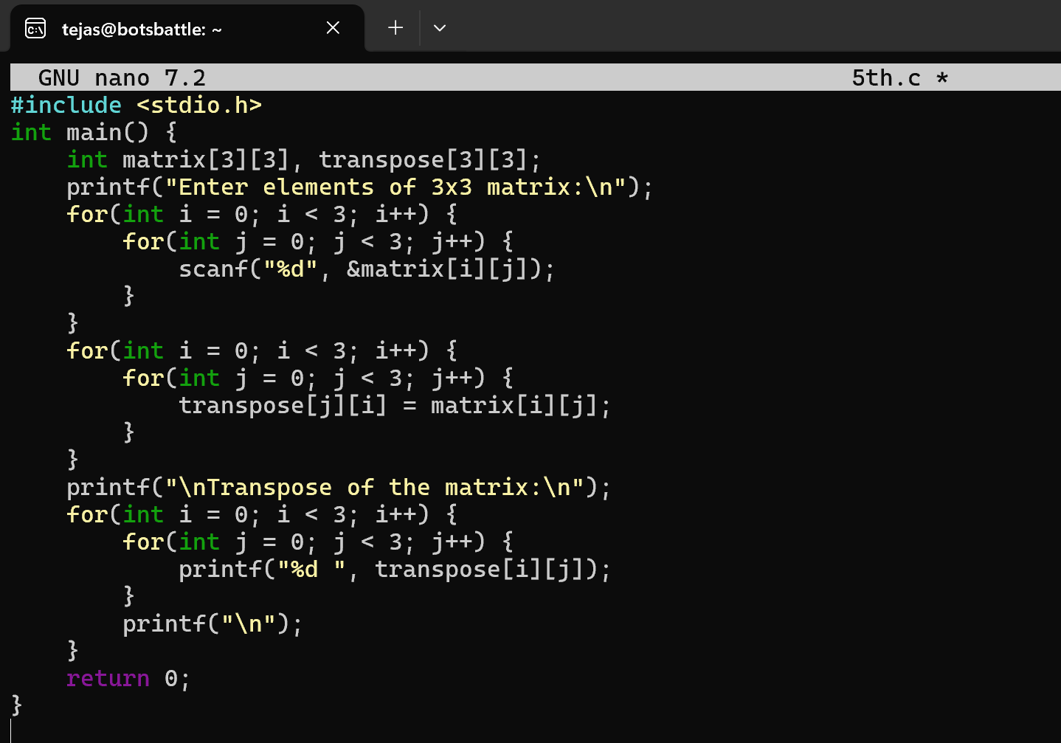
Output:-
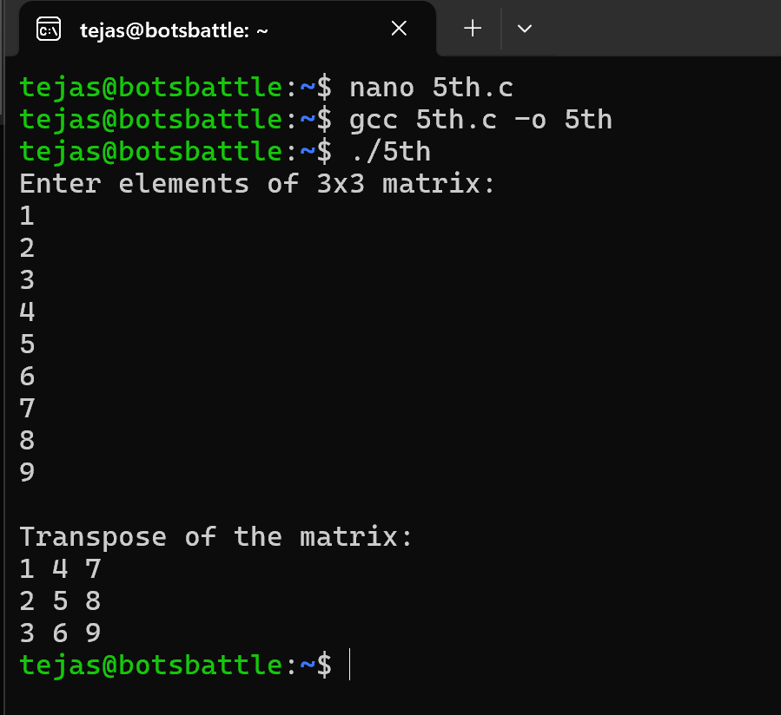
Interpretation:-
I wrote a C program that finds the transpose of a 3×3 matrix. First, I took input for all 9 elements of the matrix from the user. Then, using two nested loops, I stored each element of the original matrix into the transpose matrix by swapping the row and column positions. the element at position (i, j) was placed at position (j, i). This works because the transpose is obtained by interchanging rows and columns.
After calculating the transpose, I printed the new 3×3 matrix.
- first n numbers in the Fibonacci sequence

Code:- 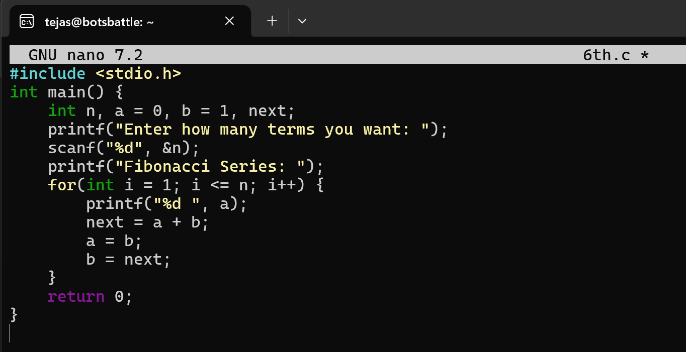
Output:-
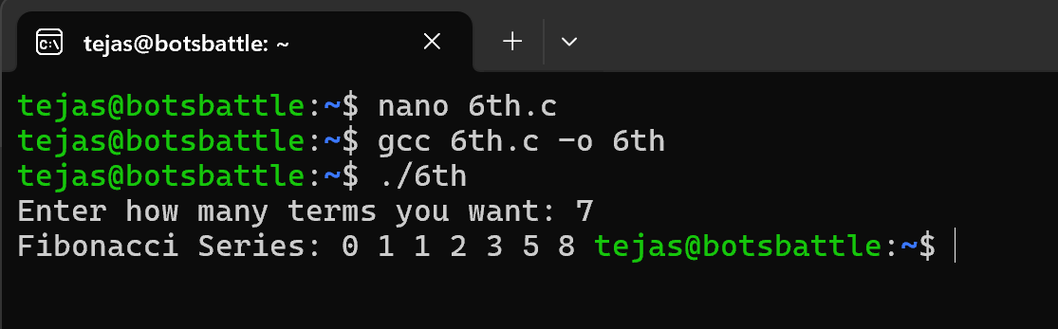
Interpretation:-
I wrote a C program that prints the Fibonacci series for the first n natural numbers using a simple loop. I started with two variables, a = 0 and b = 1, because the Fibonacci sequence always begins with these two numbers. Using a for loop, I printed the current value of a and then calculated the next term by adding a and b. After that, I updated the values by shifting b into a and the new term into b. I repeated this process n times to generate the full series. In the main() function, I took the number of terms from the user and printed the series.

