- Bubble sort
Code:-
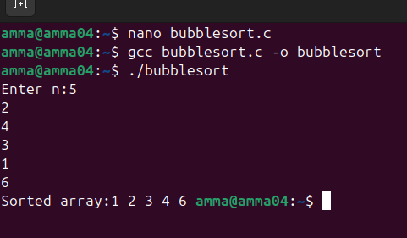
Output:-
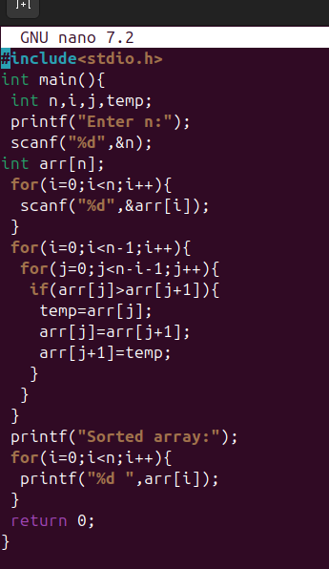

Interpretation:-
I wrote a C program to sort elements using the Bubble Sort technique. In this method, I repeatedly compared adjacent elements in the array and swapped them whenever they were in the wrong order. With each step through the array, the largest element in unsorted elements moves to its correct position at the end. This process continues until the entire array is sorted. Bubble Sort has a time complexity of O(n²) in the worst case as it uses two nested loops to compare elements. Its space complexity is O(1) as it sorts the array in place without using any extra memory.
- Selection sort

Code:-
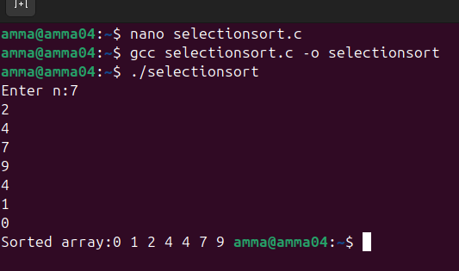Output:-
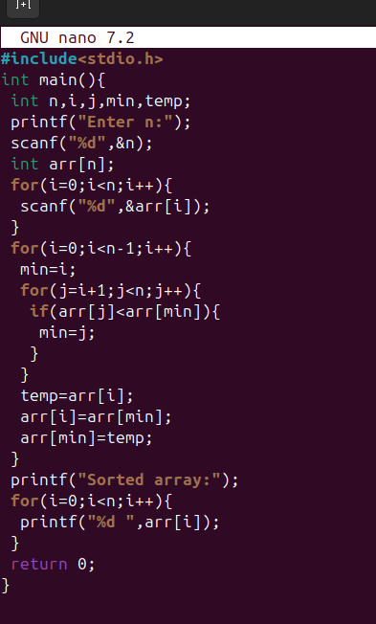
Interpretation:-
I implemented Selection Sort by dividing the array into a sorted and an unsorted part. In each step, I searched for the smallest element in the unsorted part of the array and placed it at the correct position in the sorted part by swapping. This process continues until all elements are sorted. Selection Sort has a time complexity of O(n²) because it repeatedly scans the remaining elements to find the minimum value. its space complexity is O(1) since it does not require any additional memory and performs sorting within the same array.
- Insertion sort
Code:-
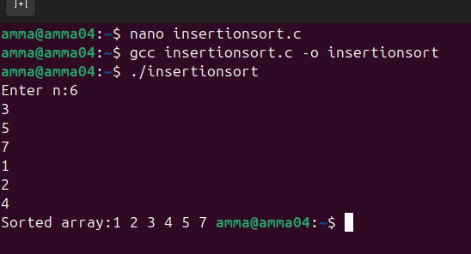Output:-
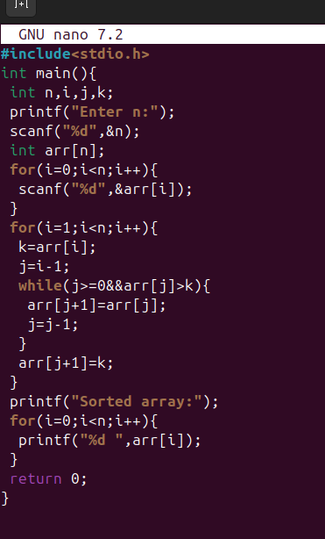
Interpretation:-
I used Insertion Sort to arrange the elements by building the sorted array one element at a time. Starting from the second element, I compared it with the elements before it and inserted it into its correct position by shifting larger elements to the right. This process continues until all elements are placed correctly. Insertion Sort has a time complexity of O(n²) in the worst case when the array is in reverse order. Its space complexity is O(1) since it sorts the elements in place without using extra memory.
- Bucket Sort
Code:-
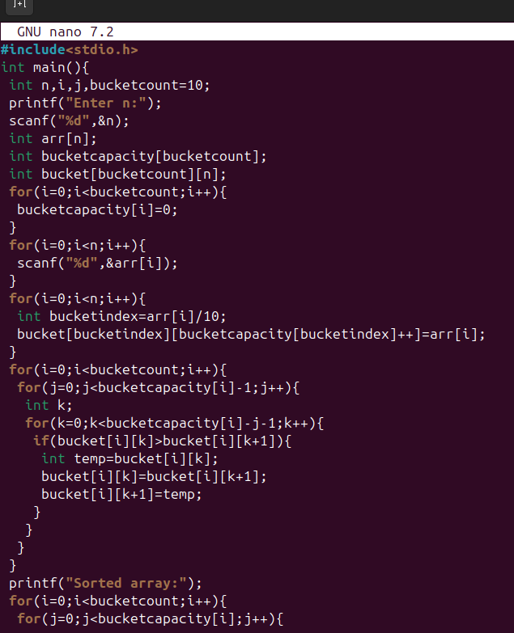
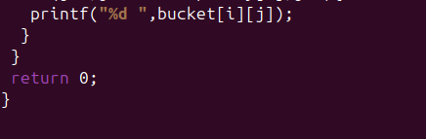Output:-
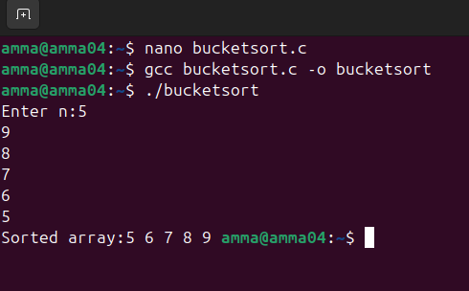Interpretation:-
I implemented Bucket Sort by distributing the elements of the array into several smaller buckets based on their value range. Each bucket is then sorted individually, and finally, all the buckets are combined to form the sorted array. This method works efficiently when the input values are uniformly distributed. Bucket Sort has an average time complexity of O(n + k), where n is the number of elements and k is the number of buckets.it requires extra memory for storing buckets, so its space complexity is O(n).
- Heap sort
Code:-
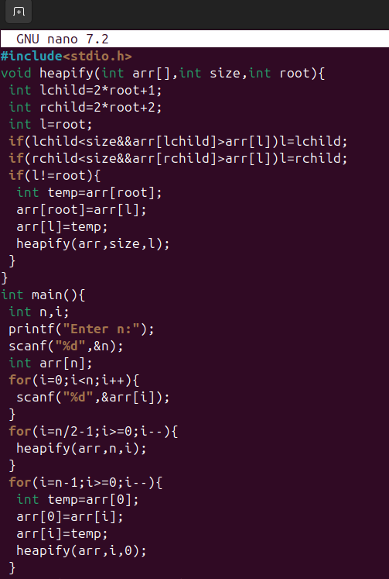
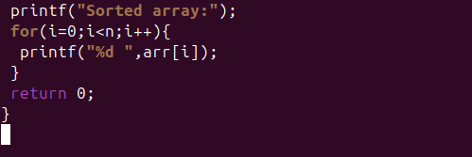Output:-
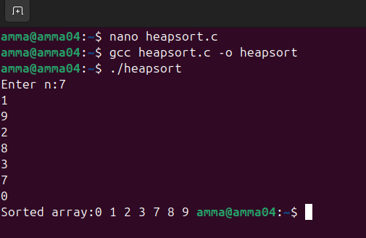Interpretation:-
I wrote a C program to sort elements using Heap Sort by first converting the array into a max heap. In a max heap, the largest element is always at the root. I repeatedly swapped the root element with the last element of the heap and reduced the heap size, then re-heapified the array to maintain the heap property. This process continues until the array is fully sorted. Heap Sort has a time complexity of O(n log n). Its space complexity is O(1) because it doesn't use additional memory.

