NASA C MAPSS FD001 Remaining Useful Life
  - Final implementation, model comparison, and deployment assessment
Prepared 20 October 2026 | CPU-bounded local study

Executive summary
The selected production candidate is a Histogram Gradient Boosting regressor trained with RUL labels capped at 125 cycles and causal 10- and 30-cycle features. It was selected on held-out engine prefixes and then retrained on all FD001 training engines. Its single final official-test evaluation achieved RMSE 13.532, MAE 9.799, R² 0.894, and PHM08 mean 2.852.
The study also implements compact CNN, LSTM, CNN-LSTM, TinyML-oriented, autoencoder, hybrid, random forest, ridge, and mean-baseline paths. The compact CNN-LSTM was the best neural candidate, but it did not outperform the selected tree model. The autoencoder is retained as an unlabeled early-life anomaly signal for triage rather than as a supervised RUL predictor.
Stage | RMSE | MAE | R² | PHM08 mean
Validation selection split | 12.773 | 8.609 | 0.877 | 2.832
Three-split validation mean ± SD | 13.623 ± 1.724 | 8.802 ± 0.561 | 0.866 ± 0.025 | 3.471 ± 1.411
Official FD001 test, one final evaluation | 13.532 | 9.799 | 0.894 | 2.852

1 Problem and data
The task predicts remaining useful life from multivariate turbofan telemetry. The FD001 files contain a unit identifier, cycle, three operating settings, and 21 sensor channels. Training trajectories run to failure; test trajectories are right-censored and have one supplied RUL target for each engine endpoint.
Split | Rows | Engines | Observed life / cycles | Audit result
Training | 20,631 | 100 | 128 to 362 cycles | All quality checks passed
Test | 13,096 | 100 | 31 to 303 observed cycles | All quality checks passed
Test RUL vector | 100 | 100 | 7 to 145 cycles | Aligned to sorted engine IDs

No missing or non-finite values, duplicate unit-cycle rows, cycle gaps, invalid IDs, or ordering faults were found. Seven near-constant sensors were screened in an ablation, but removing them did not improve the selected result.

2 Evaluation protocol and safeguards
- Engines, rather than individual rows, are split into 80 development and 20 validation engines.
- Validation evaluates 50%, 70%, and 90% prefixes of held-out trajectories, creating 60 test-like endpoint cases without exposing future cycles as features.
- Features are causal and reset at each engine boundary. Difference-to-initial-reading features use only the first observed point for that engine.
- Model selection ran without opening test_FD001.txt or RUL_FD001.txt. The selected model was then scored once on official endpoints.
- PHM08 is reported alongside RMSE, MAE, R², bias, and error-percentile measures. Its asymmetric penalty is stricter for RUL overprediction.

3 Models implemented
Family | Role in study | Result or status
Histogram Gradient Boosting | Selected tabular RUL model | Best clean validation and final official score
CNN, LSTM, CNN-LSTM | Compact sequence candidates | CNN-LSTM best neural candidate
TinyML-oriented neural regressor | Small footprint deployment comparison | Historical official-test comparison
Autoencoder | Early-life reconstruction anomaly signal | Used for anomaly persistence and triage
Hybrid TinyML plus autoencoder | Joint RUL and anomaly comparison | Historical deployment comparison
Random forest, ridge, mean | Classical baselines | Retained for benchmark context

The compact sequence study uses CPU-bounded settings: four threads, batch size 256, hidden width 16, a 20-epoch maximum, and validation early stopping. This kept training suitable for a 16 GB RAM laptop with integrated graphics.

4 Ablation and model comparison
Label capping changed the most important behavior: validation PHM08 mean fell from 19.728 for the uncapped 5/20 control to 6.286 with a 125-cycle cap. The selected 10/30 feature variant reduced it again to 2.832.
Candidate | Validation RMSE | Validation MAE | R² | PHM08 mean
HGB uncapped control, 5/20 features | 18.338 | 12.409 | 0.747 | 19.728
HGB cap 125, 5/20 features | 16.417 | 11.510 | 0.797 | 6.286
HGB cap 125, 10/30 features - selected | 12.773 | 8.609 | 0.877 | 2.832
Compact CNN-LSTM | 16.199 | 12.488 | 0.803 | 4.010
Compact CNN | 17.525 | 13.251 | 0.769 | 5.428
Compact LSTM | 18.592 | 13.844 | 0.740 | 9.125

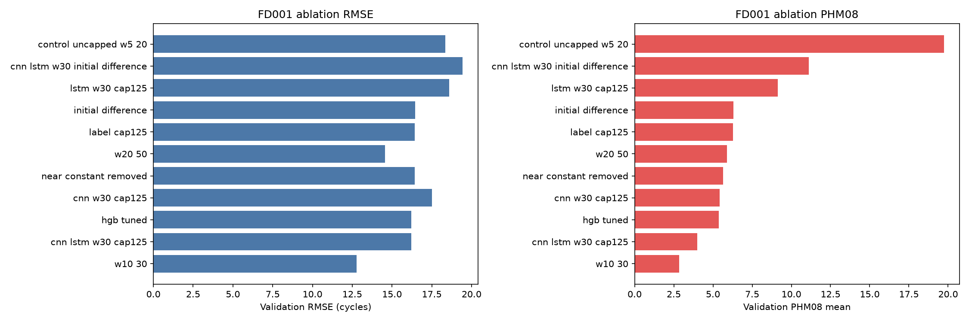
Figure 1. Validation ablation comparison. Lower values are better.

5 Official test result and error profile
After selection, the HGB model was retrained using all 100 FD001 training engines. It was evaluated once against the 100 official test endpoints. The near-zero bias and balanced direction counts indicate no material systematic over- or under-estimation in this run.
Metric | Value | Metric | Value
RMSE | 13.532 | MAE | 9.799
R² | 0.894 | PHM08 sum | 285.222
PHM08 mean | 2.852 | Bias, prediction minus actual | 0.157 cycles
P90 absolute error | 24.135 cycles | Maximum absolute error | 38.845 cycles
Over / under predictions | 50 / 50 | Official endpoint count | 100

6 On-device anomaly and maintenance workflow
An early-life autoencoder learns a reconstruction baseline from development windows. Its 99th-percentile reconstruction-error threshold is used as an unlabeled anomaly signal. It does not have anomaly accuracy metrics because FD001 lacks cycle-level anomaly labels.
- The replay evaluates each incoming record causally and combines RUL, anomaly persistence, data quality, and model version.
- Deterministic triage assigns monitoring, recommendation, planned-maintenance, high-priority, or human-review outcomes.
- Idempotency prevents duplicate work orders for the same engine and severity. The validation replay produced 43 deduplicated mock recommendations.
- An LLM is not on the safety-critical decision path. Any narrative assistant should be limited to explaining already generated evidence and must not override a maintenance decision.

7 Conclusions and recommended next work
For FD001, the selected HGB pipeline is the best current choice: it achieved the strongest validation and final official-test metrics with substantially lower training and inference cost than the neural alternatives. The compact neural and autoencoder components remain useful for edge deployment research and anomaly triage, but they should not replace the selected RUL model on the current evidence.
- Validate a deployable prefix-only change-point policy before using it in labeling or in a production decision pipeline.
- Run FD002 and FD004 studies with condition-aware normalization and grouped engine splits.
- Calibrate prediction intervals and maintenance thresholds with domain owners, cost constraints, and false-alarm tolerance.
- Measure TinyML model size, latency, RAM use, quantization error, and update cost on the intended hardware before presenting an on-device deployment claim.

8 Evidence and reproducibility
The project contains reproducible runners for the validation-only study, compact sequence study, one-time official-test evaluation, and anomaly-triage replay. The full metrics matrix, model predictions, data audit, metric audit, generated figures, and unit tests are retained in the reports and artifacts directories.
Validation completed with 16 passing tests and one skipped optional-dependency scenario. Historical official-test scores are retained as context only; they were produced before this clean selection protocol and were not used to choose the final model.
References: NASA C-MAPSS data documentation; Ensarioglu, Inkaya, and Emel (2023), Applied Sciences 13(21), 11893; and the user-provided research-paper materials and implementation notes.

