**Question 1:**

Create angular application which create two custom directives as Comp-Success

And Comp-Failure.

In case of Comp-Success directive when we move the mouse cursor over the data element its text color becomes green and in case of Comp-Failure text color becomes red.

When we remove mouse its cursor its color becomes black.

We have to use that both directives in one .html file

**Output:**

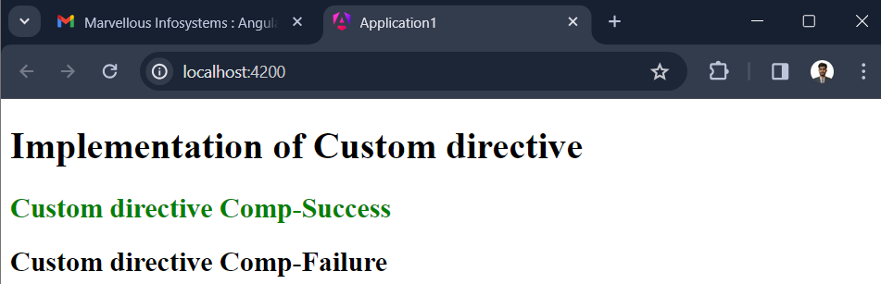

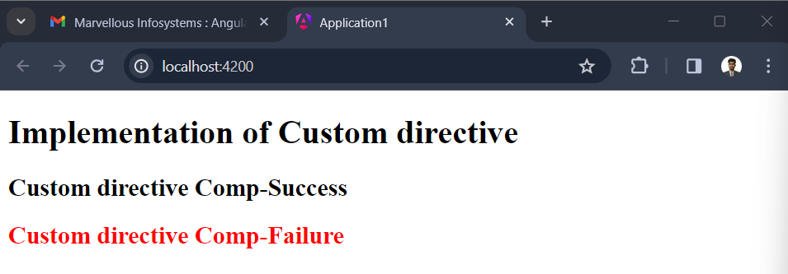

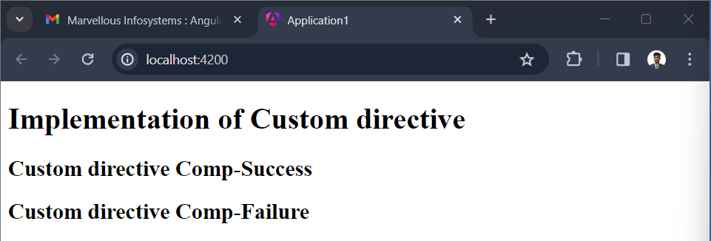

**Question 2:**

Create angular application which create one custom directives as Custom-Style.

In this directive we have to set background of our text as yellow and type of text should be bold

**Output :**

