**Question 1:**

Create the application which contains one service named as Arithmetic.

Arithmetic service contains two methods named as Add and Sub.

Both of this methods accepts two integers and perform addition and subtraction

respectively.

We have to create one child component named as Demo under app component which uses

Arithmetic service using Dependency Injection.

That methods from the service add and sub should be called from Demo component by

passing some hardcoded values. And display the result of addition and subtraction inside

Demo component.

**Output :**

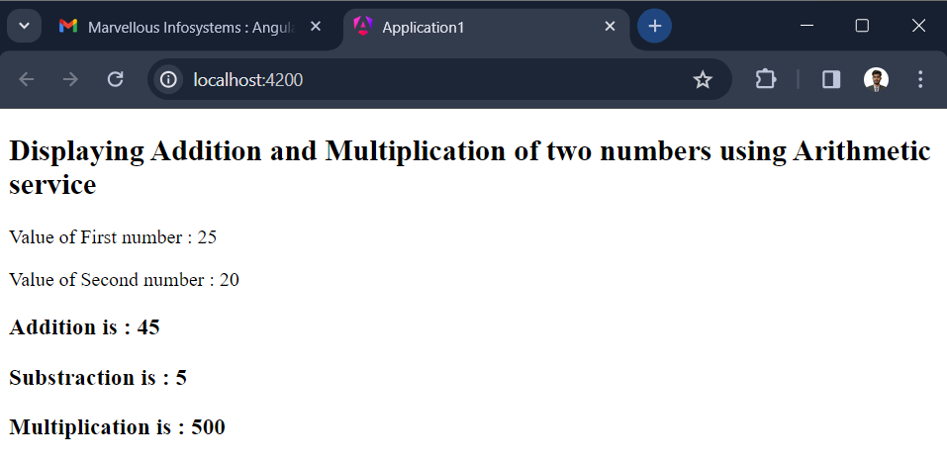

**Question 2:**

Create the application which contains two services named as Number and String.

Number service contains one method named as ChkPrime() which accepts number and

check whether that number is prime or not.

String service contains one method named as CountCapital() which counts number of

capital characters and return its count.

We have to create two child component named as Child1 & Child2 under app component

Child1 uses Number service & Child2 uses String service using Dependency Injection.

Call both the methods from the respective components by passing some hardcoded values

and display the result.

**Output :**

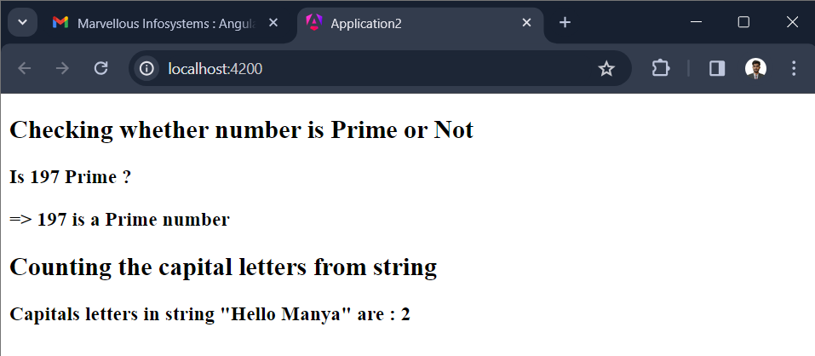

**Question 3 :**

Create the application which contains two services named as Number and String.

Number service contains one method named as ChkPrime() which accepts number and

check whether that number is prime or not.

String service contains one method named as CountCapital() which counts number of

capital characters and return its count.

We have to create one child component named as Child under app component uses

Number service String service using Dependency Injection.

Call both the methods from the components by passing some hardcoded values and display

the result.

**Output :**

